0437-全彩3D打印CD唱片模型制作记录
Full-color 3D printed CD record model
🖨️ 全彩3DP
🖥️ 打印机: HP
📦 材料: 全彩3DP
生活的每一步都蕴含着创造的力量。就像最近接到的这个全彩3D打印CD唱片模型的单子，事情总是充满了惊喜。
Every step of life contains the power of creation. Just like the recent order I received for a full-color 3D printed CD record model, things are always full of surprises.
________________________________________________________________________________
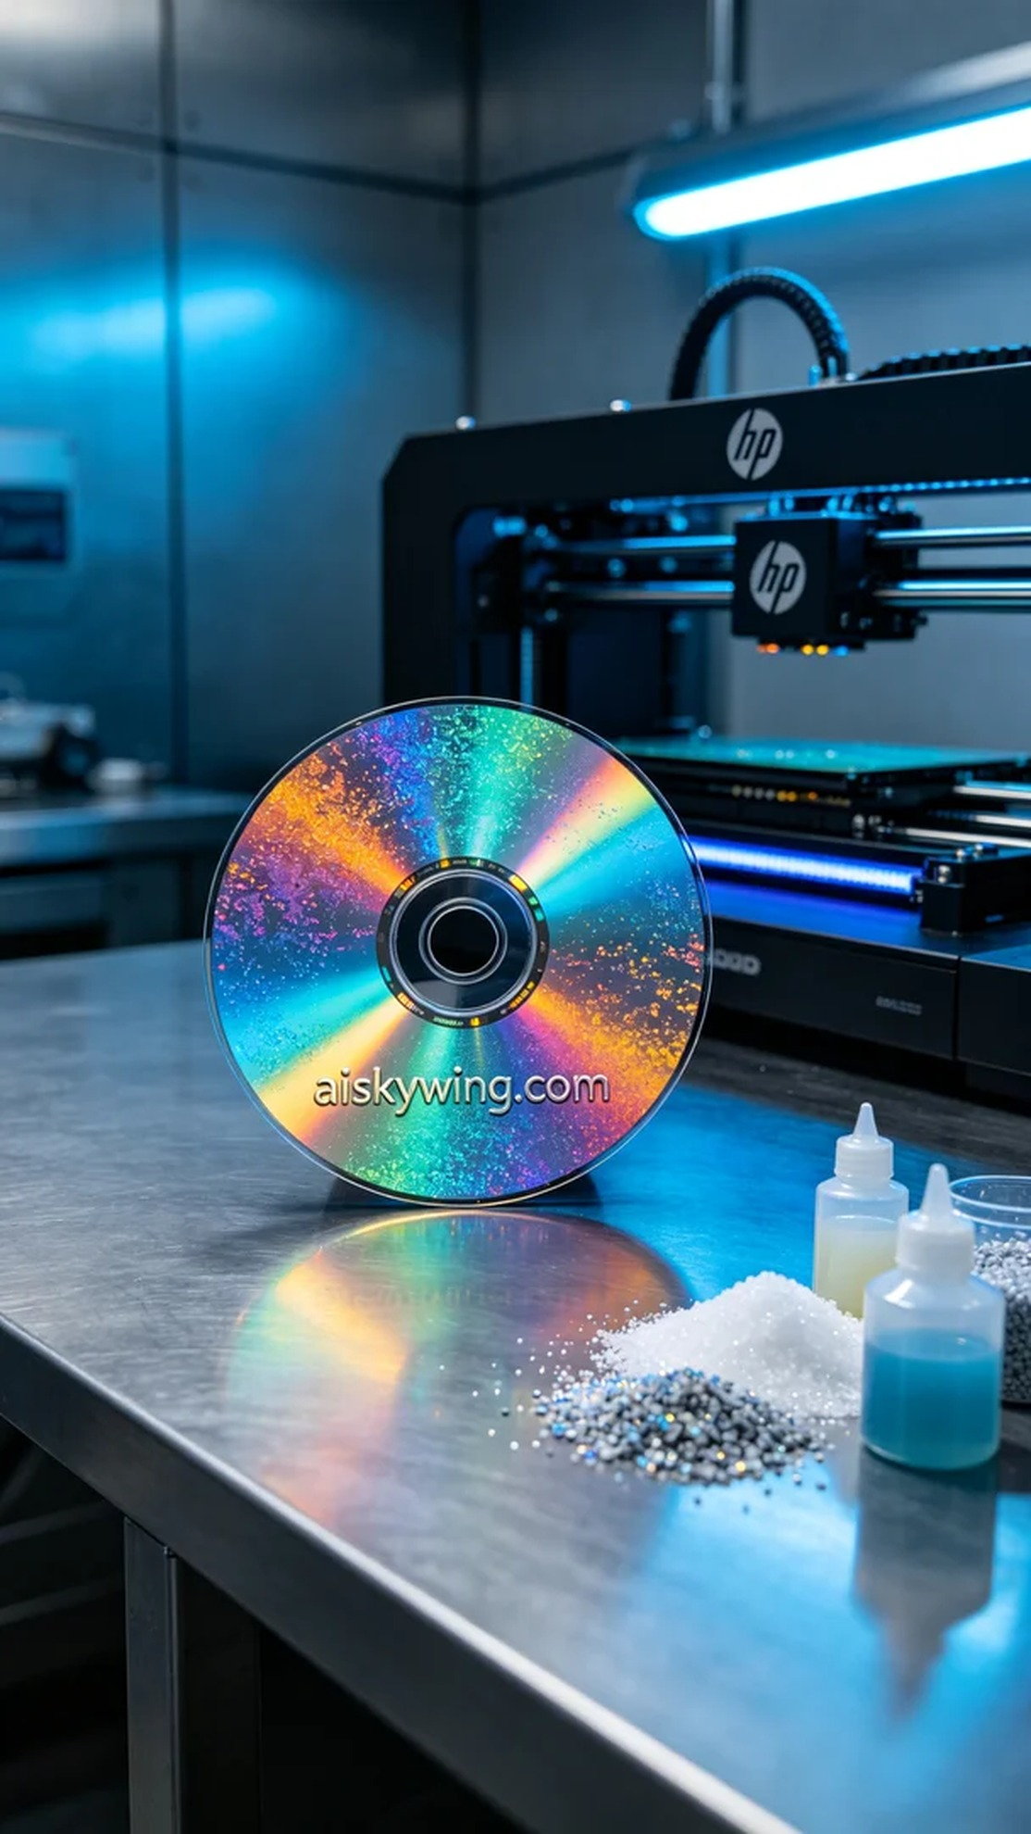
Every step in life embodies the power of creation. Recently, we received a request for a full-color 3D printed CD model through TikTok, and the project was full of surprises.
For this model, we selected full-color 3DP as the raw material. This material boasts vibrant colors and allows for complex gradient effects, matching the expectations of the requester. We used an HP full-color 3D printer, with parameters set to a layer thickness of 0.1mm, a printing temperature of 45°C, a power setting of 80%, a printing speed of 30mm/s, and an estimated print time of 12 hours.
During the printing process, the equipment ran smoothly, and we constantly monitored the print quality. As each layer gradually formed, the details of the model began to emerge. To avoid any defects, we kept checking the printer's nozzles and material feed, ensuring each step met the expected results.
Once printing was completed, we began the cleaning process, using a special cleaning solution to meticulously treat the model's surface and remove any uncurled resin. Next, we sanded the model to ensure a smooth surface. During the curing process, we placed the model under a UV lamp for 30 minutes to ensure strength and durability. Finally, we conducted a thorough inspection to make sure every detail met our standards.
After a series of meticulous procedures, the full-color 3D printed CD model presented itself before us. With its vibrant colors and vivid details, the satisfactory result once again verified our commitment to quality.
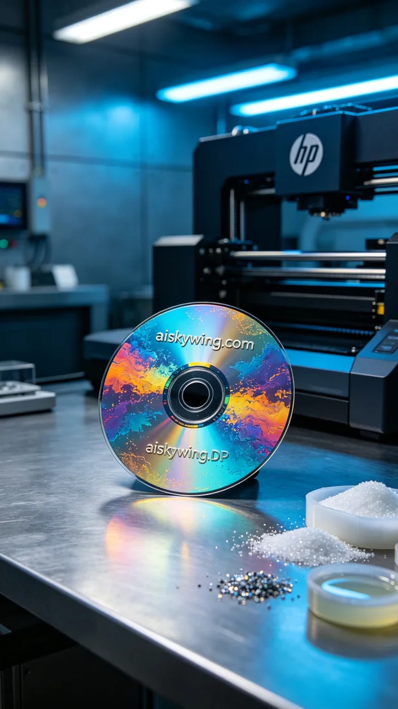
最近，有人通过TikTok找到了我们，希望能制作一个全彩3D打印CD唱片模型。他们对模型的色彩丰富性和细节呈现有很高的要求，期待能通过3D打印展现出与众不同的效果。
制作这个模型，我们选用了全彩3DP作为原材料。这种材料色彩饱满，能够实现复杂的颜色渐变，符合客户的需求。我们使用的是HP的全彩3D打印机，打印参数设置为层厚0.1mm，打印温度保持在45℃，功率设定在80%，打印速度为30mm/s，预计打印时间为12小时。
在打印过程中，设备运行平稳，我们始终保持对打印质量的监控。随着每一层的逐渐成型，模型的细节也在不断显现。为了避免出现任何瑕疵，我们不断检查打印机的喷头和材料供给，确保每一步都达到预期效果。
打印完成后，首先进行了清洗工序，使用专用清洗液对模型表面进行细致处理，去除未固化的树脂。接着，我们对模型进行了打磨，确保表面光滑。固化过程中，将模型放置在UV灯下进行30分钟的固化，以确保强度和耐用性。最后，我们进行了严格的检验，确保每个细节都符合标准。
经过一系列精细的工序，这个全彩3D打印CD唱片模型最终呈现在眼前。色彩斑斓，细节生动，令人满意的成果再次印证了我们对品质的追求。
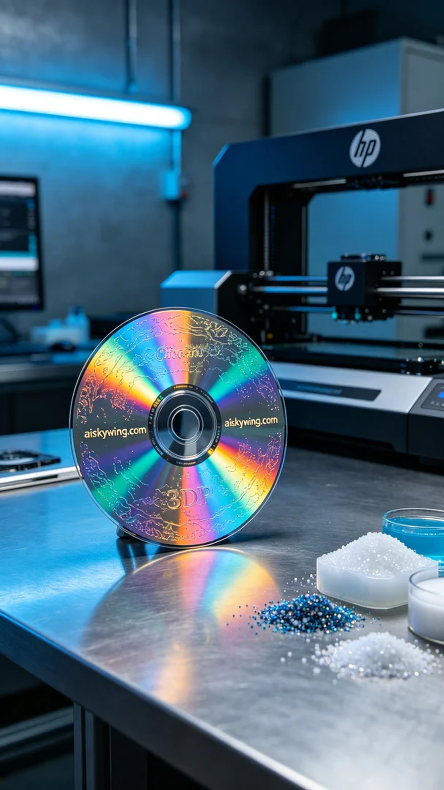
Aiskywing Industrial 3D Printing
Full-color 3D printed CD record model


