0438-全彩3D打印云朵模型生产记录
Full-color 3D printed cloud model
🖨️ 全彩3DP
🖥️ 打印机: Systems
📦 材料: 全彩3DP彩色打印
生活中的每一步都在启示我们，像那全彩3D打印云朵模型，尽管看似轻盈，却凝聚着无数的努力与坚持。最近有朋友在Instagram上找我们，想要一个富有创意的云朵模型。
Every step in life inspires us, just like that full-color 3D-printed cloud model. Although it appears light and airy, it embodies countless efforts and perseverance. Recently, a friend reached out to us on Instagram, looking for a creative cloud model.
________________________________________________________________________________
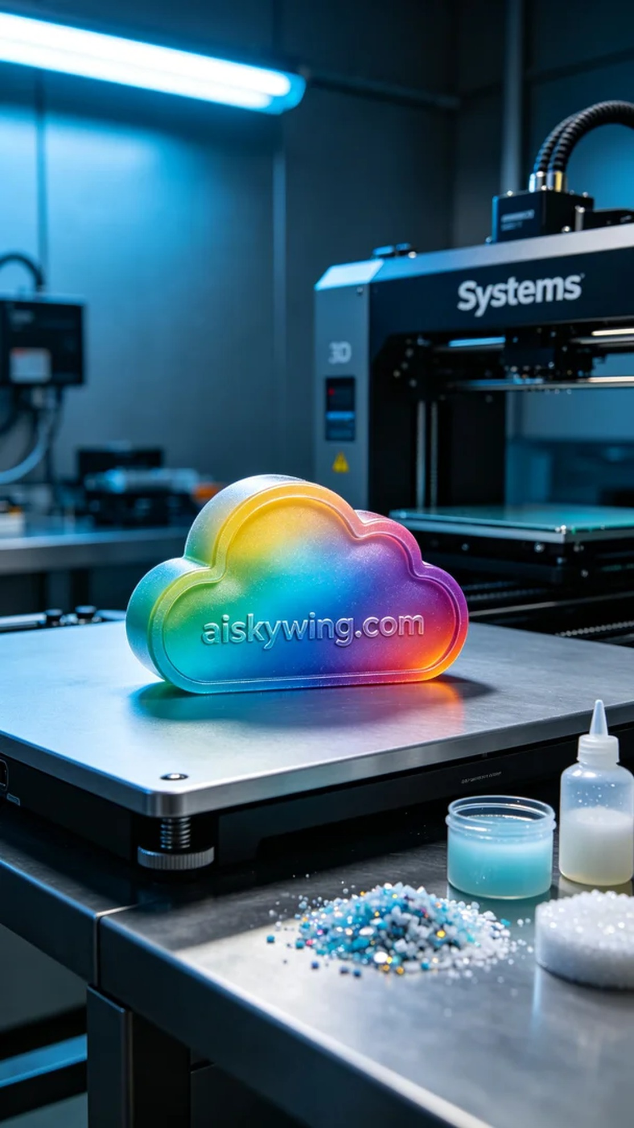
Every step in life offers us insights, just like this full-color 3D printed cloud model, which may seem light but embodies countless efforts and perseverance. Recently, a friend reached out to us through Instagram, requesting a creative cloud model.
For this project, we utilized full-color 3DP printing materials, known for their high-fidelity color representation and intricate color gradients. Our Systems printer was meticulously prepared, setting the layer thickness to 0.1mm, the printing temperature at 210℃, the power adjusted to 80W, and the printing speed set at 30mm/s. The estimated printing time was around three hours to ensure flawless layers.
As the printing process commenced, the Systems printer operated smoothly, with quality checks performed throughout. Gradually, the color gradients emerged, and the cloud shape became more defined. The printing progressed steadily according to our preset parameters, and we eagerly anticipated the final product.
Once the printing was complete, we moved on to the post-processing phase. First, the cloud model was placed into a washing station, cleaned thoroughly with alcohol to remove excess resin. Next, we polished the surface to ensure a smooth finish. After that, the model was cured using a UV light to enhance its hardness and durability. Finally, each detail was meticulously inspected to guarantee no flaws, achieving the desired outcome we aimed for.
This full-color 3D printed cloud model not only met our design requirements but also helped us gain valuable experience in the production process. We look forward to applying such creativity to more projects in the future.
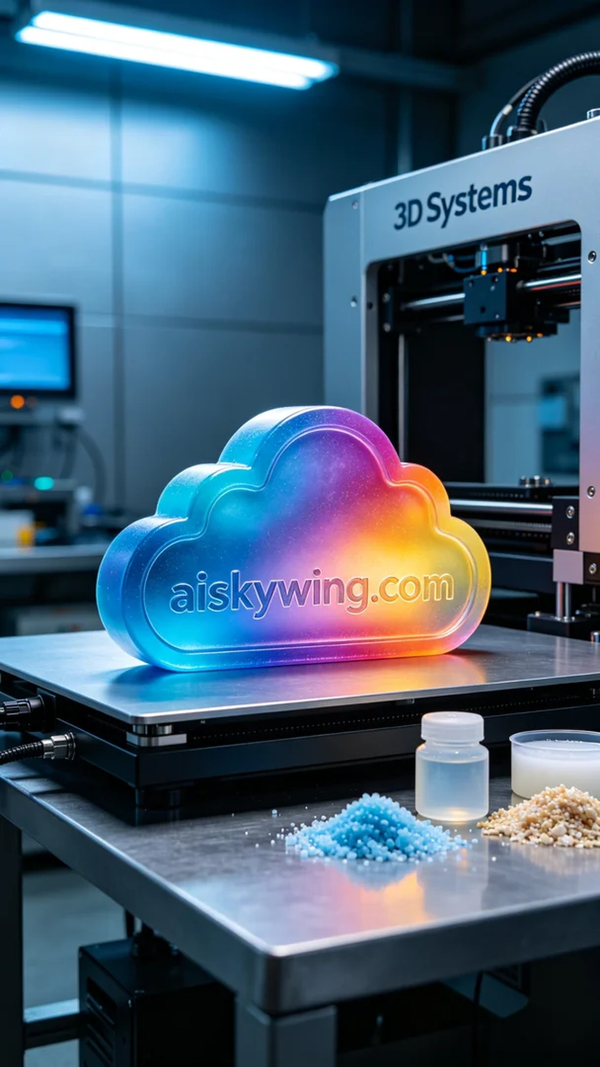
这次的全彩3D打印云朵模型，源于一位朋友在Instagram上看到的创意。由于他希望能够将这个模型应用于商业产品展示，便找上了我们。有些特定的要求，需要色彩非常丰富且细节表现力强，以便充分吸引观众的目光。
在原材料方面，我们使用了全彩3DP彩色打印材料。这种材料具有高保真的色彩呈现能力，能实现细腻的颜色渐变。为了确保打印效果，我们的Systems打印机进行了精细的准备工作。我们设定了层厚0.1mm，打印温度为210℃，功率调整到80W，打印速度为30mm/s，预计打印时间为3小时，以此确保每一层都能完美成型。
打印过程开始后，Systems打印机运转顺利。我们全程监控打印质量，确保每一层都能准确附着。随着打印的推进，色彩渐变逐渐展现出来，云朵的形状也在不断清晰。根据预设的参数，打印进程稳步推进，期待最终的成品能如预想般出色。
打印完成后，我们进入后处理工序。首先，将云朵模型放入清洗槽中，用酒精彻底清洗模型表面，以去除多余的光敏树脂。接着，进行打磨，确保表面光滑。随后，将模型放入固化机中，通过紫外线固化处理，增强模型的硬度与耐用性。最后，我们仔细检验每一个细节，确保没有瑕疵，完美呈现出我们所追求的效果。
这次的全彩3D打印云朵模型不仅满足了设计要求，更为我们在生产过程中积累了经验，期待未来能在更多的项目中将这样的创意付诸实践。
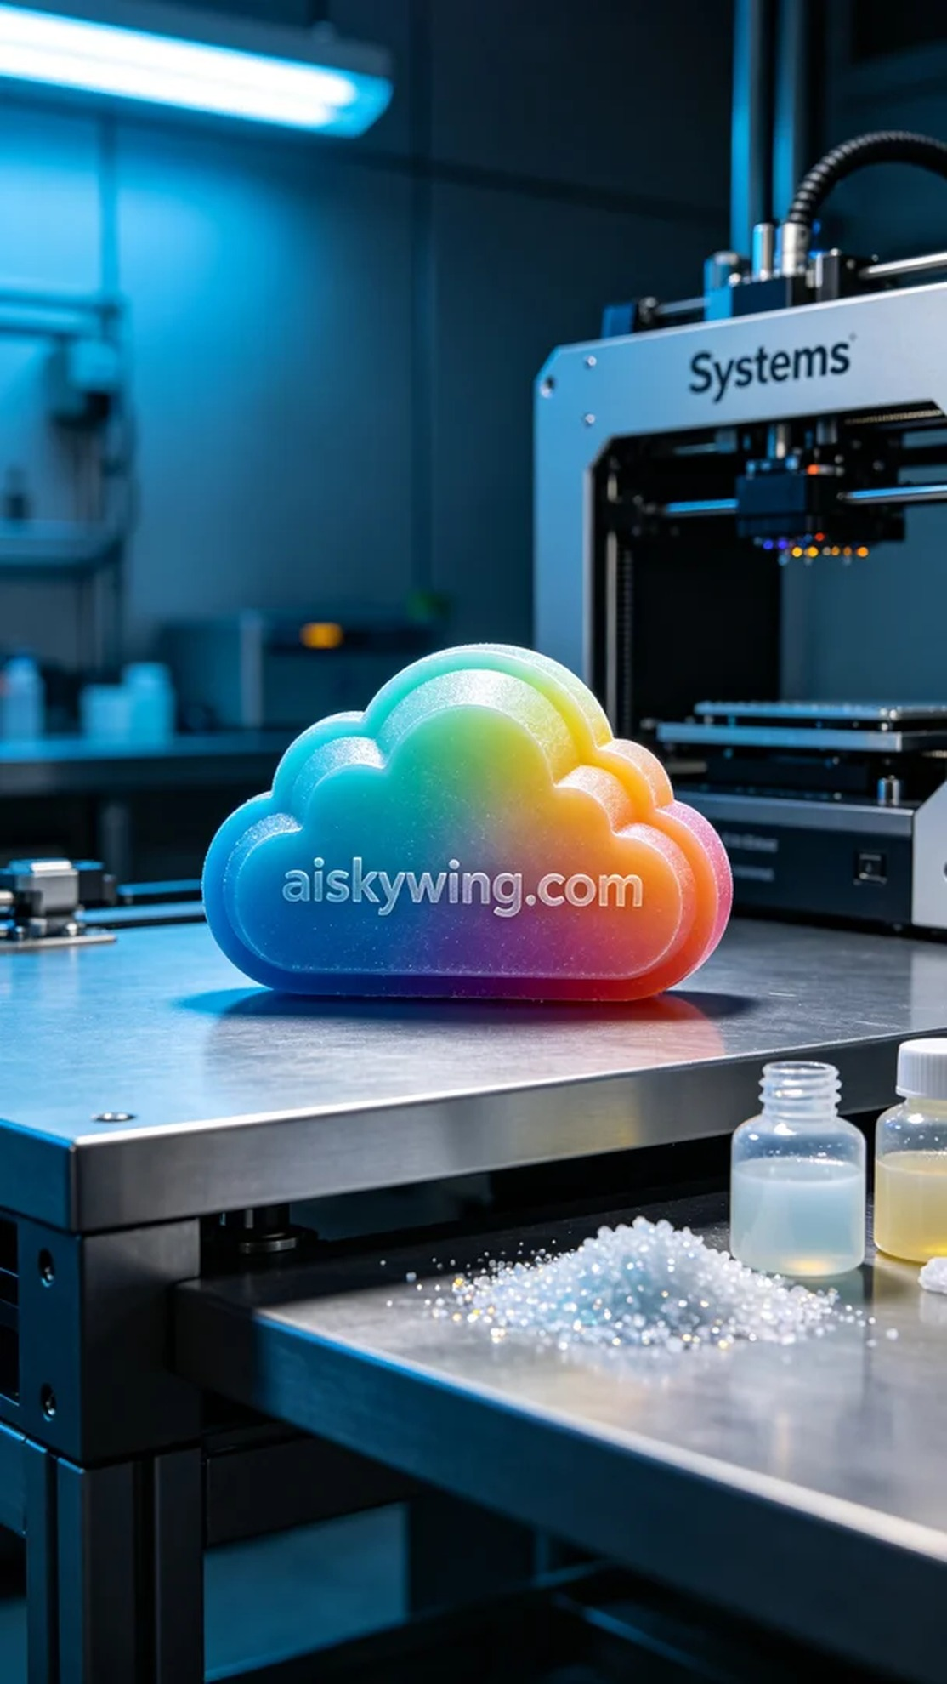
Aiskywing Industrial 3D Printing
Full-color 3D printed cloud model


