0439-全彩3D打印人像模型制作记录
Full-color 3D printed portrait model
🖨️ 全彩3DP
🖥️ 打印机: Voxeljet
📦 材料: 全彩3DP彩色打印
生活就像一场创作之旅，永远要勇敢尝试。最近，有人因需要制作一个全彩3D打印人像模型而找上我，给我带来了新的挑战。
Life is like a creative journey, where one must always be brave enough to try. Recently, someone approached me to create a full-color 3D printed portrait model, which presented me with a new challenge.
________________________________________________________________________________
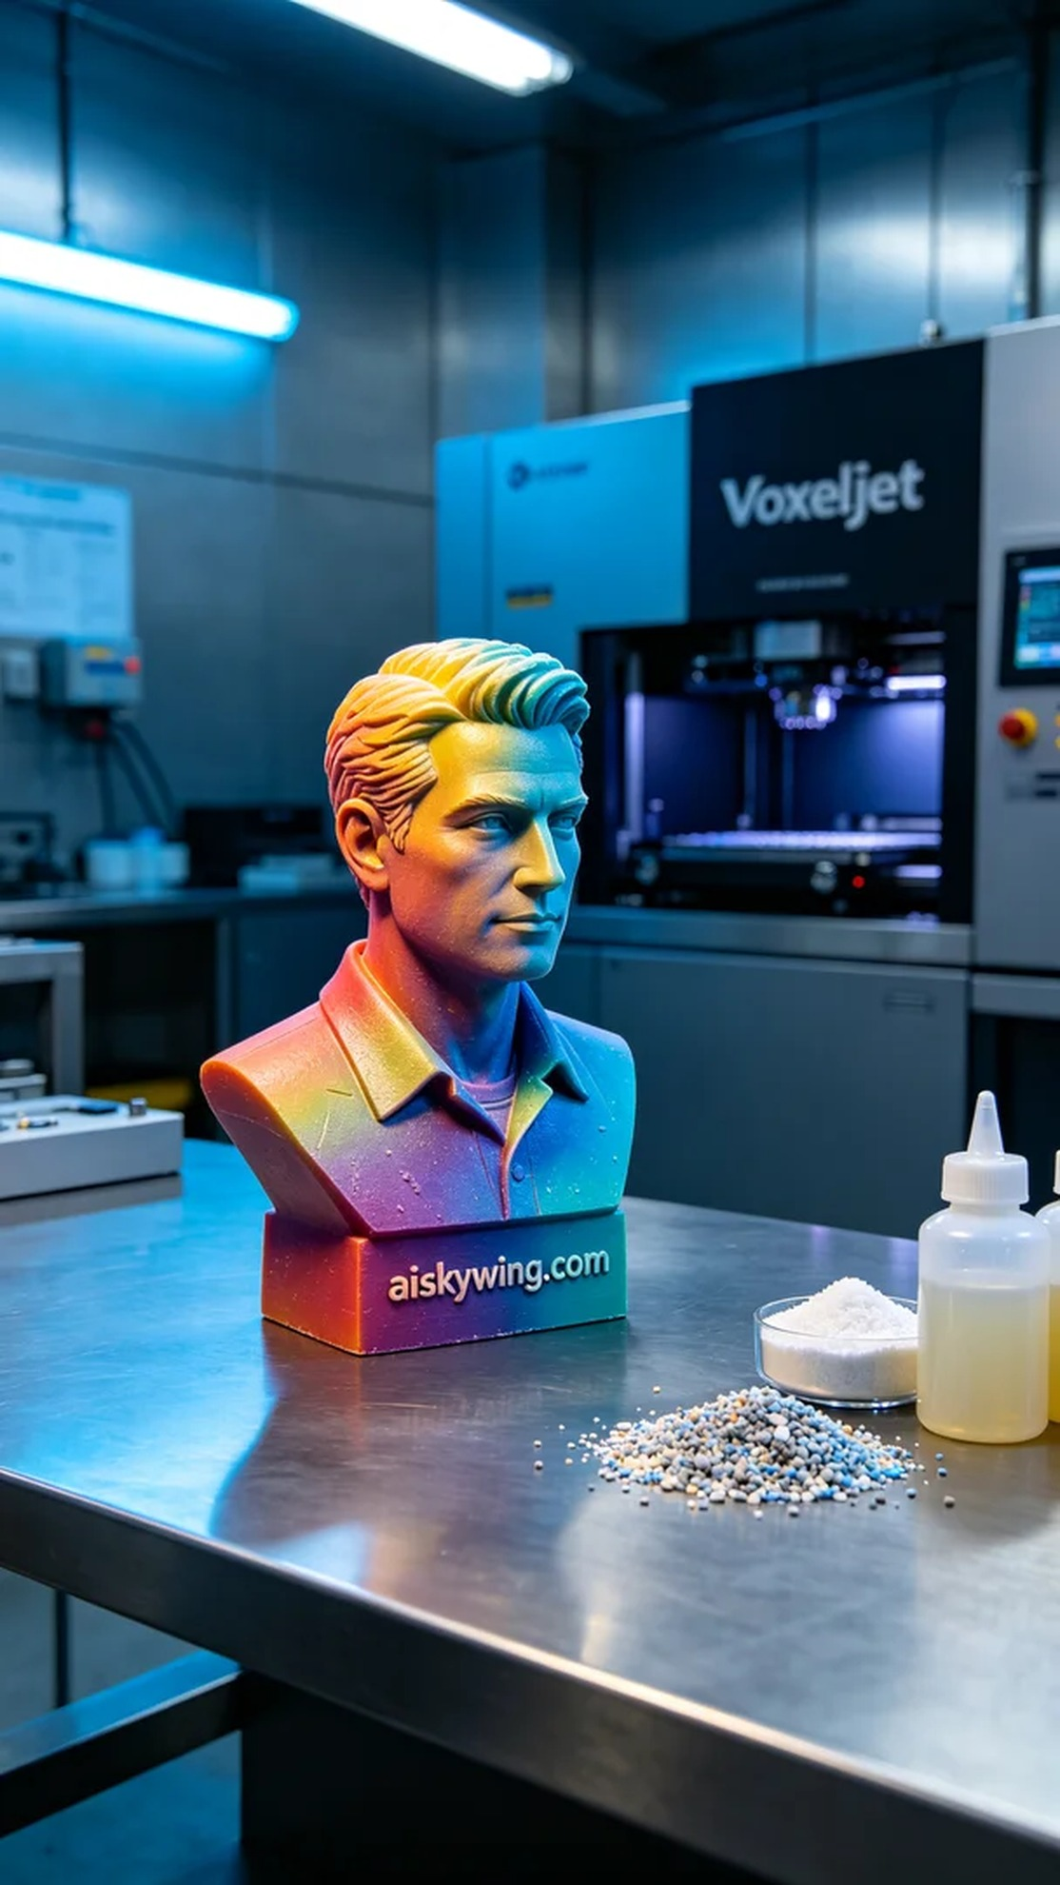
Life is a creative journey, and we must always be brave enough to try. Recently, someone approached us with a request to produce a full-color 3D printed portrait model for commercial display, bringing a new challenge.
To meet market demands, someone needed us to create a full-color 3D printed portrait model. This task requires not only exquisite skills but also a keen attention to detail. We quickly got to work, ensuring that every step would be executed perfectly.
We chose full-color 3DP printing material, known for its rich colors and high fidelity, making it ideal for showcasing complex color gradients and details. We utilized a Voxeljet 3D printer for this project. The settings were configured with a layer thickness of 0.1mm, a temperature of 25℃, a power of 300 watts, and a speed of 50mm per second, with an estimated total print time of 12 hours.
Once printing commenced, the equipment operated smoothly, and we regularly monitored quality to ensure each layer met our expectations. As the printing progressed layer by layer, the clarity of colors and details brought us great joy, and the entire process went off without a hitch, boosting our confidence significantly.
After completing the print, we proceeded with the post-processing steps. We began by washing the model's surface with a cleaning agent to remove any residual resin. Following that, we meticulously sanded the model to achieve a smoother finish. Finally, we cured the model under a UV lamp to ensure its durability and color stability. After thorough inspection, the final product met our high standards.
From the initial material preparation to the final product, every step was a challenge of both technology and artistry. The production of this full-color 3D printed portrait model was not just a successful practice but a testament to our team's collaborative spirit.
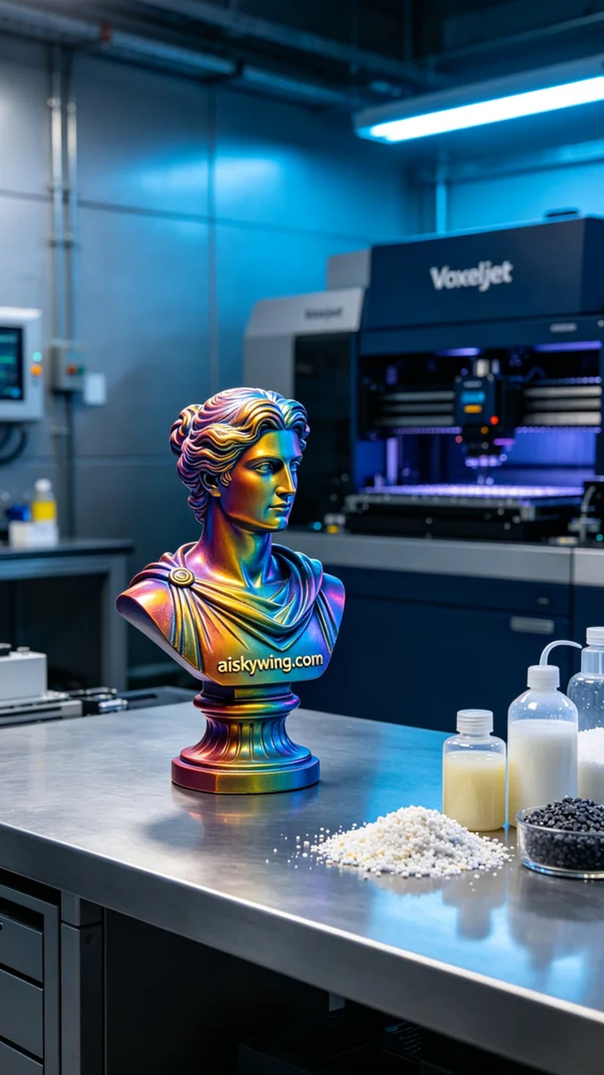
为了迎合市场的需求，有人希望我们生产一个全彩3D打印人像模型，以便用于商业展示。这项工作不仅需要精湛的技术，更需要对细节的苛求。我们迅速着手准备，确保每一个步骤都能完美呈现。
我们选择全彩3DP彩色打印材料，这种材料的特点是色彩丰富且高保真，非常适合呈现复杂的颜色渐变和细节。在设备方面，我们使用的是Voxeljet品牌的3D打印机。打印参数设定为层厚0.1毫米，温度设定在25℃，功率300瓦，打印速度为50毫米每秒，整个打印过程预计需要12小时。
打印开始后，设备运行稳定，我们定期监控质量，确保每一层的打印效果都符合预期。随着打印逐层进行，色彩清晰度和细节刻画让人欣喜，整个过程顺畅无阻，极大地增加了我们的信心。
完成打印后，我们进行了后处理工序。首先使用清洗剂将模型表面清洗干净，去除残留的树脂。然后对模型进行打磨，使表面更加光滑。最后在紫外线固化机中进行固化，确保模型的耐久性和色彩稳定。经过细致的检验，最终的成品符合我们的高标准。
从最初的材料准备到最后的成品，每一步都是对技术和艺术的挑战。这次全彩3D打印人像模型的制作，不仅是一次成功的实践，也是我们团队默契合作的见证。
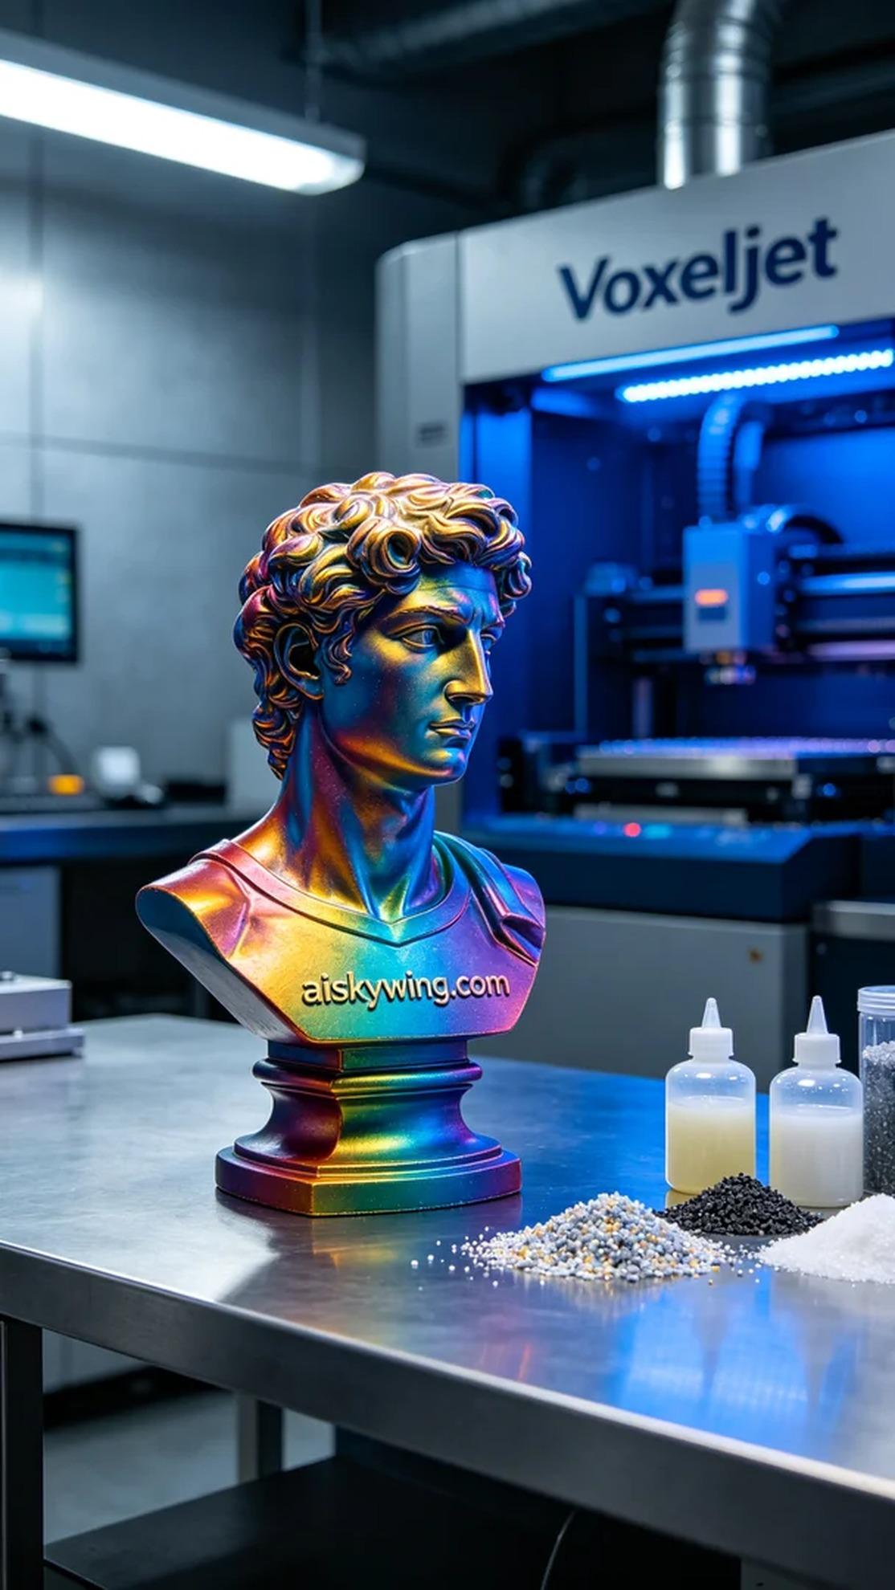
Aiskywing Industrial 3D Printing
Full-color 3D printed portrait model


