0440-全彩3D打印兵马俑模型生产记录
Full-color 3D printed Terracotta Warrior model
🖨️ 全彩3DP
🖥️ 打印机: Stratasys
📦 材料: 全彩3DP彩色树脂
生活就像3D打印，层层叠加，缺一不可。有人希望我们制作一个全彩3D打印兵马俑模型，以展现历史的魅力和工艺的精湛。
Life is like 3D printing, with layers stacked upon each other, each one indispensable. Some hope that we can create a full-color 3D printed model of the Terracotta Warrior to showcase the charm of history and the excellence of craftsmanship.
________________________________________________________________________________
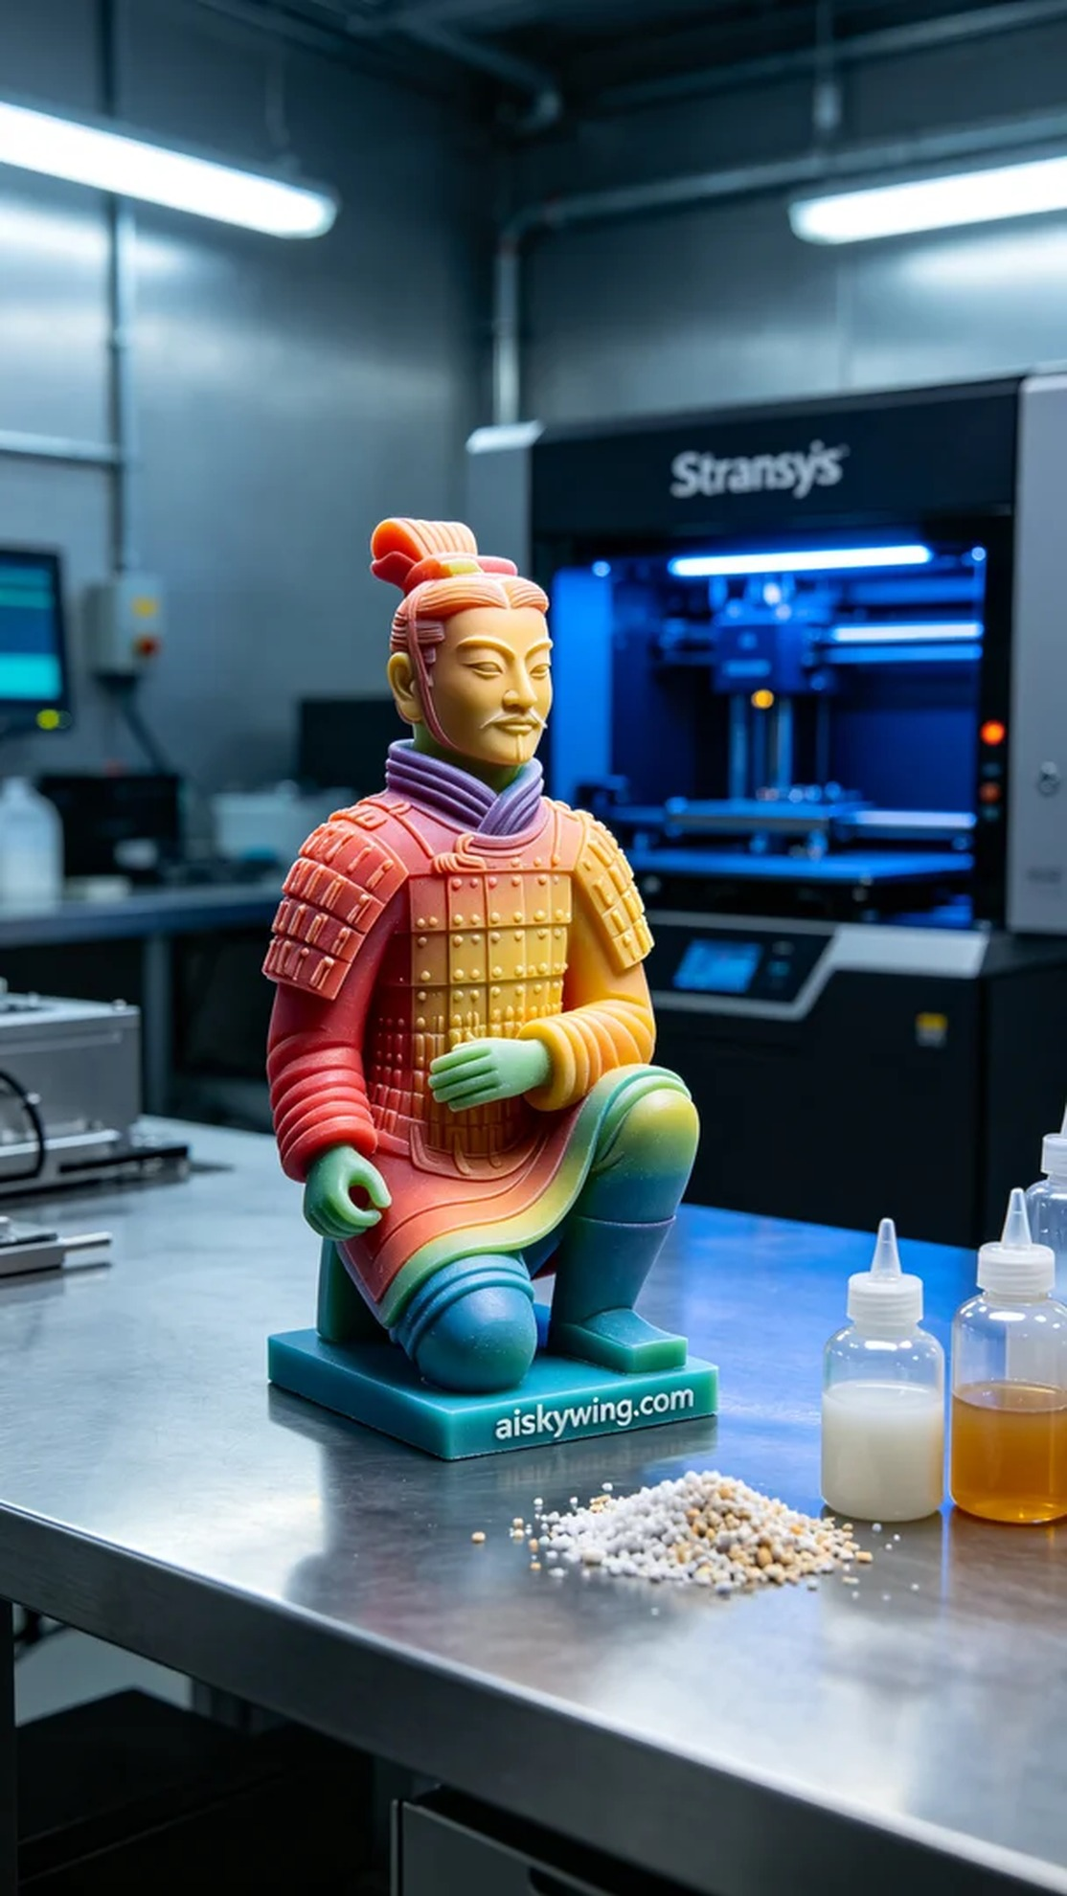
Life is like 3D printing, layer by layer, each part essential. Someone reached out to us on Facebook, hoping to create a full-color 3D printed Terracotta Warrior model to showcase the charm of history and exquisite craftsmanship.
We used full-color 3DP resin, a material known for its excellent color saturation and gloss, which can reflect the intricate details and historical essence of the warrior. To ensure the best print quality, I set the layer thickness to 0.1 mm, maintained a printing temperature at 25 degrees Celsius, with a power level of 80% and a speed of 15 mm per hour. The entire printing process was estimated to take around eight hours.
During the printing phase, the Stratasys printer performed reliably, allowing me to monitor each layer's quality closely. As the model took shape layer by layer, I frequently checked its status to ensure there were no defects. The use of full-color resin made it possible to achieve perfect color gradients and intricate detailing, resulting in a final product that I was very pleased with.
After printing, we moved on to the post-processing stage. First, the model was submerged in a cleaning solution to remove any excess photopolymer resin. Next, I used fine sandpaper to smooth the model's surface. Following this, a curing process was done to enhance the model's strength and durability, and finally, every detail was meticulously inspected to ensure the best display quality.
After a series of careful procedures, the completed full-color 3D printed Terracotta Warrior model showcased vibrant colors and realistic details. This result not only reflects the achievement of technology but also embodies the spirit of craftsmanship, making me feel incredibly proud.
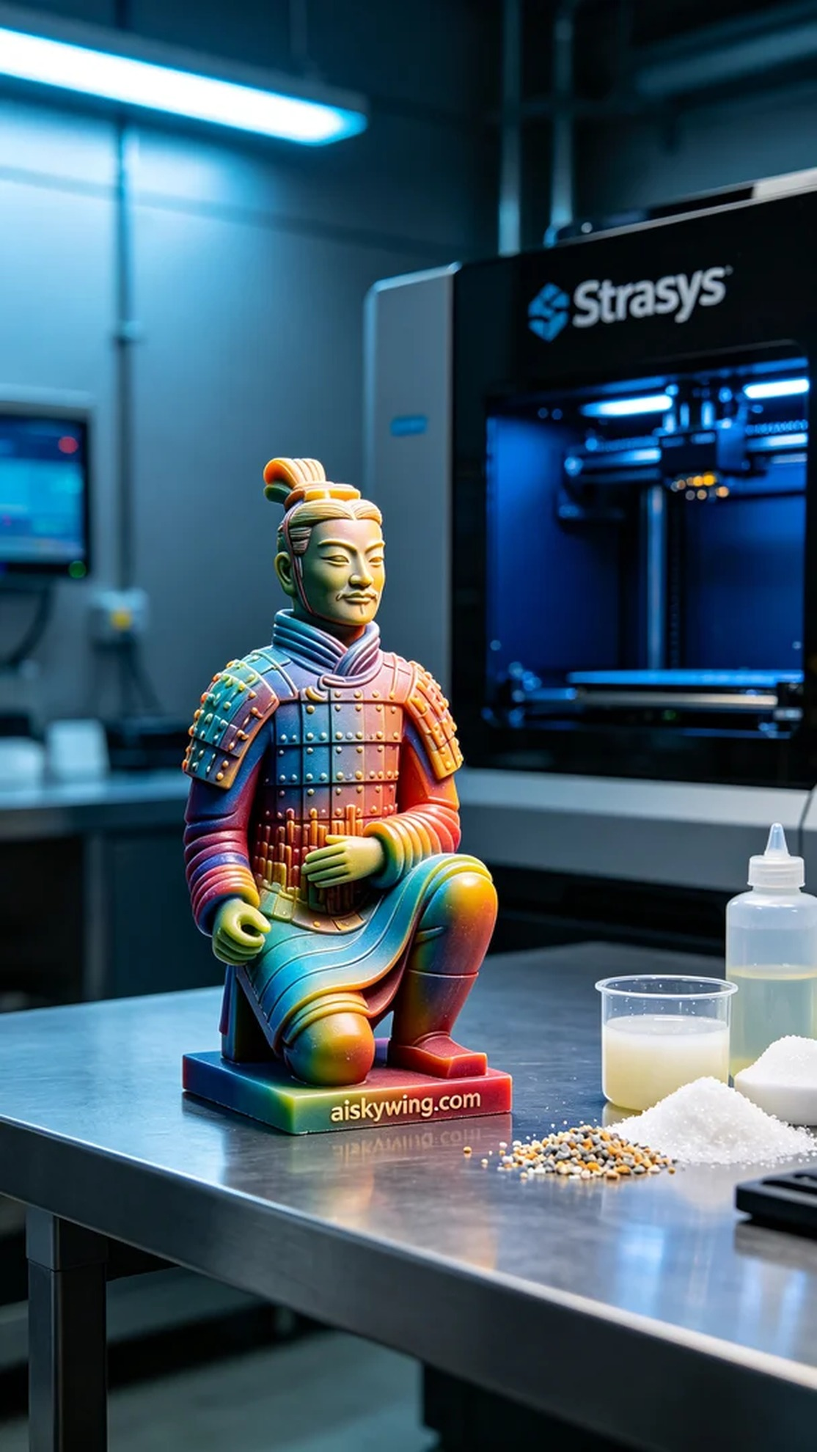
在Facebook上，有人联系我，希望制作一个全彩3D打印兵马俑模型，目的是为了在展览中展示传统文化与现代科技的结合。为了满足这个需求，我决定运用Stratasys打印机，充分展现模型的细节与色彩。
我们使用的是全彩3DP彩色树脂，这种材料具有优异的色彩饱和度和光泽感，能够呈现出兵马俑的细腻纹理与历史韵味。为确保打印效果，我设置了层厚0.1毫米，打印温度控制在25度，打印功率为80%，速度则保持在每小时15毫米。整个打印过程预计需要八个小时。
在打印过程中，Stratasys打印机表现稳定，有效监控每一个打印层的质量。随着模型逐层成型，我不时检查打印状态，确保没有出现任何瑕疵。全彩树脂的应用使得颜色渐变及细节呈现得以完美实现，最终效果让我十分满意。
完成打印后，我们进入后处理阶段。首先将模型浸入清洗液中，清除多余的光敏树脂。接着，使用细砂纸对模型表面进行打磨，使其更加光滑。然后进行固化处理，以增强模型的强度和耐久性，最后仔细检验每一处细节，确保展示效果达到最佳。
经过一系列细致的工艺流程，最终的全彩3D打印兵马俑模型展现出了绚丽的色彩和逼真的细节。这不仅是技术的成果，更是工匠精神的体现，令人感到无比自豪。
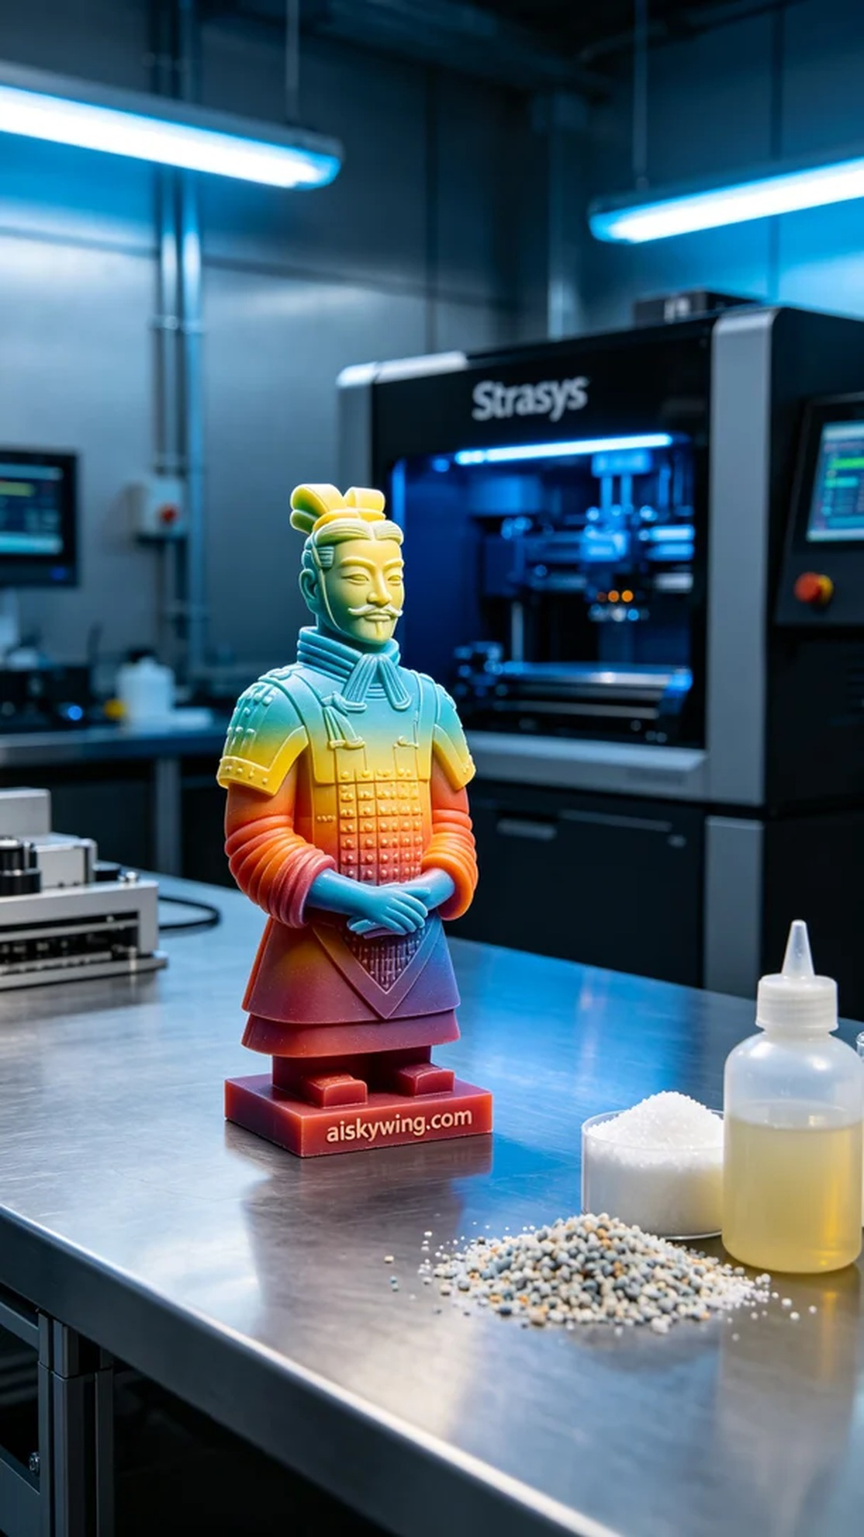
Aiskywing Industrial 3D Printing
Full-color 3D printed Terracotta Warrior model


