0441-全彩3D打印冰山模型生产记录
Full-color 3D printed iceberg model
🖨️ 全彩3DP
🖥️ 打印机: Rize
📦 材料: 摆放着未成型的液态光敏
生活再难，也别停下脚步。就像接下这个全彩3D打印冰山模型的单子，有人想让它在视觉上震撼所有人。
No matter how difficult life gets, don't stop moving forward. Just like taking on the order for this full-color 3D printed iceberg model, someone wants it to visually impress everyone.
________________________________________________________________________________
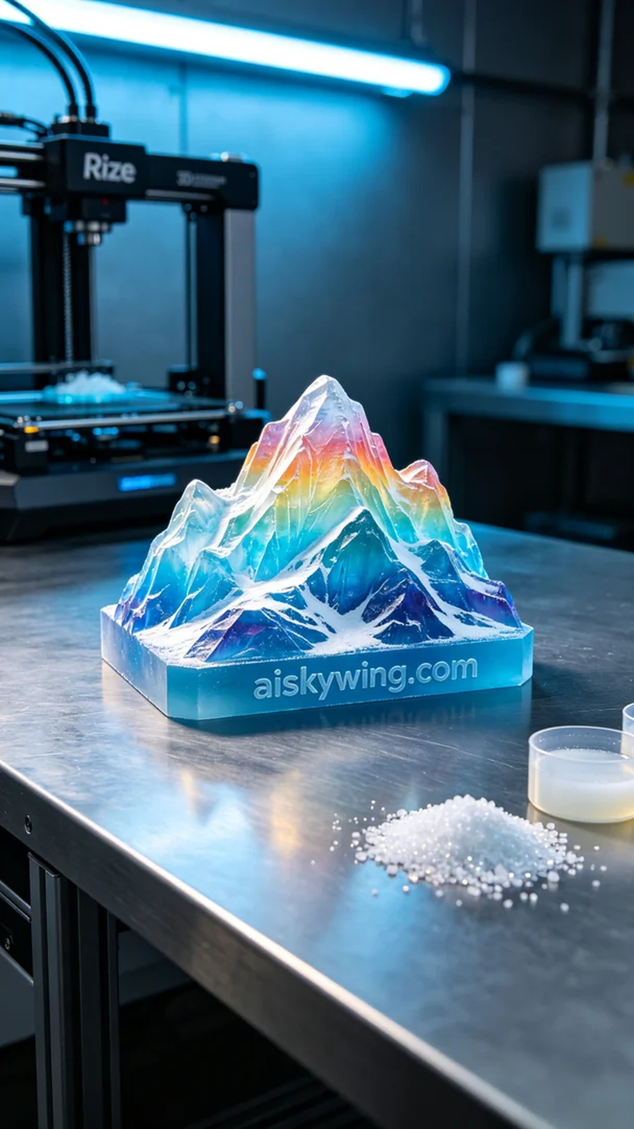
Life can be tough, but we must keep moving forward. Just like taking on the project of a full-color 3D printed iceberg model, someone wanted to create a striking visual impact.
To ensure optimal printing results, we selected uncured liquid photopolymer resin as our material. This resin offers excellent flow characteristics and a smooth surface, making it ideal for high-precision printing. Our Rize printer was carefully calibrated, with layer thickness set to 0.1mm, printing temperature maintained at 25°C, power set to 60 watts, printing speed at 20mm/s, and an estimated print time of 15 hours.
During the printing process, the Rize printer operated smoothly while automatically monitoring material usage. We kept a close eye on the print quality, ensuring that each layer properly adhered to create a realistic iceberg appearance. The cool blue ambient lighting set an industrial tone, enhancing the model's liveliness in the interplay of light and shadow.
Once printing was complete, we moved on to the post-processing stage. The model was first cleaned with a solvent to remove any uncured resin. Then, we carefully sanded the surface with fine sandpaper to enhance both texture and visual appeal. Finally, the model was placed in a UV curing chamber to solidify, ensuring it would retain its form over time. After rigorous inspection, we confirmed that every detail met our standards.
Overall, the production process for this full-color 3D printed iceberg model went smoothly, and we were very pleased with the final result.
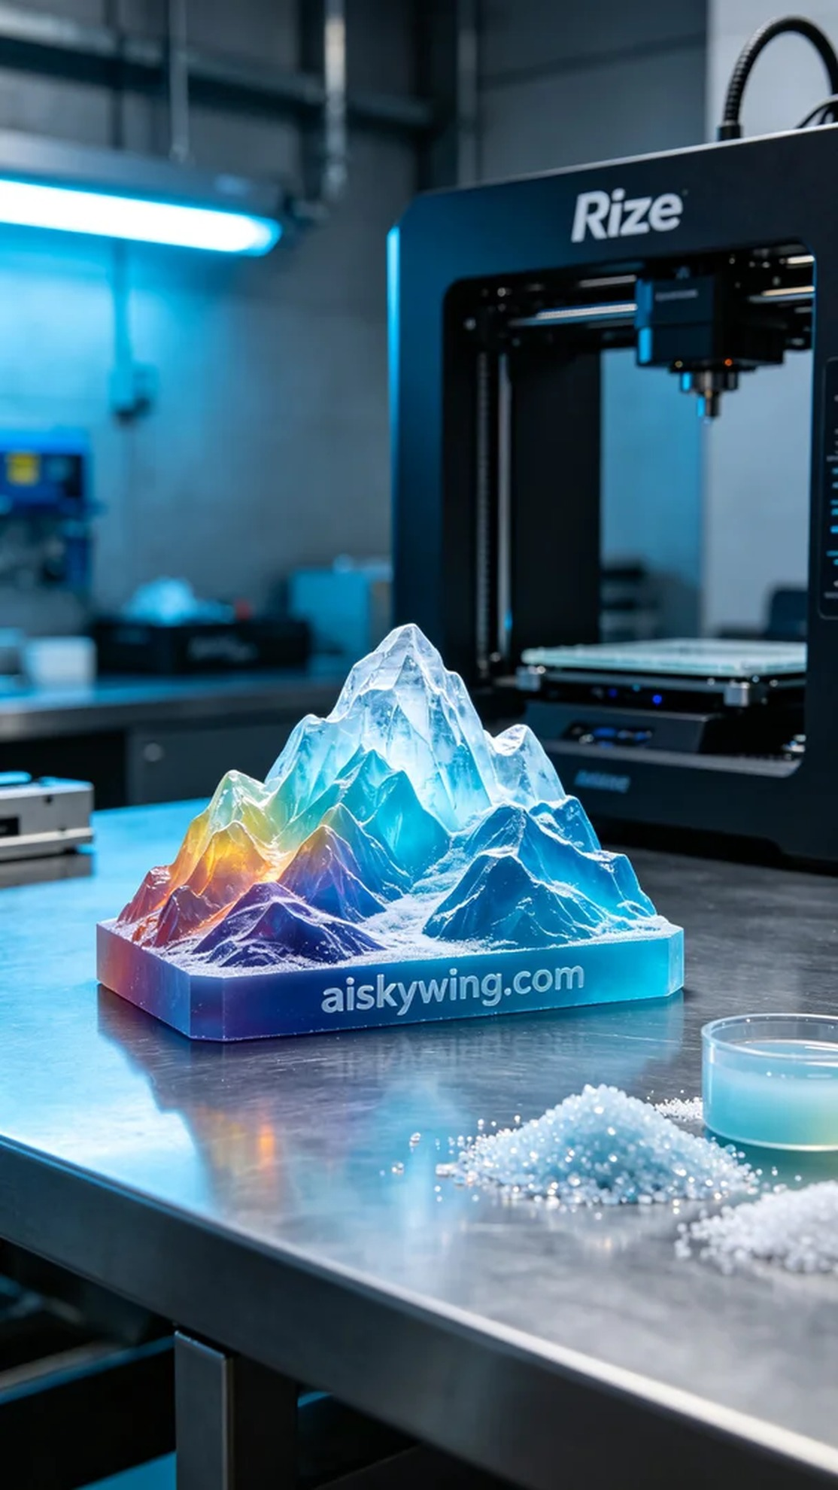
在Instagram上，有人希望我们制作一款全彩3D打印冰山模型，想要在产品展示中营造出一种极致的视觉效果。这个模型不仅要色彩丰富，还要有足够的细节，以吸引观众的眼球。
为了确保打印效果，我们选择了未成型的液态光敏树脂作为原材料。这种材料具有优良的流动性和平滑的表面，适合用于高精度打印。使用的Rize打印机经过仔细调试，设置层厚为0.1毫米，打印温度保持在25摄氏度，功率设置为60瓦，打印速度为20毫米/秒，预计打印时间为15小时。
在打印过程中，Rize打印机平稳运行，自动监测材料耗用情况。为了控制质量，我们随时观察打印效果，确保每一层都能完美叠加，形成逼真的冰山效果。冷色调的蓝色氛围灯营造出了一种冷峻的工业气息，让模型在光影的交错中更加生动。
完成打印后，我们进入了后处理阶段。首先用清洗剂对模型进行清洗，确保去除未固化的树脂。接着用细砂纸轻轻打磨表面，以提升触感和视觉效果。最后，将模型放在紫外线固化箱中进行固化，确保它能在长时间使用中保持稳定的形态。经过严格的检验，确保每个细节都达到我们的标准。
总的来说，这个全彩3D打印冰山模型的制作过程顺利完成，最后呈现的效果也让我们感到非常满意。
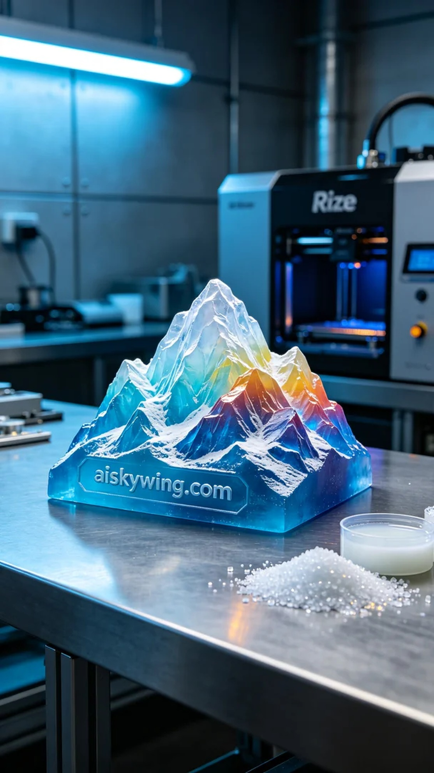
Aiskywing Industrial 3D Printing
Full-color 3D printed iceberg model


