0442-全彩3D打印冰淇淋模型生产记录
Full-color 3D printed ice cream model
🖨️ 全彩3DP
🖥️ 打印机: Xjet
📦 材料: 全彩3DP
生活如同3D打印，细致入微也需要耐心。有人在Instagram上为了呈现完美的全彩3D打印冰淇淋模型找到了我们，这正是我们的使命。
Life is like 3D printing; it requires attention to detail and patience. Someone found us on Instagram to showcase a perfect full-color 3D printed ice cream model, and that is exactly our mission.
________________________________________________________________________________
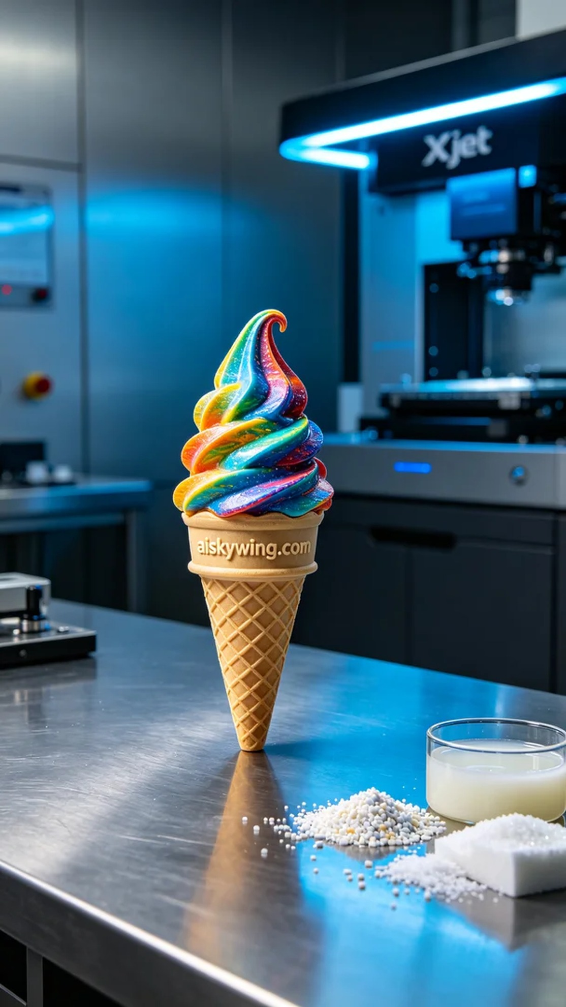
Today, we received an order for a full-color 3D printed ice cream model. Someone reached out to us on Instagram seeking assistance to showcase a realistic model that would draw more attention to their social media presence. We understood that the key to the success of this model lay in its detail and color representation.
To begin with, we selected full-color 3DP as the material due to its excellent color performance and detail reproduction capabilities. For printing this model, we utilized the Xjet printer, setting the layer thickness to 0.1 mm, keeping the nozzle temperature at 50 degrees Celsius, the printing power at 80W, and the speed at 30 mm per hour, expecting a total print time of approximately 6 hours. These parameters were chosen to ensure the rich color gradient and intricate details of the model.
As the printing process commenced, the Xjet printer operated steadily, accompanied by a subtle mechanical sound. We monitored the quality closely, ensuring each layer conformed to our standards. With time passing, the ice cream model gradually took shape, and the vibrant colors and intricate textures built anticipation.
After printing, we proceeded with post-processing. First, we cleaned the model to remove any excess resin from the surface. Next, we polished it to ensure smooth edges. We then placed the model in a curing device to ensure its hardness and strength, followed by a thorough inspection to check for any defects.
After a series of meticulous procedures, the full-color 3D printed ice cream model was finally completed. Not only was it vibrant in color, but it also showcased exceptional detail, perfectly reflecting our craftsmanship and level of technology. Such a piece always fills us with immense pride.
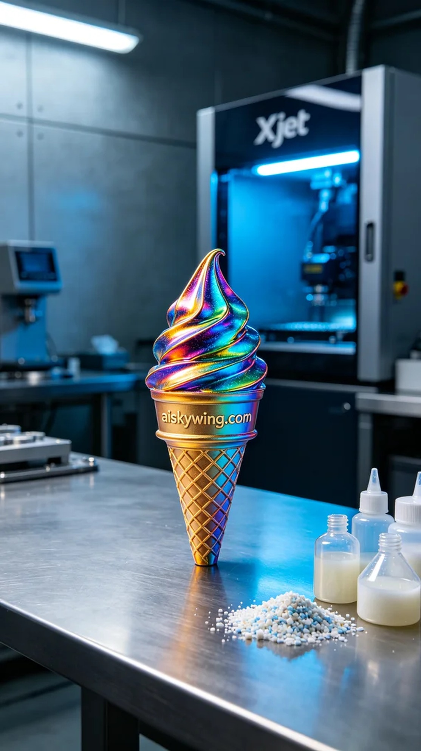
今天，我们接到了一个全彩3D打印冰淇淋模型的订单。有人因为想在社交平台上展示逼真的模型而寻求我们的帮助，希望通过这款模型吸引更多的关注。我们知道，细节和色彩的呈现是这款模型成功的关键。
首先，我们选择了全彩3DP作为原材料，这种材料具有出色的色彩表现和细节还原能力。为了打印这款模型，我们使用了Xjet打印机，设定了层厚为0.1毫米，喷头温度保持在50摄氏度，打印功率设置为80W，速度保持在每小时30毫米，预计打印时间为6小时。这样的参数能够确保模型的色彩渐变和细节丰富性。
打印过程开始了，Xjet打印机稳定地运行，伴随着轻微的机械音。我们在旁边进行了质量监控，确保每一层的打印都符合标准。随着时间的推移，冰淇淋模型逐渐成型，丰富的色彩和精细的纹理让人期待。
打印完成后，我们进行了后处理工序。首先，对模型进行了清洗，以去除表面的多余树脂。随后，进行了打磨，确保模型的边缘光滑。接着，我们将模型放入固化设备中，确保其硬度和强度，最后进行了一次全面的检验，查看是否有瑕疵。
经过一系列严格的工序，这款全彩3D打印冰淇淋模型终于完成。它不仅色彩丰富，还细节出众，完美呈现了我们的工艺和技术水平。这样的作品总是让人感到无比自豪。
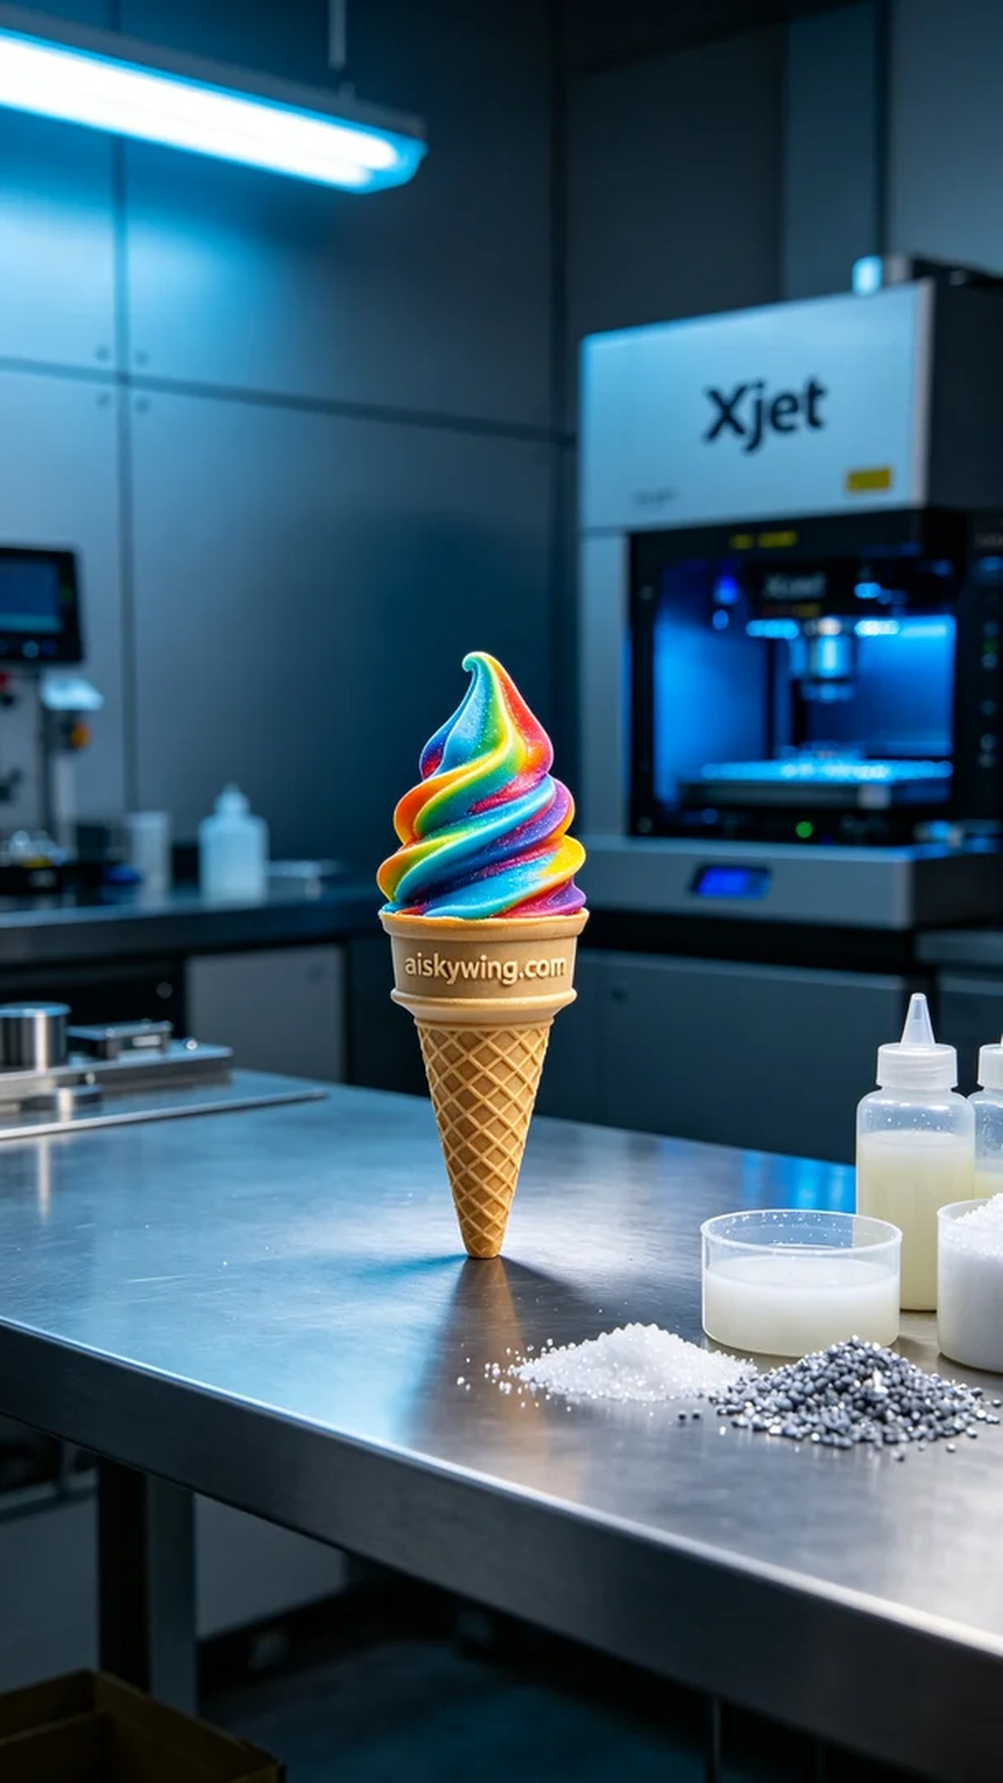
Aiskywing Industrial 3D Printing
Full-color 3D printed ice cream model


