0443-全彩3D打印凯旋门模型生产记录
Full-color 3D printed Arc de Triomphe model
🖨️ 全彩3DP
🖥️ 打印机: Stratasys
📦 材料: 摆放着未成型的液态光敏
生活再难，也别停下脚步。就像接下这个全彩3D打印凯旋门模型的单子，难度虽高，但每个细节都值得我们去打磨。
No matter how difficult life gets, don't stop moving forward. Just like taking on this order for a full-color 3D printed Arc de Triomphe model, the challenge is great, but every detail is worth refining.
________________________________________________________________________________
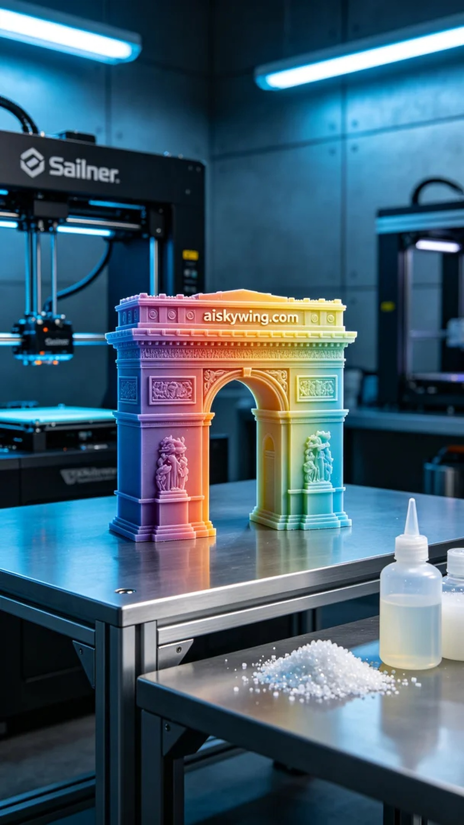
Recently, someone reached out to us on LinkedIn, looking to create a full-color 3D printed Arc de Triomphe model. They wanted this model to not only capture the intricate details of the monument but also showcase exceptional color representation. Upon hearing this request, I immediately recognized the challenge ahead but also saw it as an opportunity to demonstrate our capabilities.
We prepared to use the liquid photopolymer resin that was on hand as our raw material, which is excellent for achieving complex color gradients and fine details. To ensure printing quality, we chose the Stratasys 3D printer for the job. In terms of printing parameters, we set the layer thickness to 0.1mm, maintained a temperature of 25°C, adjusted power to 80%, and kept the speed at 40mm per second, with an estimated printing time of about 12 hours.
Once the printing process commenced, we closely monitored the machine's performance, ensuring every step was precise. The Stratasys printer steadily built up the liquid photopolymer resin layer by layer, and as time passed, the outline of the Arc de Triomphe began to emerge. We conducted checks on the print quality every hour to ensure that there were no issues.
After printing, the model underwent a series of post-processing steps. First, we placed it into a cleaning solution to remove any excess resin from the surface. Next, we gently sanded it with fine sandpaper to ensure a smooth finish. After that, the model was placed in a curing device and exposed to UV light for solidification. Finally, we conducted a comprehensive inspection to ensure that every detail met our high standards.
In the end, this full-color 3D printed Arc de Triomphe model was completed on schedule, showcasing rich colors and high detail fidelity. Every print is a new learning experience and an opportunity for growth; here's to the next challenge!
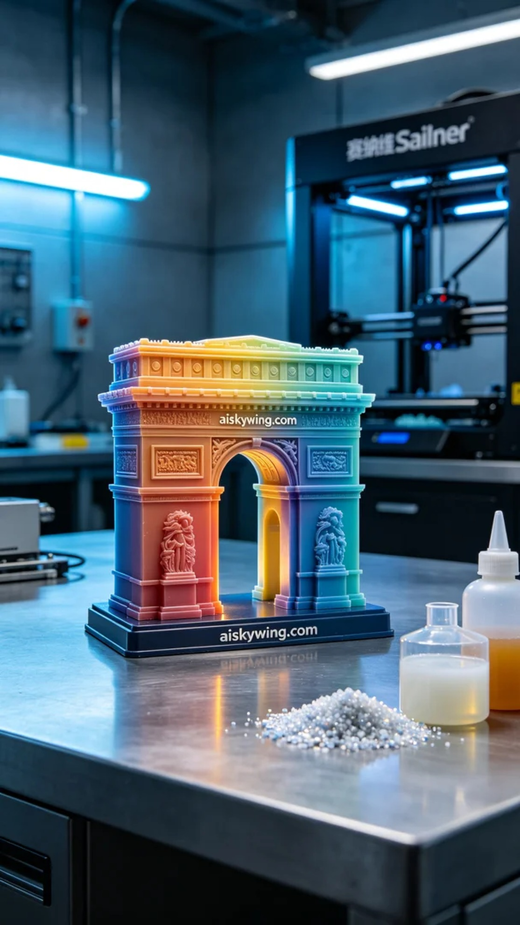
前几天，有人在LinkedIn上找到我们，希望能制作一个全彩3D打印凯旋门模型。他们希望这个模型不仅能高度还原凯旋门的细节，还要具备极致的色彩表现力。听到这个要求，我立刻意识到这是一个不小的挑战，但也是一个展现我们实力的机会。
我们准备使用摆放着未成型的液态光敏作为原材料，这种材料能很好地呈现复杂的色彩渐变和细腻的细节。同时，为确保打印质量，我们选择了Stratasys的3D打印机。打印参数方面：层厚设定为0.1毫米，温度控制在25℃，功率调节为80%，速度保持在40毫米每秒，预计打印时间约为12小时。
打印过程开始后，我们仔细监控设备的运行状态，确保每一步都精准无误。Stratasys打印机平稳地将液态光敏材料逐层堆积，随着时间的推移，凯旋门的轮廓逐渐显现。为了确保打印的精度，我们每隔一小时就对打印效果进行一次检查，确保没有出现任何异常。
完成打印后，模型需要经过一系列后处理工序。首先，我们将其放入清洗液中，去除表面多余的树脂。接着，使用细砂纸轻轻打磨，确保表面光滑无瑕。随后，将模型放置在固化设备中，经过UV光照射进行固化。最后，我们还要进行全面检验，确保每一个细节都达到高标准。
最终，这个全彩3D打印凯旋门模型如期完成，展现了丰富的色彩和极高的细节，还原度。每一次打印都是一次新的学习和成长，期待下一个挑战。
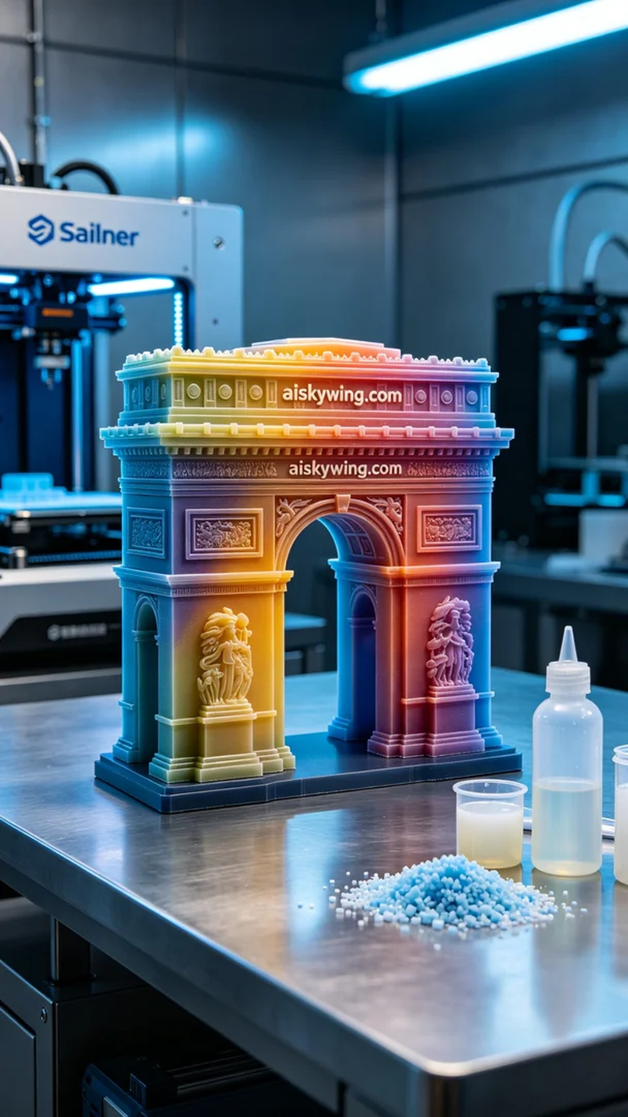
Aiskywing Industrial 3D Printing
Full-color 3D printed Arc de Triomphe model


