0444-全彩3D打印动物模型制作记录
Full-color 3D printed animal models
🖨️ 全彩3DP
🖥️ 打印机: Rize
📦 材料: 摆放着未成型的液态光敏
有时候咬牙坚持，不是为了证明什么。就像做这个全彩3D打印动物模型一样，很多时候只有亲历才能体会其中的乐趣与挑战。
Sometimes, gritting your teeth and persevering isn't about proving anything. Just like making this full-color 3D printed animal model, often only by experiencing it firsthand can one truly appreciate the joy and challenges involved.
________________________________________________________________________________
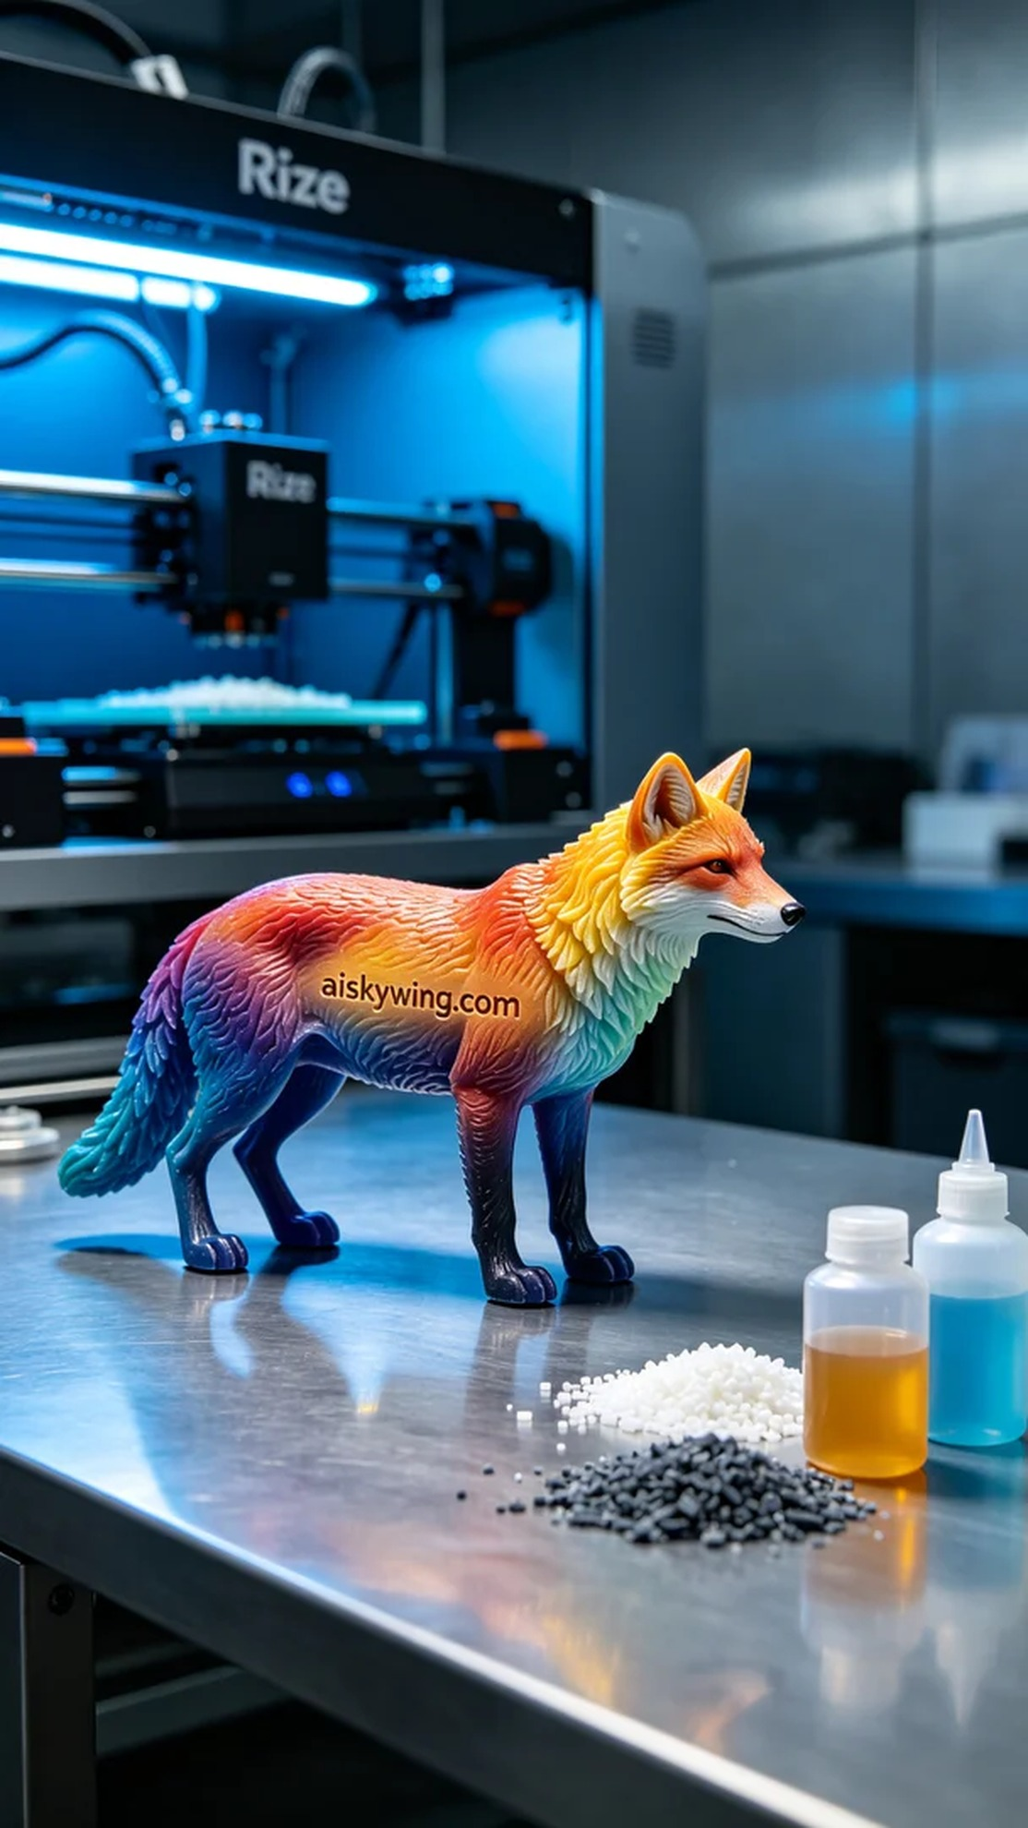
Sometimes, sticking to something isn't about proving anything. It's like creating this full-color 3D printed animal model; often, only through experience can we truly appreciate the joy and challenges it brings.
Recently, someone reached out to us via LinkedIn, hoping to create a full-color 3D printed animal model. They wanted a vibrant and realistic model to showcase the fine craftsmanship and design of the product. Thus, we embarked on this challenge.
We chose to use liquid photopolymer resin as the primary material, renowned for its excellent color reproduction and detail presentation. To ensure print quality, we set the Rize printer parameters to a layer thickness of 0.1 mm, printing temperature at 25°C, power adjustment to 80%, and speed controlled at 30 mm per second. The estimated printing time was about 8 hours, allowing maximum detail and color gradient rendering.
During the printing process, the Rize printer operated smoothly, applying the liquid photopolymer resin evenly, layer by layer. We constantly monitored the machine’s status to ensure no defects occurred during printing. Each time we saw the model gradually reveal its rich colors and delicate textures, we felt a deep sense of satisfaction.
After printing, we immediately moved on to post-processing. First, the printed model was placed in a cleaning machine to thoroughly remove any uncured resin from the surface. Next, we performed sanding to ensure a smooth surface, enhancing both tactile and visual appeal. The curing step was essential; we placed the model in a UV curing machine for thorough exposure to ensure durability. Finally, we meticulously inspected every detail, ensuring the model met the highest quality, perfectly embodying the designer's intention.
After a series of meticulous processes, this full-color 3D printed animal model was finally completed. It not only boasts vibrant colors and distinct layers but also reflects our dedication and passion for craftsmanship.
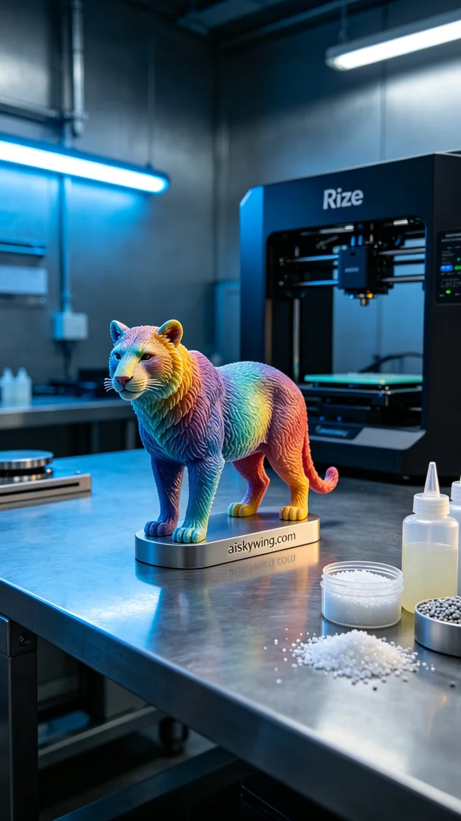
最近，有人通过LinkedIn找到我们，希望能制作一款全彩3D打印动物模型。他们想要一个色彩丰富、逼真的模型来展示产品的细腻工艺和设计。于是我们开始了这项挑战。
我们选择了摆放着未成型的液态光敏树脂作为主要原材料，这种材料以其出色的色彩还原和细节表现著称。为了确保打印质量，我们将Rize打印机的参数设置为：层厚0.1毫米，打印温度设定在25°C，功率调节至80%，速度控制在30毫米每秒。预计打印时间约为8小时，这样的设置能最大程度展现模型的细节和色彩渐变。
在打印过程中，Rize打印机运转顺畅，液态光敏树脂均匀喷涂，模型逐层成型。我们时刻监控设备的运行状态，确保打印过程中没有出现任何瑕疵。每当看到模型逐渐显现出丰富的色彩与细腻的纹理，心中不禁感到一阵欣慰。
打印完成后，随即开始了后处理工序。首先是将打印好的模型放入清洗设备，彻底去除表面未固化的树脂。随后，我们进行了打磨，以确保表面光滑，提升触感和视觉效果。固化环节不可或缺，我们将模型放入紫外线固化机中进行充分照射，确保其坚固耐用。最后，我们仔细检验了每一个细节，确保模型达到最佳品质，完美呈现出设计师的初衷。
经过一系列精细的工艺流程，这个全彩3D打印动物模型终于完成了。它不仅色彩丰富、层次分明，更是体现了我们对工艺的执着与热爱。
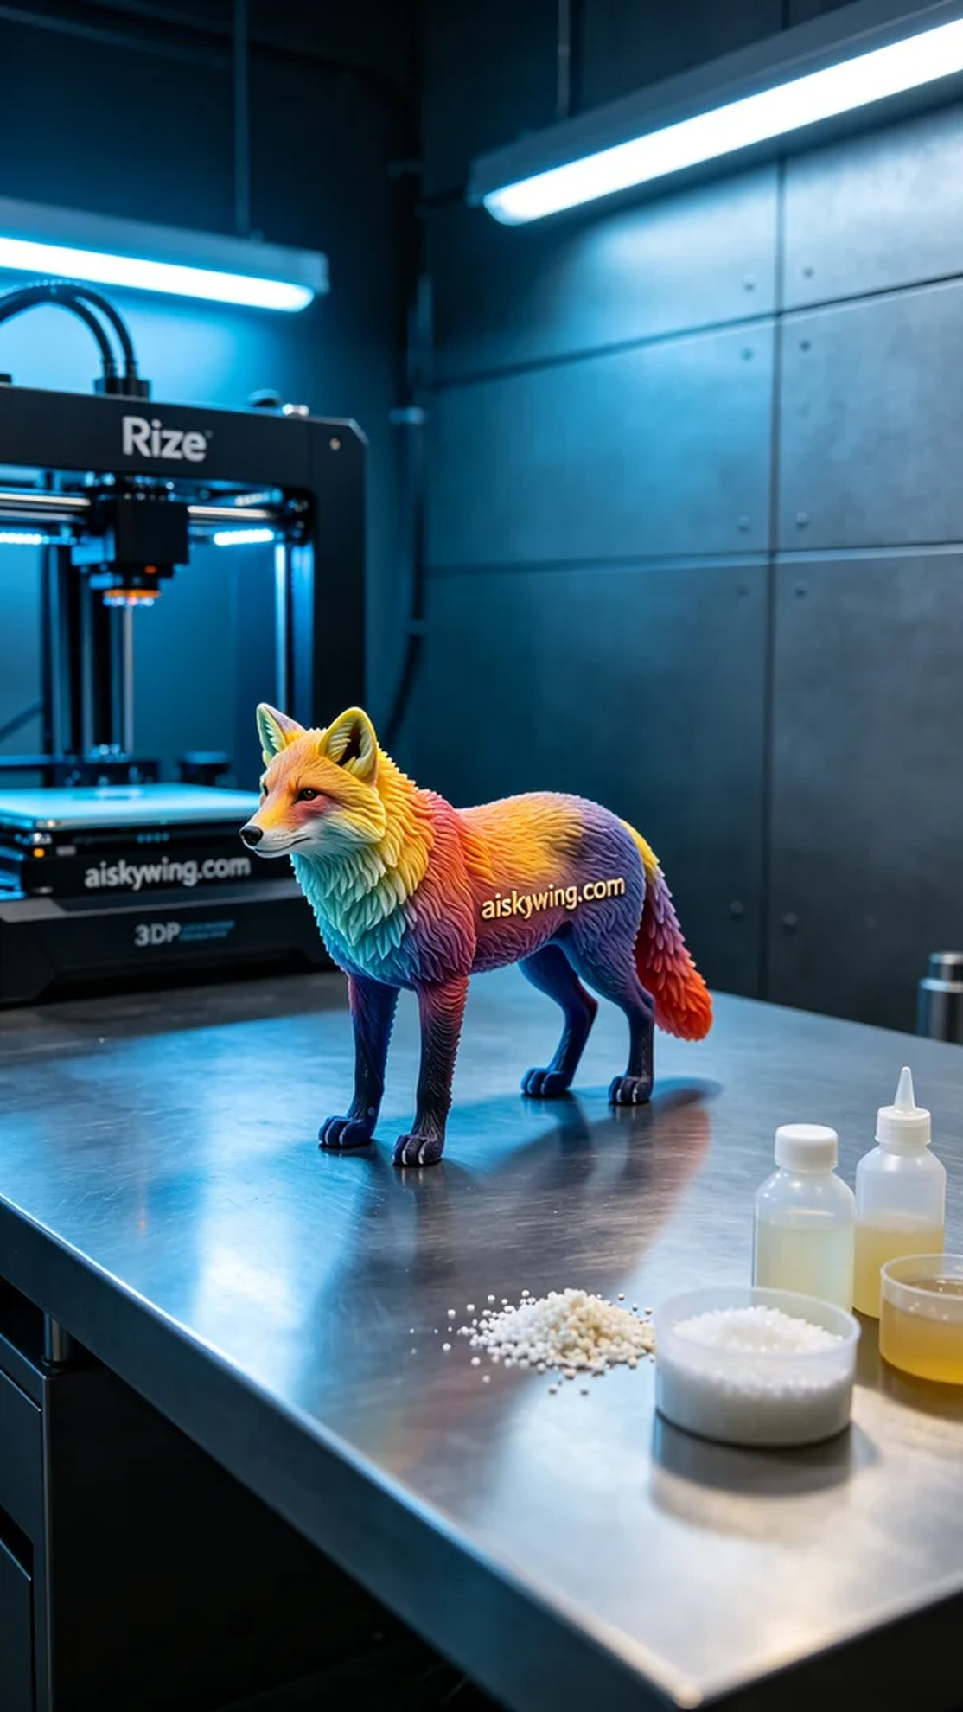
Aiskywing Industrial 3D Printing
Full-color 3D printed animal models

