0445-全彩3D打印卫星模型生产记录
Full-color 3D printed satellite model
🖨️ 全彩3DP
🖥️ 打印机: Carbon
📦 材料: 全彩3DP
在LinkedIn上，有人因为一个全彩3D打印卫星模型的需求而找上我们。生活的挑战，正是成就作品的动力。
On LinkedIn, someone approached us with a request for a full-color 3D printed satellite model. The challenges of life are the driving force behind creating great works.
________________________________________________________________________________
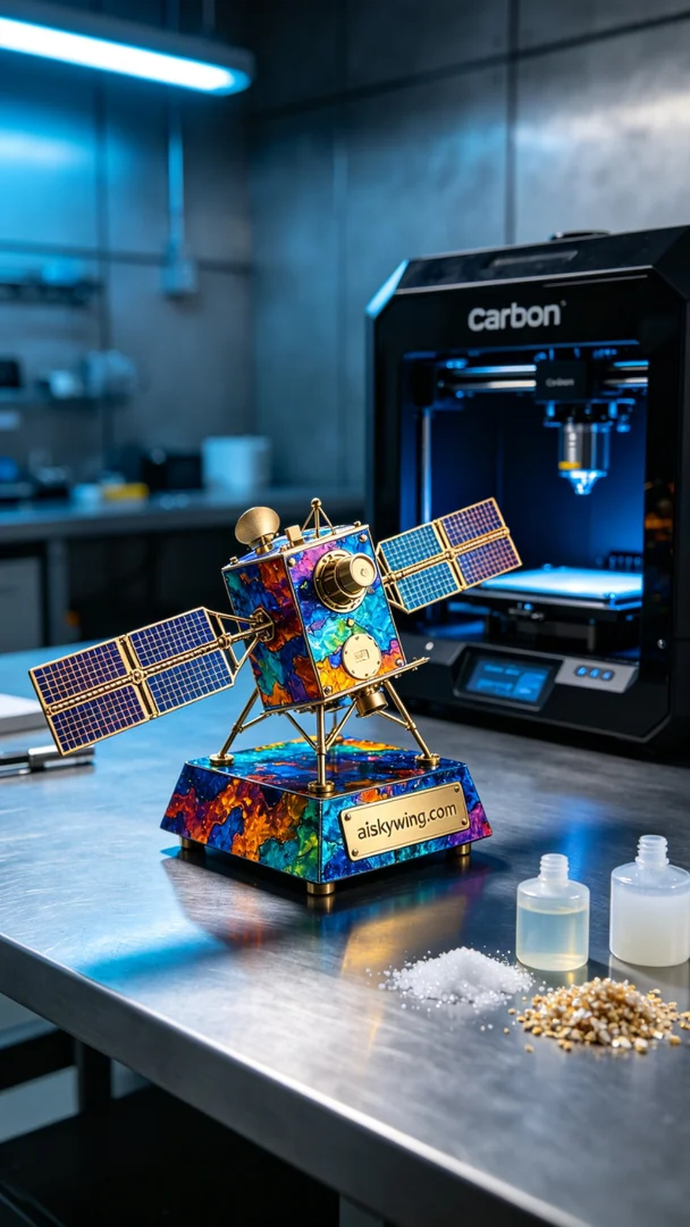
We recently took on a project involving a full-color 3D printed satellite model after someone reached out to us on LinkedIn with specific issues related to color and detail presentation. Life's challenges often serve as the motivation for our creations.
We utilized full-color 3DP materials known for their vibrant colors and intricate textures. The Carbon printer was set with a layer thickness of 0.1mm, printing temperature at 25°C, power set to 70W, and speed at 50mm/s. We specifically adjusted the printing parameters to achieve the best results in color gradients and detail clarity.
During the printing process, the Carbon printer operated smoothly for approximately 8 hours. We maintained a keen eye on real-time quality monitoring to ensure that every detail was accurate. Careful observation and timely adjustments helped us avoid potential errors throughout the process.
After printing, we moved into post-processing. The model was first cleaned to remove excess resin, followed by light sanding to ensure a smooth surface for every detail. The model was then cured in the curing machine for 30 minutes to ensure strength and durability. Finally, we meticulously inspected each detail to ensure high standards were met.
After a series of precise processes, the full-color 3D printed satellite model was completed, showcasing vivid colors and rich details that met our expectations.
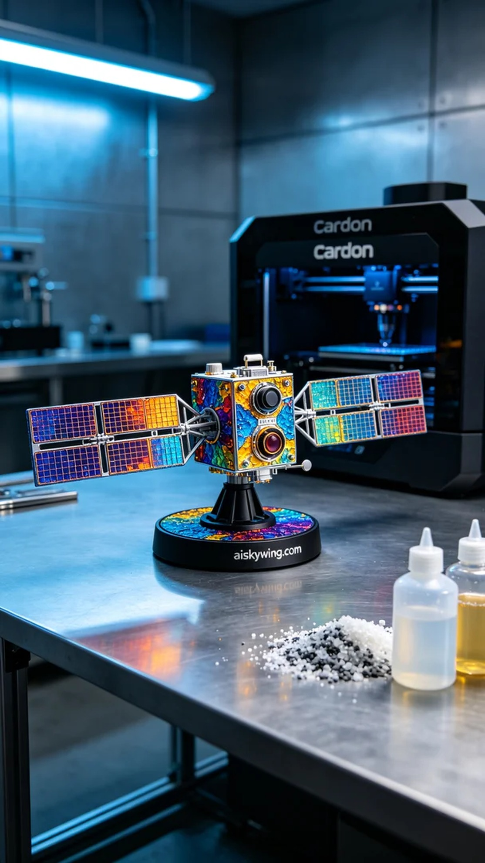
这次的项目涉及到一个全彩3D打印卫星模型，客户遇到了色彩和细节呈现的问题，寻求我们的帮助。通过我们的技术，最终能够将这个复杂的设计完美实现。
我们使用了全彩3DP材料，这种材料以其丰富的颜色和细腻的纹理而闻名。打印机采用Carbon型号，设置层厚为0.1mm，打印温度保持在25°C，功率设定为70W，速度为50mm/s。为了确保色彩的渐变和细节的清晰度，我们特别调整了打印参数以达到最佳效果。
打印过程中，Carbon打印机稳定地运行着，整个过程持续了约8小时。我们专注于实时监控打印质量，确保每个细节都准确无误。细致的观察和及时的调整，让我们在过程中避免了潜在的误差。
完成打印后，进入了后处理环节。首先进行清洗，以去除多余的树脂；然后轻轻打磨表面，确保每个细节都光滑可见。接下来，将模型放入固化机中固化30分钟，确保其强度和耐用性。最后，仔细检验每一个细节，确保达到高标准。
经过一系列的工艺流程，这个全彩3D打印卫星模型终于完工，色彩鲜明，细节丰富，达到了预期效果。
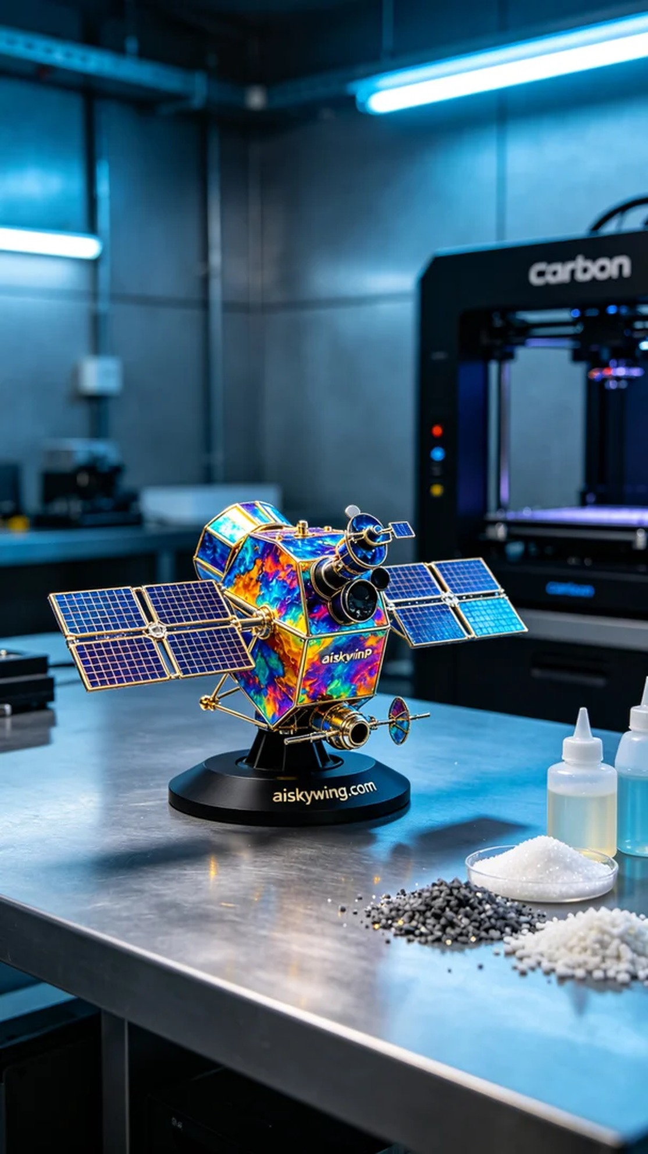
Aiskywing Industrial 3D Printing
Full-color 3D printed satellite model


