0446-全彩3D打印圣诞树模型生产记录
Full-color 3D printed Christmas tree model
🖨️ 全彩3DP
🖥️ 打印机: Xjet
📦 材料: 全彩3DP
生活就像一场艺术创作，每一步都值得珍惜。最近有人找我们打印这个全彩3D打印圣诞树模型，想在节日里增添一丝色彩。
Life is like a work of art, and every step is worth cherishing. Recently, someone approached us to print this full-color 3D Christmas tree model, hoping to add a touch of color to the holiday season.
________________________________________________________________________________
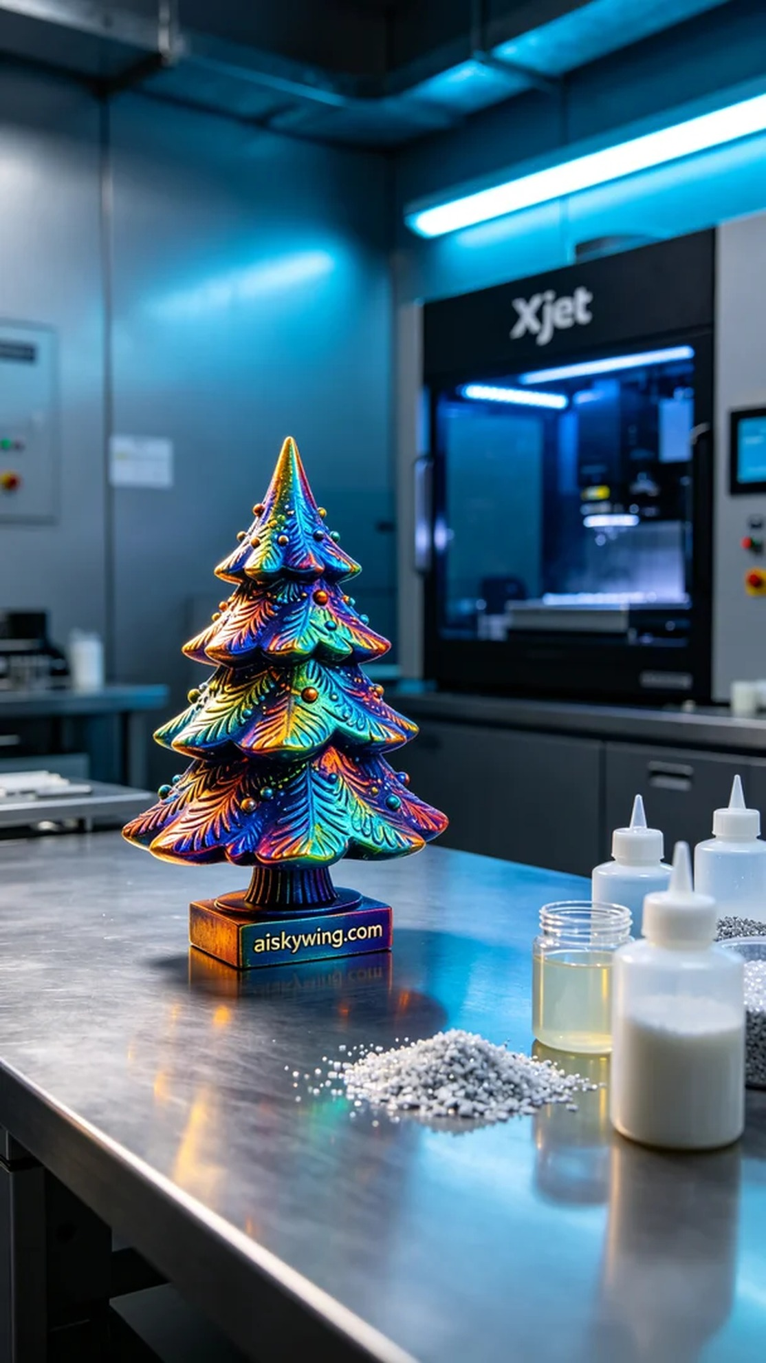
Life is like an artistic creation, every step is worth cherishing. Recently, someone approached us to print a full-color 3D Christmas tree model, hoping to add a touch of color to the holiday season.
We prepared the full-color 3DP material, which is rich in color and has a strong sense of realism, perfectly matching the client's needs. The equipment used was the Xjet 3D printer, and we set the appropriate printing parameters: layer thickness of 0.1mm, printing temperature at 30 degrees Celsius, power set at 80%, and printing speed of 60mm per hour, with an estimated total printing time of 14 hours to ensure every detail is perfectly presented.
Once the printing process started, the Xjet printer ran steadily, with the nozzle constructing layer by layer on the liquid photopolymer resin. As each layer was printed, the outline of the Christmas tree gradually became visible. We continuously monitored the print quality to ensure that the color gradients and details were as expected, especially under the reflections of light, the textures of the tree appeared particularly vivid.
After the print was completed, we proceeded to post-processing. First was cleaning, to remove any uncured resin. Next, we polished the model to eliminate surface flaws and enhance smoothness. Then, we placed the model in a curing box, utilizing UV light for curing to increase durability and longevity. Finally, after thorough quality inspection, we ensured every detail was flawless.
Through this production, we successfully delivered a high-quality full-color 3D printed Christmas tree model, adding color and joy to the holiday season. Looking forward to the next creative challenge!
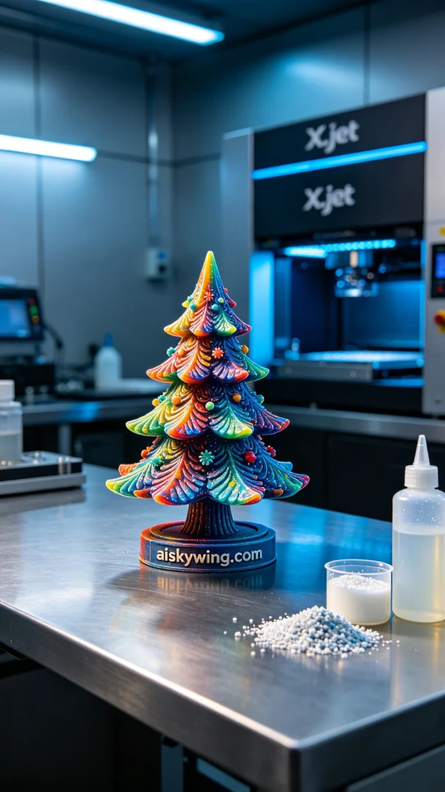
在TikTok上，有人因自己的节日装饰需要而找到了我们，要求制作一个全彩3D打印圣诞树模型。他们想要一个在视觉上冲击力十足的作品，能够引起家人和朋友的喜爱。
我们准备了全彩3DP材料，这种材料色彩丰富且真实感强，完美契合了客户的需求。使用的设备是Xjet 3D打印机，我们设定了合适的打印参数：层厚0.1mm，打印温度为30摄氏度，功率设置在80%，打印速度为每小时60毫米，预计总打印时间为14小时，确保每个细节都能完美呈现。
打印过程开始后，Xjet打印机稳稳运行，喷头在液态光敏树脂上逐层构建，随着每一层的打印，圣诞树的轮廓逐渐显现。我们时刻监控打印质量，确保颜色渐变和细节的呈现都如预期，尤其是在光线的反射下，树木的纹理显得尤为生动。
完成打印后，我们对模型进行了后处理。首先是清洗，将未固化的树脂清除干净。接着进行打磨，以去除表面瑕疵，提升光滑度。然后，我们将模型放入固化箱中，利用UV灯光进行固化，以增强其耐用性和使用寿命。最后，经过严格的质量检验，确保每个细节无懈可击。
通过这次生产，我们成功交付了一个高质量的全彩3D打印圣诞树模型，为节日增添了色彩和快乐。期待下一个创作挑战！
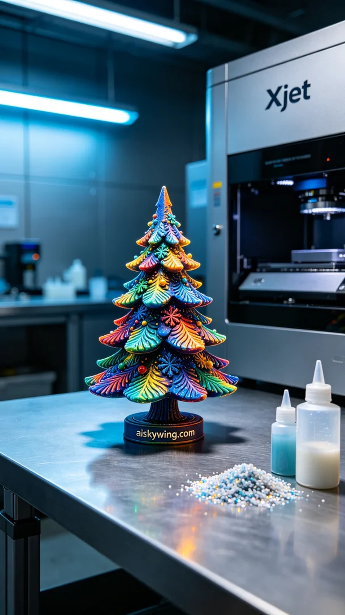
Aiskywing Industrial 3D Printing
Full-color 3D printed Christmas tree model


