0448-全彩3D打印地球模型生产记录
Full-color 3D printed Earth model
🖨️ 全彩3DP
🖥️ 打印机: EOS
📦 材料: 全彩3DP彩色树脂
生活再难，也别停下脚步。就像接这个全彩3D打印地球模型的单子，既是挑战也是一种成长的机会。
No matter how difficult life gets, never stop moving forward. Taking on this order for a full-color 3D printed globe is both a challenge and an opportunity for growth.
________________________________________________________________________________
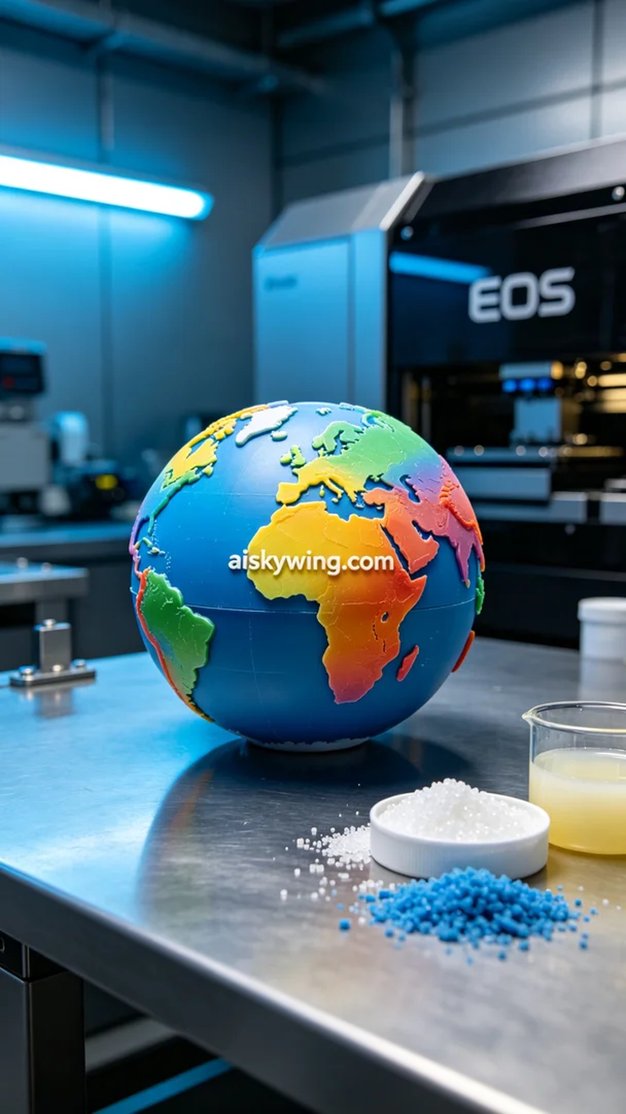
Life can be tough, but we must keep moving forward. Taking on the project of creating a full-color 3D printed globe was not just a challenge, but an opportunity for growth.
A person reached out to us via WhatsApp, expressing their desire to create a full-color 3D printed globe. They wanted it to showcase real surface details and rich colors for display and educational purposes.
To ensure the quality of the product, we selected full-color 3DP resin as the printing material. This material is vibrant and capable of presenting intricate gradient effects. We used an EOS brand 3D printer, setting the layer thickness to 0.1mm, printing temperature to 25℃, power to 50W, and controlling the print speed at 40mm/s, with an estimated total printing time of about 8 hours.
During the printing process, we monitored the machine's operation closely to ensure precision at every step. The EOS printer performed steadily, with smooth material supply and accurate application of resin layer by layer. As the printing progressed, the globe's three-dimensional effects began to take shape, with stunning details emerging.
After printing was completed, we began the post-processing. This involved soaking the model in a cleaning solution to remove any uncured resin, followed by sanding with fine-grit paper to ensure a smooth surface. Finally, we placed the model in a curing machine to enhance its durability and glossiness. Each step required careful inspection to ensure the final product met the standards.
After a series of meticulous operations, the full-color 3D printed globe was finally completed. Its vibrant colors and vivid details made it a perfect display piece that captured everyone's attention.
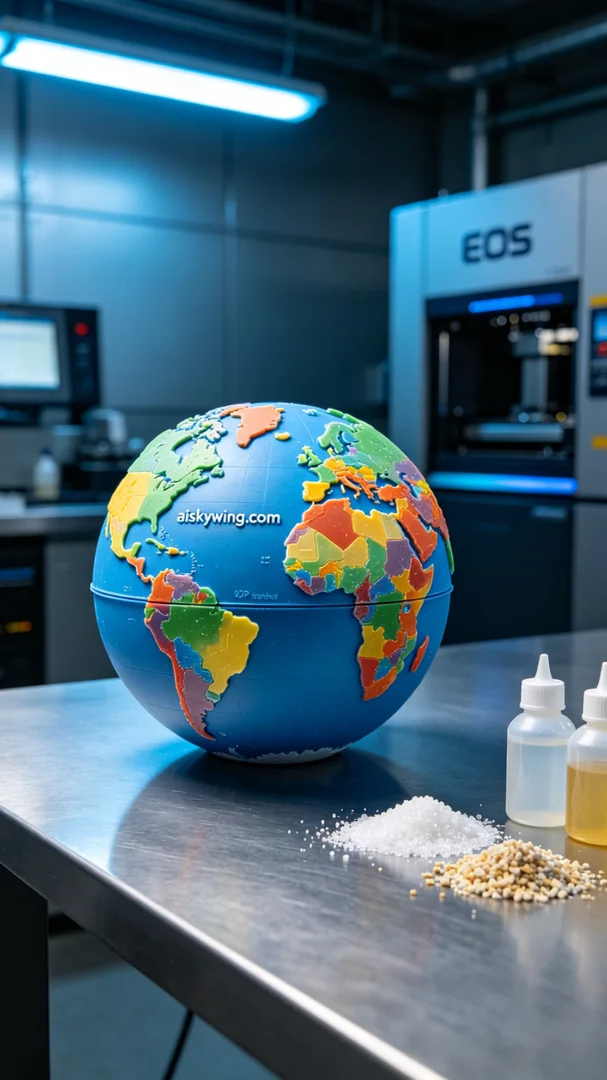
有人通过WhatsApp联系到我们，表示希望制作一款全彩3D打印地球模型。他们希望能够展现出真实的地表细节和丰富的颜色，以便用于展示和教育用途。
为了确保产品的质量，我们选择了全彩3DP彩色树脂作为打印材料。这种材料色彩鲜艳，能够呈现出细腻的渐变效果。我们使用EOS品牌的3D打印机，设定层厚为0.1mm，打印温度为25℃，功率设定为50W，打印速度控制在40mm/s，预计整个打印过程将耗时约8小时。
打印过程中，我们时刻关注机器的运行情况，确保每一步都精准无误。EOS打印机在工作中表现稳定，材料供给顺畅，打印头精确地将每一层的树脂固化。随着打印的推进，地球模型的立体效果逐渐显现，细节的展现令人惊叹。
打印完成后，我们开始进行后处理。这包括将模型浸泡在清洗液中，以去除未固化的树脂，接着用细砂纸进行打磨，确保表面光滑。最后，我们将模型放入固化机中进行固化，以提升其耐用性和光泽度。每一步都要仔细检验，确保最后的成品达到标准。
经过一系列的精细操作，这款全彩3D打印地球模型终于完成了。鲜艳的色彩和生动的细节使得它成为了一个完美的展示品，令人一见倾心。
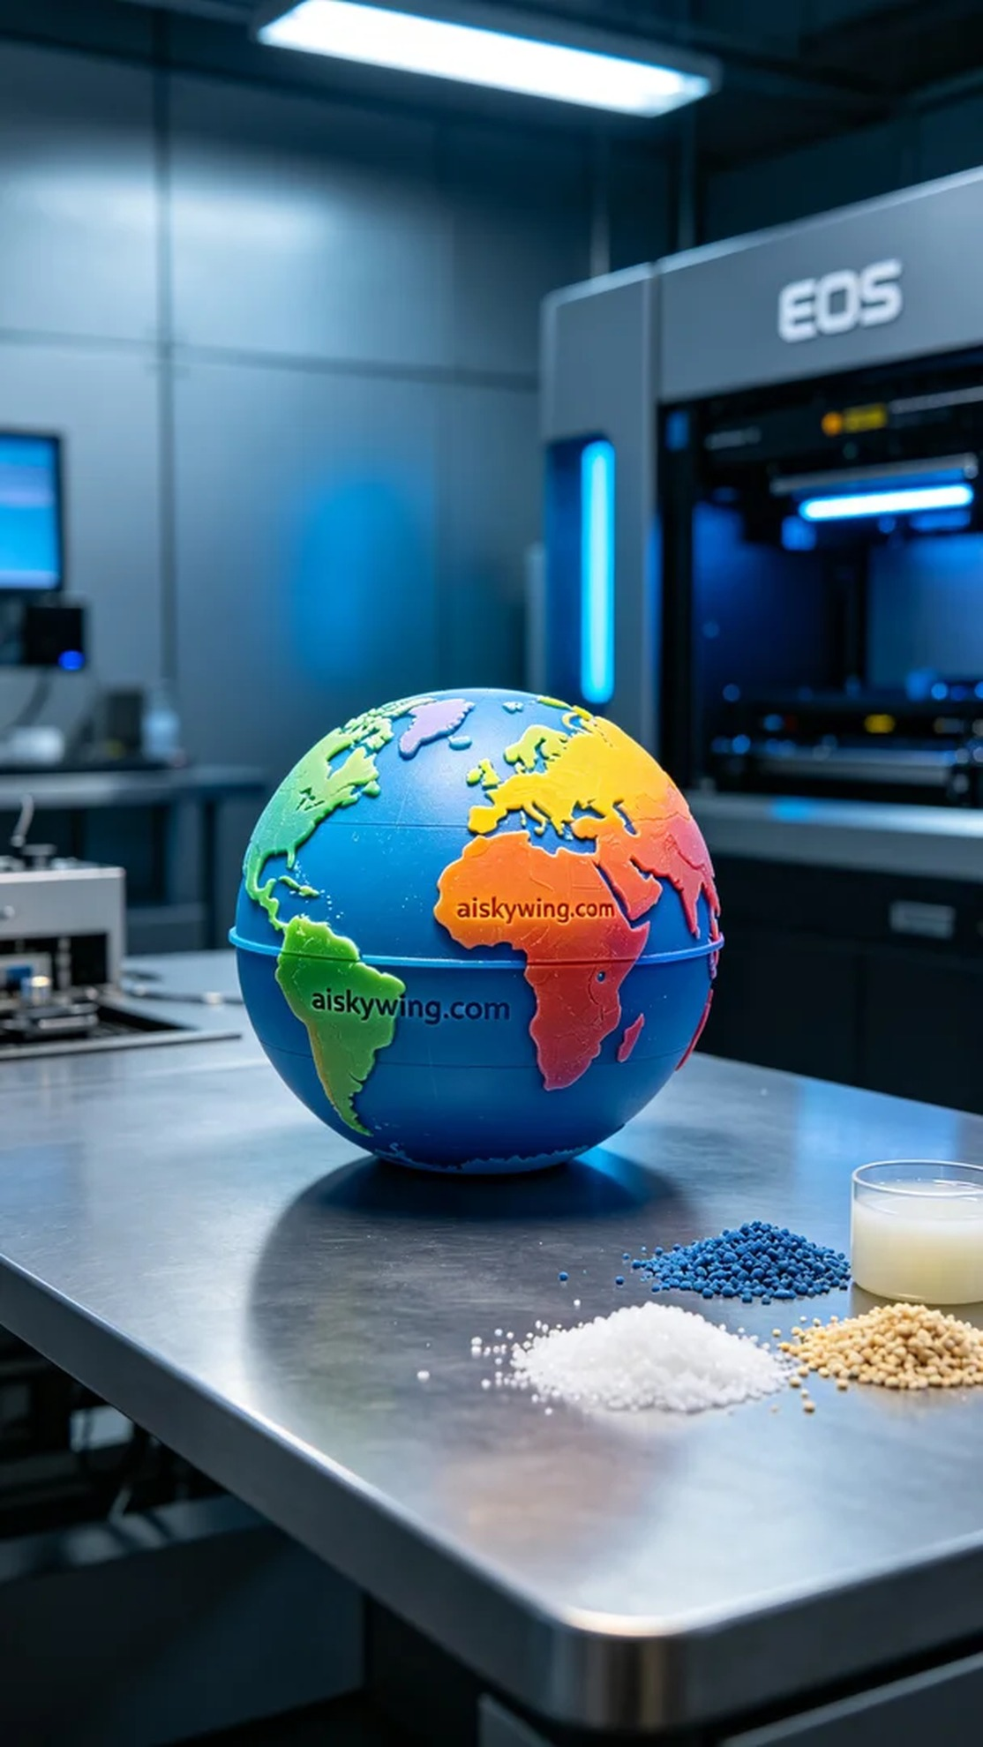
Aiskywing Industrial 3D Printing
Full-color 3D printed Earth model


