0449-全彩3D打印埃菲尔铁塔模型制作记录
Full-color 3D printed Eiffel Tower model
🖨️ 全彩3DP
🖥️ 打印机: HP
📦 材料: 全彩3DP彩色打印
生活是一场漫长的旅程，有时我们需要通过艰难的努力来创造美好的事物。就像这款全彩3D打印埃菲尔铁塔模型，在Facebook上吸引了不少人的目光。
Life is a long journey, and sometimes we need to create beautiful things through hard work. Just like this full-color 3D printed Eiffel Tower model, which has attracted a lot of attention on Facebook.
________________________________________________________________________________
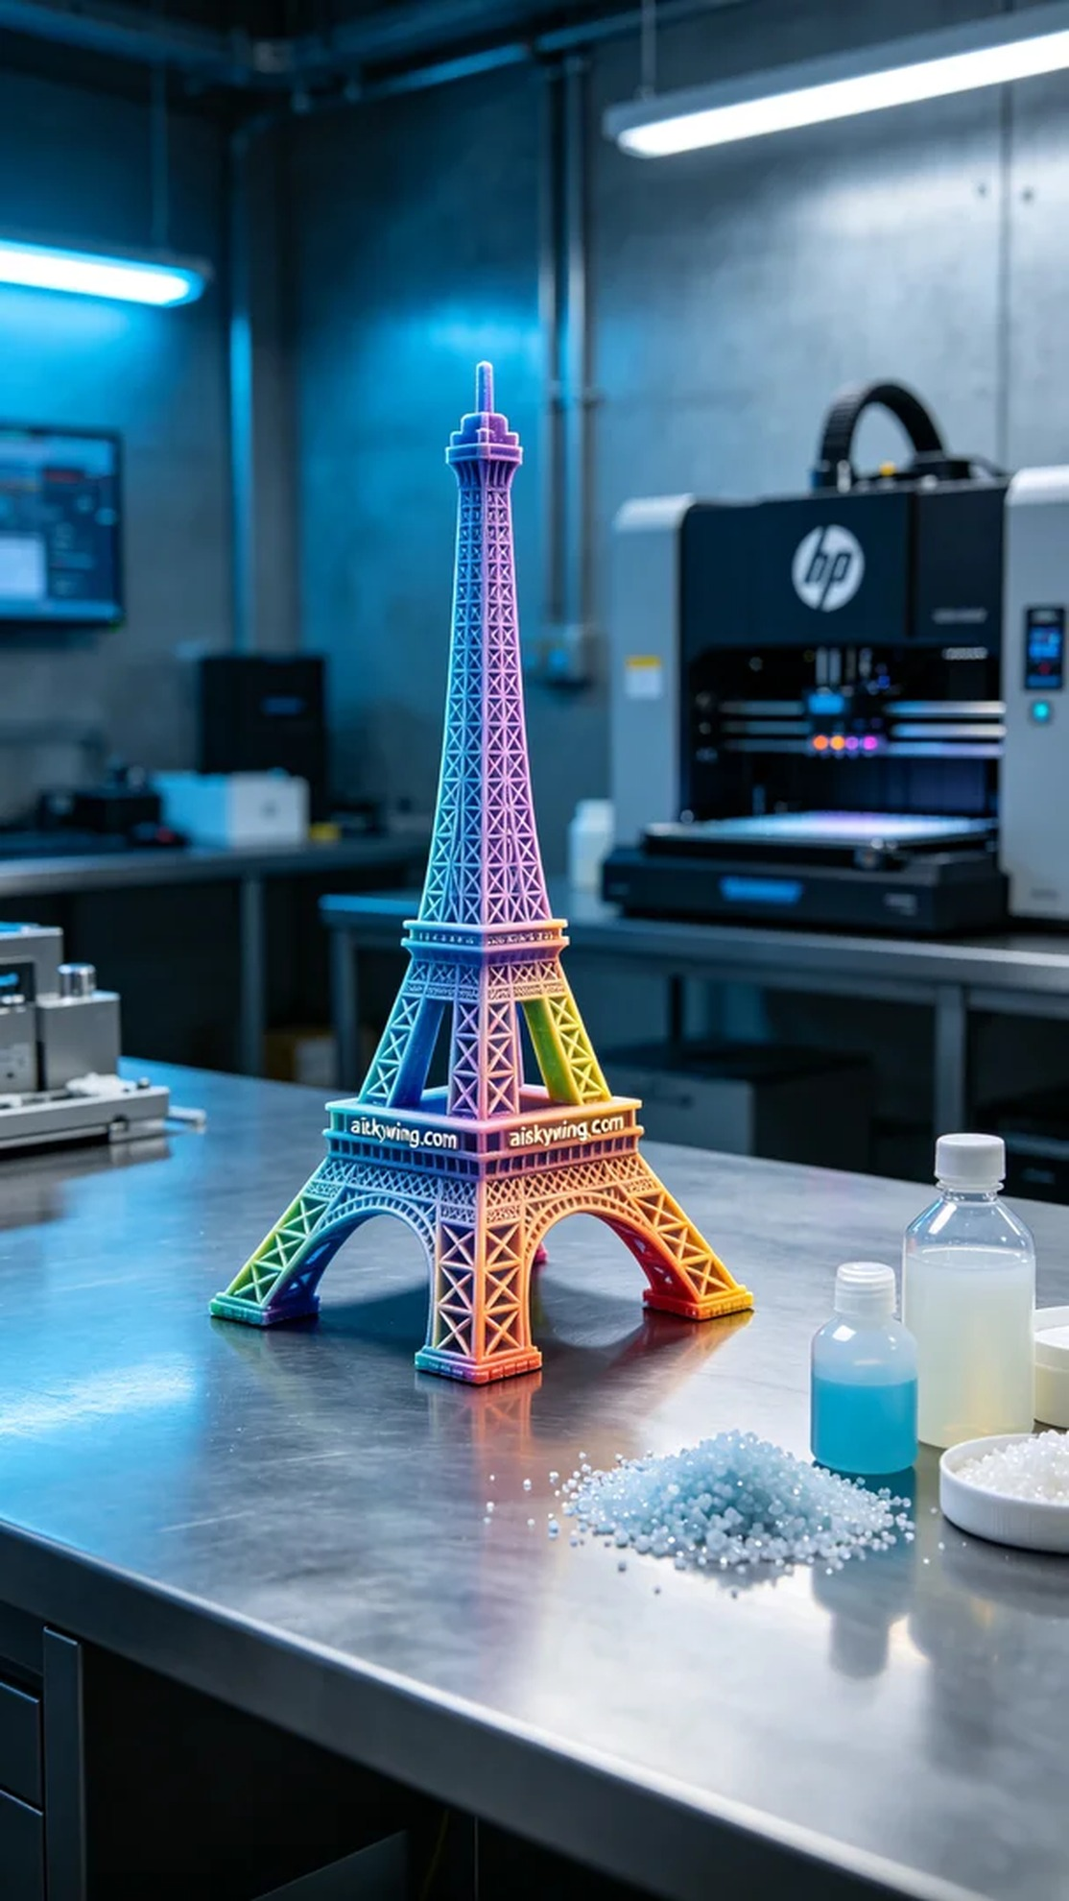
Life is a long journey, and sometimes we need to create beautiful things through hard work. Just like this full-color 3D printed Eiffel Tower model, which caught the attention of many on Facebook.
Someone found us on Facebook and inquired whether we could print a full-color model of the Eiffel Tower. They wanted to perfectly present the beauty of this iconic building. So we decided to take on this challenge and worked hard to create a model that would amaze.
We chose full-color 3DP printing material, which is not only rich in color but also has high fidelity. To ensure the printing effect, we used an HP brand 3D printer, setting the layer thickness to 0.1 mm, printing temperature to 210 degrees Celsius, power to 80%, and speed to 50 mm per second. The entire printing process was expected to take about 12 hours.
During the printing process, the device ran smoothly, and the print head accurately built the model layer by layer. We monitored the print quality throughout, ensuring every detail was not overlooked. The color gradients and depth of the model gradually emerged, making the Eiffel Tower come to life.
After printing, we carried out detailed post-processing. First, we placed the model into the cleaning tank and used a special cleaning solution to remove excess resin. Next, we lightly sanded the surface with fine sandpaper to ensure smoothness and clarity of details. Finally, we cured the model in a UV curing machine to enhance its strength and durability. After inspection, we ensured that every detail met the standards, successfully completing the model.
This full-color 3D printed Eiffel Tower model has finally been completed, with rich colors and realistic details, perfectly reflecting the original design intent. Whether as a decoration or a collectible, it will bring people endless beauty and memories.
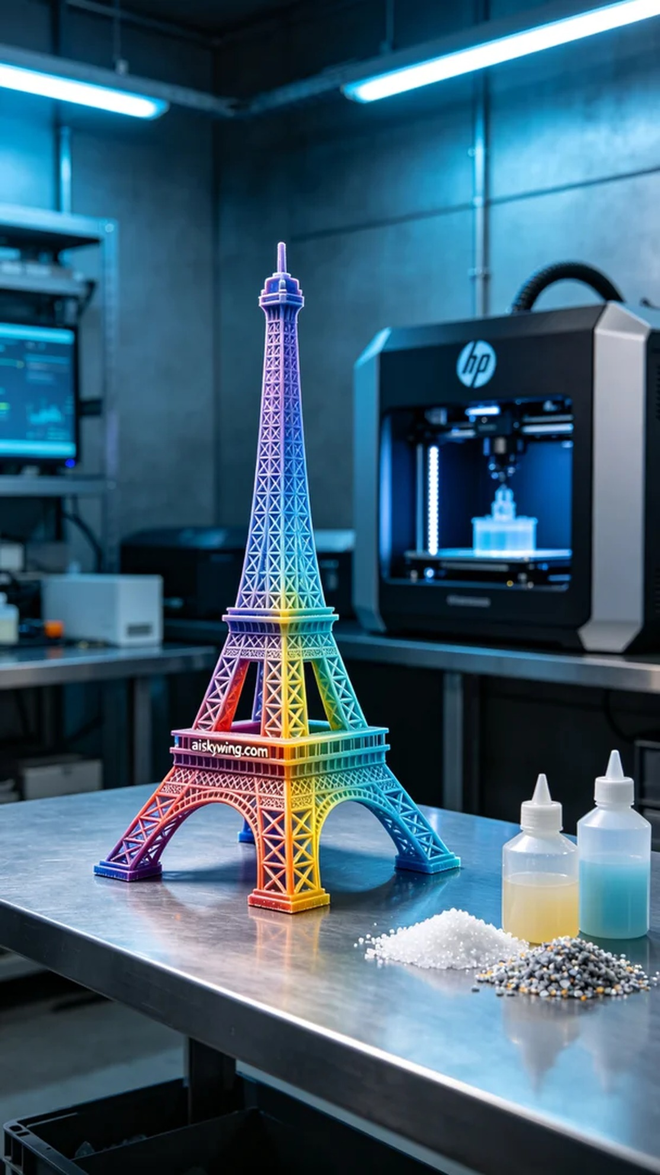
有人在Facebook上找到了我们，询问能否打印一款全彩的埃菲尔铁塔模型，他们希望能够把这座地标性建筑的美丽完美呈现。于是，我们决定接下这个挑战，努力打造出一款让人惊叹的模型。
我们选择了全彩3DP彩色打印材料，这种材料不仅色彩丰富，且有着极高的保真度。为了确保打印效果，我们使用了HP品牌的3D打印机，设置了层厚为0.1毫米，打印温度为210摄氏度，功率设定在80%，打印速度为50毫米每秒。整个打印过程预计需要大约12小时。
在打印过程中，设备运行稳定，打印头精准无误地逐层构建着模型。我们全程监控打印质量，确保每一个细节都不被忽略。色彩的渐变和层次感在这个过程中逐渐展现出来，使得埃菲尔铁塔逐渐从打印机中“走出”。
打印完成后，我们进行了详细的后处理。首先，将模型放入清洗槽中，使用专用清洗液去除多余的树脂。接着，使用细砂纸对模型表面进行了轻微的打磨，以确保光滑度和细节清晰。最后，将模型放在UV固化机中固化，彻底增强其强度和耐用性。经过检验，我们确保每一处细节都达到标准，最终完成了这款模型。
这款全彩3D打印埃菲尔铁塔模型终于成功出炉，颜色丰富、细节逼真，完美呈现了设计初衷。无论是作为装饰品还是收藏品，它都将带给人们无限的美好和回忆。
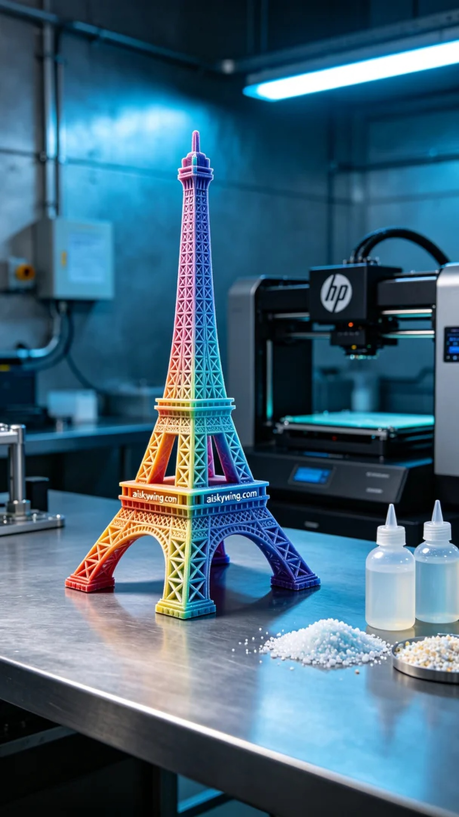
Aiskywing Industrial 3D Printing
Full-color 3D printed Eiffel Tower model


