0451-全彩3D打印城堡模型的生产记录
Full-color 3D printed castle model
🖨️ 全彩3DP
🖥️ 打印机: EOS
📦 材料: 摆放着未成型的液态光敏
在这个快节奏的时代，偶尔停下来欣赏一座全彩3D打印城堡模型的魅力，能让人明白每个细节背后的付出。正如在Twitter上有人提到的，他们需要这样一座独特的模型来展示他们的创意。
In this fast-paced era, taking a moment to appreciate the charm of a full-color 3D printed castle model can help one understand the effort behind every detail. As someone mentioned on Twitter, they need such a unique model to showcase their creativity.
________________________________________________________________________________
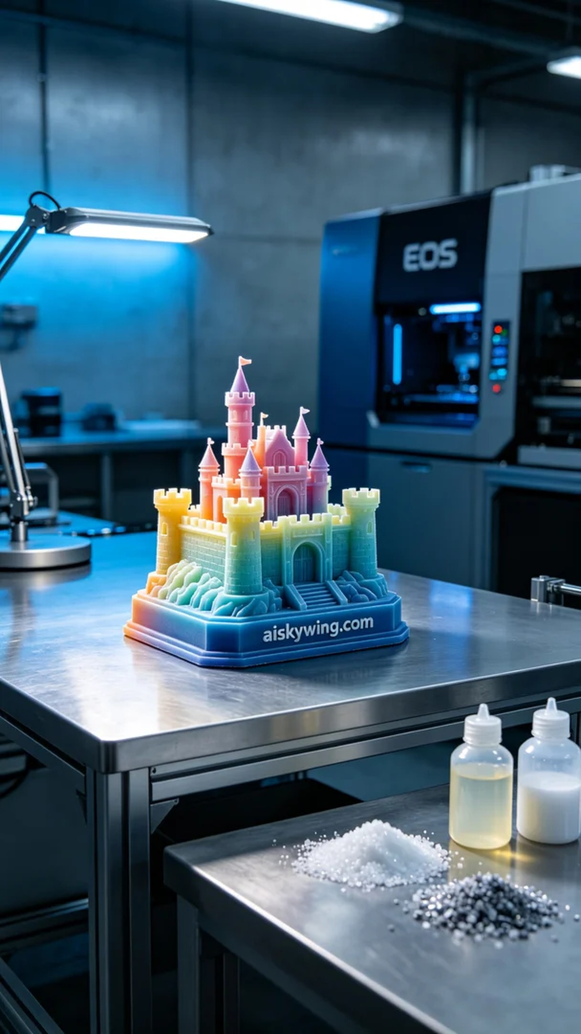
In this fast-paced world, taking a moment to appreciate the beauty of a full-color 3D printed castle model reveals the dedication behind every detail. Just like someone mentioned on Twitter, they needed a unique model to showcase their creativity.
To ensure the model's quality, we chose unformed liquid photopolymer resin as our raw material. This photopolymer resin has excellent fluidity and provides a fine surface finish, making it perfect for full-color 3D printing. We utilized an EOS 3D printer, setting the layer thickness to 0.1mm, maintaining a temperature of 25 degrees Celsius, with a power setting of 300mW and a print speed of 40mm/s, estimating a total print time of 12 hours.
As the printing commenced, the EOS printer operated steadily, precisely layering the liquid photopolymer resin. We continuously monitored the print quality to ensure that the color gradients and details matched our expectations. Throughout the printing process, the airflow and humidity monitoring systems worked to create the optimal printing environment.
After the printing was finished, we started with cleaning to remove any residual photopolymer resin from the model's surface, followed by sanding to ensure a smooth, fine finish. The curing process was crucial, exposing the model to UV light to ensure its strength and stability. Finally, we conducted a comprehensive inspection of the model to ensure every detail was perfect.
After a series of meticulous processes, the full-color 3D printed castle model was finally completed. It not only showcased vibrant colors and intricate craftsmanship but also perfectly fulfilled that call for creativity.
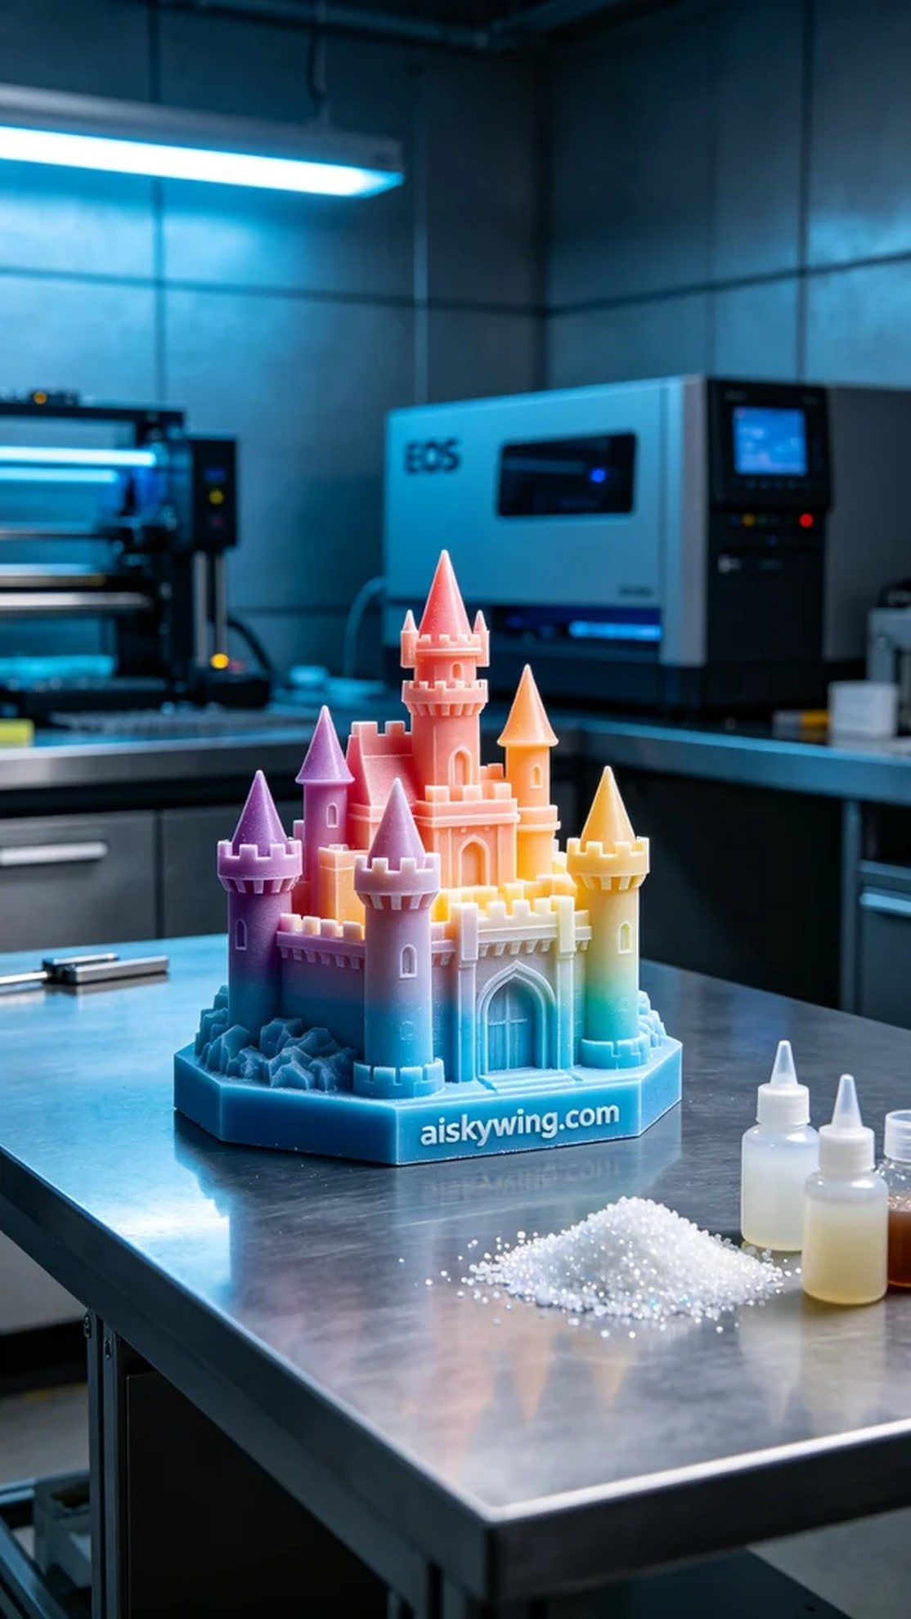
有人在Twitter上找到我们，诉说他们正在筹备一个展览，迫切需要一座全彩3D打印城堡模型。他们希望模型不仅外观精美，还能展现出丰富的色彩和细腻的细节，以吸引观众的眼球。
为确保模型的质量，我们选择了未成型的液态光敏树脂作为原材料。这种光敏树脂具有优异的流动性和细腻的表面效果，非常适合全彩3D打印。我们使用的是EOS的3D打印机，设置了层厚0.1mm，温度维持在25摄氏度，功率设定为300mW，打印速度为40mm/s，整个打印过程预计需要12小时。
打印开始后，EOS打印机稳稳地运转着，喷头准确无误地将液态光敏树脂层层叠加。我们实时监控打印质量，确保每一层的色彩渐变与细节都能如预期表现。打印过程中，气流和温湿度的监控系统都在发挥作用，以保证最佳的打印环境。
当打印完成后，我们首先进行清洗，去除模型表面的光敏树脂残留，接着进行打磨，以确保表面光滑细腻。固化环节也不能马虎，将模型置于UV灯下进行固化，确保其强度和稳定性。最后，我们对模型进行全面检验，确保每一个细节都没有遗漏。
经过一系列严谨的工序，这座全彩3D打印城堡模型终于完成了。它不仅展现了丰富的色彩和细腻的工艺，还完美回应了那份创意的呼唤。
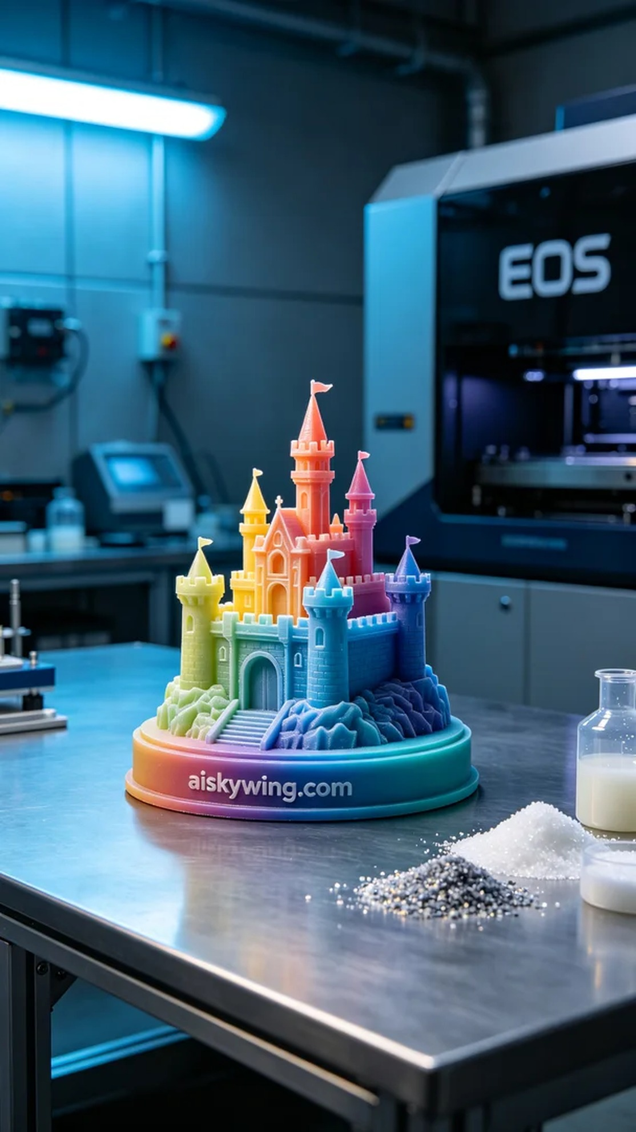
Aiskywing Industrial 3D Printing
Full-color 3D printed castle model


