0453-全彩3D打印天安门模型生产记录
Full-color 3D printed model of Tiananmen Square.
🖨️ 全彩3DP
🖥️ 打印机: Mimaki
📦 材料: 摆放着未成型的液态光敏
生活再难，也别停下脚步。就像接下这个全彩3D打印天安门模型的单子，真是充满挑战与期待。
No matter how difficult life gets, don't stop moving forward. Taking on this order for a full-color 3D printed model of Tiananmen Square is truly filled with challenges and anticipation.
________________________________________________________________________________
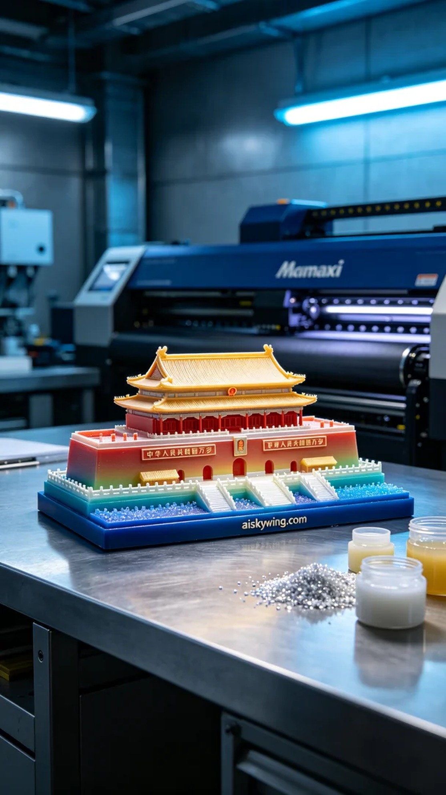
Recently, someone reached out to me with a request to create a full-color 3D printed model of Tiananmen. They had high expectations for the model’s details and colors, especially the gradient effect. After receiving this task, I felt a mix of nerves and excitement.
The material we used was unformed liquid photopolymer resin, which can showcase very delicate color gradients and high saturation. During the preparation phase, I conducted a thorough check on the Mimaki printer to ensure that all functions were operating smoothly. When setting the printing parameters, I chose a layer thickness of 0.1mm, maintained a printing temperature of 25 degrees Celsius, set the power to 80%, and adjusted the printing speed to 50mm per second. The overall estimated printing time was about 6 hours.
During the printing process, the sound of the Mimaki printer resonated through the workshop as the model gradually took shape from the liquid resin. To ensure print quality, I checked the progress every once in a while, observing the performance of various details to make sure there were no flaws. As time passed, the model's outlines became clearer, and the colors stacked layer by layer.
After the printing was completed, we entered the post-processing stage. First, I carefully removed the model from the print bed and used a specialized cleaning agent to wash it, removing any residual resin on the surface. Next, I gently sanded the model with fine sandpaper to enhance its smoothness and delicacy. Finally, I placed the model in a curing device to solidify it, ensuring its structure was robust, and after conducting a final inspection, confirmed there were no defects.
This full-color 3D printed Tiananmen model not only successfully showcased a rich array of colors and intricate details but also deepened my appreciation for the charm and challenges of 3D printing. Each attempt is a new learning experience, and next time, I’ll strive to do even better.
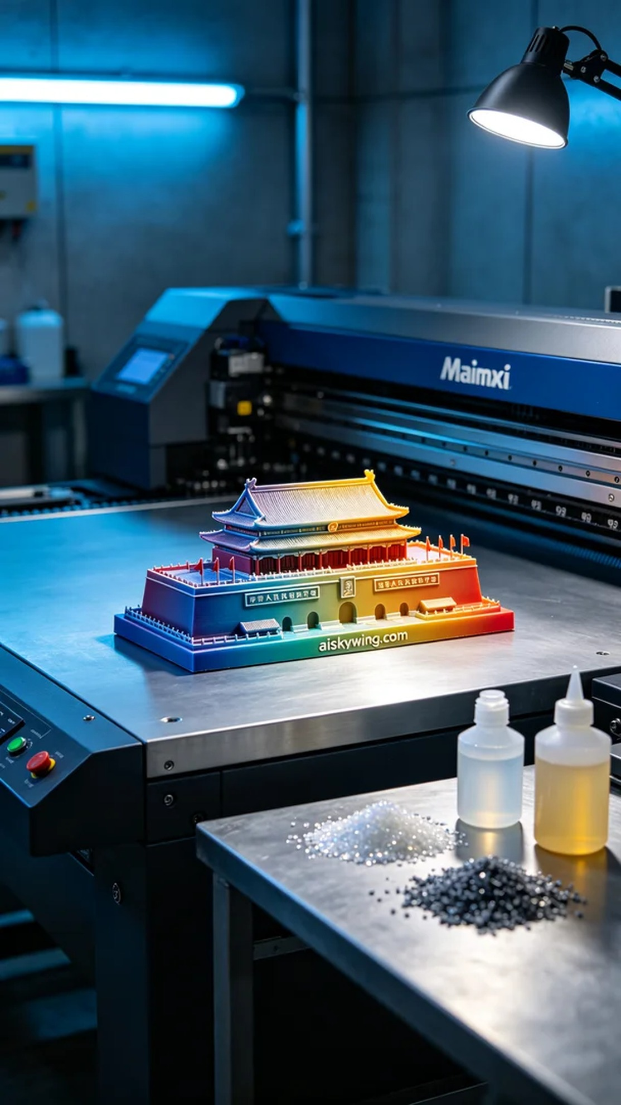
最近，有人联系我，希望能制作一个全彩3D打印天安门模型。他们对模型的细节和色彩都提出了很高的要求，尤其是颜色渐变的效果。接到这个任务，我心里暗自有点紧张，但也兴奋不已。
我们采用的原材料是未成型的液态光敏树脂，这种材料能够展现出非常细腻的色彩渐变和高艳度的效果。准备工作时，我对Mimaki打印机进行了全面检查，确保所有的功能都正常运转。设置打印参数时，层厚度选择了0.1毫米，打印温度保持在25摄氏度，功率设定为80%，打印速度调至50毫米每秒，预计整体打印时间将达到6个小时。
在打印过程中，Mimaki打印机的运转声在车间里回响，模型逐渐从液态树脂中成型。为了确保打印质量，我每隔一段时间就会检查一次打印进度，观察各个细节部位的表现，确保没有任何瑕疵。随着时间的推移，模型的轮廓逐渐清晰，色彩也一层层地叠加。
打印结束后，进入了后处理阶段。首先，我小心地将模型从打印床上取下，然后使用专用清洗剂对其进行了清洗，去除表面残留的树脂。接着，用细砂纸轻轻打磨模型的表面，以提升其光滑度和细腻感。最后，我将模型放入固化设备中进行加固，确保其结构稳固，完成检验后，确认没有任何缺陷。
这次的全彩3D打印天安门模型不仅成功呈现了丰富的色彩和细腻的细节，也让我再次深刻体会到3D打印的魅力与挑战。每一次的尝试都是一次新的学习，下一次我会做得更好。
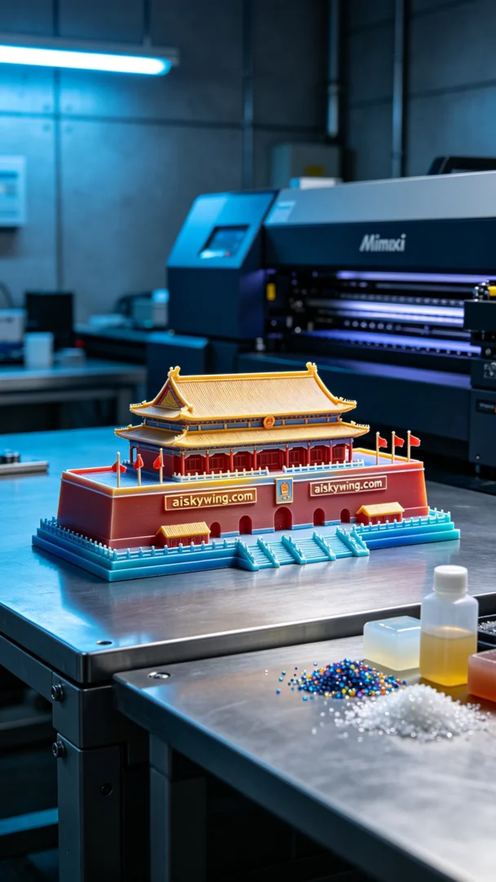
Aiskywing Industrial 3D Printing
Full-color 3D printed model of Tiananmen Square.


