0457-AR眼镜镜架的3D打印之旅
AR glasses frame
🖨️ SLA光固化
🖥️ 打印机: Xjet
📦 材料: SLA光固化树脂
有人在TikTok上看到AR眼镜镜架的展示，觉得它造型独特，但对成型工艺有疑虑。于是，我接下了这个项目，准备全力以赴。
Someone saw the display of AR glasses frames on TikTok and thought the design was unique, but had doubts about the molding process. So, I took on this project and prepared to give it my all.
________________________________________________________________________________
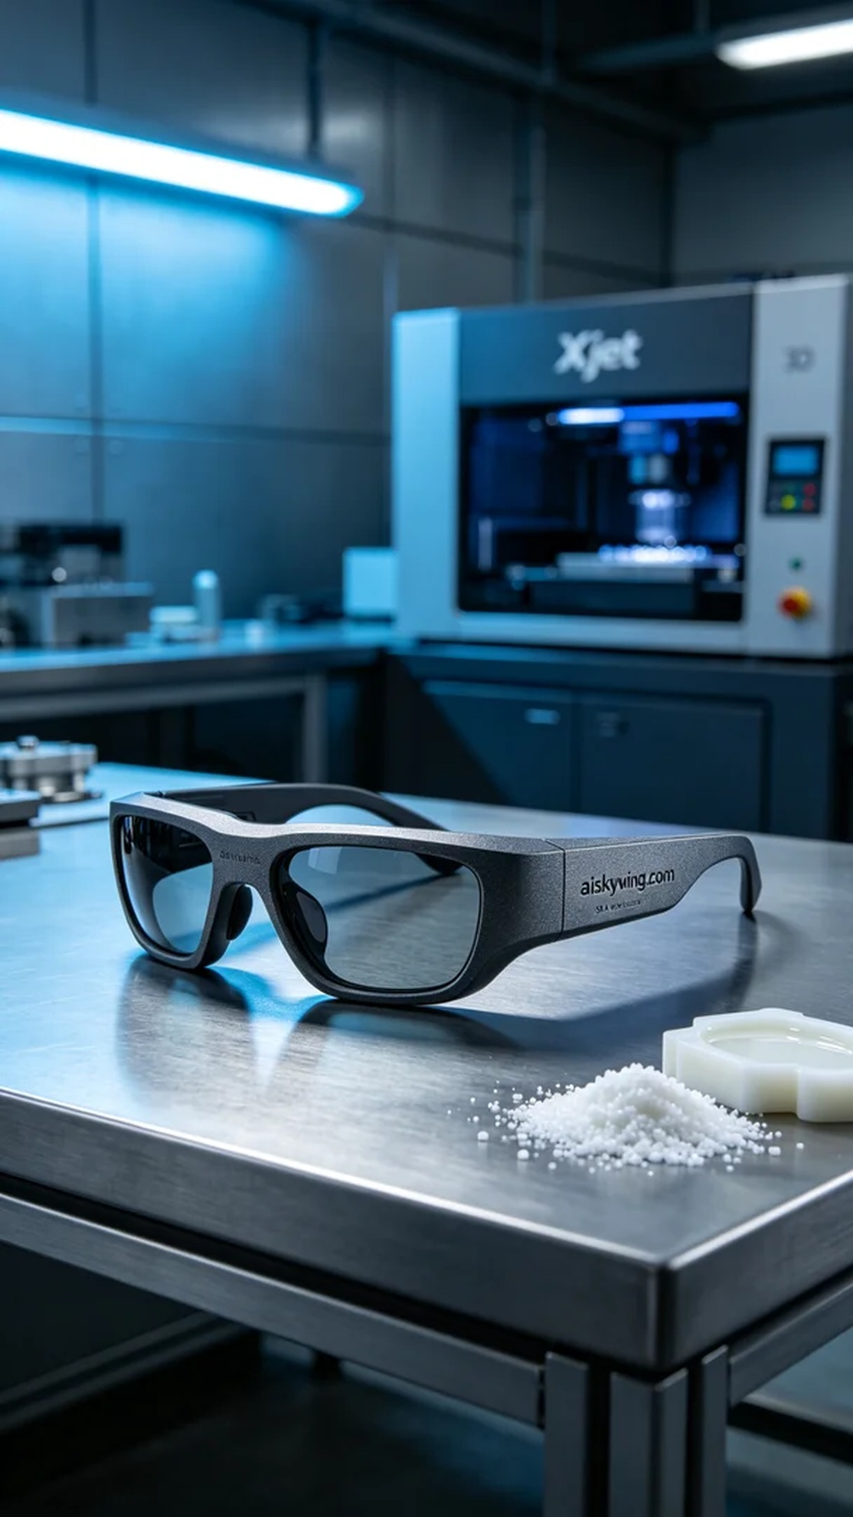
Recently, someone saw the display of the AR glasses frame on TikTok and found its design unique but had concerns about the manufacturing process. So, I took on this project, ready to give it my all.
For this project, we used SLA photopolymer resin, a material known for its exceptional detail and high strength, making it suitable for creating precise AR glasses frames. We prepared the Xjet 3D printer to ensure quality and efficiency. The printing parameters were set at a layer thickness of 0.05mm, a temperature maintained at 25°C, a power of 70%, and a printing speed of 15mm/s, with an estimated printing time of 8 hours.
As the printing process began, the Xjet printer operated steadily, and the photopolymer resin formed layer by layer under the light source. I kept a close eye on the process to ensure that each layer fully cured, avoiding bubbles and distortion. During this time, the printer's automatic monitoring system played a crucial role in ensuring the precision of every detail.
After the printing was complete, the next step was post-processing. We first placed the printed piece in a cleaning tank, using a specialized cleaning solution to remove residual resin. Once cleaned, we moved on to sanding to ensure a smooth surface. After that, the product was cured under UV light to ensure the material was fully hardened, increasing its strength. Finally, we meticulously inspected every detail to ensure there were no flaws.
After a series of rigorous steps, the AR glasses frame was finally completed. It not only boasts an elegant appearance, enhanced by meticulous treatment, but it also showcases our technical prowess. This work leaves me feeling incredibly fulfilled, and I look forward to creating more wonderful pieces in the future.
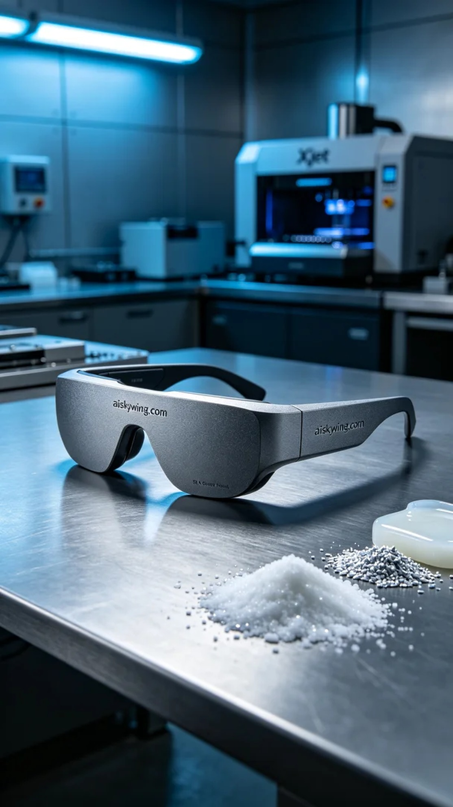
这次我们使用的是SLA光固化树脂，材料具有出色的细节表现和高强度特性，适合制作精密的AR眼镜镜架。设备方面，我们准备了Xjet品牌的3D打印机，确保打印质量和效率。打印参数设定为层厚0.05mm，温度保持在25°C，功率为70%和打印速度15mm/s，预计打印时间为8小时。
打印过程开始后，Xjet打印机稳稳地运转，光固化树脂在光源的照射下逐层成型。我时刻关注着打印进程，确保每层都完全固化，避免出现气泡和变形。在这个过程中，设备的自动监控系统也发挥了重要作用，确保了每个细节的精确呈现。
完成打印后，接下来的工作是后处理。首先，我们将打印件放入清洗槽中，使用专用清洗液去除残留的树脂。清洗完成后，进行打磨，确保表面光滑。之后使用UV灯对产品进行固化，确保材料完全硬化，增加其强度。最后，我们仔细检验每个细节，确保没有瑕疵。
经过一系列严谨的步骤，AR眼镜镜架终于完成。它不仅具备了优雅的外观，经过细腻的处理，更加彰显了我们的技术实力。这项工作让人感到无比充实，期待未来能创造出更多精彩作品。
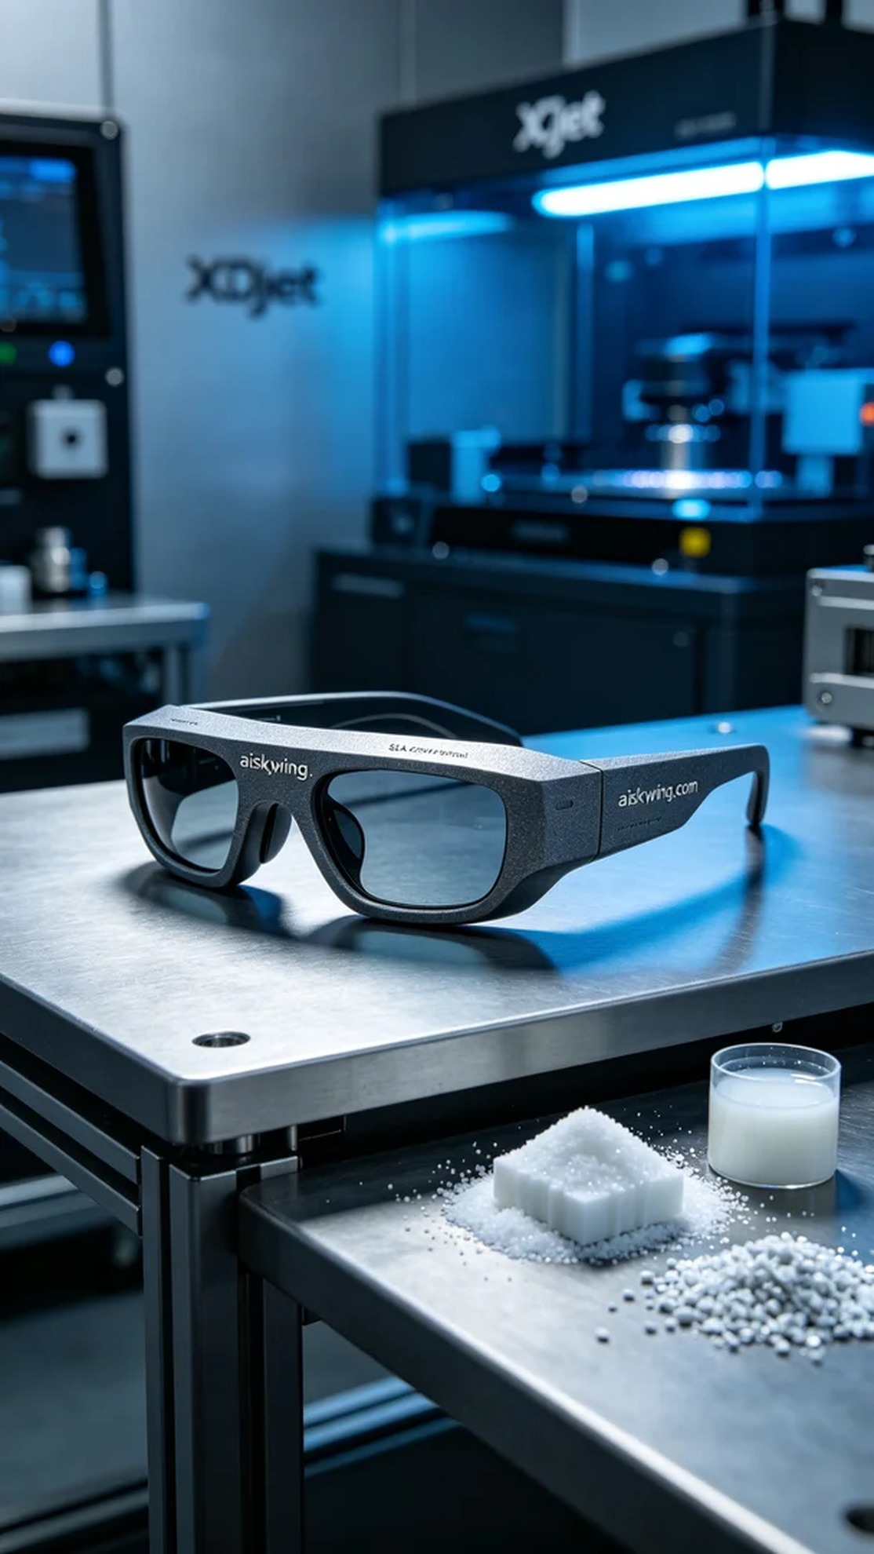
Aiskywing Industrial 3D Printing
AR glasses frame


