0460-全彩3D打印家具模型生产记录
Full-color 3D printed furniture models
🖨️ 全彩3DP
🖥️ 打印机: Rize
📦 材料: 摆放着未成型的液态光敏
生活中的每一步都是一次尝试。刚接到有人通过WhatsApp询问的全彩3D打印家具模型项目，我心里有些激动，期待这次的挑战。
Every step in life is an attempt. When I received an inquiry about a full-color 3D printed furniture model project through WhatsApp, I felt a surge of excitement and looked forward to this challenge.
________________________________________________________________________________
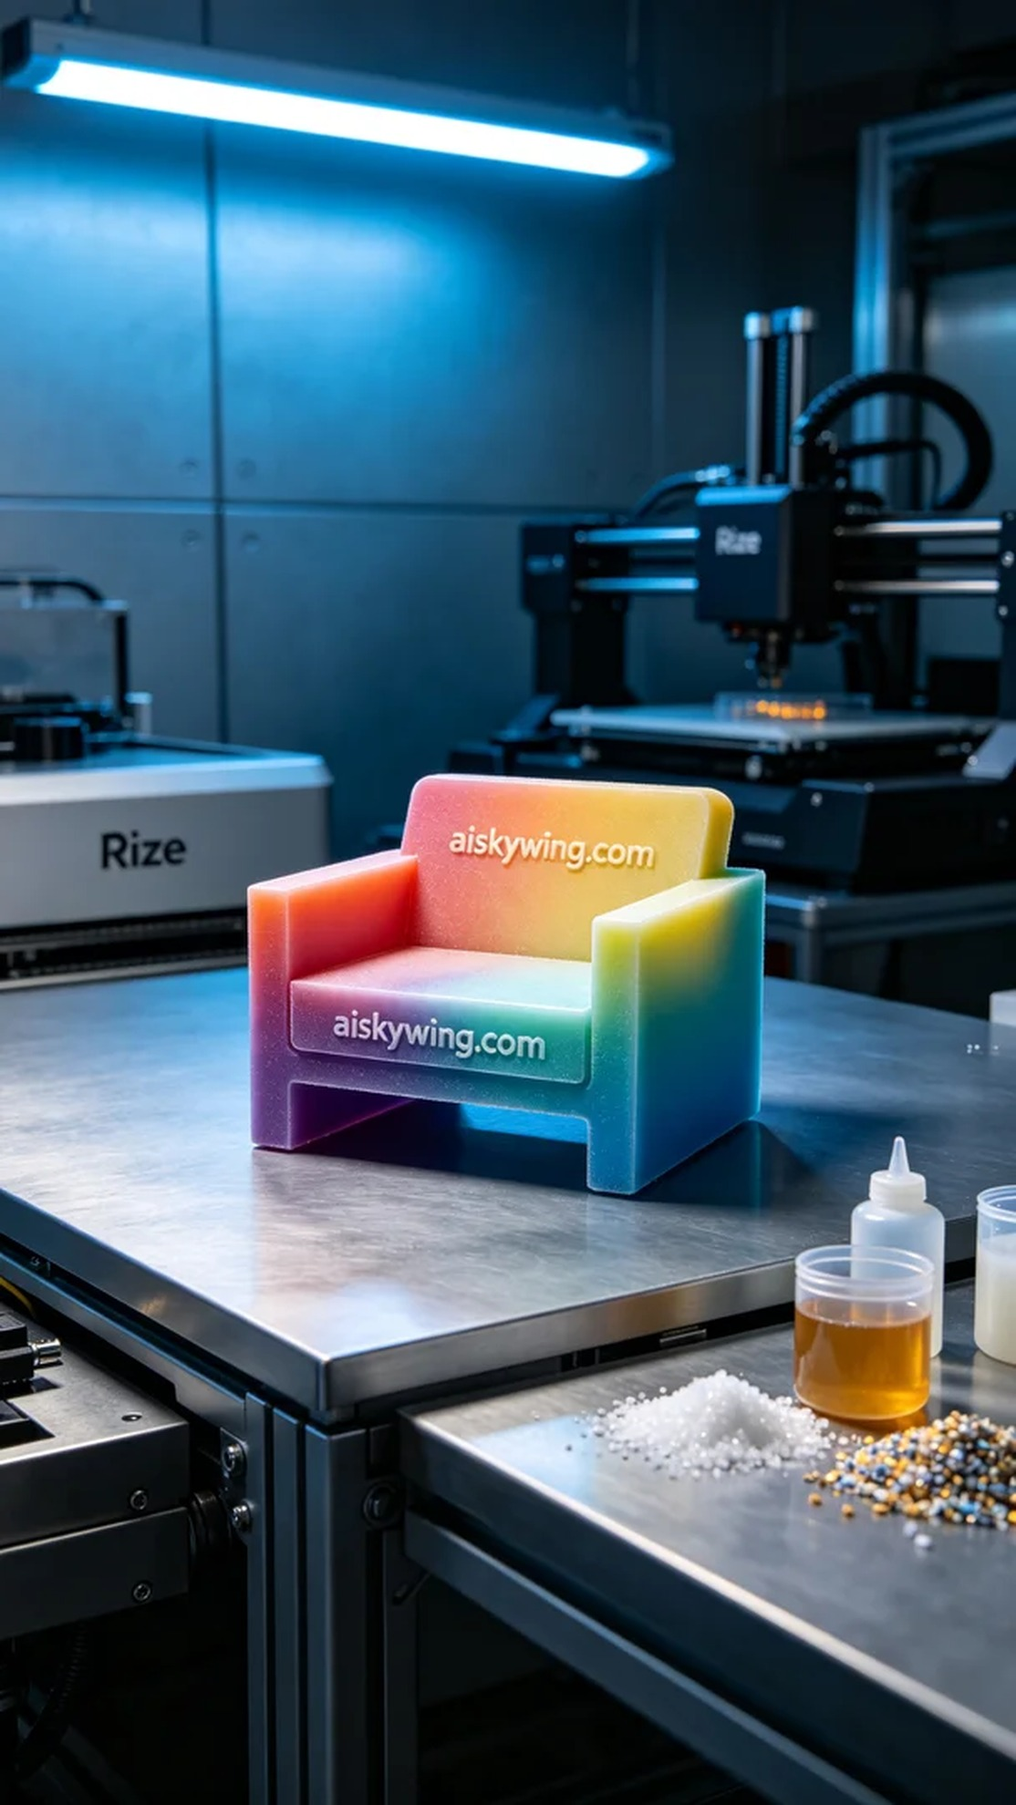
Every step in life is a new attempt. I was excited when I got a WhatsApp inquiry from someone about a full-color 3D printed furniture model project, looking forward to the challenge ahead.
This project began when someone reached out to us on WhatsApp, wanting to create a full-color 3D printed furniture model. They hoped this model could showcase high precision color gradients and fine details for commercial product photography. We immediately began preparations to ensure we could meet their expectations.
For the materials, we used unformed liquid photopolymer resin, which showcases high delicacy and color saturation once cured under light. We chose the Rize printer and set the layer thickness to 0.1mm, printing temperature at 25°C, power at 80%, and a printing speed of 50mm/s, with an estimated printing time of 4 hours. These parameters were carefully considered to ensure optimal output.
As the printing process began, we monitored the equipment's operation to ensure every detail was as expected. Layers of liquid photopolymer resin solidified, gradually revealing the model's shape and color. The printer's real-time feedback system allowed us to make timely adjustments, ensuring an efficient and stable process, ultimately resulting in a vividly colored and exquisitely detailed furniture model.
After printing, we conducted a stringent post-processing procedure. First, the model was soaked in a cleaning solution to remove excess resin. Next, we used sandpaper to polish the surface, ensuring every detail was smooth and fine. Then, the model was placed in a UV curing device to enhance its durability and glossiness. Finally, we performed a thorough inspection of the model to ensure there were no defects.
With all the processes and detailed polishing completed, the full-color 3D printed furniture model was finally finished. Seeing such a refined piece always brings a sense of satisfaction.
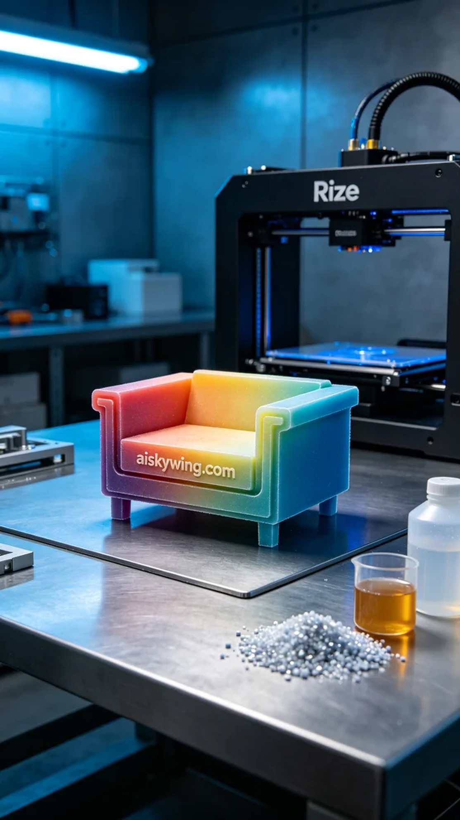
这次的项目源于有人在WhatsApp上联系我们，想要制作一款全彩3D打印家具模型。他们希望这个模型能够展示出高精度的色彩渐变和细腻的细节，以便用于商业产品摄影。我们立即着手准备，确保能够满足他们的要求。
在材料方面，我们使用了未成型的液态光敏树脂，这种材料在光照下固化后能展现出极高的细腻度和色彩饱和度。为了确保打印质量，我们选择了Rize打印机，设置了层厚为0.1mm，打印温度控制在25°C，功率设置为80%，打印速度为50mm/s，预计打印时间为4小时。这些参数都经过仔细考虑，以保证最佳的输出效果。
打印过程开始后，我们监控设备的运行状态，确保打印机的每个细节都在预期之内。随着液态光敏树脂逐层固化，模型的形状和颜色逐渐显现。打印机的实时反馈系统让我们能够及时调整参数，保证了整个过程的高效和稳定，最终打印出了一件色彩丰富、细节栩栩如生的家具模型。
完成打印后，我们进行了严格的后处理工序。首先将模型浸泡在清洗液中，去除多余的树脂。接下来，使用砂纸对表面进行打磨，确保每个细节都光滑细腻。随后，将模型放置在紫外线固化设备中，进行固化处理，以增强其耐用性和光泽度。最后，我们对模型进行了全面检验，确保没有瑕疵。
经过一系列的工序和细致的打磨，这款全彩3D打印家具模型终于完成。能够看到这样一件精致的作品，总是让人倍感欣慰。
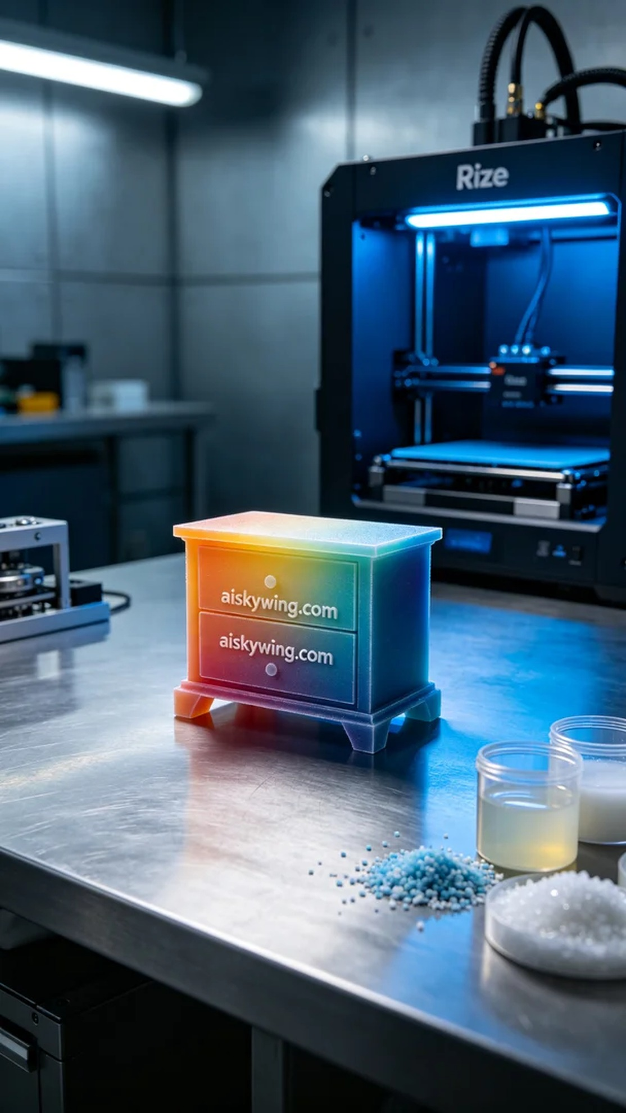
Aiskywing Industrial 3D Printing
Full-color 3D printed furniture models


