0466-全彩3D打印小提琴模型生产记录
Full-color 3D printed violin model
🖨️ 全彩3DP
🖥️ 打印机: EOS
📦 材料: 摆放着未成型的液态光敏
生活再难，也别停下脚步。就像接下这个全彩3D打印小提琴模型的单子，有人希望它在舞台上绽放光彩。
No matter how difficult life gets, don’t stop moving forward. Just like taking on this order for a full-color 3D printed violin model, someone hopes to see it shine on stage.
________________________________________________________________________________
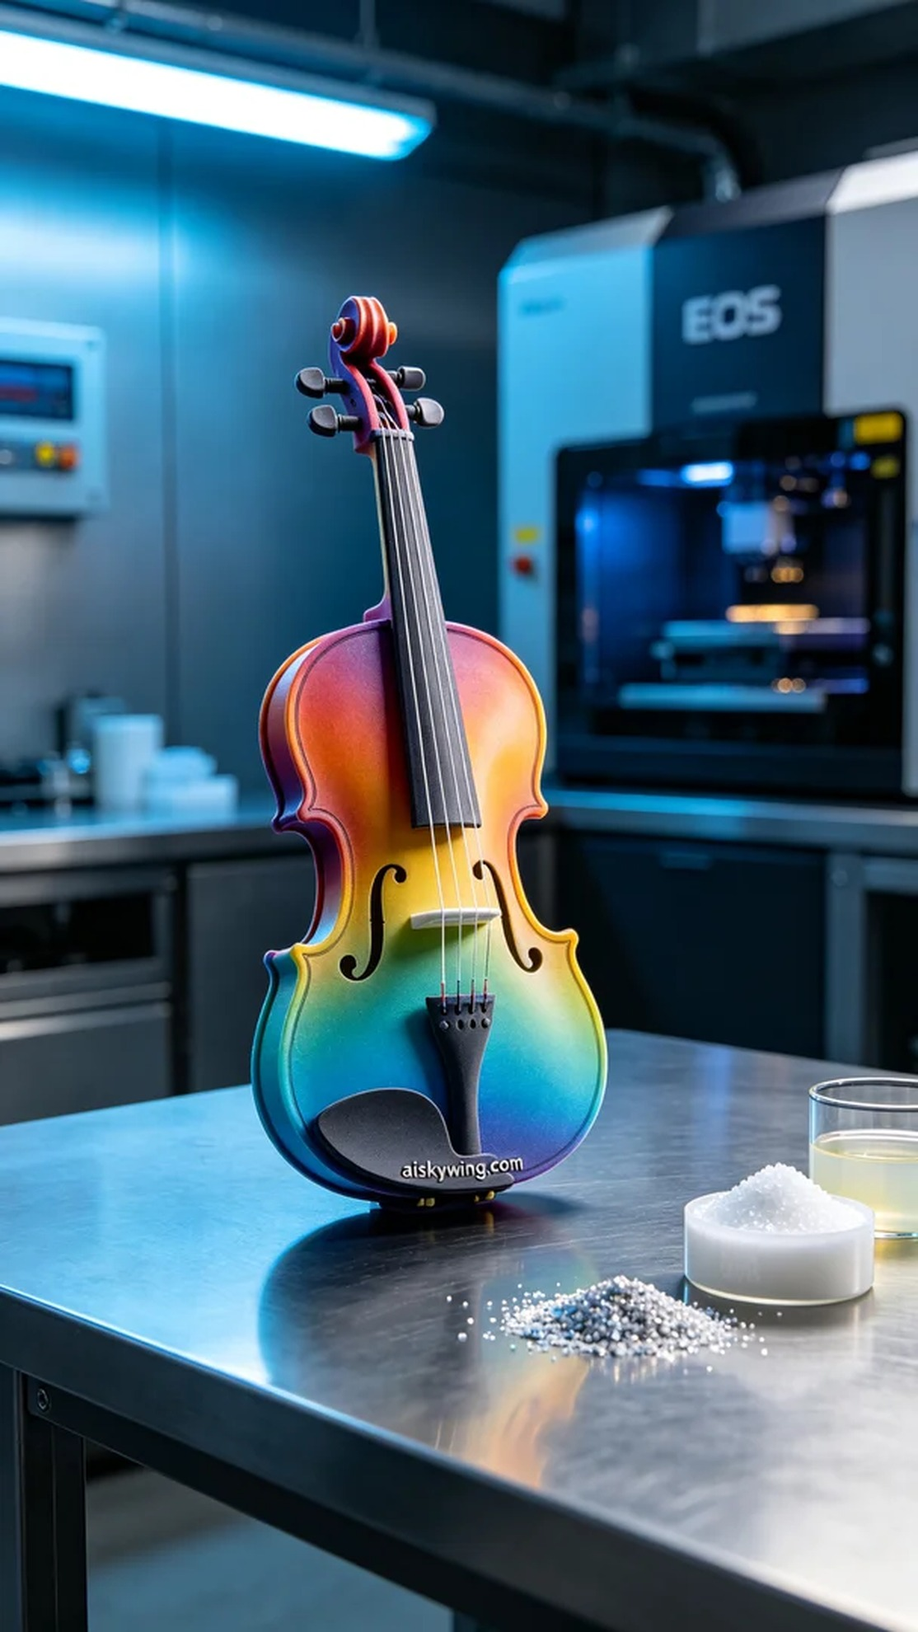
Recently, someone reached out to us via Facebook, seeking to create a full-color 3D printed violin model. They wanted this violin to not only have rich colors but also to show incredible detail, making it a captivating centerpiece for artistic displays.
We chose unformed liquid photopolymer resin as our primary material, which is ideal for high-precision printing and can showcase delicate color gradients. For the equipment, we used EOS 3D printers, setting appropriate printing parameters: a layer thickness of 0.1mm, printer temperature at 25 degrees Celsius, power at 100mW, a print speed of 30mm/s, and an estimated print time of about 18 hours.
During the printing process, the EOS printer operated smoothly, maintaining ideal temperature and humidity levels inside the device. We continuously monitored the printing status to ensure that each layer met expectations. As the printing progressed, the contours of the violin became increasingly defined, and the color gradients vividly came to life, building anticipation.
After the printing was complete, we conducted a systematic post-processing routine. First, the violin model was placed in a cleaning tank for ultrasonic cleaning to remove any excess resin. Next, we performed sanding to ensure the surface was smooth. We then carried out a curing process to guarantee the model's strength and durability. Lastly, a rigorous quality inspection was performed to ensure that every detail was flawless.
After these series of processes, our full-color 3D printed violin model was finally completed, dazzling and seemingly waiting for the next note to be born.
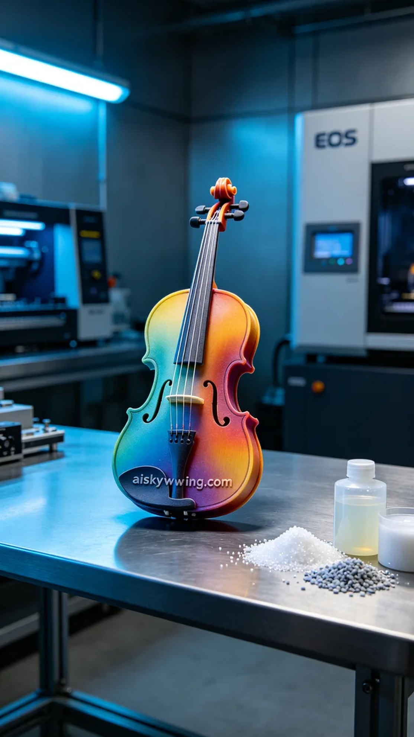
最近，有人通过Facebook联系到我们，想要制作一个全彩3D打印小提琴模型。对方希望这款小提琴不仅要色彩丰富，而且要在细节上表现得更加逼真，以便在艺术展示中吸引眼球。
我们选择了未成型的液态光敏树脂作为主要原材料，这种材料适合高精度打印，能够展示出细腻的颜色渐变。设备方面，我们使用了EOS品牌的3D打印机，设置了合适的打印参数：层厚为0.1mm，打印温度保持在25摄氏度，功率为100mW，打印速度设为30mm/s，预计打印时间约为18小时。
在打印过程中，EOS打印机平稳运行，设备内部的温度和湿度保持在理想范围。我们随时监控打印状态，确保每一层的效果都符合预期。随着打印的进行，小提琴的轮廓逐渐清晰，色彩的渐变也愈加生动，令人倍感期待。
完成打印后，我们进行了系统的后处理。首先，将小提琴模型放入清洗槽中，用超声波清洗去除多余的树脂。随后，我们进行了打磨处理，以确保表面光滑。接着，进行了固化工序，确保模型的强度和耐用性。最后，对成品进行了严格的质量检验，确认每个细节都无可挑剔。
经过这一系列的工序，我们的全彩3D打印小提琴模型终于完成，璀璨夺目，仿佛在等待下一个音符的诞生。
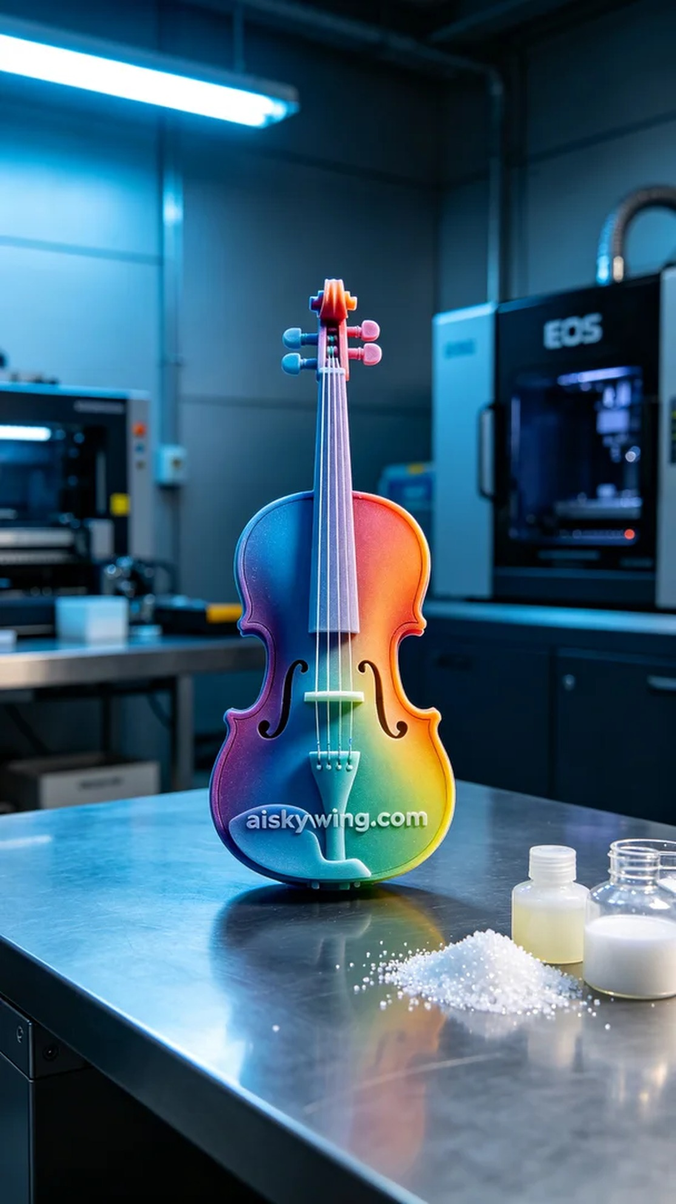
Aiskywing Industrial 3D Printing
Full-color 3D printed violin model


