0467-全彩3D打印彩虹模型生产记录
Full-color 3D printed rainbow model
🖨️ 全彩3DP
🖥️ 打印机: Carbon
📦 材料: 全彩3DP彩色树脂
生活再难，也别停下脚步。就像接下这个全彩3D打印彩虹模型的单子，挑战总是与机遇并存。
No matter how tough life gets, don’t stop moving forward. Just like taking on this order for a full-color 3D printed rainbow model, challenges always coexist with opportunities.
________________________________________________________________________________
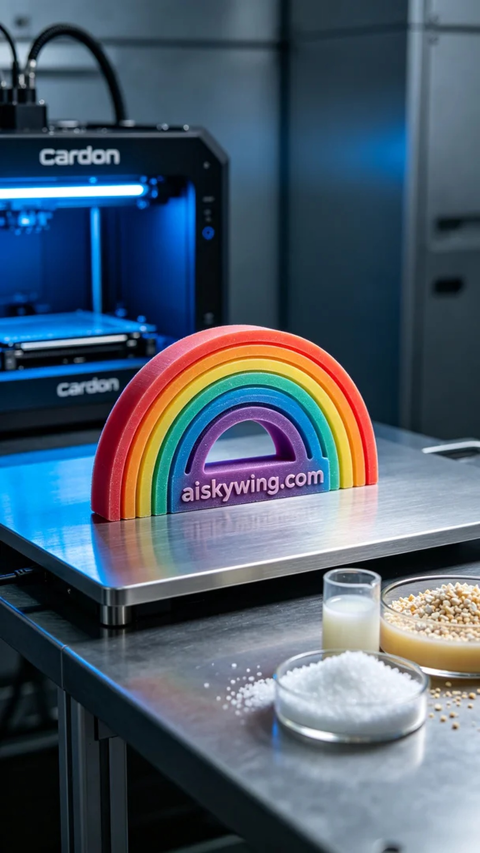
Recently, someone contacted me via WhatsApp to inquire about producing a full-color 3D printed rainbow model. They desired a piece that showcased vibrant colors and impeccable detail, making it a striking display item.
To achieve this goal, we chose full-color 3DP resin for the material. This resin offers saturated colors and a soft luster, allowing for an exquisite visual effect post-printing. We used a Carbon brand 3D printer, setting the layer thickness to 0.1 mm, maintaining the printing temperature at 25 degrees Celsius, adjusting power to 50%, and setting the printing speed to 80 mm/s, with an estimated print time of 6 hours.
As the printing process commenced, I closely monitored the machine’s operation, ensuring every detail was captured perfectly. As the printer gradually worked through each layer, the rainbow model's colors started to emerge, bringing a sense of excitement and achievement. The machine operated steadily, and quality monitoring indicated that the print was progressing well with no issues.
Once the printing was complete, we moved into the post-processing stage. First, I cleaned the model with a specialized cleaning solution to remove any residual resin from the surface. Then, I carefully sanded the surface to ensure each detail was smooth and flawless. Finally, the model was placed in a curing device to ensure it hardened thoroughly under UV light. After inspection, the final model not only boasted vibrant colors but also displayed exceptional detail.
Overall, the production of this full-color 3D printed rainbow model not only challenged my technical skills but also showcased the limitless possibilities of 3D printing.
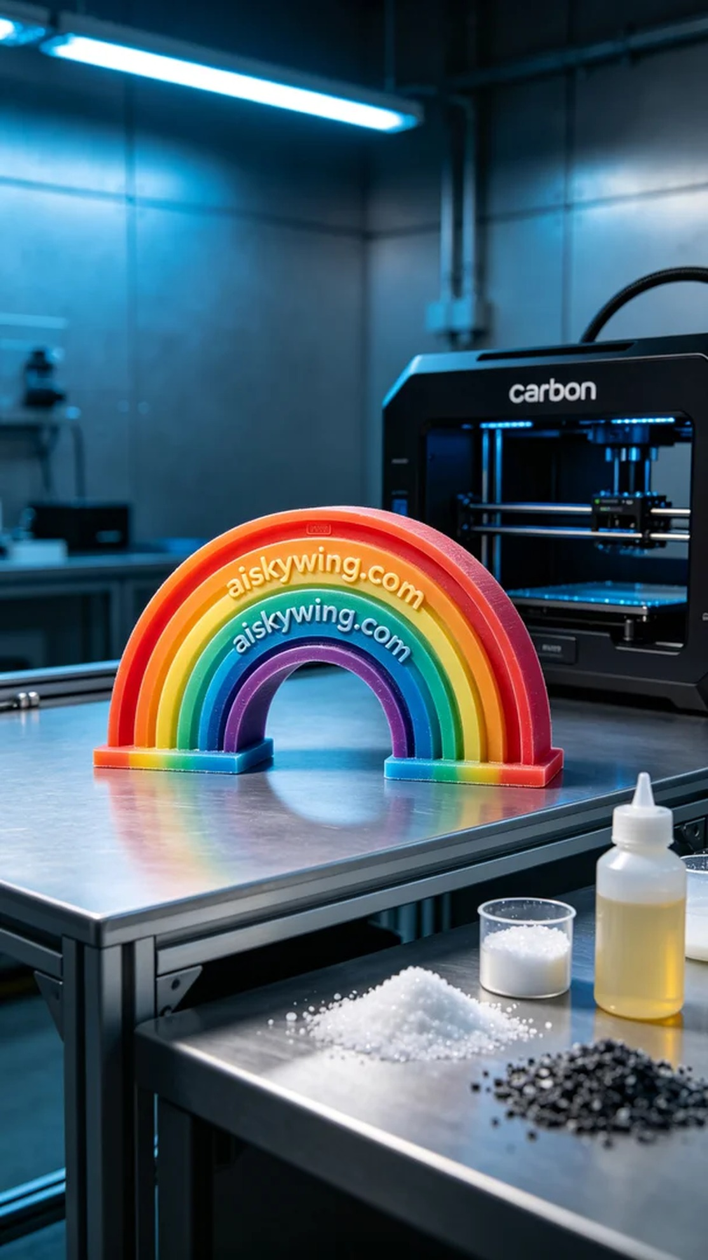
最近，有人通过WhatsApp联系我，询问全彩3D打印彩虹模型的制作事宜。他们希望这个模型不仅呈现出丰富的色彩，还要在细节上达到完美，成为一个引人注目的展示品。
为了实现这个目标，我们选择了全彩3DP彩色树脂作为原材料。这种树脂的色彩饱和，光泽柔和，能够在打印后呈现出极致的视觉效果。我们使用Carbon品牌的3D打印机，设定层厚为0.1毫米，打印温度保持在25度，功率调整为50%，打印速度设置为80毫米/秒，预计打印时间为6小时。
打印过程开始时，我认真监控设备的运行状态，确保每一个细节都能被完美捕捉。随着打印机的逐渐运作，彩虹模型的每一层色彩逐步显现，带来一种令人振奋的成就感。机器稳定运作，质量监控也显示出打印质量良好，没有出现任何问题。
打印完成后，我们进入后处理阶段。首先进行清洗，用专用的清洗液将模型表面残留的树脂一一去除。接着，我仔细打磨了模型的表面，确保每个细节都光滑无瑕。最后，将模型放入固化设备中，使其能在光照下彻底硬化。经过检验，最终的模型不仅色彩丰富，还能展现出极致的细腻感。
总的来说，这个全彩3D打印彩虹模型的制作过程不仅挑战了我的技术水平，也让我看到了3D打印的无限可能性。
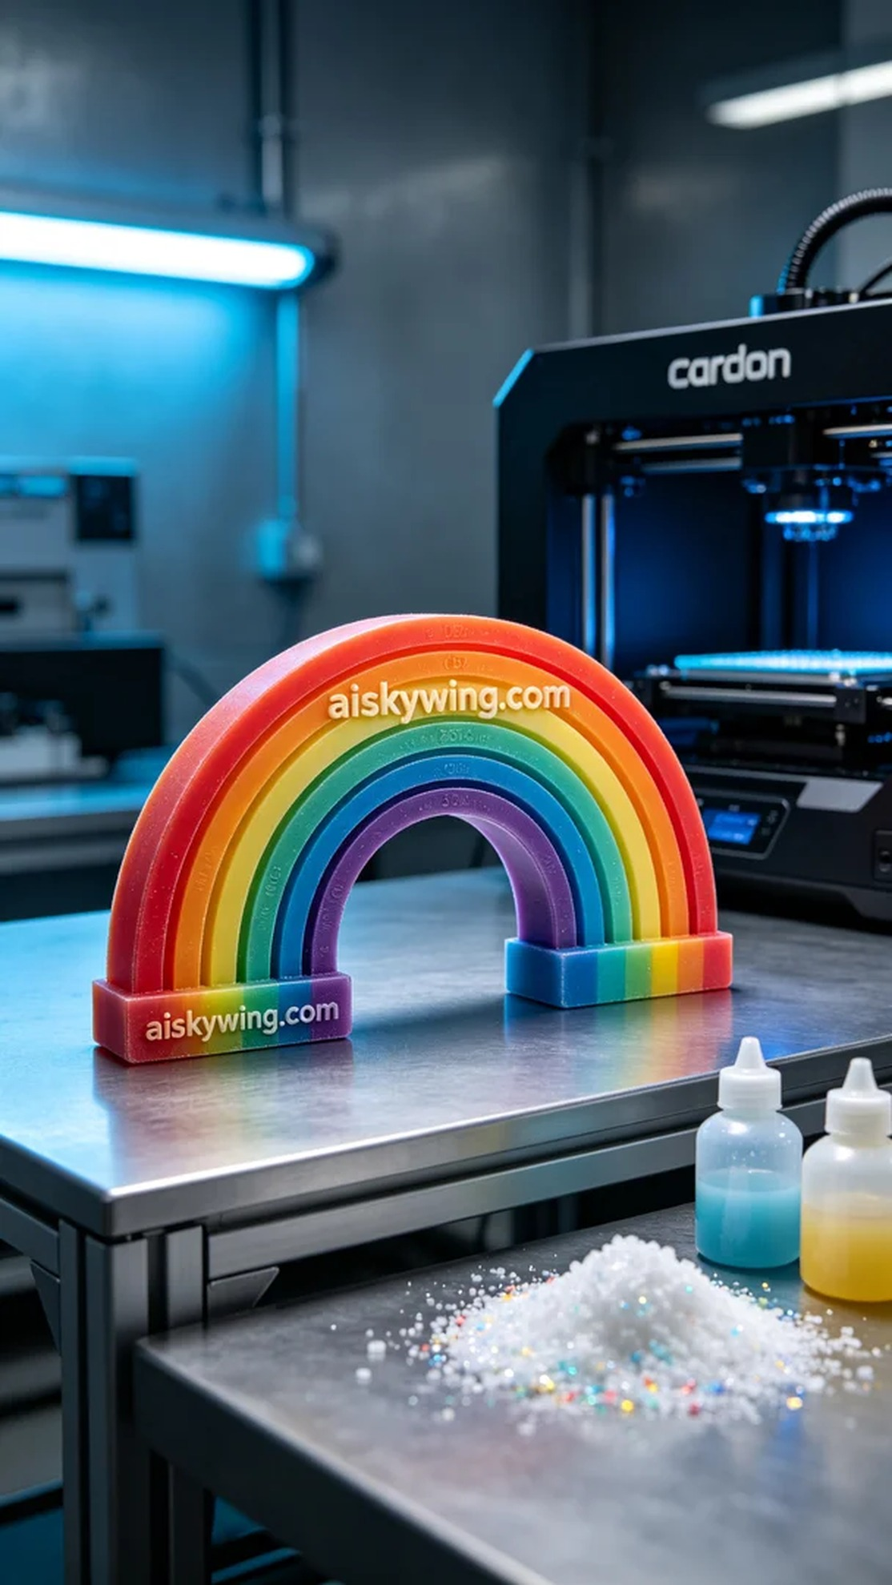
Aiskywing Industrial 3D Printing
Full-color 3D printed rainbow model


