0468-全彩3D打印悉尼歌剧院模型生产记录
Full-color 3D-printed Sydney Opera House model
🖨️ 全彩3DP
🖥️ 打印机: HP
📦 材料: 全彩3DP
有时候，生活的美丽就在于我们如何去创造。就像接下这个全彩3D打印悉尼歌剧院模型的单子，挑战与机遇总是并存。
Sometimes, the beauty of life lies in how we create it. Just like taking on the order for this full-color 3D printed model of the Sydney Opera House, challenges and opportunities always coexist.
________________________________________________________________________________
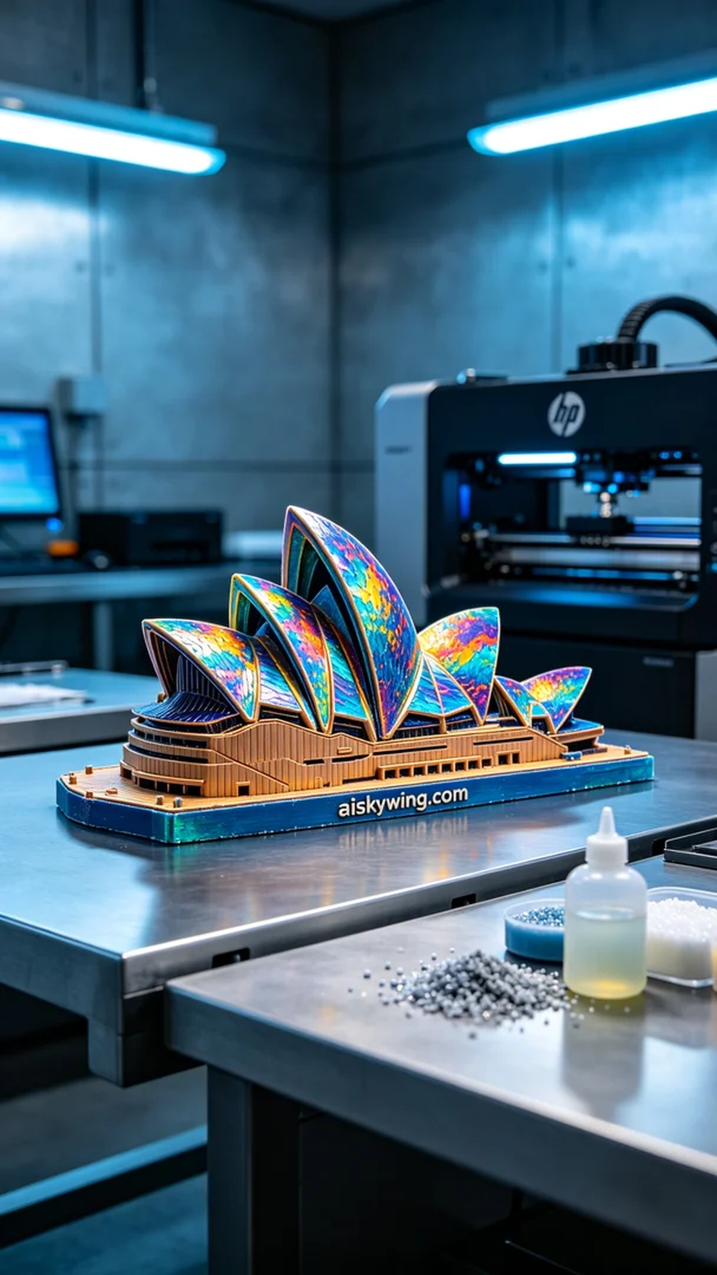
Sometimes, the beauty of life lies in how we create. Like taking on the task of printing a full-color 3D model of the Sydney Opera House, challenges and opportunities are always present.
To meet the demand, we chose full-color 3DP as our printing material. This material not only boasts rich colors but also displays intricate textures. We used an HP brand 3D printer, setting the printing parameters to a layer thickness of 0.1mm, a printing temperature of 60°C, a power of 150W, and a printing speed of 30mm/s with an estimated printing time of 12 hours to ensure every layer bonds perfectly.
During the printing process, the equipment ran steadily, maintaining an efficient pace throughout. We conducted real-time quality monitoring to ensure that the color gradients and detail representations matched expectations. Each time we saw the model's contours gradually emerge, our anticipation grew stronger.
Once printing was complete, we immediately entered the post-processing phase. First, we used a specialized cleaning solution to wash the model, removing any excess resin. Then, we sanded the surface to eliminate minor imperfections and enhance smoothness. Finally, the model was placed into a curing device to ensure its structural strength and color durability. After meticulous inspection, every detail of the model was satisfying, perfectly showcasing the elegance and uniqueness of the Sydney Opera House.
In the end, this full-color 3D printed Sydney Opera House model was successfully delivered, not only meeting their needs but also creating a beautiful creative journey. Such work fills me with gratitude and deepens my love for this technology.
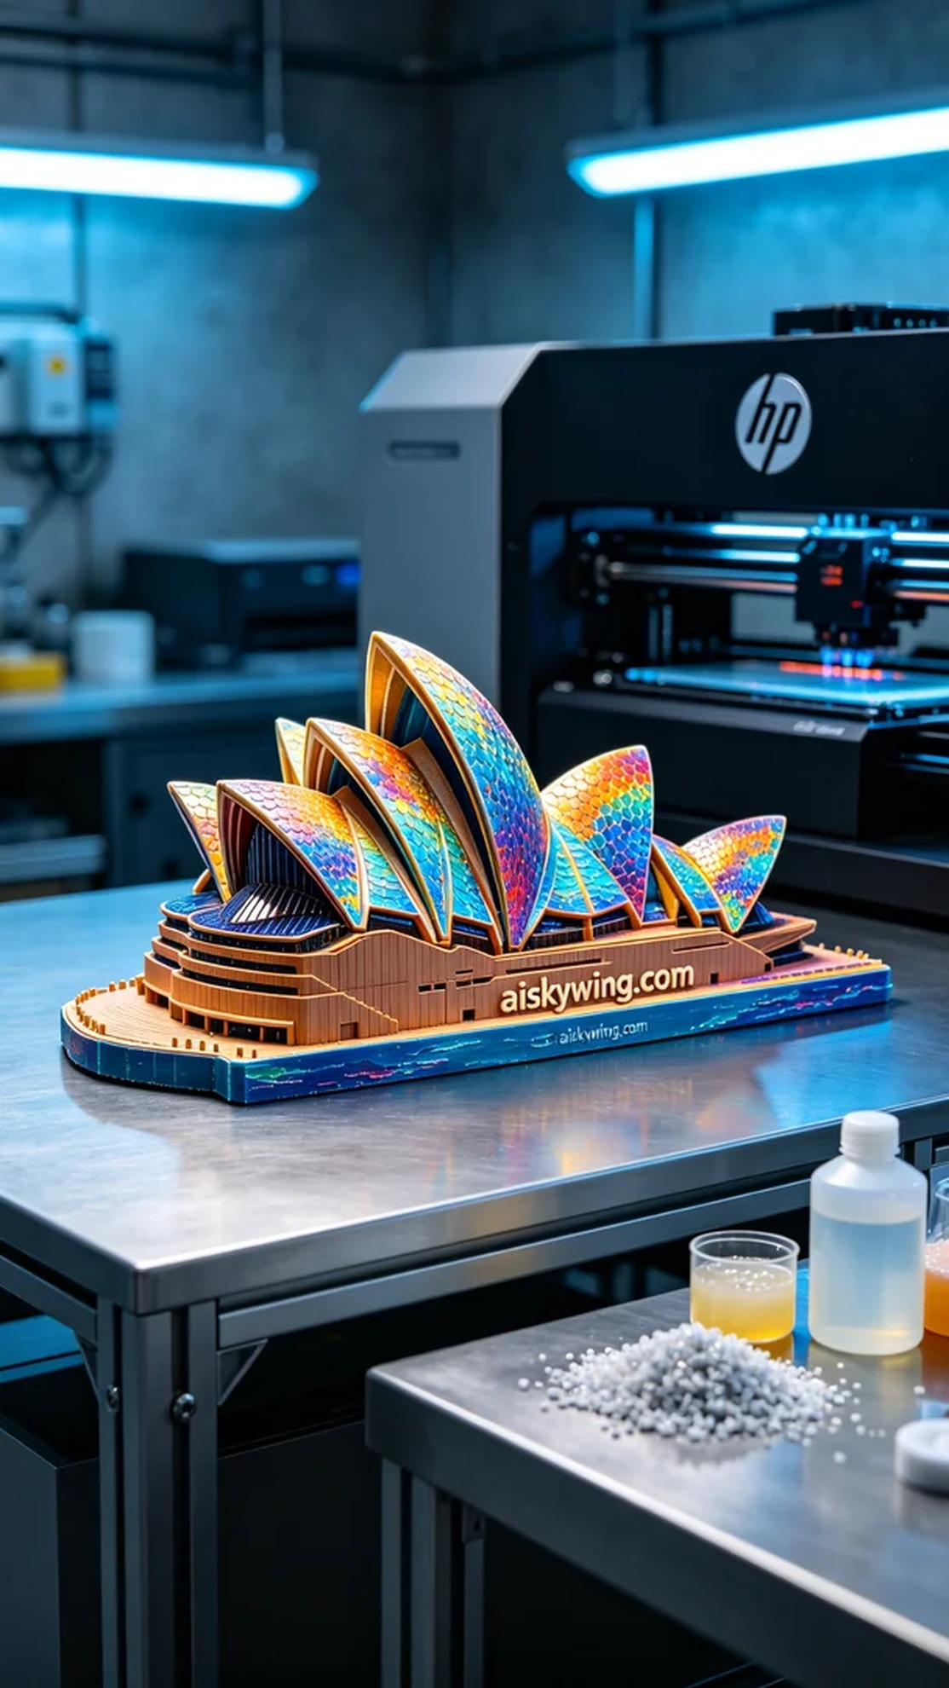
在一次Twitter交流中，有人提到希望制作一个全彩3D打印悉尼歌剧院模型，以作为展览用的艺术品。他们对模型的色彩和细节表现提出了很高的要求，希望能忠实还原悉尼歌剧院的独特魅力。
为了满足需求，我们选择了全彩3DP作为打印材料。这种材料不仅色彩丰富，还能展现细腻的纹理。使用的是HP品牌的3D打印机，打印参数设置为层厚0.1mm，打印温度设定为60℃，功率为150W，打印速度为30mm/s，预计打印时间为12小时，确保每一层都能完美结合。
在打印过程中，设备运行稳定，整个流程保持着高效的节奏。我们对打印质量进行了实时监控，确保色彩的渐变效果和细节的呈现都能达到预期。每当看到模型的轮廓逐渐显现，心中的期待感也越来越强烈。
完成打印后，随即进入后处理阶段。我们首先使用专用清洗液对模型进行清洗，去除多余的树脂。接着对模型表面进行打磨，以去除微小的瑕疵，并提升表面光滑度。最后，我们将模型放入固化设备中进行固化，确保其结构强度和色彩的持久性。经过细致的检验，模型的每一处细节都令人满意，完美展现了悉尼歌剧院的优雅与独特。
最终，这个全彩3D打印悉尼歌剧院模型成功交付，不仅满足了他们的需求，也成就了一段美好的创作旅程。这样的工作，让人倍感欣慰，也让我更加热爱这项技术。
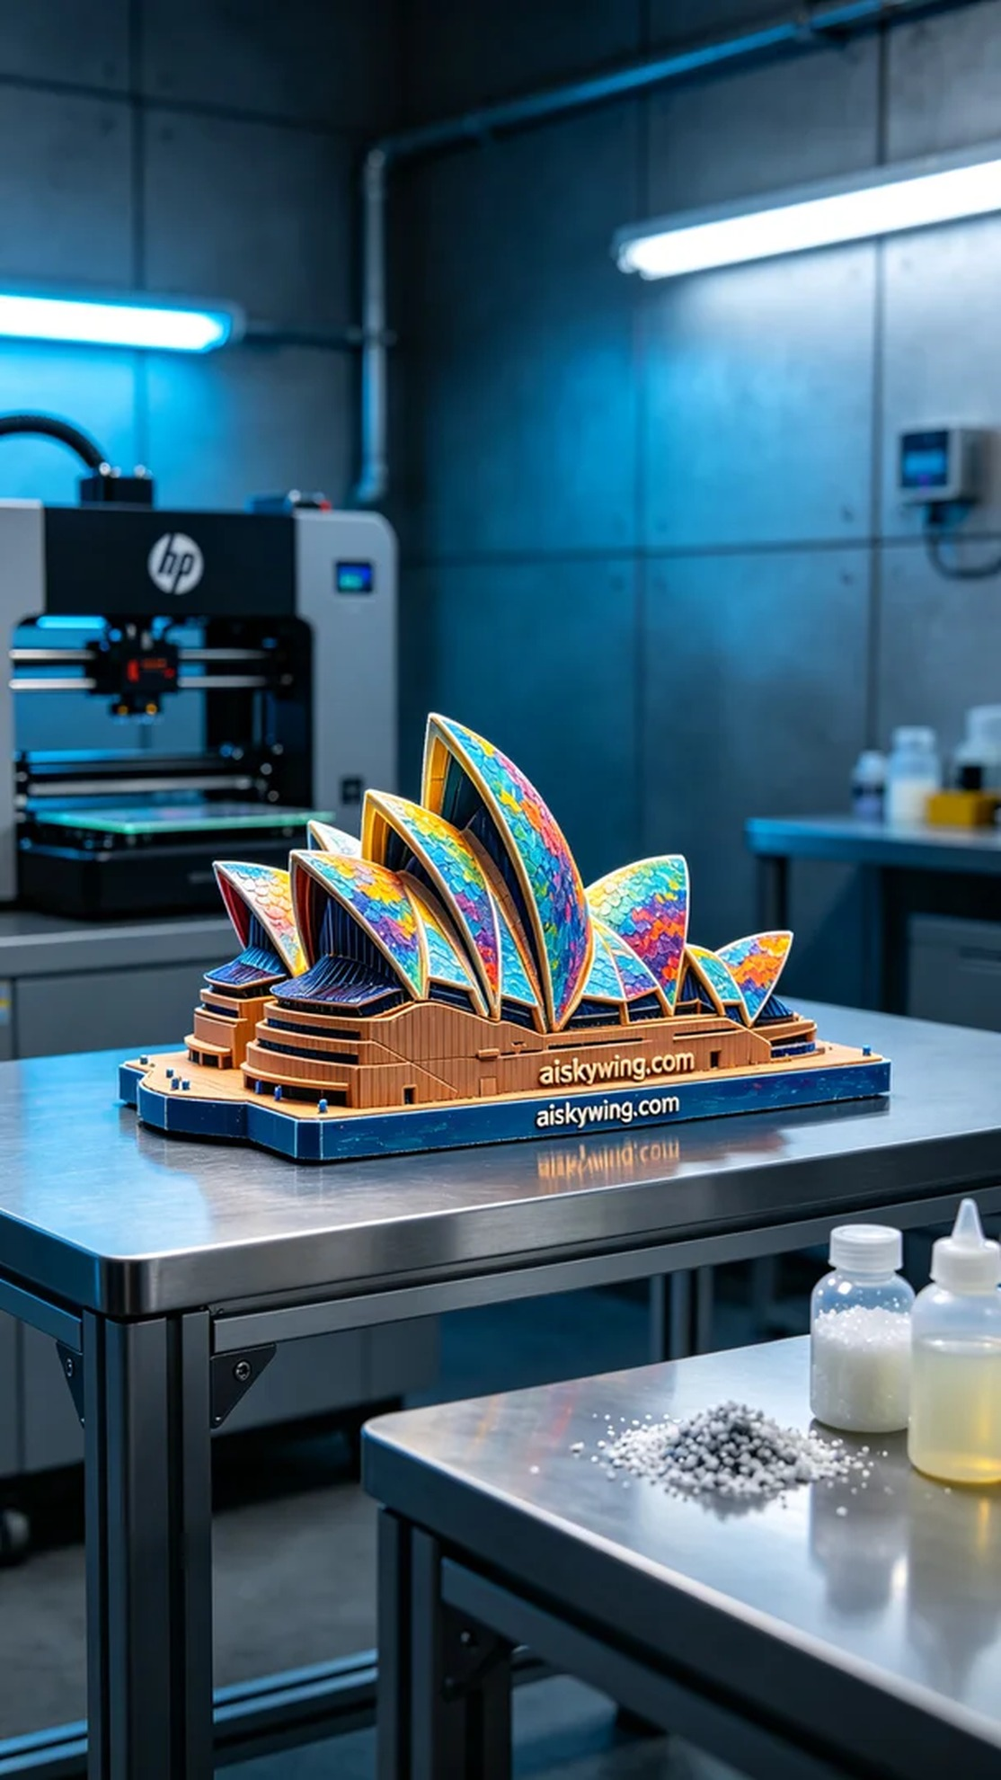
Aiskywing Industrial 3D Printing
Full-color 3D-printed Sydney Opera House model


