0469-全彩3D打印教堂模型制作记录
Full-color 3D printed church model
🖨️ 全彩3DP
🖥️ 打印机: Mimaki
📦 材料: 摆放着未成型的液态光敏
生活就像一场创造的旅程，有时候我们需要用心去雕刻每一个细节。就像今天的全彩3D打印教堂模型，正是为了解决有人对复杂模型制作品质的追求。
Life is like a journey of creation, and sometimes we need to carefully sculpt every detail. Just like today's full-color 3D printed church model, which is designed to address the pursuit of quality in the production of complex models.
________________________________________________________________________________
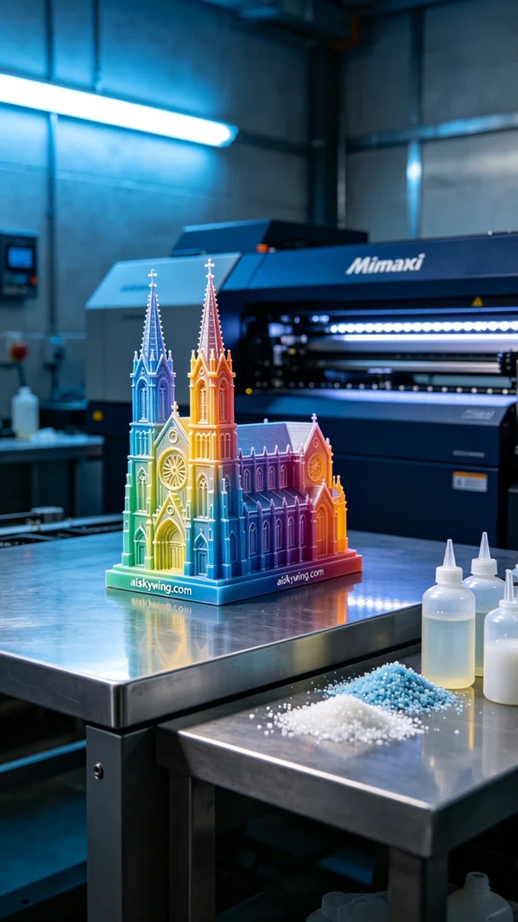
Recently, someone reached out to us through Facebook, inquiring about the production of a colorful 3D printing church model. They hoped the model could showcase the intricacies and complexities of art, focusing particularly on the vibrancy of colors and the level of detail.
To ensure success, we chose to use liquid photopolymer resin as the raw material. This type of material can present rich color layers once cured under light, enhancing the detail representation of the model. We set the Mimaki printer to a layer thickness of 0.1mm, a printing temperature of 25 degrees Celsius, a power setting of 80%, and a speed of 40mm per second, with the entire printing process expected to take around 8 hours.
During the printing process, the Mimaki printer operated smoothly, and we closely monitored the printing quality in real-time. The liquid photopolymer resin was cured layer by layer as it was sprayed from the print head, creating delicate color gradients and precise details. Throughout this process, we maintained a close watch on the equipment's operational status to ensure no printing accidents occurred, thus guaranteeing a high-quality output for the model.
Once printing was complete, we proceeded with the post-processing steps. We first cleaned the model to remove any residual resin on the surface. Next, we used fine sandpaper to smooth out the surface, followed by placing the model in a UV curing device to ensure that all details received adequate light exposure. Finally, we conducted a thorough quality inspection to ensure that every part of the model met the expected standards.
After a series of efforts, we successfully completed the production of this colorful 3D printing church model, displaying vivid colors and intricate craftsmanship. This achievement was not only a challenge to our technical skills but also a perfect presentation of artistry.
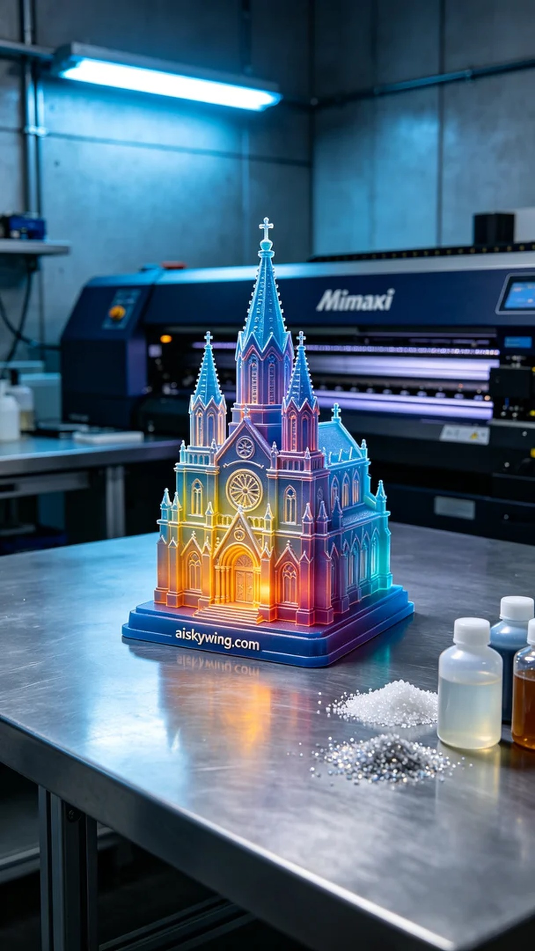
近日，有人通过Facebook联系到我们，询问能否制作一款全彩3D打印教堂模型。他们希望这款模型能充分展现出艺术的细腻与复杂性，特别是在颜色和细节上的表现。
为确保成功，我们选择了未成型的液态光敏树脂作为原材料。这种材料在光照下固化后能够呈现出丰富的色彩层次，提高模型的细节表现。我们使用的Mimaki打印机设置了每层0.1毫米的厚度，打印温度控制在25摄氏度，功率设置为80%，速度设置为40毫米每秒，整个打印过程预计需要8个小时。
在打印过程中，Mimaki打印机顺利运行，我们对打印质量进行了实时监控。液态光敏树脂在打印头的喷射下，逐层固化，创造出细腻的色彩渐变和精确的细节。这一过程中密切观察设备的运行状态，确保没有出现任何打印事故，从而保证了模型的高质量输出。
完成打印后，我们进行了后处理工序。首先对模型进行清洗，以去除表面残留的树脂。接着，使用细砂纸进行打磨，以确保表面光滑。然后将模型放置在紫外线固化设备中进行固化，确保灯光能够全面照射到每一处细节，之后进行了最终的质量检验，确保模型的每一部分都达到预期的效果。
经过一系列的努力，最终我们顺利完成了这款全彩3D打印教堂模型的制作，展现了生动的色彩和细腻的工艺。这样的成果不仅是对技术的挑战，更是对艺术的一次完美呈现。
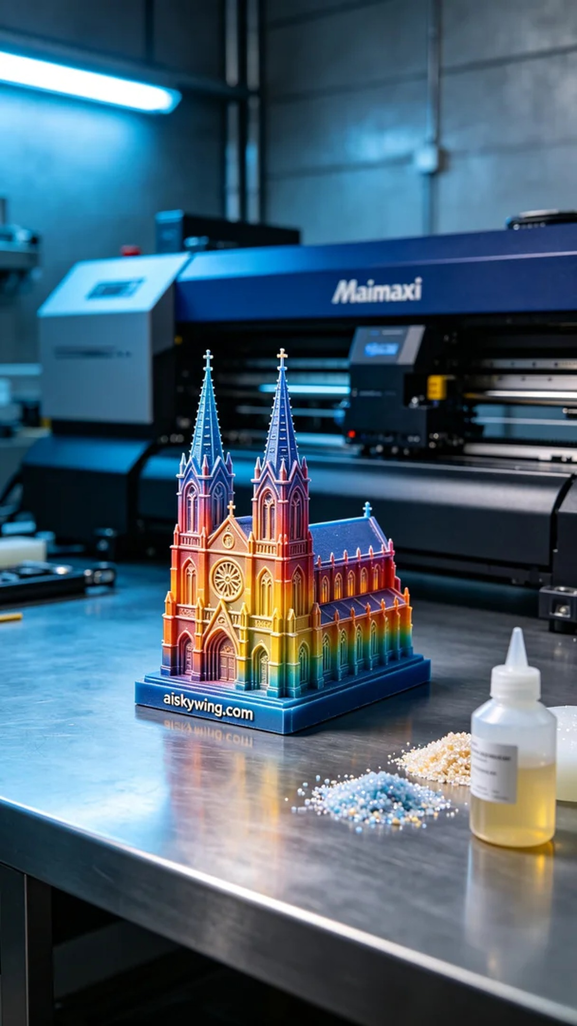
Aiskywing Industrial 3D Printing
Full-color 3D printed church model


