0471-全彩3D打印月亮模型的生产记录
Full-color 3D printed moon model
🖨️ 全彩3DP
🖥️ 打印机: Xjet
📦 材料: 摆放着未成型的液态光敏
生活中有许多美好的瞬间值得被定格，就像这个全彩3D打印月亮模型在LinkedIn上的引起关注，让人们盯住了每个细节。
There are many beautiful moments in life that are worth capturing, just like this full-color 3D printed moon model that has garnered attention on LinkedIn, drawing people's focus to every detail.
________________________________________________________________________________
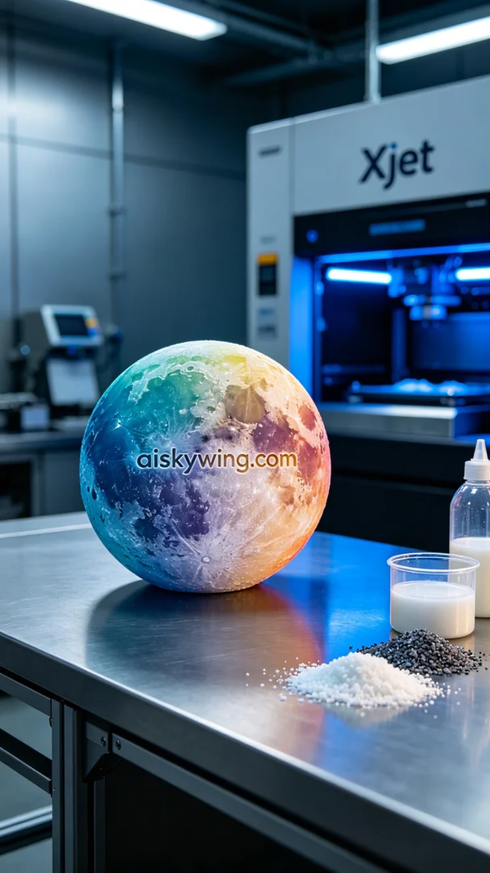
Recently, someone reached out to us seeking help in creating a full-color 3D printed moon model. This model needed to showcase rich color gradients and intricate details while standing out against an industrial backdrop. Thus, we began preparing our materials and equipment.
We selected unformed liquid photopolymer resin as our primary material, which possesses excellent flow and hardening properties, making it ideal for 3D printing. For equipment, we used the Xjet brand 3D printer, setting a layer thickness of 50 microns, a printing temperature of 25 degrees Celsius, a power level of 35 watts, and a print speed of 40 millimeters per second. The entire printing process was estimated to take about 8 hours.
During the printing process, the Xjet printer performed exceptionally well, with the liquid photopolymer resin distributing evenly across the build plate, gradually revealing intricate details. We closely monitored print quality to ensure that each color gradient met expectations, especially in terms of contrast and texture detail, striving to replicate the true surface of the moon.
Once the printing was completed, we moved on to the post-processing stage. First, we cleaned the model to remove any excess resin. Next, we sanded the surface with fine sandpaper to ensure a smooth finish. Finally, we cured the model under UV light to enhance its strength and durability. After a thorough inspection, we confirmed that every detail met our standards, and we were very pleased with the outcome.
Throughout this production process, we not only created a beautiful piece of art but also honed our professional skills and teamwork, ultimately presenting this full-color 3D printed moon model beautifully.
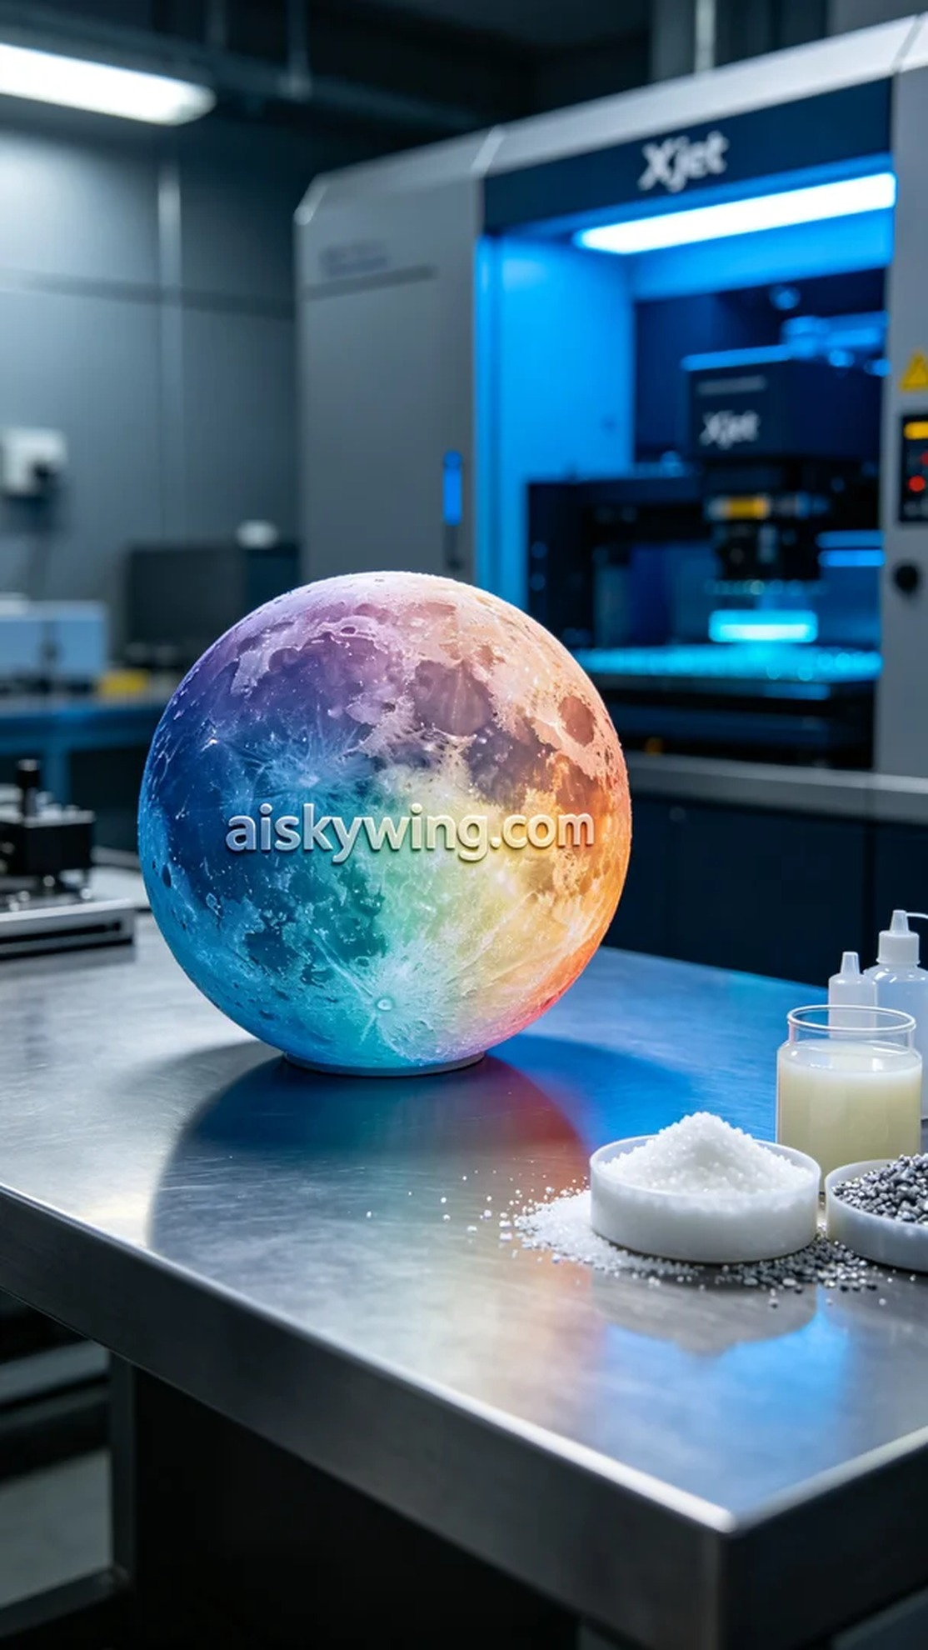
近日，有人联系到我们，寻求帮助制作一个全彩3D打印月亮模型。这个模型不仅需要具备丰富的颜色渐变和细节呈现，还要在工业风格的背景中淋漓尽致地展现出来。为了完成这项任务，我们开始准备材料和设备。
我们选用了未成型的液态光敏树脂作为主要原材料，这种材料具有优良的流动性和硬化特性，非常适合3D打印。在设备方面，我们使用了Xjet品牌的3D打印机，设定了层厚为50微米，打印温度保持在25摄氏度，功率为35瓦，打印速度设定为40毫米每秒，整个打印过程预估耗时约为8小时。
在打印过程中，Xjet打印机的性能表现十分稳定，液态光敏树脂在打印床上的分布均匀，细节逐渐显现。我们严格监控打印质量，确保每一个色彩的渐变都能达到预期，特别是在明暗对比和纹理细节上，致力于还原出真实的月亮表面。
完成打印后，我们进入后处理阶段。首先，我们对模型进行了清洗，去除多余的树脂。接着，我们用细砂纸进行打磨，确保模型表面光滑无瑕。最后，将模型放入紫外线灯下固化，以增强其强度和耐久性。经过严格检验，确保每一处细节都符合标准，成果让我们非常满意。
在这次生产过程中，我们不仅完成了一件美丽的艺术作品，也锻炼了自己的专业技能和团队协作能力，最终将这个全彩3D打印月亮模型完美呈现。
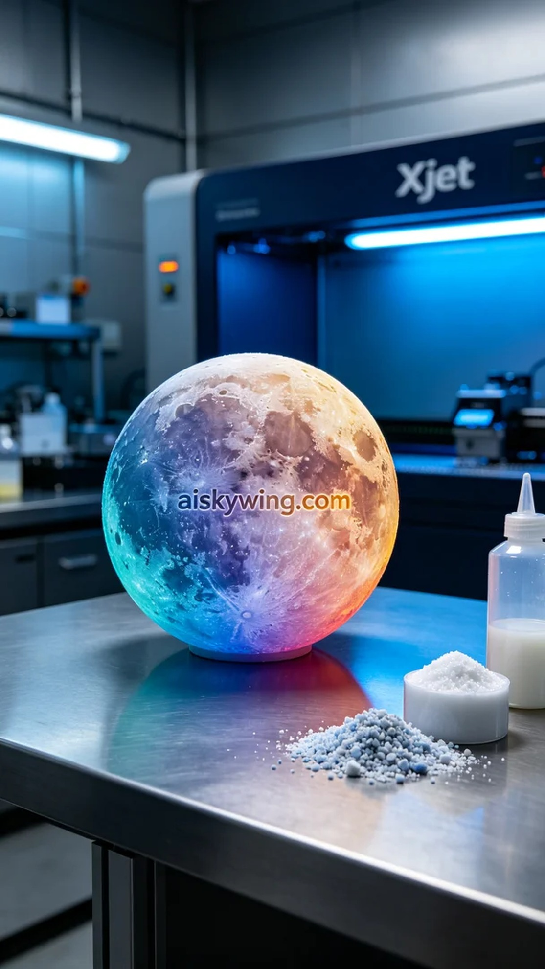
Aiskywing Industrial 3D Printing
Full-color 3D printed moon model


