0475-全彩3D打印汽车模型的生产记录
Full-color 3D printed car model
🖨️ 全彩3DP
🖥️ 打印机: Mimaki
📦 材料: 全彩3DP彩色树脂
生活再难，也别停下脚步。就像接下这个全彩3D打印汽车模型的单子，有人希望通过它展现创意和工艺。
No matter how difficult life gets, don't stop moving forward. Just like taking on this order for a full-color 3D printed car model, someone hopes to showcase creativity and craftsmanship through it.
________________________________________________________________________________
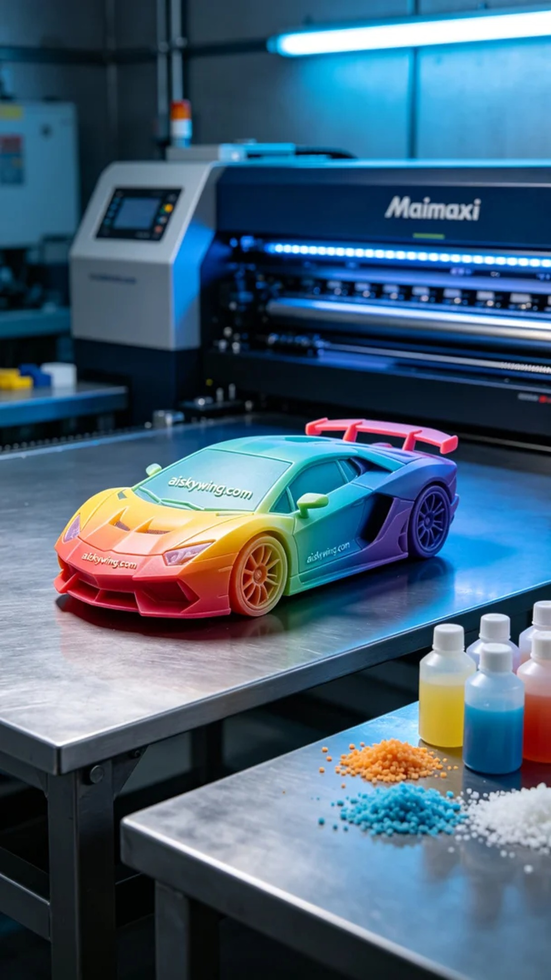
In a Facebook group, someone reached out to us seeking help to create a full-color 3D printed car model. They desired a vibrant and detail-rich model that could perfectly showcase every aspect of its design. This excited us, as it's right in our wheelhouse.
We began by preparing the full-color 3DP resin, ensuring the material's freshness and integrity. The main device we used was the Mimaki printer, and we set the layer thickness to 0.1mm, maintaining a printing temperature of 25 degrees Celsius, while adjusting the power to 80% and speed to 60mm per second. Given the complexity of the model, the overall printing time was estimated to be around 10 hours.
During the printing process, the Mimaki printer operated efficiently while keeping the temperature and humidity under close observation to ensure print quality. We meticulously watched each layer being printed and adjusted the nozzle and resin flow as needed to ensure vibrant color gradients and precise detail presentation. After several hours of work, we finally saw the model taking shape, filling us with anticipation.
Once printing was complete, we moved to the post-processing stage. First, we soaked the model in a cleaning solution to remove excess resin. Then, we carefully sanded it to make the surface smoother. Next, we cured the model to enhance its sturdiness and stability, followed by a final inspection to ensure every detail was flawless.
In the end, the full-color 3D printed car model presented itself beautifully, with vibrant colors and vivid details, showcasing our passion and dedication to the craft. This outcome not only validated our work but also represented a zest for life itself.
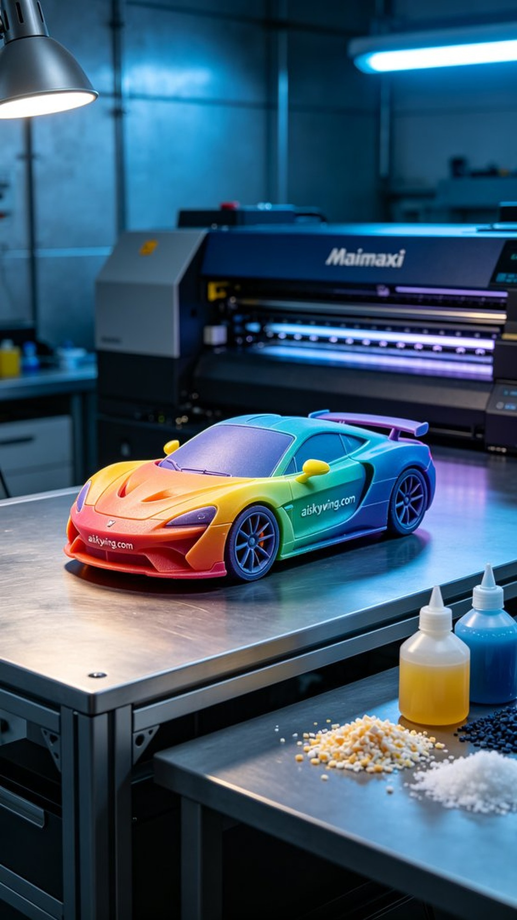
在某个Facebook群组中，有人寻求我们帮助，想要制作一款全彩3D打印汽车模型。这个模型需要色彩鲜艳、细节丰富，能够完美展示其设计的每一处细节。这让我们感到兴奋，因为这是我们擅长的领域。
我们首先准备了全彩3DP彩色树脂，确保材料的新鲜度和完整性。使用的Mimaki打印机是我们的主力设备，打印时设定层厚为0.1毫米，打印温度保持在25摄氏度，功率设定在80%，速度调整为60毫米每秒。根据模型的复杂度，整体打印时间预计在10个小时左右。
打印过程中，Mimaki打印机高效地运作，设备的温度和湿度都在监控范围之内，以确保打印质量。我们仔细观察每一层的打印，及时调整喷头和树脂的流量，确保色彩的渐变和细节的精准展现。经过几个小时的努力，终于看到模型逐渐成形，心中充满期待。
一旦打印完成，后处理环节便开始了。首先，我们将模型浸泡在清洗液中，确保去除多余的树脂。然后，经过细致的打磨，让表面更加光滑。接着，将模型进行固化处理，以增强其坚固性和稳定性，最后进行检验，确保每一个细节都完美无瑕。
最终，这个全彩3D打印汽车模型令人满意地呈现在眼前，色彩饱满且细节生动，展现出我们对工艺的热爱和追求。这样的成果，不仅是对工作的认可，更是一种对生活的热情。
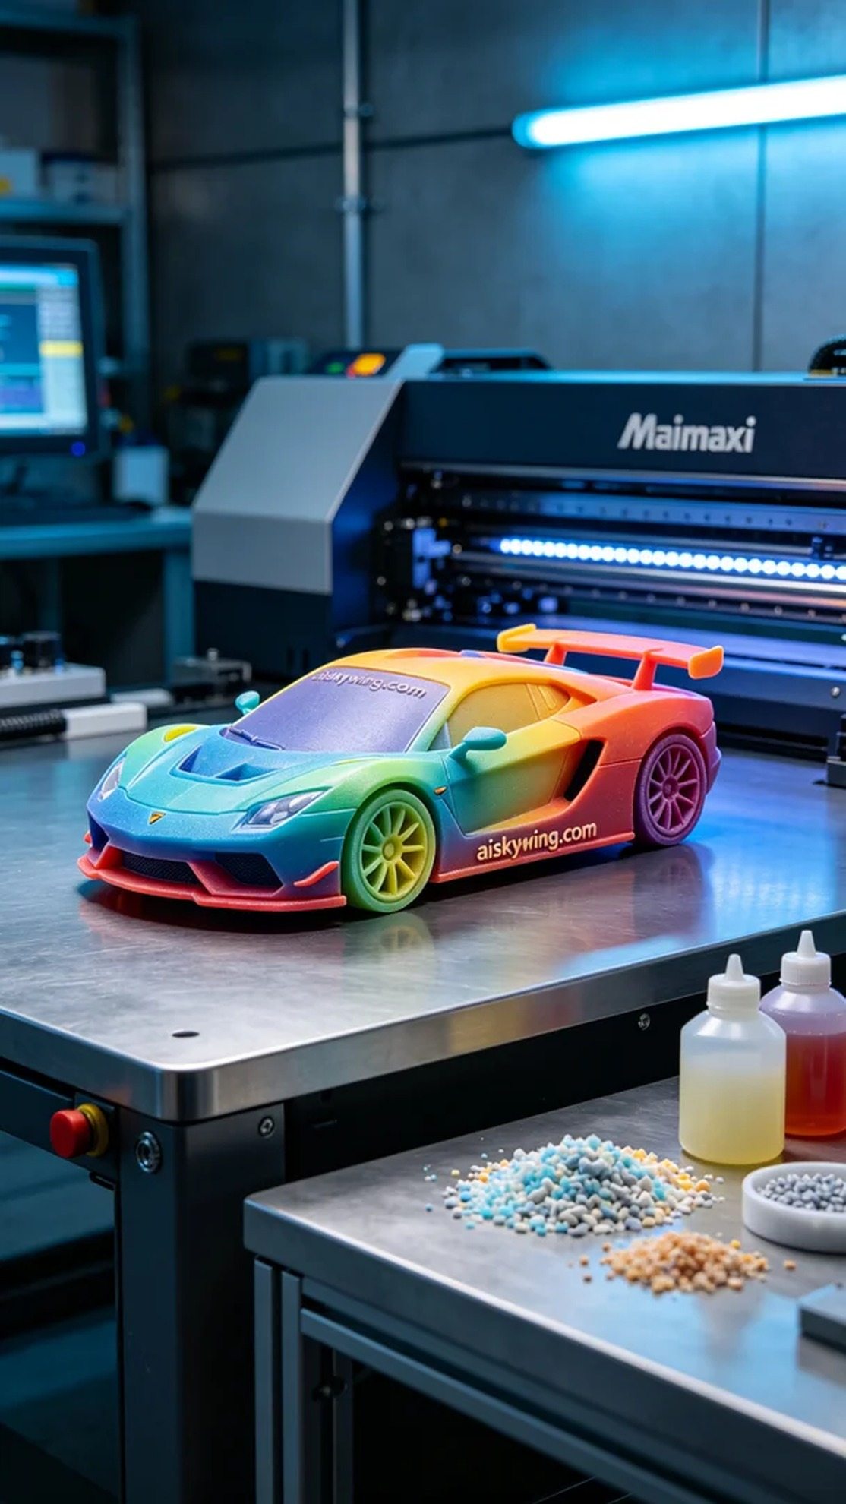
Aiskywing Industrial 3D Printing
Full-color 3D printed car model


