0479-全彩3D打印火箭模型生产记录
Full-color 3D printed rocket model
🖨️ 全彩3DP
🖥️ 打印机: Stratasys
📦 材料: 全彩3DP彩色打印
生活就像一场航行，虽然风浪不断，但我们始终要勇往直前。就像接下这个全彩3D打印火箭模型的单子一样，充满挑战与期待。
Life is like a voyage; although there are constant winds and waves, we must always forge ahead. It's just like taking on the order for this full-color 3D-printed rocket model, filled with challenges and anticipation.
________________________________________________________________________________
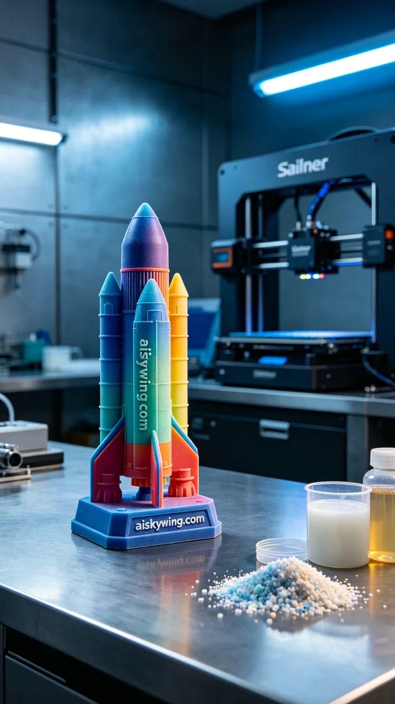
Life is like a voyage; despite the constant storms, we must sail ahead. Taking on this full-color 3D printed rocket model order is filled with challenges and anticipation.
From LinkedIn, someone approached us seeking to create a high-fidelity rocket model. They desired that the full-color 3D printed rocket model not only be visually stunning but also showcase depth and gradient in its colors.
The material we used is full-color 3DP printing material, known for its rich colors and excellent performance. To achieve the best printing results, we selected a Stratasys 3D printer for this task. In terms of printing parameters, we set the layer thickness to 0.1 mm, maintained a printing temperature of 60 degrees Celsius, set the printing speed at 50 mm per hour, and estimated an overall print time of about 12 hours to ensure every detail was perfectly rendered.
During the printing process, the Stratasys printer operated smoothly, with the print head gliding lightly across the surface of the model, gradually revealing the gradient layers of color. We continuously monitored the device's operation to ensure there were no clogs or material wastage; quality control was paramount in our work.
After printing was completed, we undertook a thorough post-processing routine for the model. First, we cleaned the surface with a cleaning solution to remove excess resin. Next, we sanded the model using fine sandpaper to ensure a smooth, flawless surface. It was then placed into the curing device for further hardening, enhancing its durability, followed by a strict quality inspection to ensure it met our expectations.
After a series of processes, this full-color 3D printed rocket model showcased astonishing results, with rich colors and clear details, perfectly reflecting our technical prowess and craftsmanship. We look forward to the next challenge!
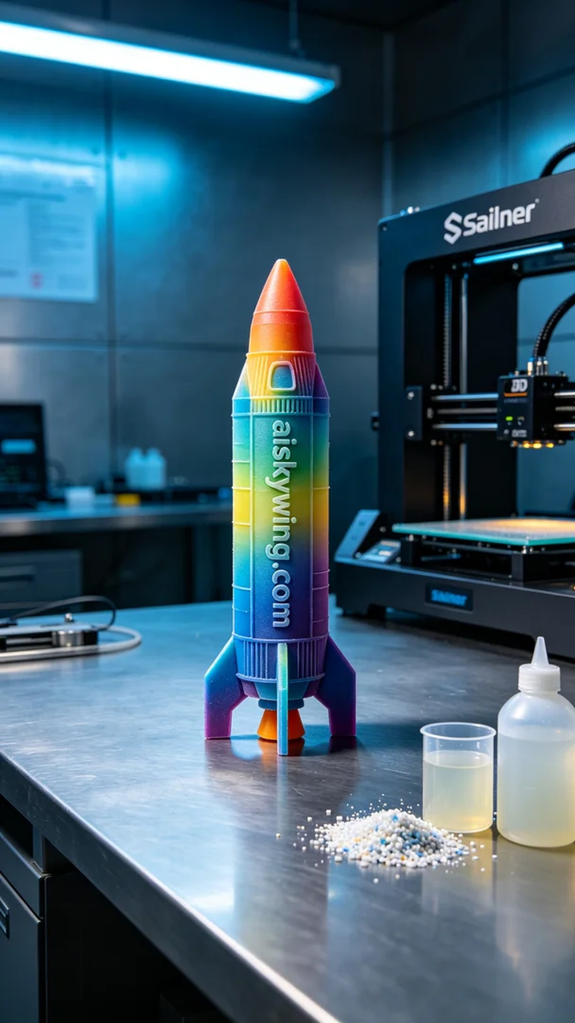
从LinkedIn上，有人因为希望制作一个高保真的火箭模型而找到了我们。他们希望这个全彩3D打印火箭模型不仅外观精美，细节丰富，更能展示出色彩的层次感和渐变效果。
我们使用的原材料是全彩3DP彩色打印材料，拥有丰富的色彩和优良的表现力。为了得到更好的打印效果，选择了Stratasys的3D打印机进行制作。打印参数方面，我们设定了层厚为0.1毫米，打印温度维持在60摄氏度，打印速度为每小时50毫米，整体打印时间大约为12小时，以确保每个细节都能完美展现。
在打印过程中，Stratasys打印机运转平稳，打印头在工件表面轻盈移动，色彩之间的渐变层次逐渐显现。我们时刻监控设备的运行状态，确保没有出现任何堵塞或材料浪费，质量控制是我们工作的重中之重。
打印完成后，我们对模型进行了详细的后处理。首先，使用清洗液对模型表面进行了彻底清洗，以去除多余的树脂。接下来，我们采用细砂纸进行打磨，确保表面光滑无瑕。随后，将模型放入固化设备中进行进一步的固化处理，以增强其耐用性，最后进行严格的质量检验，确保达到预期的效果。
经过一系列工序后，这个全彩3D打印火箭模型展现出了惊人的效果，色彩丰富，细节清晰，完美地传达出我们的技术实力与工匠精神。期待下一个挑战！
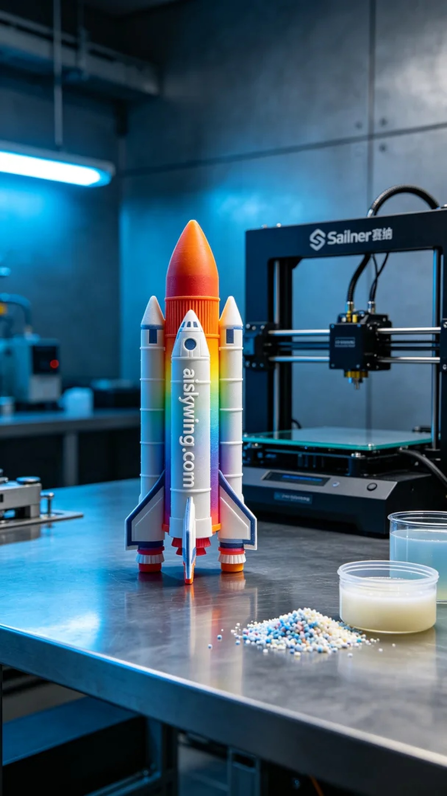
Aiskywing Industrial 3D Printing
Full-color 3D printed rocket model


