0482-全彩3D打印相框生产记录
Full-color 3D printed photo frame model
🖨️ 全彩3DP
🖥️ 打印机: Xjet
📦 材料: 全彩3DP彩色打印
生活再难，也别停下脚步。就像接下这个全彩3D打印相框模型的单子，有人希望用它记录美好瞬间。
No matter how difficult life gets, don't stop moving forward. Just like taking on this order for a full-color 3D printed photo frame model, someone hopes to use it to capture beautiful moments.
________________________________________________________________________________
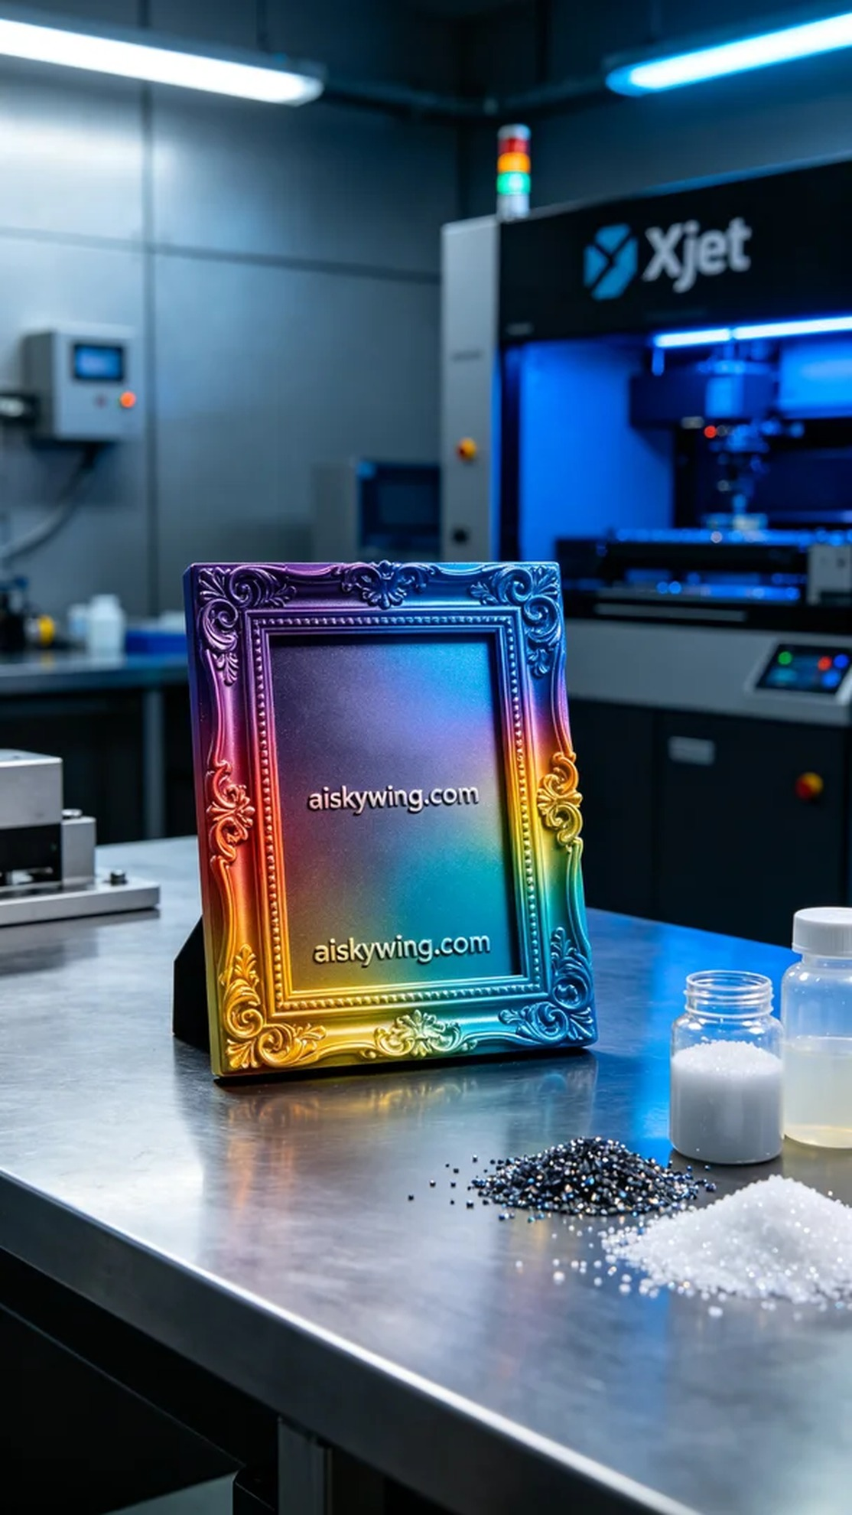
Recently, someone reached out to us via Facebook, seeking assistance in creating a full-color 3D printed frame model. They expressed a desire for the frame to vividly showcase colors and details, allowing them to better display beautiful moments captured in photos.
To meet this request, we prepared full-color 3DP printing materials to ensure the frame could exhibit a rich and lifelike color spectrum. During the printing process, we utilized an Xjet brand printer, setting appropriate printing parameters: a layer thickness of 0.1mm, a printing temperature of 25°C, a power setting of 80%, a printing speed of 40mm/s, and an estimated printing time of 6 hours.
The printing process proceeded smoothly, with the Xjet printer running steadily while we maintained quality monitoring. We periodically checked the printed model to ensure each layer was flawless, guaranteeing perfect color gradients and detail representation while avoiding any defects.
Post-processing is a critical step in ensuring model quality. We first placed the printed frame in the cleaning tank, using a specialized cleaning solution to remove any residual liquid photopolymer resin from the surface. Next, we meticulously sanded the frame to ensure every edge was smooth and flawless. Finally, we cured the frame in the curing device to ensure optimal strength and glossiness. After rigorous inspection, the final frame met our high standards.
Through this production, we not only completed the task of creating a full-color 3D printed frame model but also deepened our understanding and application of 3D printing technology. We look forward to the next project and continuing to create more beautiful moments.
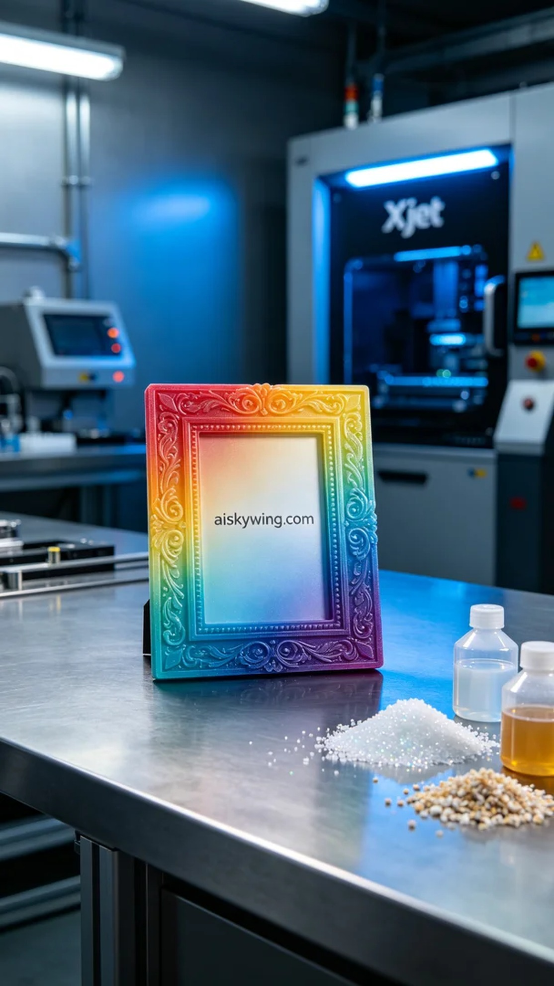
最近，有人通过Facebook联系到我们，寻求帮助制作一个全彩3D打印相框模型。他们提到希望这个相框能够展现丰富的色彩和细节，以便更好地展示照片中的美好瞬间。
为了满足这个需求，我们准备了全彩3DP彩色打印材料，确保相框的色彩可以呈现得更为丰富且逼真。打印过程中，我们使用了Xjet品牌打印机，设定了合理的打印参数：层厚0.1mm，打印温度25°C，功率设置为80%，打印速度为40mm/s，预计打印时间为6小时。
打印过程进行得相当顺利，Xjet打印机运行平稳，质量监控也保持在最佳状态。我们定时检查打印模型，确保每一层都完美无瑕，确保色彩渐变和细节的完美呈现，避免任何瑕疵的出现。
后处理工序是确保模型质量的关键一步。我们首先将打印好的相框放入清洗槽中，使用专用清洗液清除表面残留的液态光敏树脂。接下来，我们进行了细致的打磨，确保每个边角都光滑无瑕。最后，我们将相框放入固化设备中进行固化，确保其强度和光泽度达到最佳状态。经过严格检验，最终的相框符合我们的高标准。
通过此次的制作，我们不仅完成了全彩3D打印相框模型的任务，更加深了对3D打印技术的理解与应用。期待下一个项目的到来，让我们继续创造更多美好的瞬间。
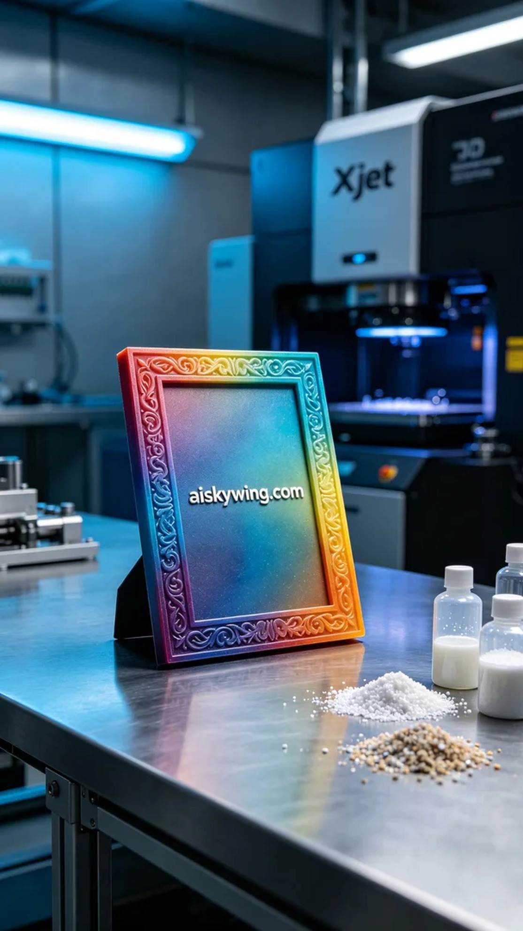
Aiskywing Industrial 3D Printing
Full-color 3D printed photo frame model


