0487-全彩3D打印耳机模型生产记录
Full-color 3D printed headphone model
🖨️ 全彩3DP
🖥️ 打印机: HP
📦 材料: 全彩3DP彩色打印
生活再难，也别停下脚步。就像接下这个全彩3D打印耳机模型的单子，总是要迎接挑战。
No matter how difficult life gets, don't stop moving forward. Just like taking on this full-color 3D printed headphone model project, we must always embrace challenges.
________________________________________________________________________________
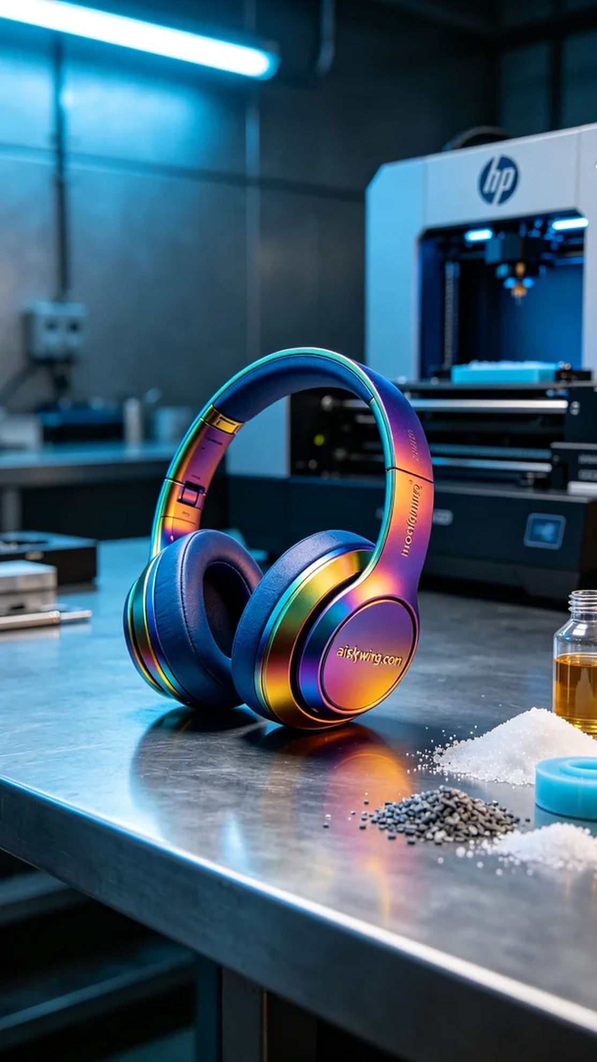
Recently, someone reached out to me via WhatsApp, expressing the need for a full-color 3D printed headphone model that demands vibrant colors and intricate details. The challenge was to maintain high fidelity while ensuring the printing quality and efficiency.
We opted for full-color 3DP printing material, which allows us to achieve a gradient of colors and high detail rendering. In the preparation stage, we used an HP printer and set the parameters to a layer thickness of 0.1mm, a printing temperature of 30°C, power at 80%, and a printing speed of 50mm/s, estimating a total printing time of 8 hours to ensure the model's details wouldn't be lost.
During the printing process, the equipment ran smoothly, and I kept a close eye on quality control. Although printing can be a lengthy process, witnessing each layer gradually taking shape was a joy. Under the cool-toned lighting, the colors of the model constantly shifted, making it truly exciting.
After printing, we followed several post-processing steps. First, we cleaned the model to remove any residual resin. Next, we proceeded with sanding to ensure a smooth surface. Then we cured it to ensure the colors remained vibrant under light exposure. Finally, we meticulously inspected the model, confirming there were no defects.
After a series of rigorous processes, the full-color 3D printed headphone model was completed on schedule, showcasing vibrant colors and outstanding texture. Every detail looked incredibly lifelike, just as we had hoped.
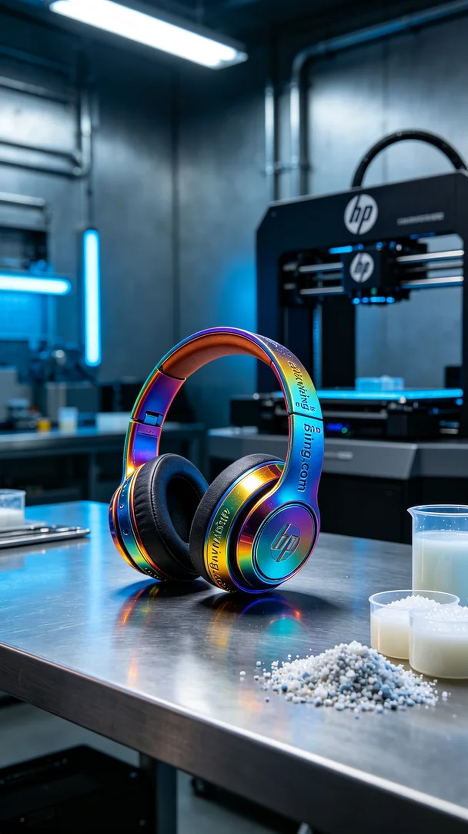
最近有人通过WhatsApp联系我，说想要制作一款全彩3D打印耳机模型，要求色彩丰富且细节突出。这个项目的挑战在于如何在保持高保真的同时，确保打印质量和效率。
我们选用了全彩3DP彩色打印材料，这种材料可以呈现出色彩渐变和高细节的效果。准备工作中，使用了HP的打印机，设置参数为层厚0.1毫米，打印温度为30°C，功率为80%，打印速度设定为50毫米/秒，预计打印时间为8小时，这样可以确保模型的细节不会流失。
在打印过程中，设备运行得非常平稳，我时刻留意着质量监控。虽然打印是一个漫长的过程，但每一层的逐渐成型都让人欣喜。冷色调的灯光照射下，模型色彩在不断变化，真是让人期待。
完成打印后，我们进行了多道后处理工序。首先对模型进行清洗，去除残余树脂。接着进行了打磨，这一步是为了确保表面光滑。随后对其进行固化处理，确保色彩在光线照射下依旧鲜艳。最后，我们细致地检查了模型，确认没有瑕疵。
经过一系列严格的工序，最终全彩3D打印耳机模型如期完成，色彩鲜艳且质感出众。每个细节都显得栩栩如生，正如我们所期待的那样。
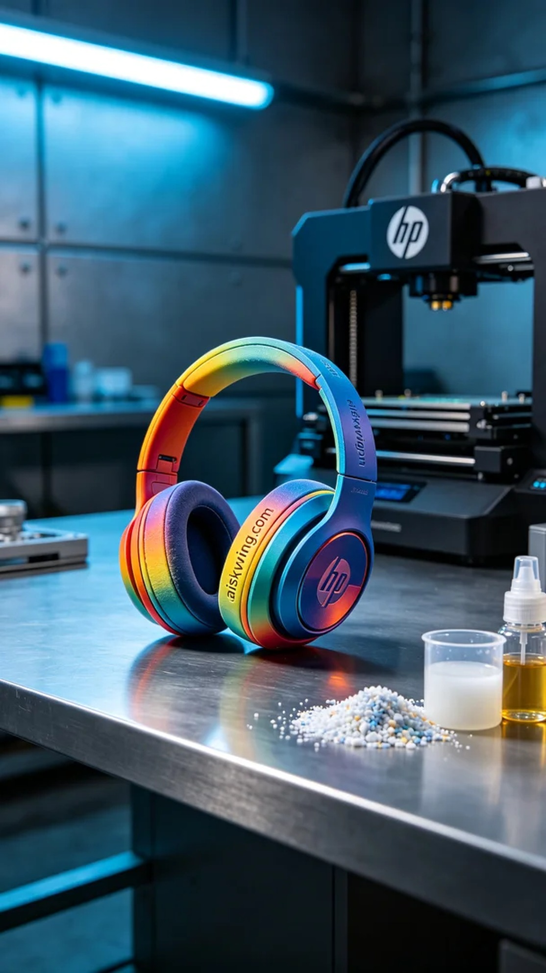
Aiskywing Industrial 3D Printing
Full-color 3D printed headphone model


