0490-全彩3D打印花卉模型生产记录
Full-color 3D printed flower model
🖨️ 全彩3DP
🖥️ 打印机: Stratasys
📦 材料: 摆放着未成型的液态光敏
生活再难，也别停下脚步。就像接下这个全彩3D打印花卉模型的单子，挑战虽多，但每一次尝试都是成长的机会。
No matter how difficult life gets, don't stop moving forward. Just like taking on this order for a full-color 3D printed flower model, there are many challenges, but each attempt is an opportunity for growth.
________________________________________________________________________________
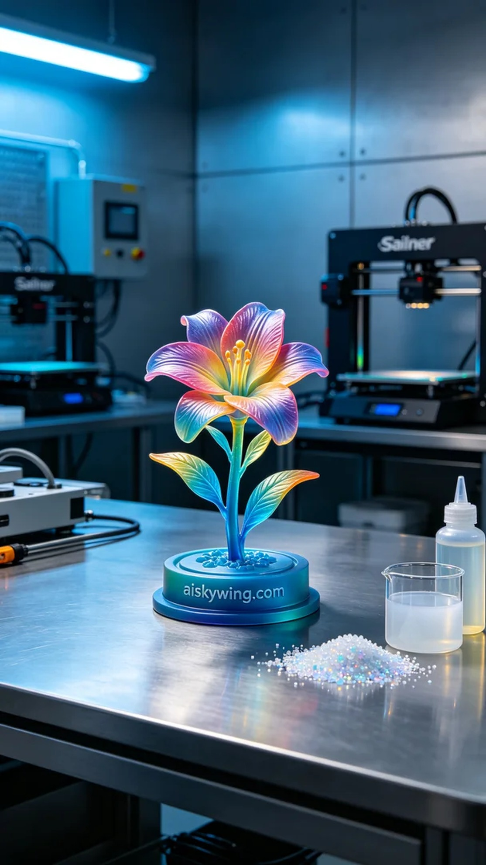
Recently, someone found us through YouTube, looking to create a full-color 3D printed flower model. They wanted a model rich in colors and vivid details to provide a stunning visual impact. This is precisely our area of expertise, so we decided to take on this project.
In the preparation phase, we used unformed liquid photo-sensitive resin as the raw material. This resin is particularly suitable for high-precision printing and can showcase intricate color gradients and complex details. We selected a Stratasys printer, setting the layer thickness to 0.1 mm, printing temperature at 25°C, power at 80%, and printing speed at 40 mm per second, with an estimated print time of 8 hours.
During the printing process, the Stratasys printer ran steadily, with a monitoring system in place to continuously check the quality of the model. As each layer stacked up, the color gradient became increasingly vivid, and our technical team remained vigilant to ensure there were no defects. When the printing was completed, we gazed eagerly at this lifelike flower model, filled with a sense of accomplishment.
Next came the post-processing steps. First, we placed the printed model into a cleaning tank and used alcohol to wash away any excess resin. After cleaning, we sanded the surface with fine sandpaper to ensure it was smooth. Following that, the model was placed in a curing device where it was exposed to UV light for solidification, ultimately achieving its best strength. Finally, we conducted a rigorous inspection to ensure every detail was flawless.
After a series of processes, the full-color 3D printed flower model was finally complete. Its colors and details met our expectations, allowing people to feel the vitality and beauty of life.
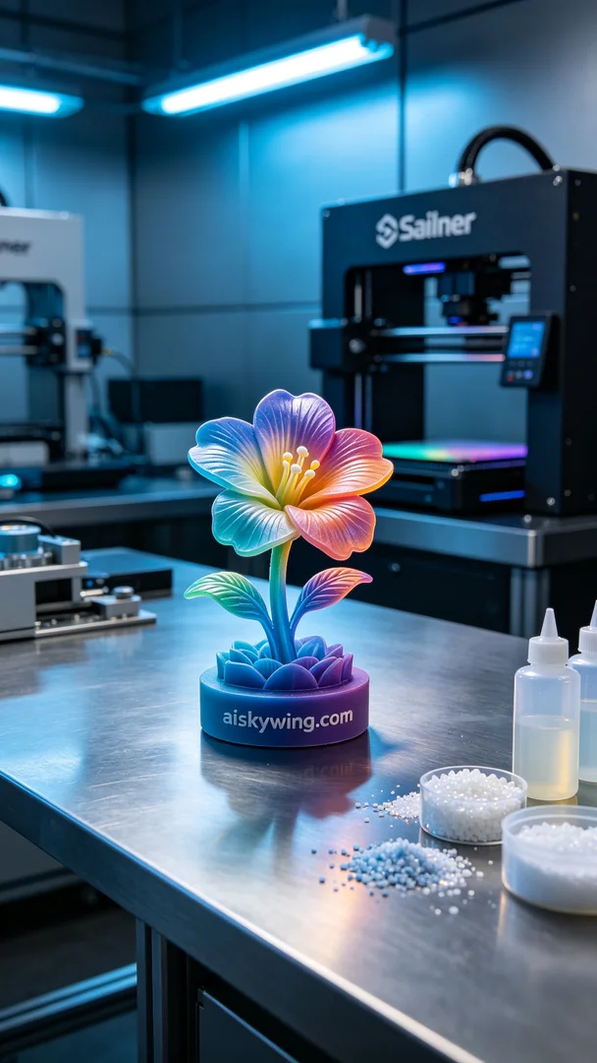
最近，有人通过YouTube找到了我们，想要制作一个全彩3D打印花卉模型。他们希望这个模型色彩丰富、细节鲜明，能够在视觉上给人以震撼。这正是我们擅长的领域，于是我们决定接下这个项目。
在准备阶段，我们使用了未成型的液态光敏树脂作为原材料。这种树脂特别适合高精度打印，能够展现出细腻的色彩渐变和复杂的细节。我们选择了Stratasys打印机，设置了层厚0.1毫米，打印温度保持在25℃，功率为80%，打印速度设定为40毫米每秒，预计打印时间为8小时。
打印过程中，Stratasys打印机稳稳运行，监控系统实时检测模型的质量。随着每一层的逐渐叠加，色彩渐变变得愈加明显，我们的技术团队也始终保持警觉，确保没有任何瑕疵。打印完成时，满心期待地看着这个栩栩如生的花卉模型，心中充满了成就感。
接下来是后处理工序。首先，我们将打印好的模型放入清洗槽中，用酒精清洗，去除多余的树脂。清洗完成后，我们用精细的砂纸进行打磨，确保表面光滑。之后，将模型放入固化设备中固化，经过照射紫外线，最终让其达到最佳的坚固状态。最后，我们进行了严格的检验，确保每个细节都无可挑剔。
经过一系列的工序，这个全彩3D打印花卉模型终于完成了。它的色彩和细节达到了预期的效果，让人感受到生命的活力与美好。
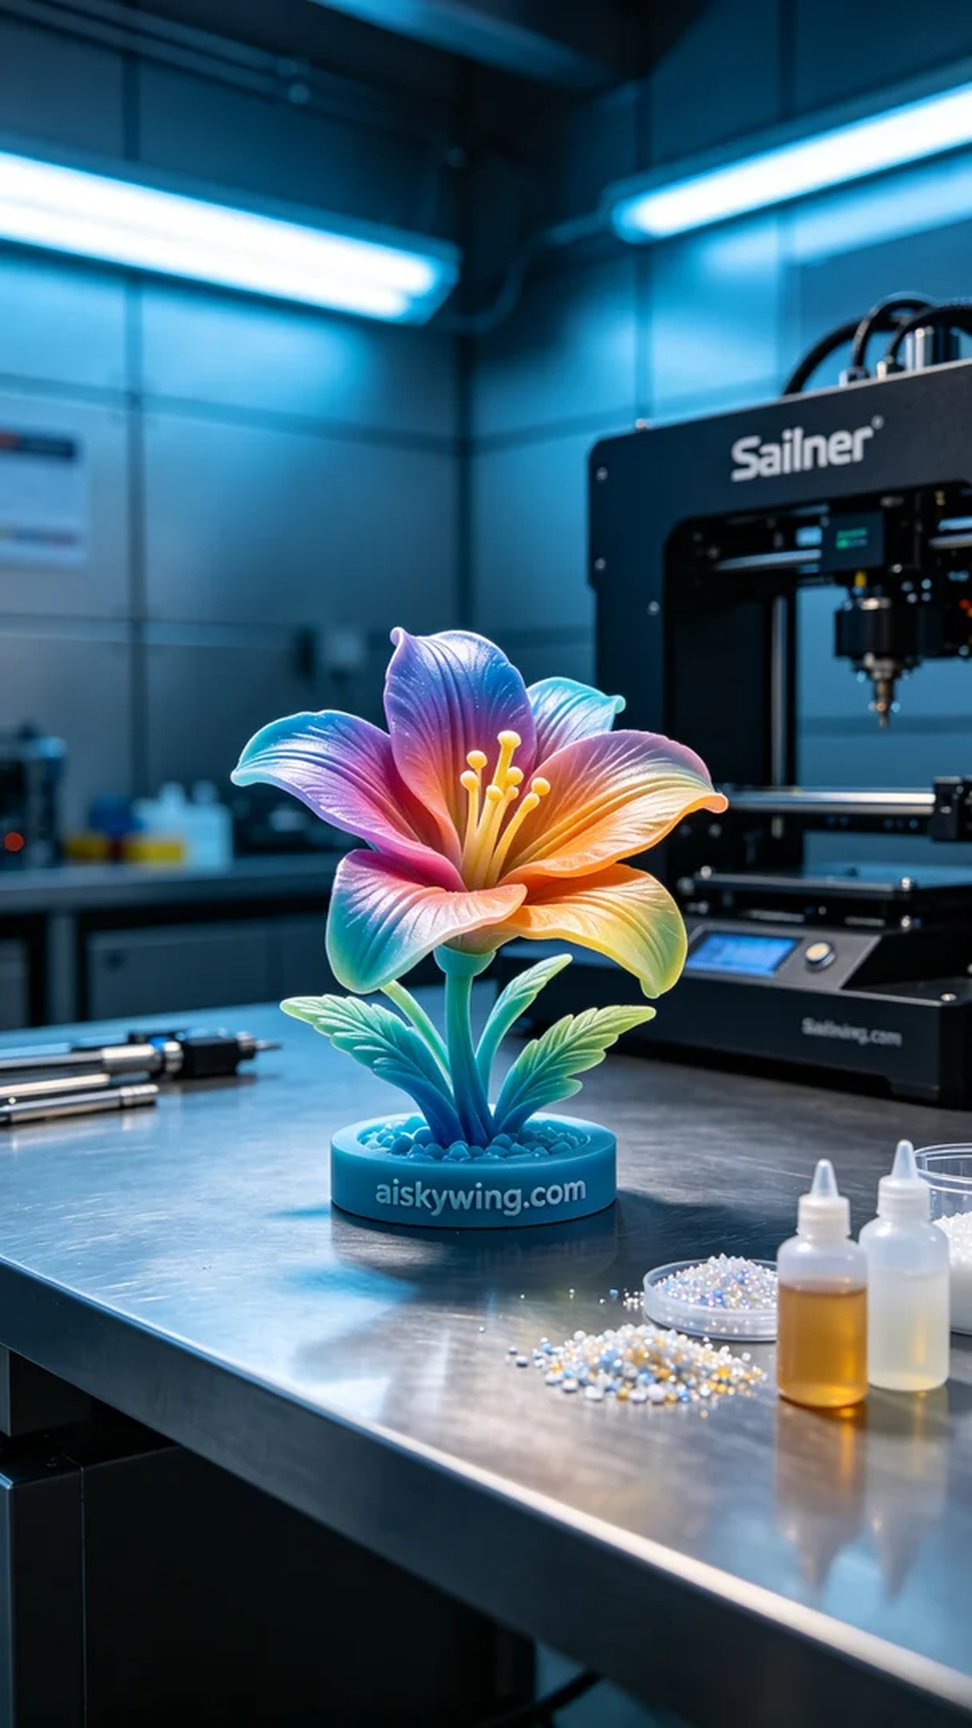
Aiskywing Industrial 3D Printing
Full-color 3D printed flower model


