0491-全彩3D打印花瓶模型生产记录
Full-color 3D printed vase model
🖨️ 全彩3DP
🖥️ 打印机: Stratasys
📦 材料: 全彩3DP彩色树脂
生活再难，也别停下脚步。就像接下这个全彩3D打印花瓶模型的单子，有人希望能在我们这里实现他们的创意梦想。
No matter how difficult life gets, don't stop moving forward. Just like taking on this order for a full-color 3D printed vase model, there are people who hope to realize their creative dreams with us.
________________________________________________________________________________
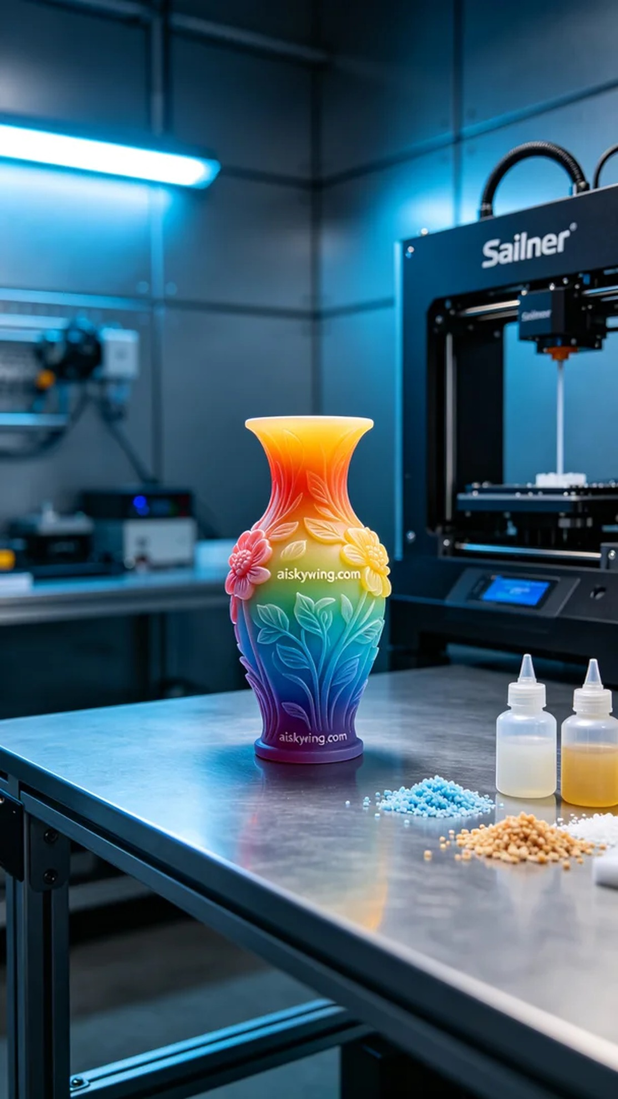
On Twitter, someone reached out to us because they wanted to create a vibrant and detailed full-color 3D printed vase model. They hoped to complete this project in a short time, with high expectations for the printing outcome.
We chose full-color 3DP resin as the printing material. This material not only has vivid and saturated colors but also allows for high detail representation. To ensure optimal results, we prepared a Stratasys 3D printer, setting the parameters to a layer thickness of 0.1mm, printing temperature at 60°C, power at 70%, and speed at 25mm/s. The estimated printing time was 10 hours to ensure perfect gradient and detail presentation.
During the printing process, the Stratasys printer ran smoothly while we closely monitored the printing quality. Each detail gradually took shape, with rich colors beginning to emerge. We regularly checked the model throughout the printing process to ensure the layering precision and avoid defects.
After printing, we moved into post-processing. First, we cleaned the vase with water to remove any excess resin from the surface. Next, we sanded the edges to eliminate any burrs, making the surface smooth. Finally, we placed the vase in a UV curing machine for solidification, enhancing its durability and gloss. A final inspection ensured that every detail met the standards.
Having completed this full-color 3D printed vase model and witnessing the vibrant outcome, I felt a sense of satisfaction. This project was not just a reflection of our technology but also a realization of creativity.
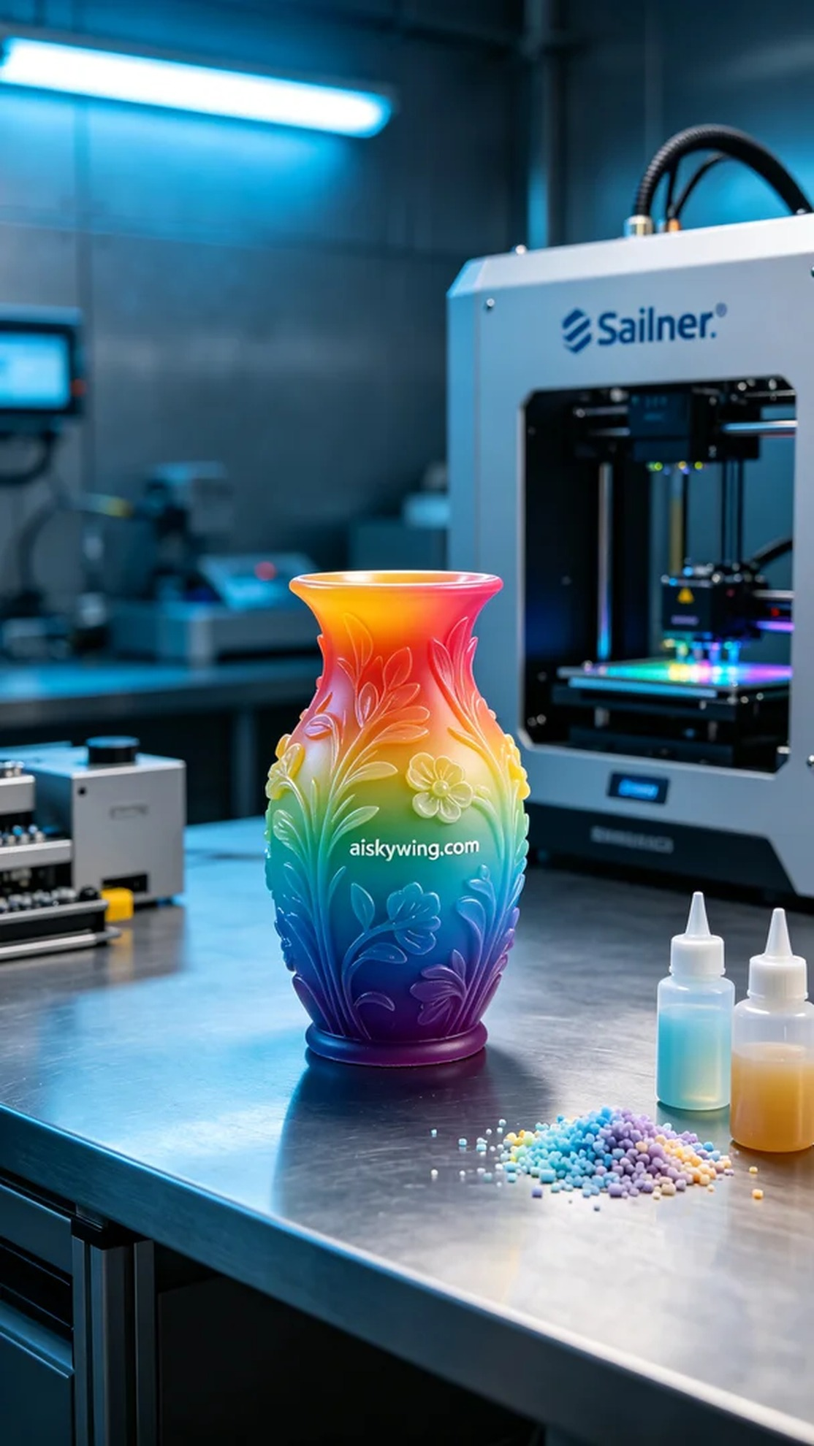
在Twitter上，有人因为想要制作一款色彩丰富且细节逼真的全彩3D打印花瓶模型而联系了我们。他们希望在短时间内完成这个项目，并对打印效果寄予厚望。
我们选择了全彩3DP彩色树脂作为打印材料。这种材料不仅色彩鲜艳饱和，而且能够呈现出极高的细节。为了保证打印效果，我们准备了一台Stratasys 3D打印机，设定参数为：层厚0.1mm、打印温度60℃、功率70%、速度25mm/s。预计打印时间为10小时，确保每个渐变和细节都能完美呈现。
在打印过程中，Stratasys打印机稳定运行，我们密切监控打印质量。每个细节都在逐步成型，丰富的色彩逐渐显现。打印过程中，我们定时检查模型，确保各个部分的层叠精准无误，避免出现瑕疵。
打印完成后，我们进入后处理环节。首先使用清水对花瓶进行清洗，确保去除表面多余的树脂。之后我们进行打磨，尽量消除边缘的毛刺，使表面光滑。最后，将花瓶放置在UV固化机中进行固化，以增强耐用性和光泽感。经过最终检验，确保每个细节都达到标准。
完成了这款全彩3D打印花瓶模型，看到那色彩斑斓的效果，心里倍感欣慰。这不仅是技术的体现，更是对创意的兑现。
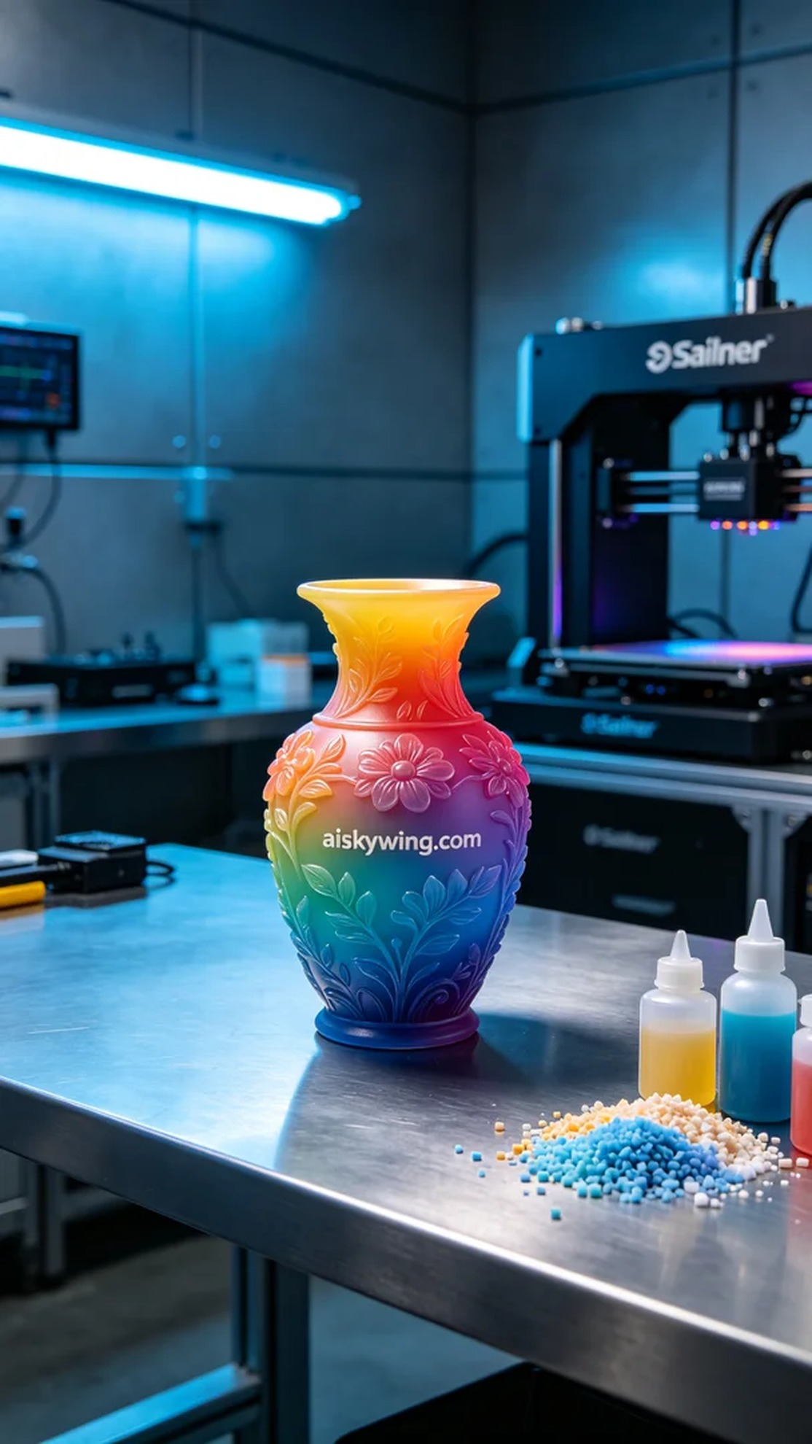
Aiskywing Industrial 3D Printing
Full-color 3D printed vase model


