0492-全彩3D打印蔬菜模型生产记录
Full-color 3D printed vegetable models
🖨️ 全彩3DP
🖥️ 打印机: Rize
📦 材料: 全彩3DP彩色树脂
生活再难，也别停下脚步。就像接下这个全彩3D打印蔬菜模型的单子，有人因为需要一个逼真的展示模型而找上我们。
No matter how difficult life gets, don't stop moving forward. Just like when we took on the order for this full-color 3D printed vegetable model; someone approached us because they needed a realistic display model.
________________________________________________________________________________
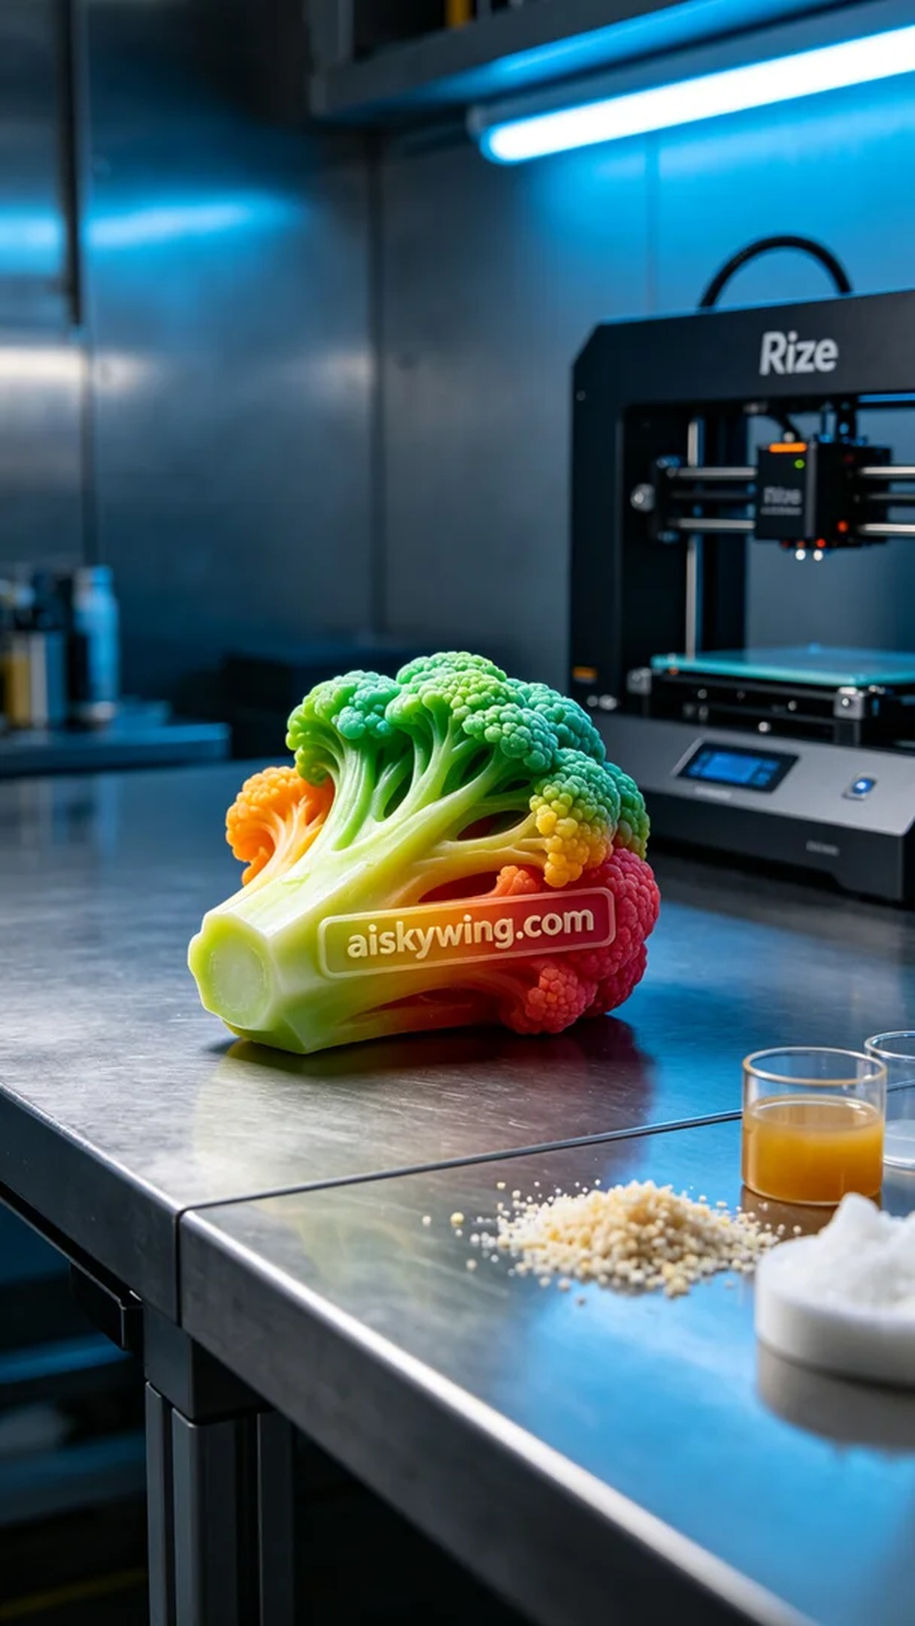
Life can be tough, but we must keep moving forward. Just like when we took on the job of creating a full-color 3D printed vegetable model; someone reached out to us looking for a realistic display model.
On LinkedIn, someone sought a vibrant vegetable model to showcase their product. They desired this model to be rich in color and detail, perfectly reflecting their product's features. After understanding their needs, we decided to utilize the full-color 3DP process to accomplish this project.
For materials, we selected full-color 3DP resin, known for its excellent color representation and surface gloss, making it ideal for lifelike models. In preparing the equipment, we used a Rize brand 3D printer, setting the layer thickness to 0.1mm, printing temperature at 25°C, power adjusted to 60W, and print speed at 40mm/s, with an expected print time of 12 hours to ensure rich detail presentation.
During the printing process, the Rize printer operated smoothly, and we monitored progress and quality in real-time through the software. To ensure print quality, we periodically checked the nozzle and material status, guaranteeing that each layer met our expectations. Ultimately, the vegetable model was completed on schedule, accompanied by the subtle hum of the printer.
After printing, we moved into the post-processing stage. First, we placed the model into a cleaning tank, using water and a small amount of detergent to remove excess resin from the surface. Next, we sanded the model with fine sandpaper to ensure a smooth surface and clear details. Finally, we cured the model under UV light to ensure structural stability and conducted a final quality inspection to ensure there were no defects.
After a series of meticulous processes, this full-color 3D printed vegetable model not only displayed vibrant colors but also showcased exceptional detail and realism, perfectly meeting the requirements. This is the charm of 3D printing, turning our creativity into reality at our fingertips.
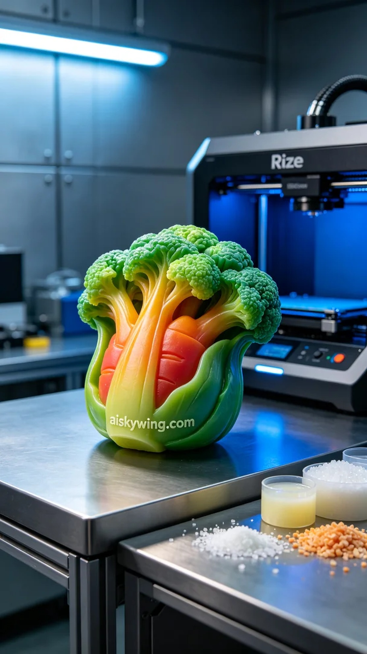
在LinkedIn上，有人因为需要一个全彩的蔬菜模型来展示产品而联系我们。他们希望这个模型色彩丰富、细节真实，能够完美呈现他们的产品特色。在了解了他们的需求后，我们决定使用全彩3DP工艺来完成这个项目。
原材料方面，我们选择了全彩3DP彩色树脂，这种材料具有出色的色彩表现力和表面光泽，非常适合做出栩栩如生的模型。在设备准备方面，我们使用了Rize品牌的3D打印机，设置了层厚为0.1mm，打印温度设定在25°C，功率调整为60W，打印速度为40mm/s，预计打印时间为12小时，以确保细节的丰富呈现。
打印过程中，Rize打印机稳定运行，我们通过软件实时监控打印进度和质量。为了保证打印效果，我们定期检查喷头和材料的状态，确保每一层的打印都能够满足我们的预期标准。最终，伴随着打印机的轻微嗡嗡声，蔬菜模型如期而至。
完成打印后，我们进入了后处理环节。首先，我们将模型放入清洗槽，用清水和少量清洁剂进行清洗，去除表面的多余树脂。接着，使用细砂纸对模型进行打磨，以确保表面光滑，细节清晰。最后，将模型放入UV灯下固化，确保其结构稳定，并进行最终的质量检验，确保没有瑕疵。
经过一系列精细的工艺处理，这个全彩3D打印蔬菜模型不仅色彩饱满，更是展示了极高的细节和真实感，完美满足了需求。这就是3D打印的魅力，让我们的创意在指尖变为现实。
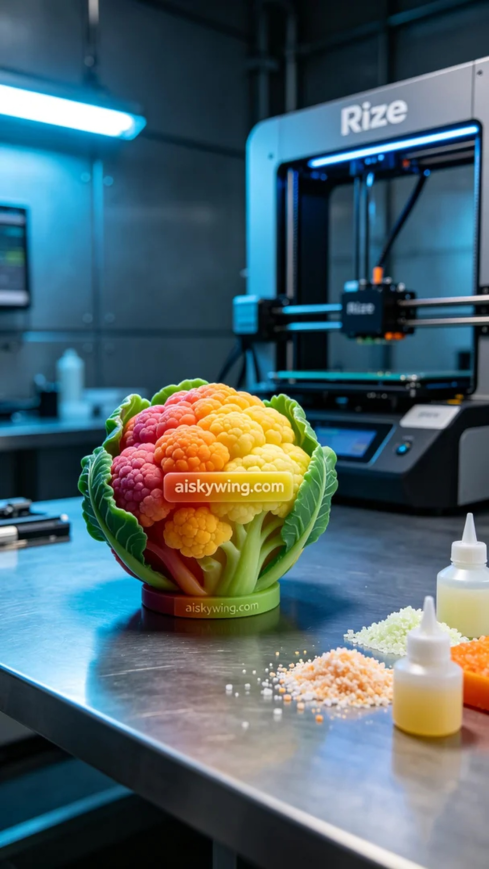
Aiskywing Industrial 3D Printing
Full-color 3D printed vegetable models


