0493-全彩3D打印蛋糕模型生产记录
Full-color 3D printed cake model
🖨️ 全彩3DP
🖥️ 打印机: EOS
📦 材料: 全彩3DP彩色打印
生活就像这全彩3D打印蛋糕模型置于画面正中央，有时候需要耐心与细致去雕琢。今天，我们在YouTube上接到一个特别的项目。
Life is like this full-color 3D printed cake model placed at the center of the frame; sometimes it requires patience and attention to detail to carve it out. Today, we received a special project on YouTube.
________________________________________________________________________________
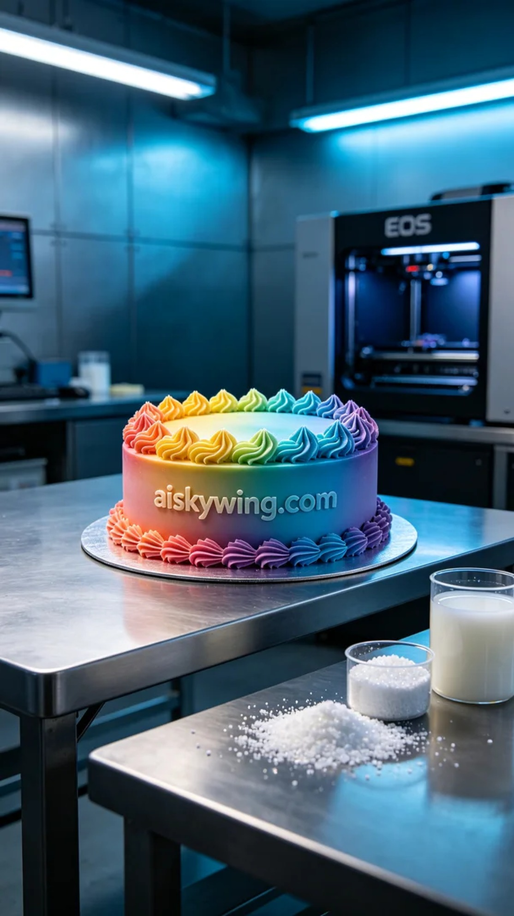
Life is like this full-color 3D printed cake model; sometimes, it requires patience and attention to detail to shape it right. Today, we received a special project through YouTube.
To meet the need for a full-color 3D printed cake model, we chose full-color 3DP printing material. This material is known for its rich color and high-fidelity surface, making it ideal for our project. During the preparation phase, we first checked the materials required for the EOS 3D printer, ensuring that the liquid photopolymer resin and other fine particles were in good condition.
Setting the printing parameters is crucial. This time, we set the layer thickness to 0.1mm, maintained a printing temperature of around 25°C, adjusted the power to 80%, and set the printing speed to 30mm/s. The entire printing process was expected to take about 8 hours. Before the operation, we performed a detailed inspection to ensure that the printer's functions were normal and to avoid any failures during the printing process.
During the printing process, our EOS printer ran smoothly, while the quality monitoring system provided real-time feedback, ensuring that every detail of the model met expectations. As time passed, the color gradients and details gradually emerged, resembling the birth of an art piece. We regularly checked to ensure the curing of each layer was satisfactory, preventing any defects.
Once printing was complete, the post-processing steps were crucial. First, we cleaned the model to ensure there were no residues on the surface. Then, we performed meticulous sanding to smoothen the edges and proceeded with the curing process to enhance the model's durability and stability. Finally, we conducted a comprehensive inspection to ensure that every detail was flawless before it was ready for use.
After a series of meticulous steps, this full-color 3D printed cake model was finally completed. Seeing it perfectly presented before us brought a sense of accomplishment, much like the rewards that come from persistence in life.
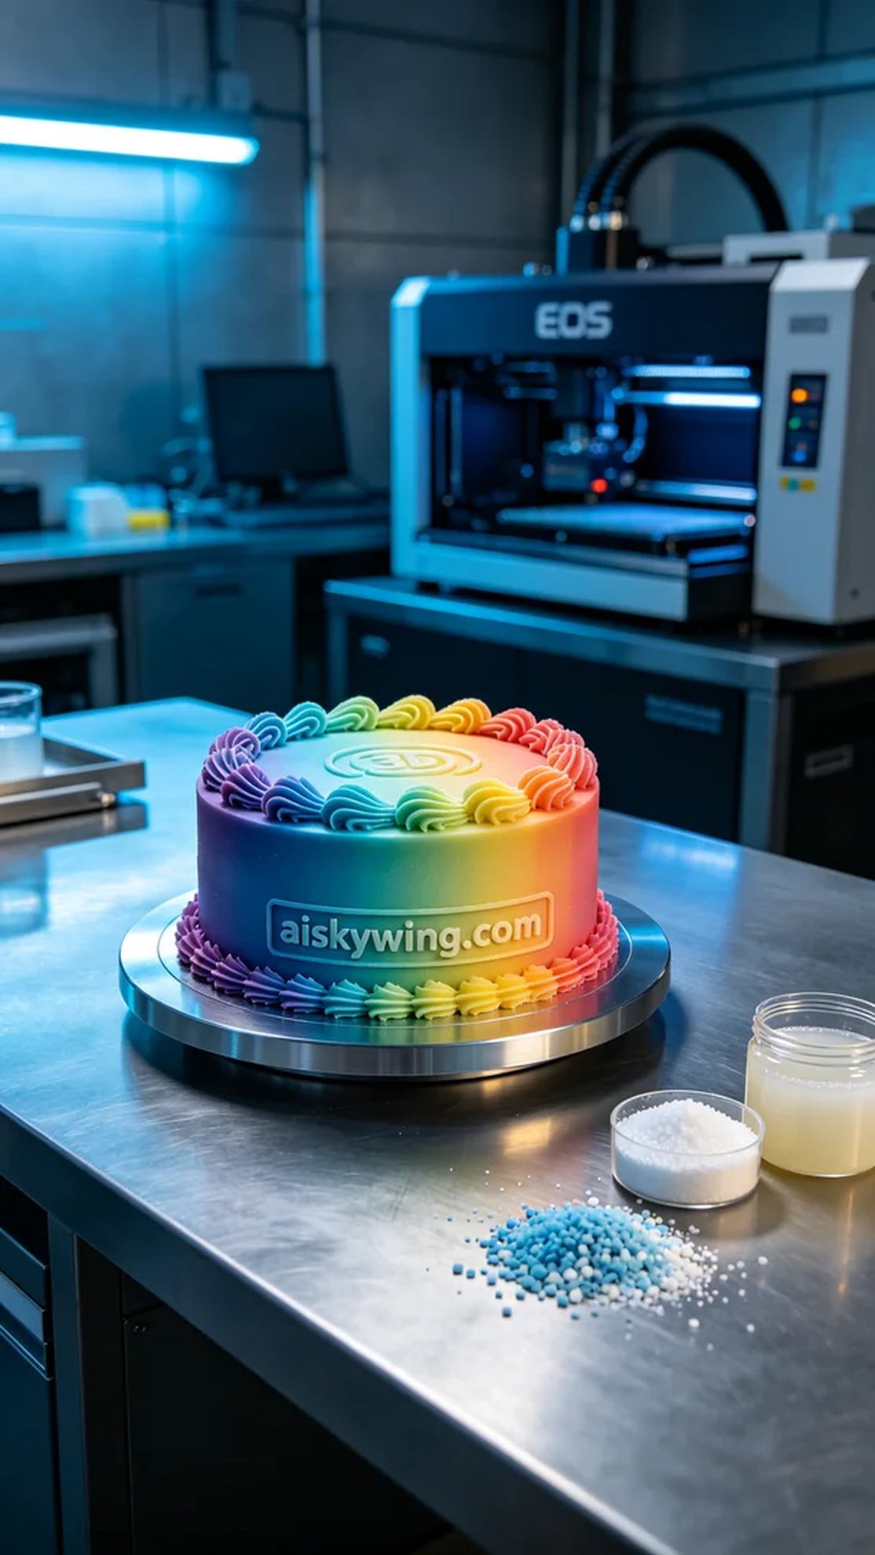
为了满足有人对全彩3D打印蛋糕模型的需求，我们选用了全彩3DP彩色打印材料。这种材料以其色彩丰富和高保真的表面效果而著称，适合我们这次的项目。在准备阶段，我们首先清点了EOS品牌3D打印机所需的原料，确保液态光敏树脂及其它细碎颗粒都完好无损。
打印参数设置是关键。这次我们设定了0.1mm的层厚，打印温度保持在25℃左右，功率调整为80%，打印速度为30mm/s。整个打印过程预计需要8个小时。设备运行前，我们进行了详细的检查，以确保打印机的各项功能正常，避免在打印过程中发生故障。
在打印过程中，我们的EOS打印机运转平稳，质量监控系统实时反馈，保证了模型的每个细节都达到预期。随着时间的推移，色彩渐变与细节呈现逐渐显现出来，仿佛一场艺术的诞生。我们定时观察，确保每层的固化情况良好，避免出现任何缺陷。
打印完成后，后处理工序至关重要。首先，我们对模型进行了清洗，确保表面没有任何残留物。接着，进行细致的打磨，使得边缘更加光滑，然后再进行固化处理，以增强模型的耐用性与稳定性。最后，进行一次全面检验，确保每个细节都完美无缺，才能交付使用。
经过一系列细致的工序，这个全彩3D打印蛋糕模型终于完成了。看着它完美地呈现在眼前，我们也感受到了一种成就感，正如生活中每一次坚持的努力，总会有回报。
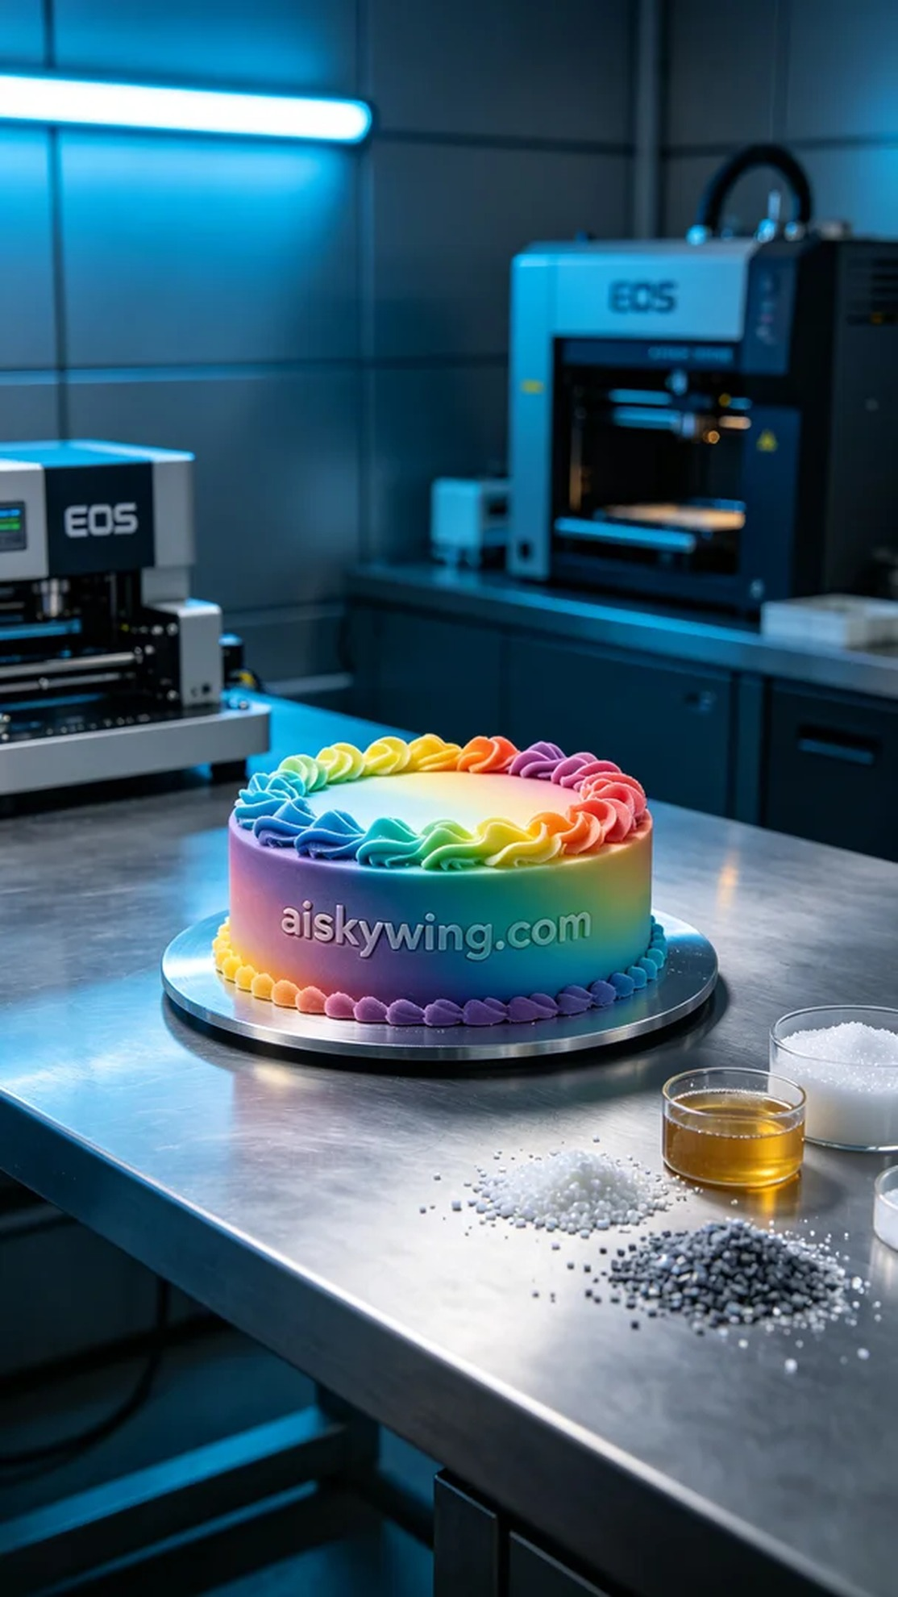
Aiskywing Industrial 3D Printing
Full-color 3D printed cake model


