0494-全彩3D打印轮船模型生产记录
Full-color 3D printed ship model
🖨️ 全彩3DP
🖥️ 打印机: EOS
📦 材料: 全彩3DP彩色打印
生活就像一场航行，总要迎接风浪。最近，有人通过TikTok找到了我们，想制作一款全彩3D打印轮船模型，带来了一些特别的要求。
Life is like a voyage, always facing winds and waves. Recently, someone found us through TikTok and wanted to create a full-color 3D printed ship model, bringing some special requests.
________________________________________________________________________________
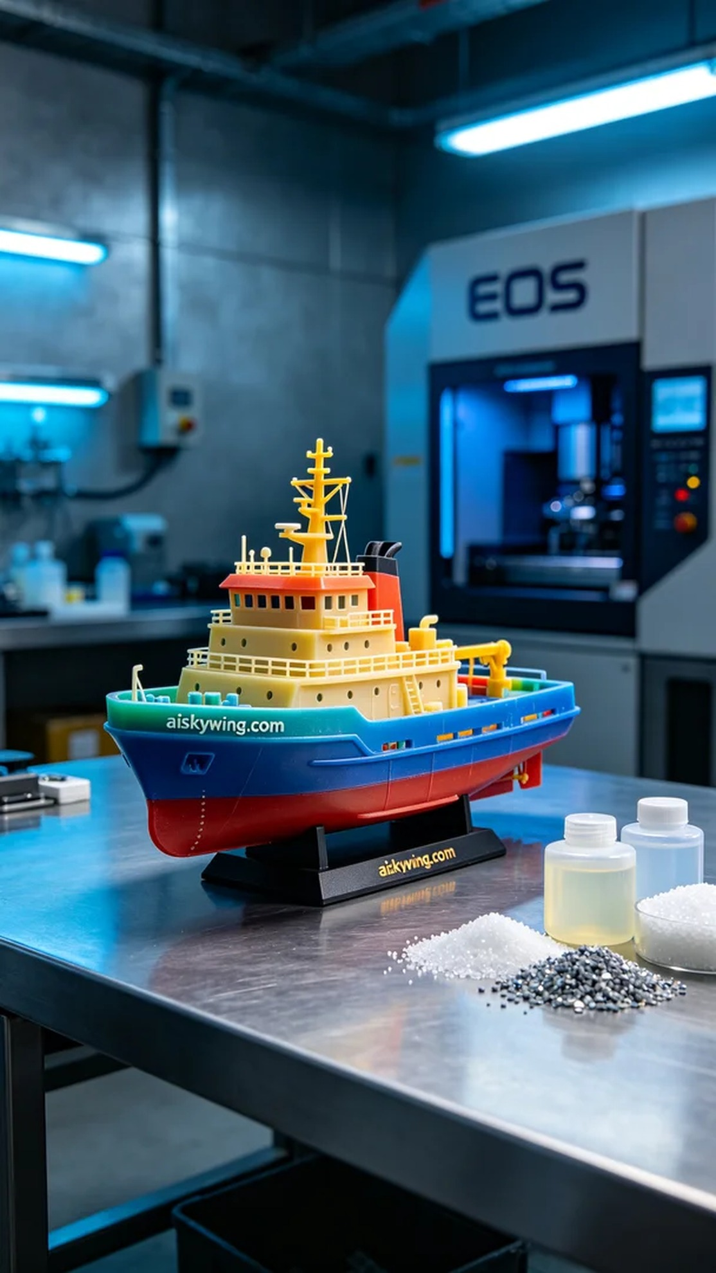
Life is like a voyage, always welcoming the storms. Recently, someone found us through TikTok, wanting to create a full-color 3D printed ship model with some specific requirements.
For this project, we prepared full-color 3DP printing material to ensure the final result meets high fidelity and rich colors. The person who reached out wanted to replicate intricate details and shadows of the ship accurately, thus we selected the best materials for the job.
We used full-color 3DP printing materials known for their high color saturation, perfect for showcasing complex gradients and fine details. Before starting, I checked the equipment to make sure the EOS printer was in good condition, setting the layer thickness to 0.1mm, printing temperature to 220℃, power at 80%, and speed at 50mm/s, estimating a printing time of 8 hours.
During the printing process, the EOS printer operated smoothly, building the ship model layer by layer. We closely monitored the quality throughout, ensuring each detail met our expectations. The gentle humming of the machine provided a sense of reassurance as the material gradually took shape, with the color gradients slowly revealing the elegant contours of the model.
After printing, we proceeded to post-processing. First, the model was placed in a cleaning tank to remove any residual liquid resin. Next, we used fine sandpaper to smooth the surface of the model, ensuring a pleasant touch. Then, it was cured in a curing machine for an appropriate amount of time to enhance its strength and durability. Finally, we meticulously inspected every detail to ensure there were no flaws.
In the end, the full-color 3D printed ship model presented itself beautifully, with vibrant colors and clear details, showcasing high fidelity. This was not just a successful print, but a perfect interpretation of our technology.
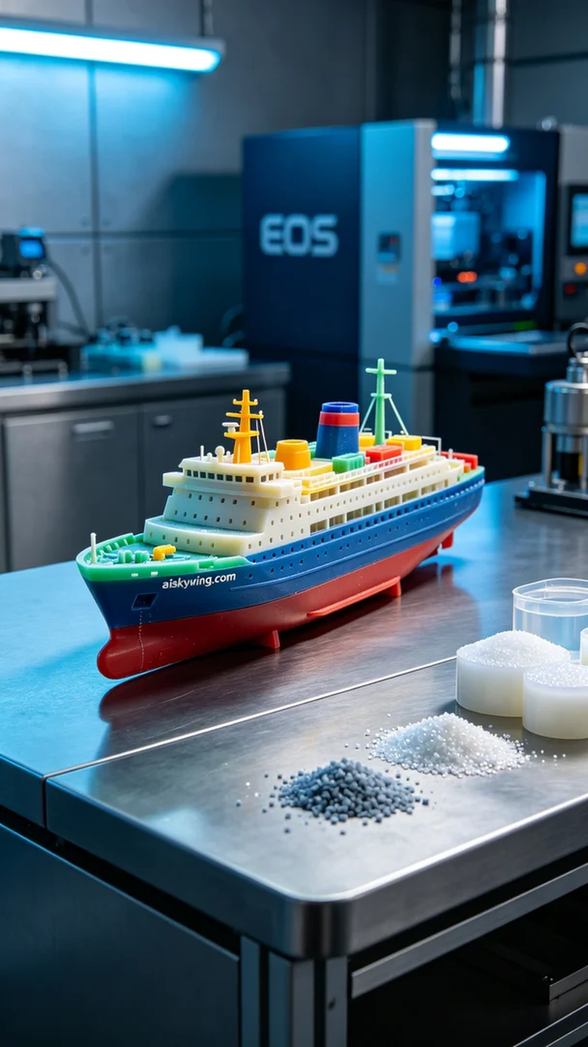
这次的项目是为了一位在TikTok上看到我们案例的人。他希望能制作一款全彩3D打印轮船模型，要求高保真和色彩丰富，能够真实再现出轮船的细节和光影效果。为了满足他的需求，我们准备了全彩3DP彩色打印材料，确保最终效果完美。
原材料方面，我们使用的是全彩3DP彩色打印材料，这种材料的色彩饱和度高，适合展示复杂的渐变和精细的细节。打印前，我检查了设备，确保EOS打印机一切正常，设置了层厚为0.1毫米，打印温度为220℃，功率为80%，速度保持在50毫米每秒，预计打印时间为8小时。
在打印过程中，EOS打印机运转平稳，逐层构建轮船模型。我们全程监控打印质量，确保每个细节的表现都符合预期。打印过程中，设备在运行时发出的轻微嗡鸣声伴随着材料的逐渐成型，给人一种安心感。每层的色彩渐变都在显现，逐渐体现出模型的精致轮廓。
打印完成后，进入后处理工序。首先，我们将模型放入清洗槽中，去除表面残留的液态光敏树脂。接着，使用细砂纸对模型表面进行打磨，以确保触感光滑。随后，将模型放入固化机中，经过适当的固化时间以增强其强度和耐久性。最后，我们仔细检验每个细节，确保没有瑕疵。
最终，这款全彩3D打印轮船模型如愿展现在我们面前，色彩鲜艳，细节清晰，展现出高保真的效果。这不仅是一次成功的打印，更是对技术的一次完美诠释。
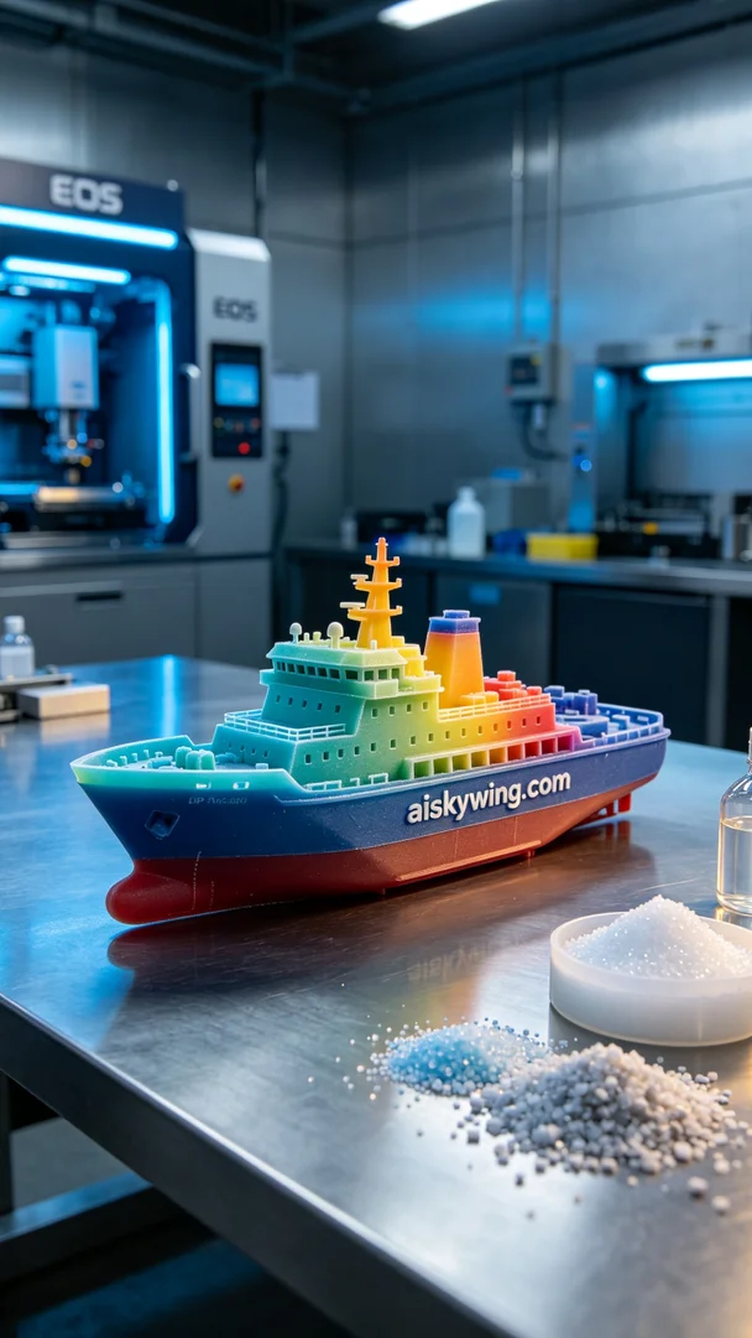
Aiskywing Industrial 3D Printing
Full-color 3D printed ship model


