0500-全彩3D打印金字塔模型生产记录
Full-color 3D printed pyramid model
🖨️ 全彩3DP
🖥️ 打印机: Mimaki
📦 材料: 全彩3DP彩色树脂
生活再难，也别停下脚步。就像接下这个全彩3D打印金字塔模型的单子，真是让我体会到坚持的力量。
No matter how difficult life gets, don't stop moving forward. Just like when I took on the order for this full-color 3D printed pyramid model, it truly made me experience the power of perseverance.
________________________________________________________________________________
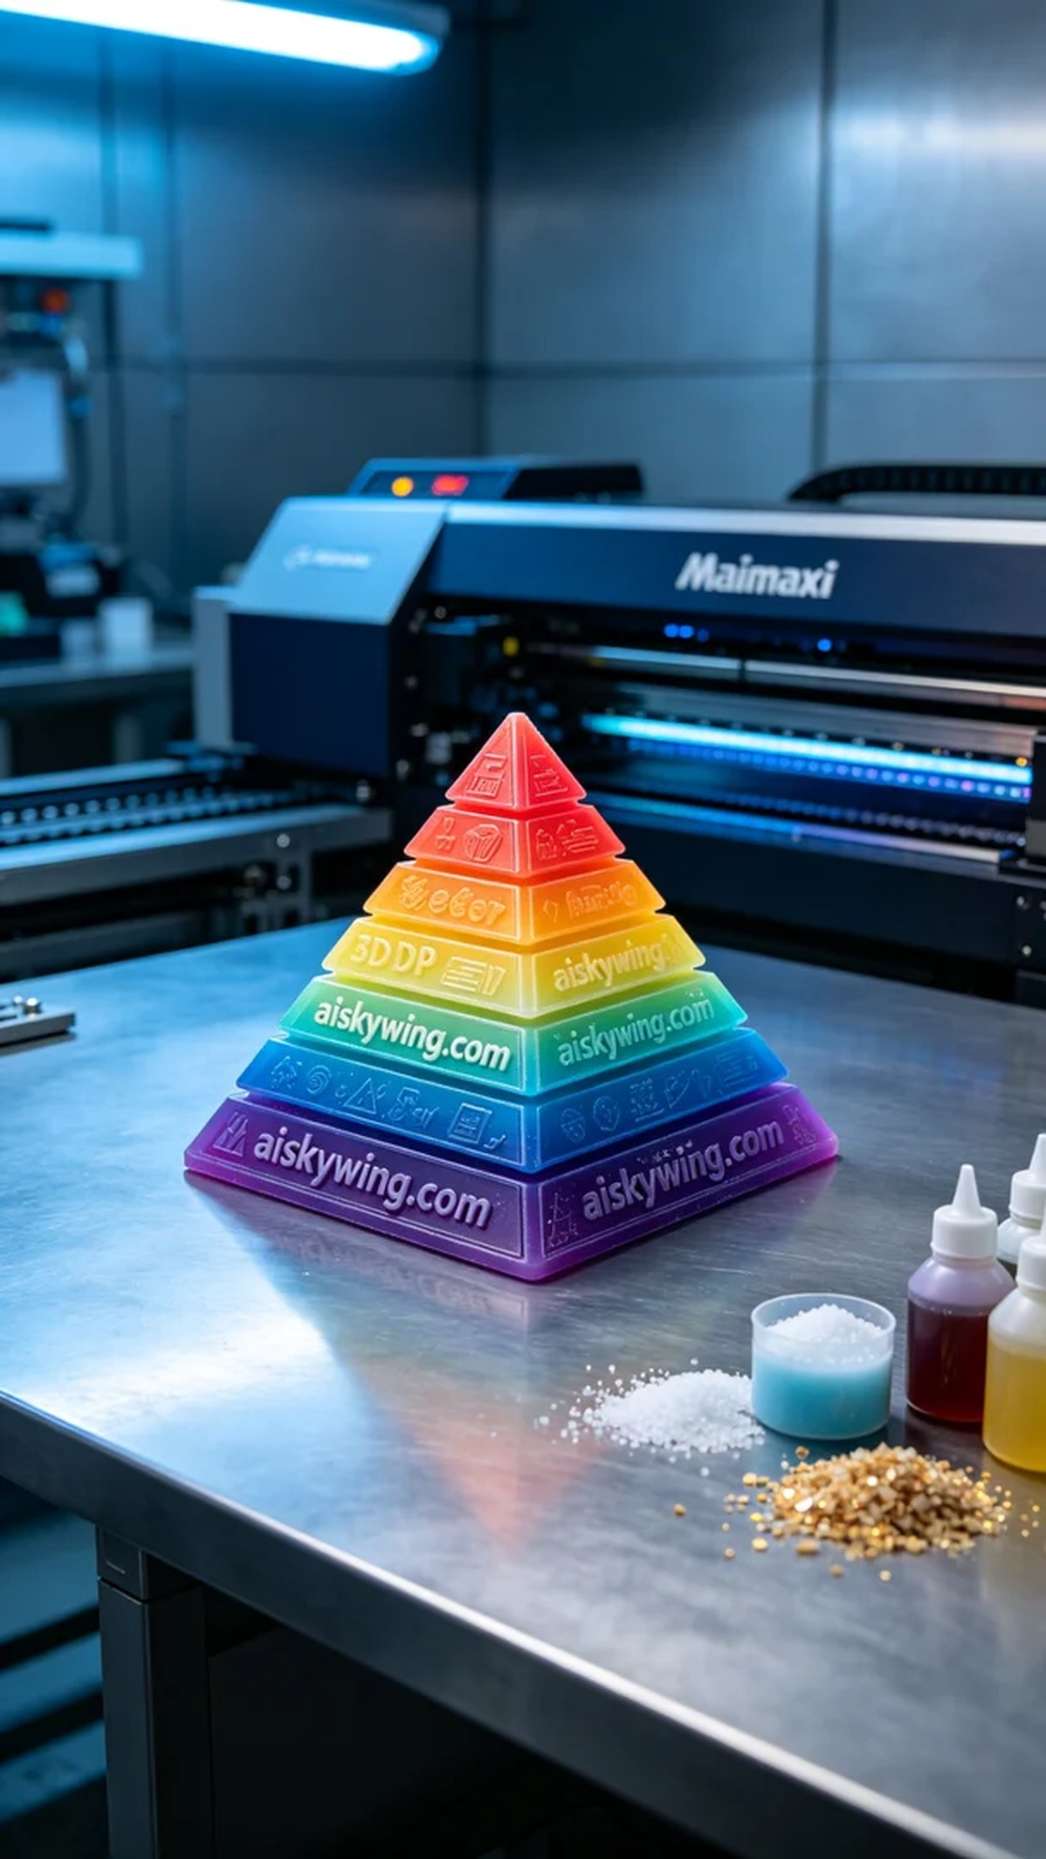
Life can be tough, but we must keep moving forward. Just like taking on this project for a full-color 3D printed pyramid model, it truly makes me realize the power of persistence.
Today on Twitter, someone reached out to us wanting a unique full-color 3D printed pyramid model that demanded vibrant colors and realistic details. I felt a quick tightening in my chest, ready to embrace this challenge head-on.
We chose full-color 3DP resin as our printing material. This resin is known for its vivid and saturated colors, capable of showcasing amazing gradients that create a strong visual impact. For the equipment, we utilized a Mimaki 3D printer, setting the print parameters to a layer thickness of 0.1mm, a temperature of 25℃, power at 80W, and a printing speed of 30mm/s, with an estimated print time of 12 hours to ensure every detail was captured perfectly.
As the printing commenced, the Mimaki printer ran steadily, with liquid photopolymer resin continuously cured under exposure. The model's layers gradually took shape, and I closely monitored the progress to ensure no bubbles or imperfections emerged. Watching the pyramid's outline become clearer, I felt a sense of relief wash over me.
Once the printing was completed, we moved on to the post-processing phase. First, the model was placed in a cleaning tank to remove uncured resin. Next, we gently sanded the surface with fine sandpaper to enhance its smoothness. Then, the model was placed in a curing chamber for exposure to ensure every detail was solid and durable. Finally, after a thorough inspection to confirm there were no flaws, this vivid pyramid model was ready.
Reflecting on the entire process, despite the hard work put in, the final product of the full-color 3D printed pyramid model brings immense satisfaction. Just like every persistence in life, it leads to unexpected joy.
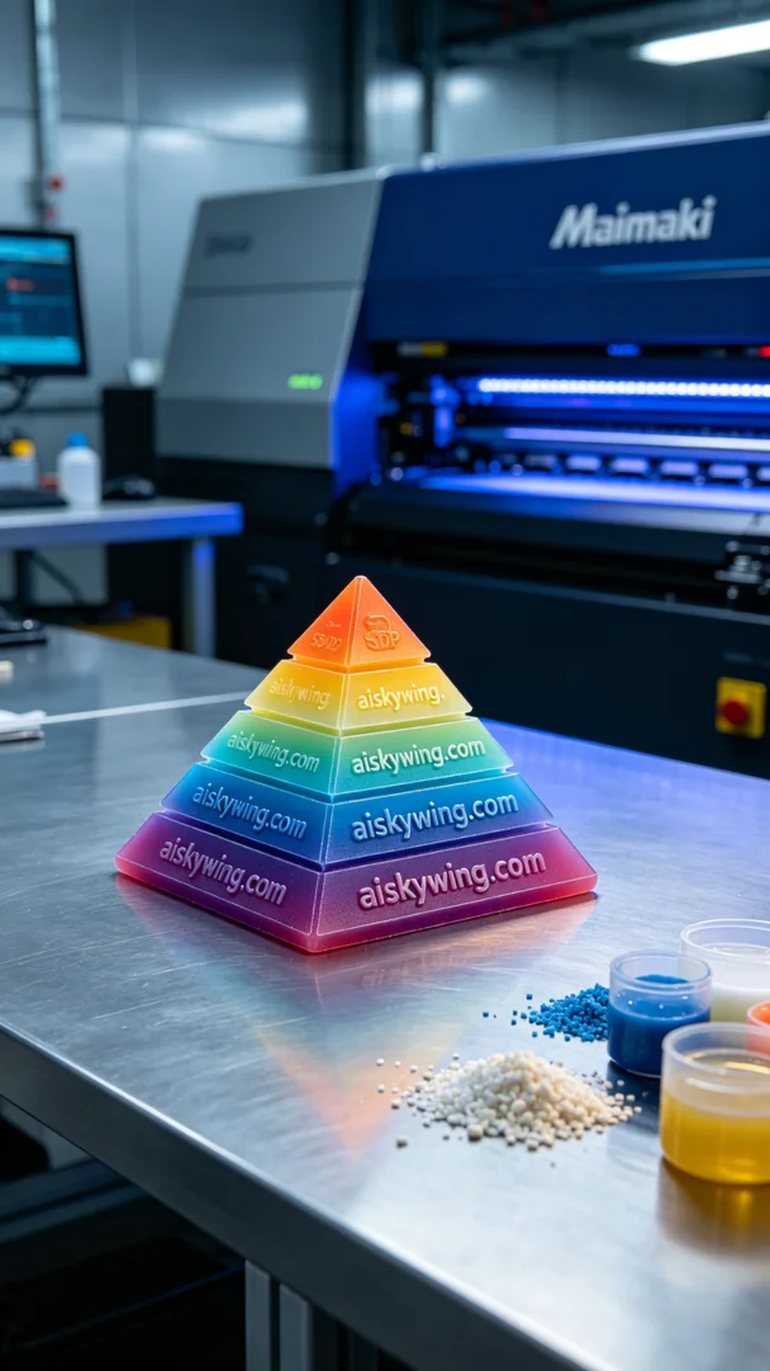
今天在Twitter上，有人因为想要制作一个独特的全彩3D打印金字塔模型找到了我们，要求色彩丰富且细节逼真。我心里一紧，准备充分迎接这个挑战。
首先，我们选用了全彩3DP彩色树脂作为打印材料。这种树脂的特点是色彩鲜艳饱和，能够很好地呈现渐变效果，给人一种视觉冲击。在设备方面，我们使用了Mimaki 3D打印机，打印参数设置为层厚0.1mm，温度设定在25℃，功率调节为80W，打印速度为30mm/s，预计打印时间为12小时，确保每一个细节都能呈现到位。
打印过程开始后，Mimaki打印机稳定运行，液态光敏树脂不断被照射固化。每个层次的模型逐渐形成，我时刻监控打印进度，确保没有出现气泡或者其他瑕疵。当看到金字塔的轮廓越来越清晰，心里也逐渐放下了心来。
完成打印后，我们进入了后处理工序。首先，将模型放入清洗槽中，清洗掉未固化的树脂。接下来，使用细砂纸轻轻打磨表面，使其更加光滑。然后，将模型放入固化箱中进行照射，确保每个细节都坚固耐用。最后，经过严格的检验，确认没有瑕疵后，这个生动的金字塔模型终于完成了。
回想整个过程，虽然付出了不少努力，但最终呈现出的全彩3D打印金字塔模型让人感到无比满足。如同生活中的每个坚持，都会收获意想不到的惊喜。
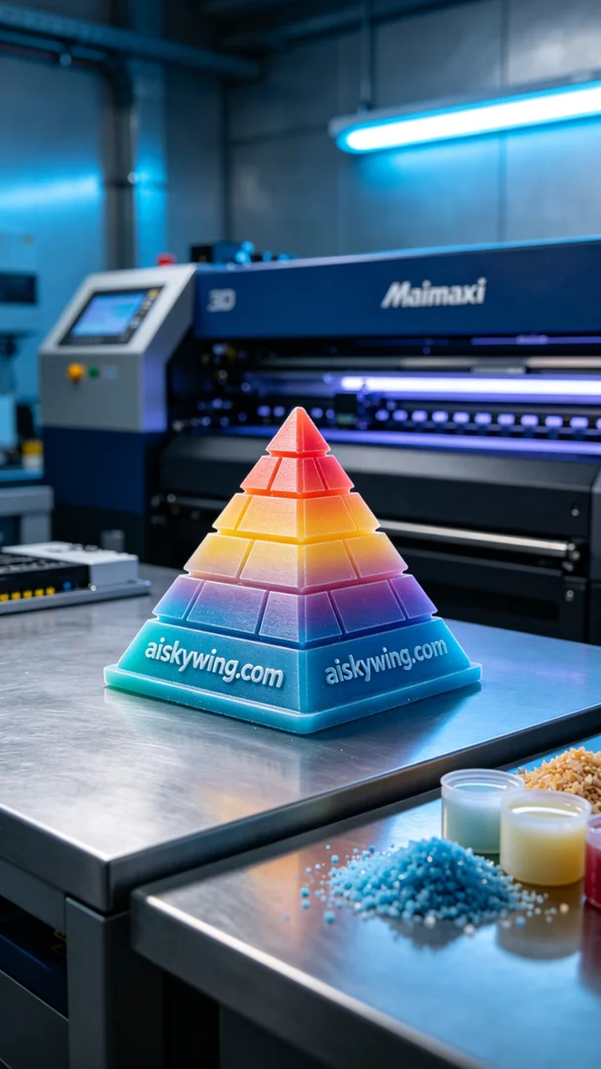
Aiskywing Industrial 3D Printing
Full-color 3D printed pyramid model


