0501-全彩3D打印钢琴模型生产记录
Full-color 3D printed piano model
🖨️ 全彩3DP
🖥️ 打印机: Voxeljet
📦 材料: 摆放着未成型的液态光敏
生活就像一场演奏，有时需要勇气去面对挑战。就如有人在TikTok上看到我们的全彩3D打印钢琴模型，想要制作一款独特的艺术品。
Life is like a performance, sometimes requiring the courage to face challenges. Just like someone who saw our full-color 3D-printed piano model on TikTok and wanted to create a unique piece of art.
________________________________________________________________________________
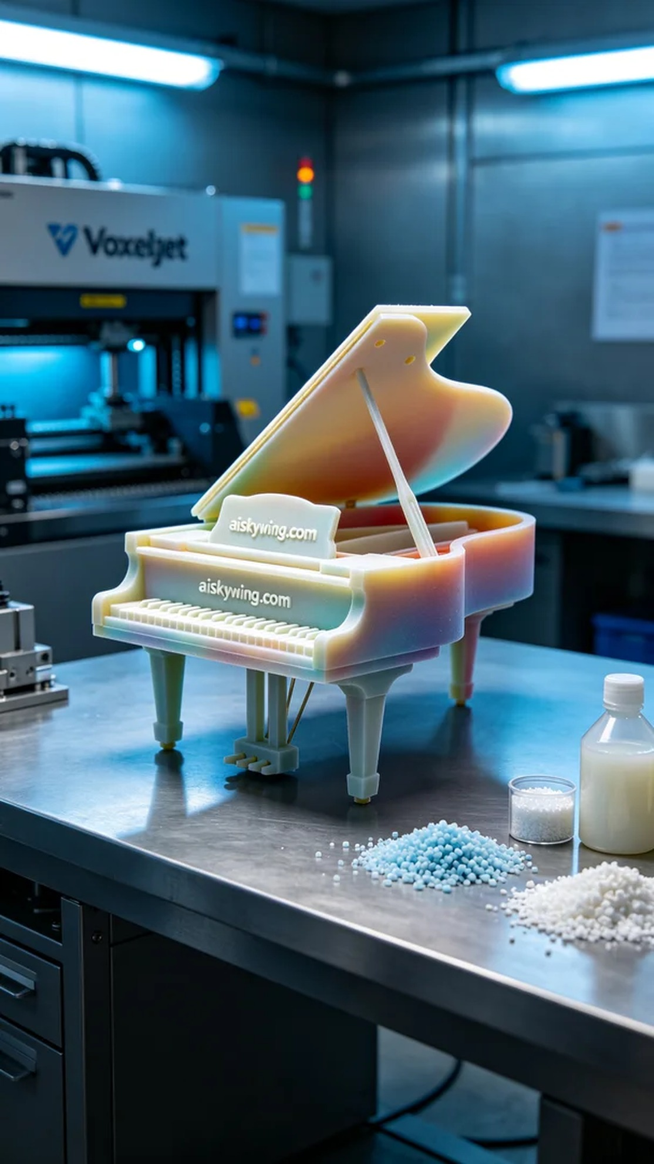
Life is like a performance; sometimes it takes courage to face challenges. Just like someone who saw our full-color 3D-printed piano model on TikTok and wanted to create a unique piece of art.
We chose liquid photopolymer resin as the raw material, which performs excellently in full-color 3DP printing, achieving high color fidelity and intricate details. To ensure printing quality, we used a Voxeljet 3D printer with settings of a layer thickness of 0.1mm, a printing temperature of 25℃, a power setting of 60W, and a printing speed of 30mm per hour, with an expected completion time of 8 hours.
During the printing process, the machine ran smoothly. We constantly monitored the quality to ensure that each layer stacked perfectly. The cool industrial light reflected on the silver-gray desktop enhanced the product's texture. Throughout this process, we closely observed the color gradients and detail presentation, ensuring everything met expectations.
After completion, we entered the post-processing stage. First, we used a cleaning solution to wash the model, removing excess photopolymer resin. Next, we meticulously sanded the surface with professional tools to ensure a smooth and flawless feel. Finally, we placed the model in a curing oven for final solidification while conducting a final inspection to ensure every detail was impeccable.
By the end of the process, this full-color 3D-printed piano model not only showcased our technical expertise but also proved the synergy of our team. In the end, we delivered a satisfying piece to this art enthusiast, creating a unique melody that belongs to him.
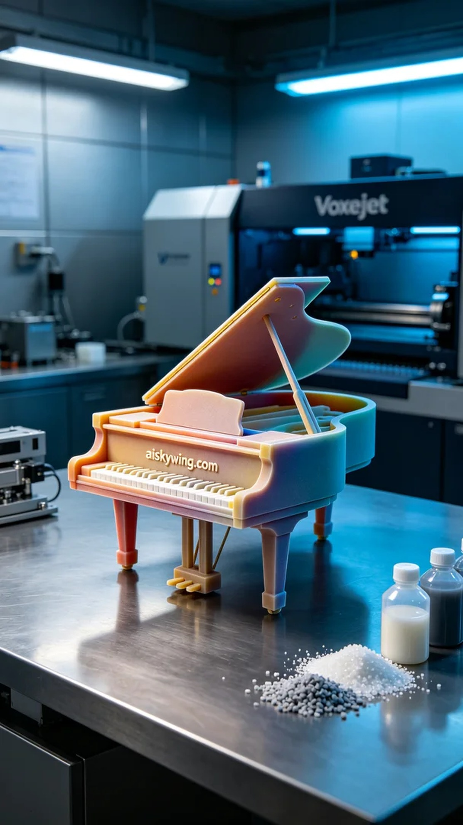
在社交平台TikTok上，一位热爱音乐的人找上我们，希望能制作一款全彩3D打印钢琴模型，以表达他对音乐的热爱和对艺术的追求。他对色彩的丰富性和逼真度有很高的要求，因此我们义不容辞地接下了这个任务。
我们选择使用液态光敏树脂作为原材料，这种材料在全彩3DP打印中表现出色，能实现高还原度的颜色与精细的细节。为了确保打印质量，我们使用的是Voxeljet品牌的3D打印机，设置的打印参数为层厚0.1mm，打印温度保持在25℃，功率设定为60W，打印速度为每小时30mm，预计打印完成时间为8小时。
打印过程中，设备运转顺利。我们持续监控打印质量，确保每一层都能完美叠加。冷色调的工业光线在银灰色的桌面上反射，增强了产品的质感。在此过程中，我们还仔细观察颜色的渐变与细节呈现，确保一切符合预期。
打印完成后，我们进入后处理阶段。首先，我们用清洗液对模型进行清洗，去除多余的光敏树脂。接着，使用专业打磨工具对模型表面进行细致打磨，确保触感平滑无瑕。最后，将模型放入固化炉中进行固化，同时进行最终检验，确保每一个细节都无可挑剔。
全过程下来，这款全彩3D打印钢琴模型不仅展现了我们的技术实力，也证明了团队的默契合作。最终，我们为这位热爱艺术的人交付了一个令人满意的作品，创造了属于他的独特乐章。
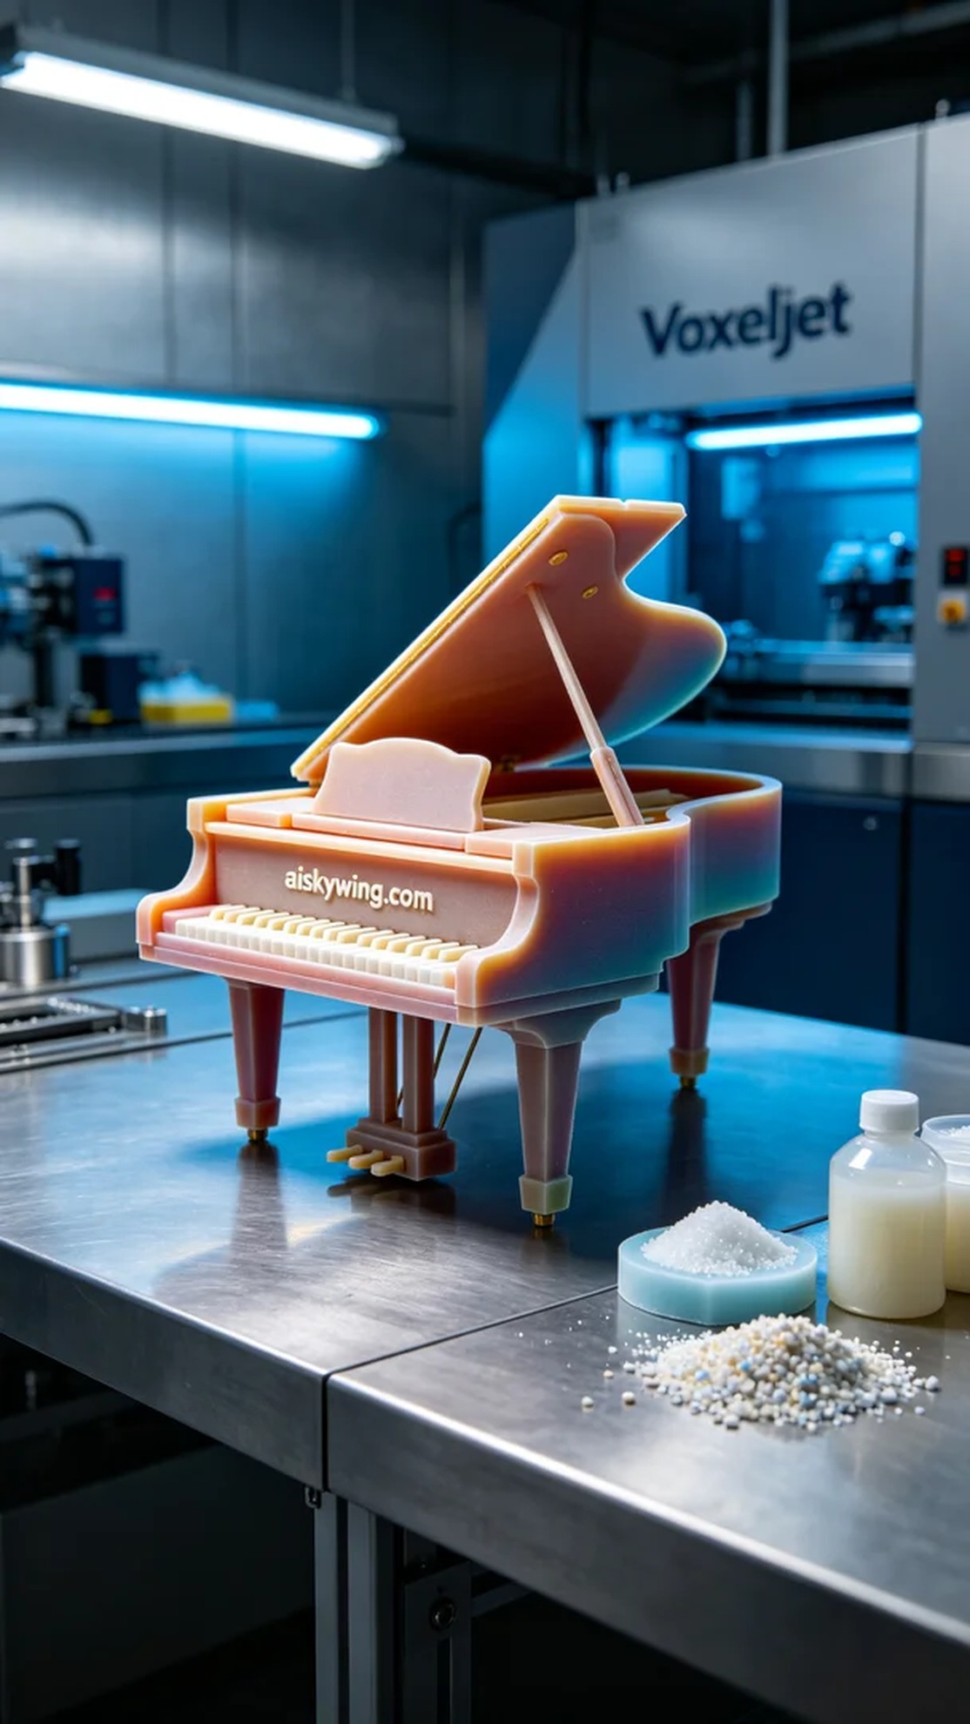
Aiskywing Industrial 3D Printing
Full-color 3D printed piano model


