0502-全彩3D打印雪花模型生产记录
Full-color 3D printed snowflake model
🖨️ 全彩3DP
🖥️ 打印机: Voxeljet
📦 材料: 摆放着未成型的液态光敏
生活再难，也别停下脚步。就像接下这个全彩3D打印雪花模型的单子，挑战总会伴随着新的机遇。
No matter how difficult life gets, don't stop moving forward. Just like taking on this order for a full-color 3D printed snowflake model, challenges always come with new opportunities.
________________________________________________________________________________
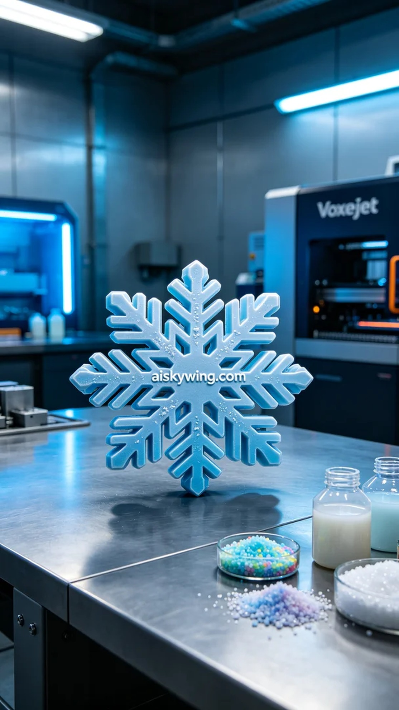
Recently, someone reached out to us, looking to create a full-color 3D printed snowflake model that would play a central role in their product photography. They saw our work on YouTube and believed we could deliver excellent color representation and detailed presentation.
To achieve this, we prepared liquid photopolymer resin as our material. This material can exhibit high finesse and smoothness during printing, making it perfect for the full-color 3DP process. We used the Voxeljet printer, setting parameters at a layer thickness of 0.1mm, maintaining a printing temperature of 25°C, a power level of 90%, a printing speed of 50mm per second, with an estimated printing time of 8 hours.
During the printing process, the machine operated steadily as the liquid photopolymer resin was deposited layer by layer, intricately recreating the complex structure of the snowflake. We closely monitored the machine's status to ensure that every step aligned with our expectations. Once completed, the model exhibited beautiful color gradients and reflected the cold industrial light perfectly, aligning with the design requirements.
The post-processing procedures were also crucial. We first cleaned the printed model to remove any residual resin, followed by meticulous sanding to ensure a smooth surface. Next, the model was cured under UV light to enhance its stability and durability. Finally, we conducted a comprehensive inspection of the finished product to ensure it was flawless and presented beautifully.
After our efforts, the full-color 3D printed snowflake model was completed on schedule, successfully showcasing our dedication and passion for high-fidelity color printing.
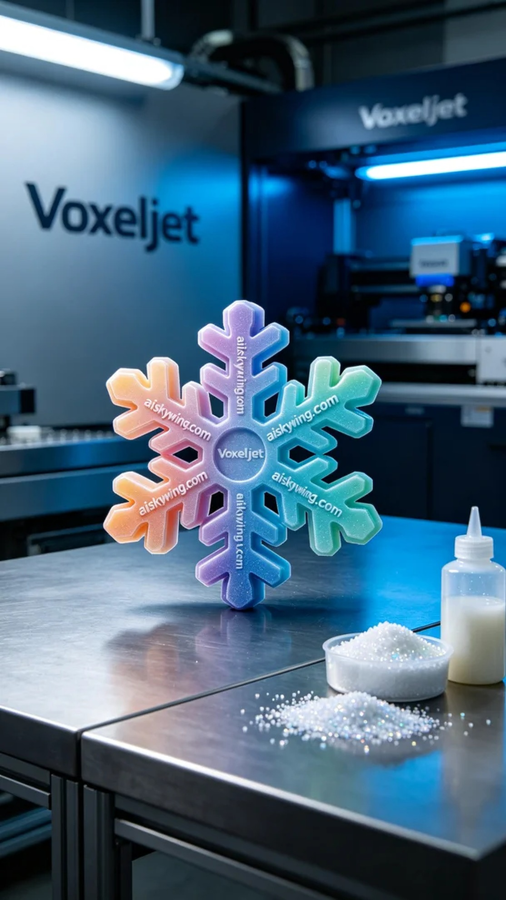
最近，有人找到我们，希望制作一款全彩3D打印的雪花模型，想让它在产品摄影中占据重要位置。他们在YouTube上看到我们的作品，认为我们能够做到出色的色彩还原和细节呈现。
为了实现这个目标，我们准备了液态光敏树脂作为原材料。这个材料在打印时能够展现出极高的细腻度和光滑度，适合全彩3DP工艺。我们使用了Voxeljet打印机，设定的参数包括层厚0.1毫米，打印温度维持在25℃，功率设置为90%，打印速度为50毫米每秒，预计打印时间为8小时。
打印过程中，机器运行稳定，液态光敏树脂逐层沉积，细致地再现了雪花的复杂结构。我们严密监控设备的状态，确保每一步都符合预期。打印完成后，模型展现出了优美的色彩渐变，表面反射出冷峻的工业光线，完美契合了设计需求。
后处理工序也至关重要。我们首先对打印完成的模型进行清洗，去除残留的树脂，然后进行细致打磨，确保表面光滑。接下来，模型在紫外线灯下固化，以增强其稳定性和耐用性。最后，我们对成品进行了全面检验，确保无缺陷，完美呈现。
经过努力，这款全彩3D打印雪花模型如期完成，成功展现了我们对高保真彩色打印的追求与热情。
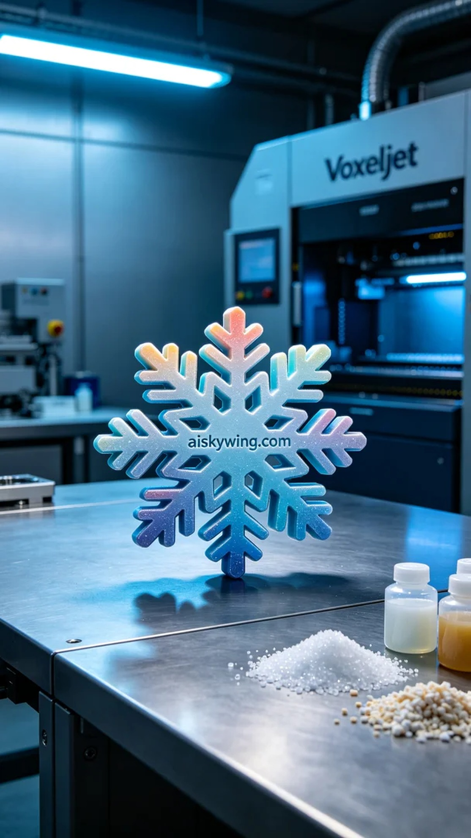
Aiskywing Industrial 3D Printing
Full-color 3D printed snowflake model


