0503-全彩3D打印音乐符号模型生产记录
Full-color 3D printed musical note model
🖨️ 全彩3DP
🖥️ 打印机: Xjet
📦 材料: 全彩3DP
生活再难，也别停下脚步。就像接下这个全彩3D打印音乐符号模型的单子，我知道这是一个充满挑战与机遇的项目。
No matter how difficult life gets, don't stop moving forward. Just like taking on this order for a full-color 3D printed musical symbol model, I know this is a project filled with challenges and opportunities.
________________________________________________________________________________
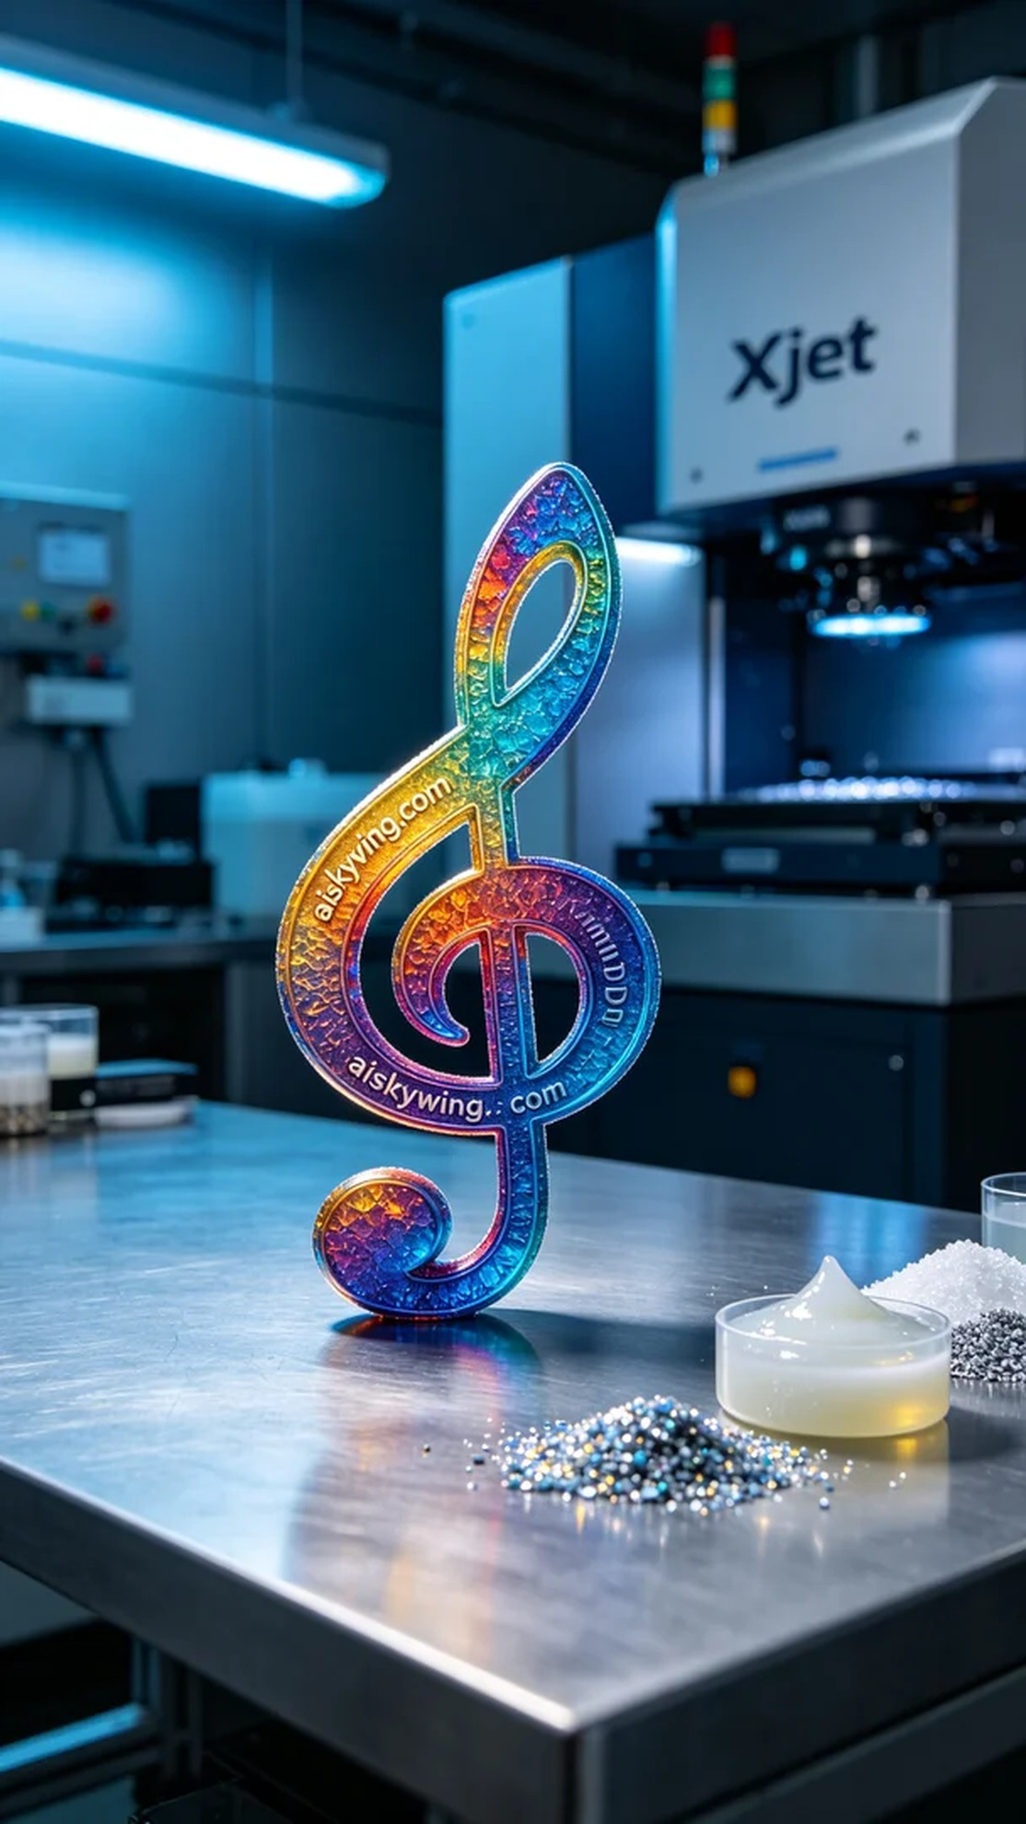
Recently, someone reached out to me through WhatsApp, inquiring about the production of a full-color 3D printed music symbol model. They wanted to create a piece that is vibrant in color and rich in detail, perfect for commercial product photography. This was a great opportunity to showcase our technical capabilities.
We chose full-color 3DP as the primary material, which not only offers vivid colors but also enables the presentation of intricate details, providing a realistic feel. For the equipment, we used Xjet brand printers, setting the layer thickness to 0.1mm, maintaining a printing temperature of 25°C, with power set at 75W and a printing speed of 30mm per hour. These parameters were tested and optimized to ensure the best results.
During the printing process, the Xjet printer ran steadily with sound levels well controlled. Under our strict quality monitoring, we ensured that each layer was printed accurately. After the print finished, we checked the overall effect of the model; the color gradient was seamless, and the intricate details were flawless, which was very satisfactory.
After that, we moved on to detailed post-processing steps. We began by cleaning the model with a cleaning agent to remove any residual photopolymer resin on the surface. Next, we lightly sanded the model with fine sandpaper to ensure a smooth surface. Finally, we placed the model into a curing box for the curing process, which is crucial for enhancing the model's durability and glossiness. Upon completion of curing, we conducted a final inspection to ensure every detail met our standards.
After a series of processes, this full-color 3D printed music symbol model is not only visually stunning but also highly reliable in quality. This was truly a successful endeavor, and I look forward to seeing it shine in upcoming product photography.
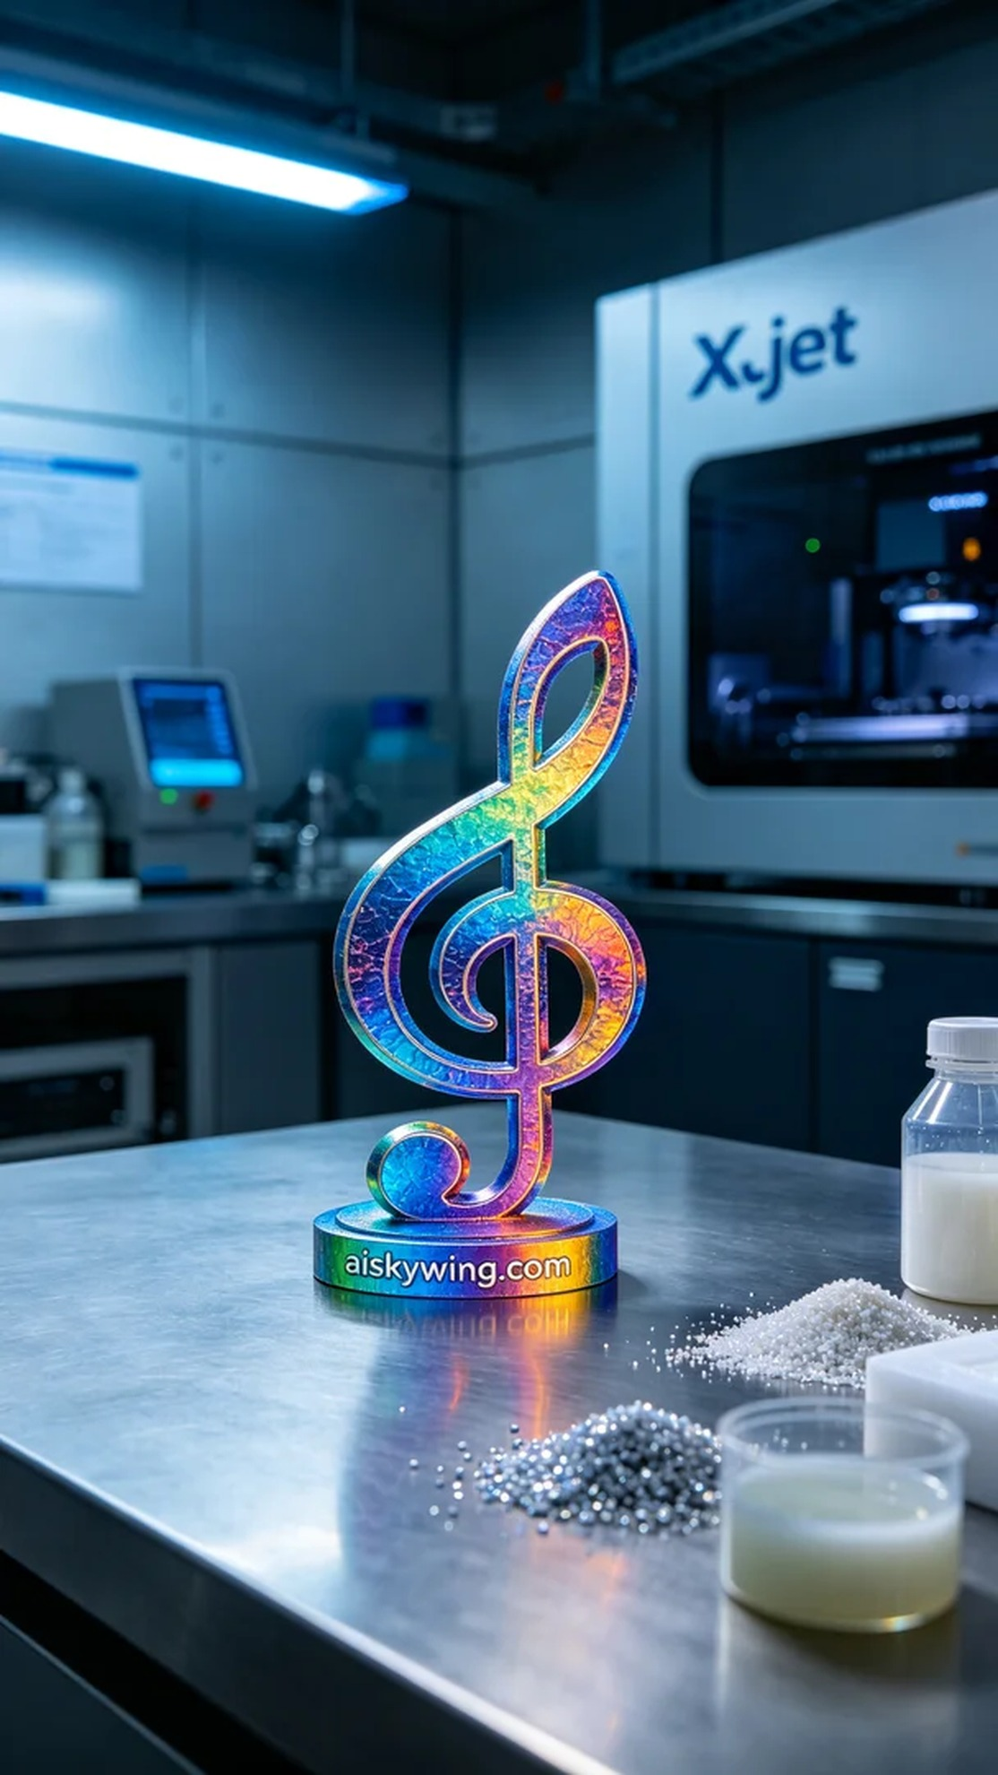
最近，有人通过WhatsApp联系我，询问全彩3D打印音乐符号模型的生产事宜。他们希望能够打造一个色彩丰富、细节精彩的作品，以便在商业产品摄影中展现。这是一个能展现我们技术实力的好机会。
我们选择了全彩3DP作为主要材料，这种材料不仅色彩鲜艳，且能够展现复杂的细节，给人以真实的感受。设备方面，我们使用了Xjet品牌的打印机，设置层厚为0.1mm，打印温度保持在25°C，功率设为75W，打印速度则调整至每小时30mm。这些参数经过多次测试和优化，确保能够达到最佳效果。
在打印过程中，Xjet打印机运行稳定，噪音控制得当。在我们严密的质量监控下，确保每一层的打印都精准无误。打印完成后，检查了模型的整体效果，颜色渐变十分顺滑，细节部分也没有任何缺陷，令人满意。
之后，我们进行了细致的后处理工序。首先使用清洗剂对模型进行清洗，去除表面残留的光敏树脂。接着，用细砂纸对模型进行轻微打磨，以确保表面光滑。最后，我们将模型放入固化箱中进行固化处理，这一步至关重要，能够增强模型的耐用性和光泽度。固化完成后，进行了最后的检验，确保每个细节都达到标准。
经过一系列的处理，这个全彩3D打印音乐符号模型不仅在视觉上令人惊艳，质量也是相当可靠。这真是一次成功的尝试，期待它在接下来的产品摄影中大放异彩。
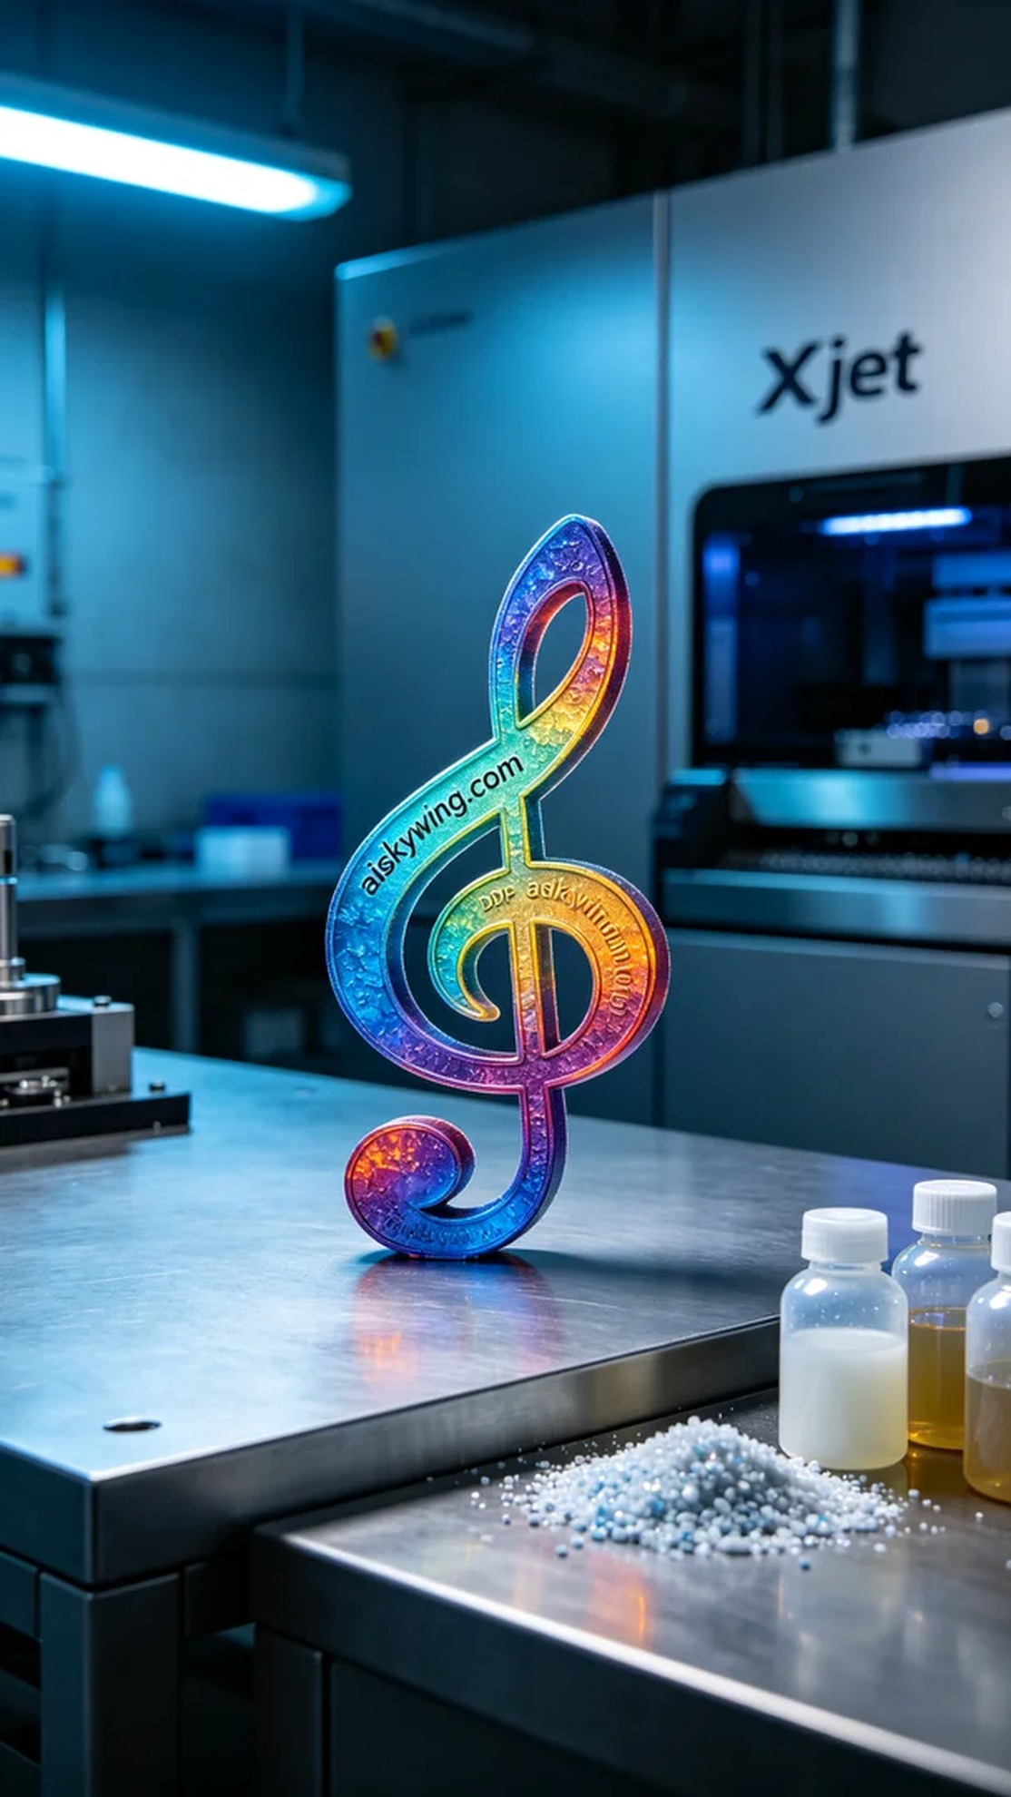
Aiskywing Industrial 3D Printing
Full-color 3D printed musical note model


