0504-全彩3D打印餐具模型生产记录
Full-color 3D printed tableware model
🖨️ 全彩3DP
🖥️ 打印机: Rize
📦 材料: 摆放着未成型的液态光敏
生活就像一场精密的打印，有时需要我们耐心调整。最近，有人找我们做这个全彩3D打印餐具模型，想要呈现出色彩的丰富和细腻。
Life is like a precise printing process that sometimes requires us to adjust patiently. Recently, someone approached us to create a full-color 3D printed tableware model, aiming to showcase the richness and delicacy of colors.
________________________________________________________________________________
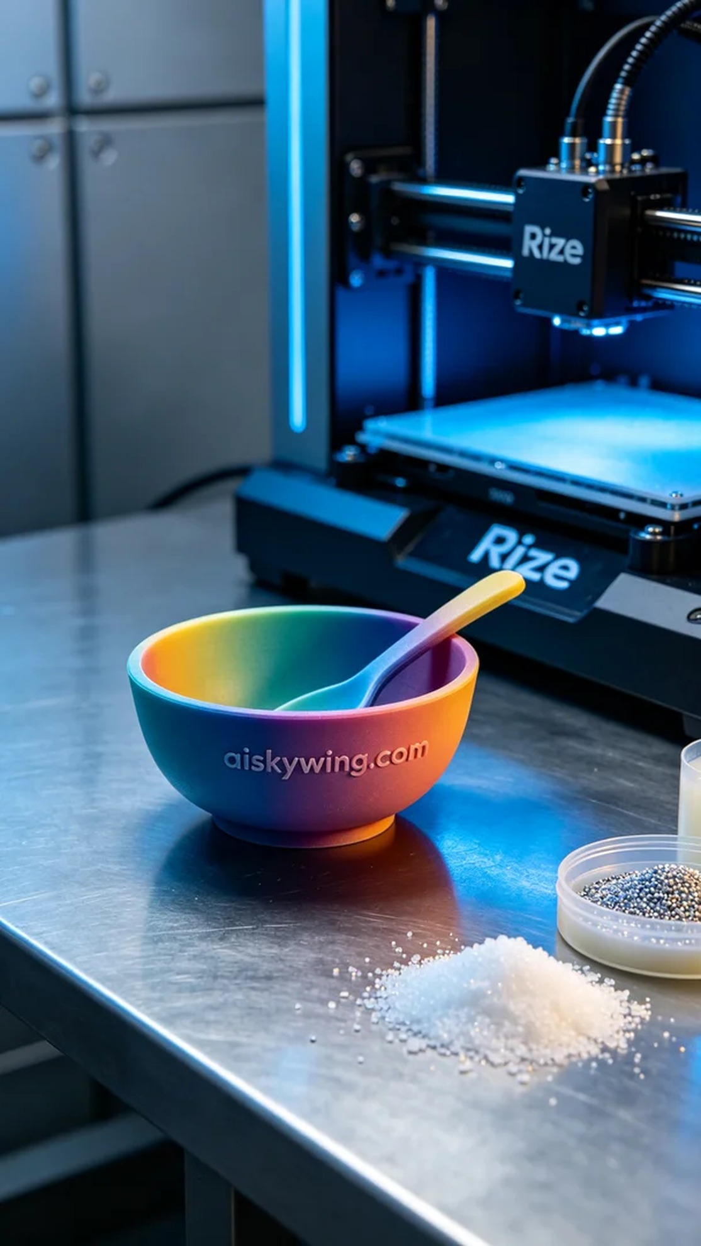
Life is like a precise print; sometimes it requires our patience to make adjustments. Recently, someone approached us to create a full-color 3D printed tableware model, aiming to showcase rich colors and fine details.
In terms of materials, we used unformed liquid photopolymer resin, which has excellent fluidity and good forming effects. After preparing these materials, we first ensured that the printer's environment temperature was stable and suitable for the photopolymer resin. Based on the desired model details, we set the printing parameters to a layer thickness of 0.1mm, a temperature of 25 degrees Celsius, a printing speed of 50mm/s, and a power of 100%.
As the printing process began, the Rize printer's light source gradually illuminated, evenly coating the worktable with liquid photopolymer resin. Throughout the printing process, we regularly monitored the machine's operations to ensure that the curing effect of each layer met expectations. Through real-time monitoring, we found that the color gradient was beautifully represented, and model details were perfectly preserved, aligning with the design intent.
Once the printing was complete, we entered the post-processing stage. First, we cleaned the model using a specialized cleaning solution to thoroughly remove any excess resin from the surface. Next, we polished the surface of the model to enhance its fineness. After that, we cured the model under a UV light to ensure its strength and durability were at 100%, followed by a meticulous inspection of every detail to ensure there were no flaws.
After a series of precise procedures, this full-color 3D printed tableware model was finally perfectly presented. Its rich color and intricate design gave us great satisfaction, and we look forward to more exciting projects like this.
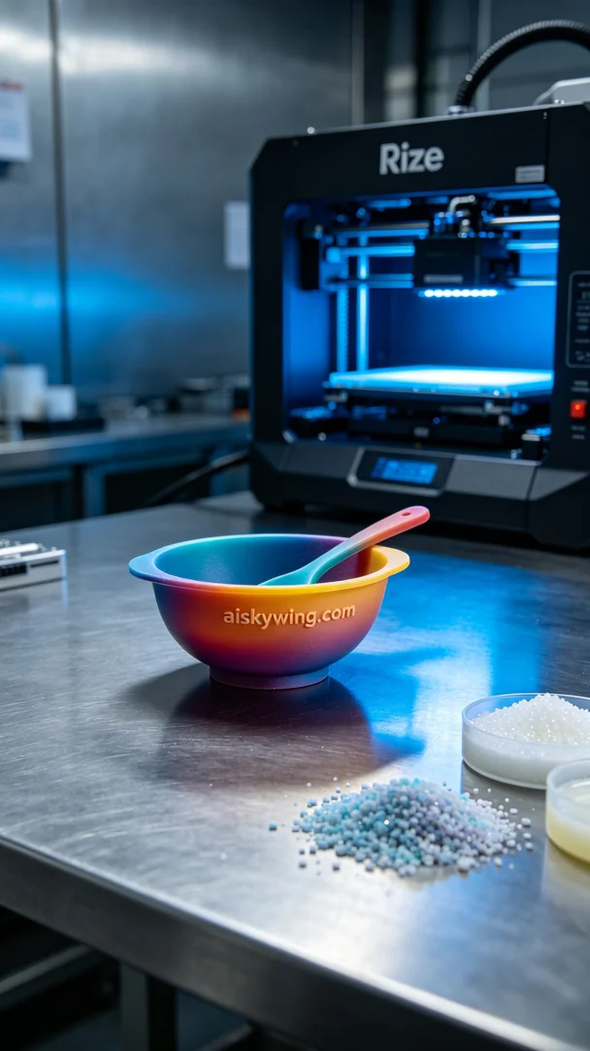
材料方面，我们使用的是未成型的液态光敏树脂，具备优良的流动性和良好的成型效果。准备好这些材料后，首先要确保打印机的环境温度稳定，适合光敏树脂的特性。根据所需的模型细节，我们将打印参数设置为层厚0.1毫米，温度维持在25摄氏度，打印速度设定为50毫米/秒，功率为100%。
打印过程开始时，Rize打印机的灯源逐渐亮起，液态光敏树脂在工作台上均匀涂布。整个打印过程中，我们定期监控机器的运行状态，确保每一层的固化效果都达到预期。通过实时监测，我们发现色彩渐变的呈现效果非常出色，模型细节得以完美保留，符合设计初衷。
打印完成后，我们进入后处理阶段。首先对模型进行清洗，使用专用的清洗液，将表面多余的树脂彻底去除。之后，进行打磨，将模型表面稍作处理，以提升细腻度。接着，我们用UV灯对模型进行固化，确保其强度和耐用性达到百分之百，最后仔细检查每个细节，确保没有瑕疵。
经过一系列精密工序后，这个全彩3D打印餐具模型终于完美呈现。它的色彩丰富性和细致的设计令我们倍感欣慰，期待更多这样有趣的项目。
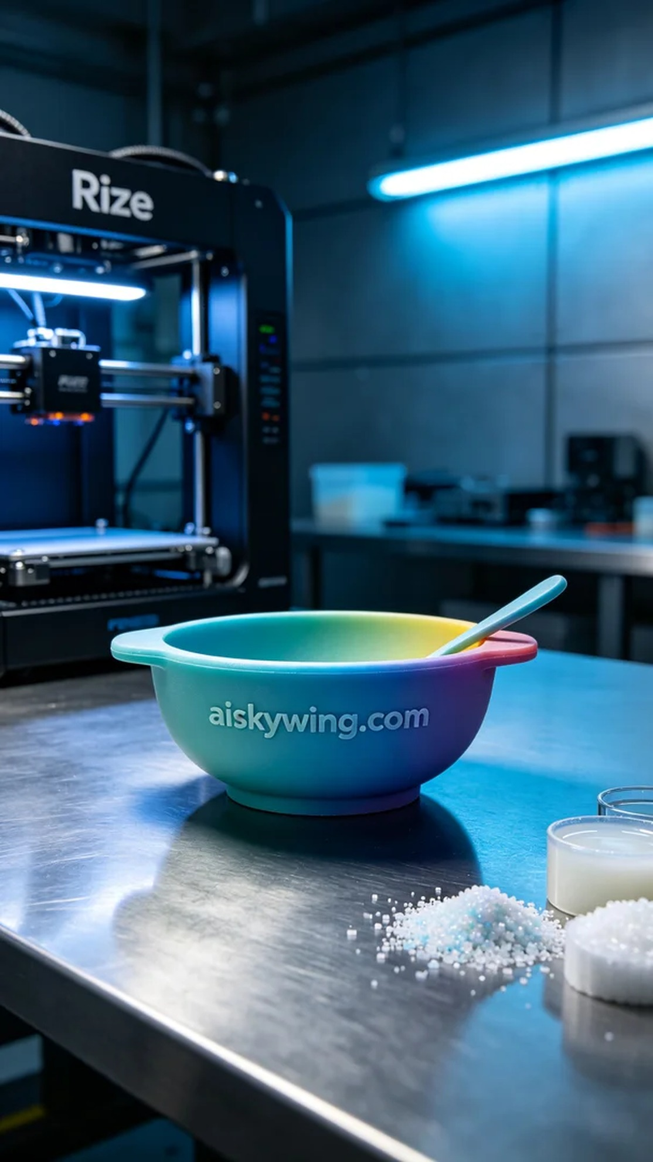
Aiskywing Industrial 3D Printing
Full-color 3D printed tableware model


