0505-全彩3D打印鼓模型制作记录
Full-color 3D printed drum model
🖨️ 全彩3DP
🖥️ 打印机: Stratasys
📦 材料: 全彩3DP彩色树脂
生活就像3D打印的过程，总是需要调试与耐心。最近，有人通过Instagram找到我们，希望定制一个全彩3D打印鼓模型。
Life is like the process of 3D printing, always requiring debugging and patience. Recently, someone found us through Instagram and wanted to customize a full-color 3D printed drum model.
________________________________________________________________________________
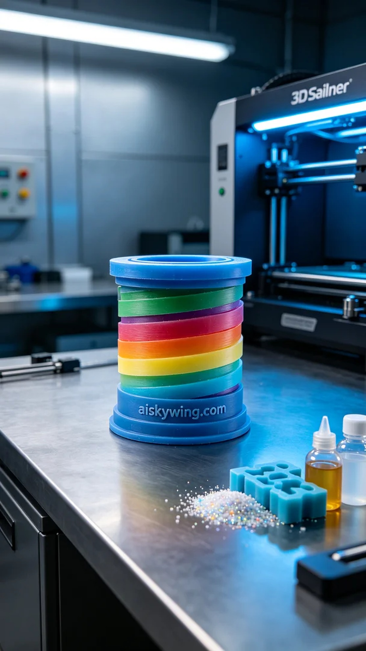
Life is like the process of 3D printing; it always requires fine-tuning and patience. Recently, someone reached out to us via Instagram, hoping to create a vibrant full-color 3D printed drum model.
For this project, we chose full-color 3DP resin to ensure the printed colors would be saturated and have a soft sheen. We utilized a Stratasys printer, setting the appropriate printing parameters: a layer thickness of 0.1 mm, a printing temperature of 25 degrees Celsius, a power setting of 80 watts, a print speed of 40 mm/s, and an expected print time of 12 hours.
During the printing process, the Stratasys printer operated smoothly, and we closely monitored the quality of the print. We paid careful attention to the deposition of each layer, ensuring that the color gradients and details were rendered clearly. The machine functioned without any hitches, and the entire process went on without issues.
After printing, we proceeded to the post-processing phase. We began by rinsing the print in water to remove any residual resin from the surface. Next, we sanded the model with fine-grit sandpaper, ensuring a smooth finish. Finally, the model was placed in a curing device for solidification, confirming its strength and durability, and we verified that it met the quality standards.
Each print is a new challenge, and this full-color 3D printed drum model not only showcases our team's technical skills but also brings out the vibrancy and joy of life.
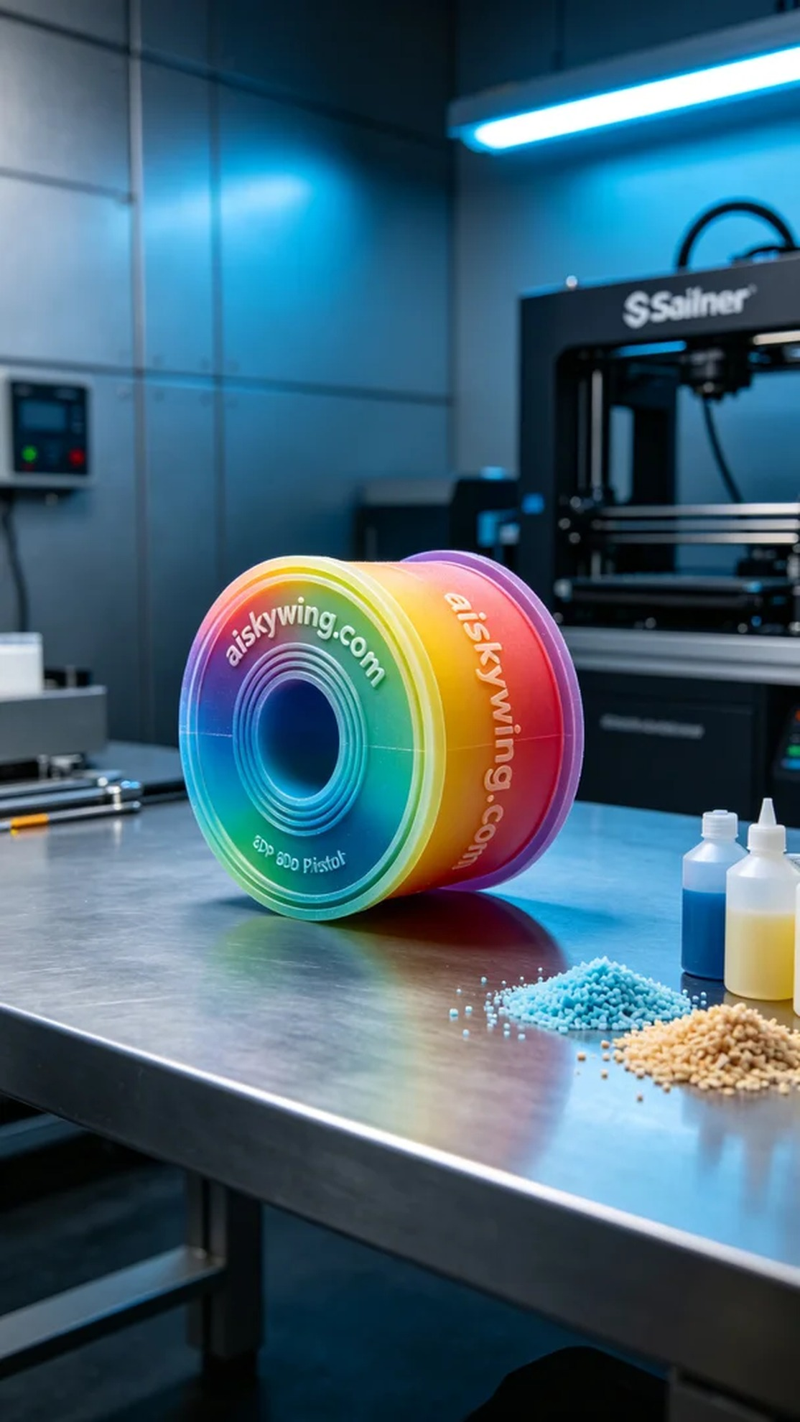
这次的项目来自于一个爱好音乐的人，他想要一个细致入微的全彩3D打印鼓模型。通过Instagram与我们联系，他希望这个模型能够完美呈现色彩的丰富性与细节。
我们选择了全彩3DP彩色树脂作为原材料，确保打印出的颜色饱和且光泽柔和。设备方面，我们使用了Stratasys打印机，设定了合适的打印参数。层厚设置为0.1毫米，打印温度保持在25摄氏度，功率为80瓦，打印速度控制在40毫米/秒，预计打印时间为12小时。
在打印过程中，Stratasys打印机稳定运行，实时监控打印质量。我们仔细观察每一层的沉积情况，确保颜色渐变和细节的清晰可见。设备运行良好，整个过程顺利，没有出现任何故障。
打印完成后，我们进入了后处理工序。首先用清水清洗打印件，以去除表面的残留树脂。接着，使用细砂纸对模型进行打磨，使表面更加光滑。最后，将模型放入固化设备中进行固化处理，确保其强度和耐用性，经检验后确认质量符合标准。
每一次的打印都是一次新的挑战，而这次的全彩3D打印鼓模型不仅展现了我们团队的技术，也让人感受到生活中的色彩与乐趣。
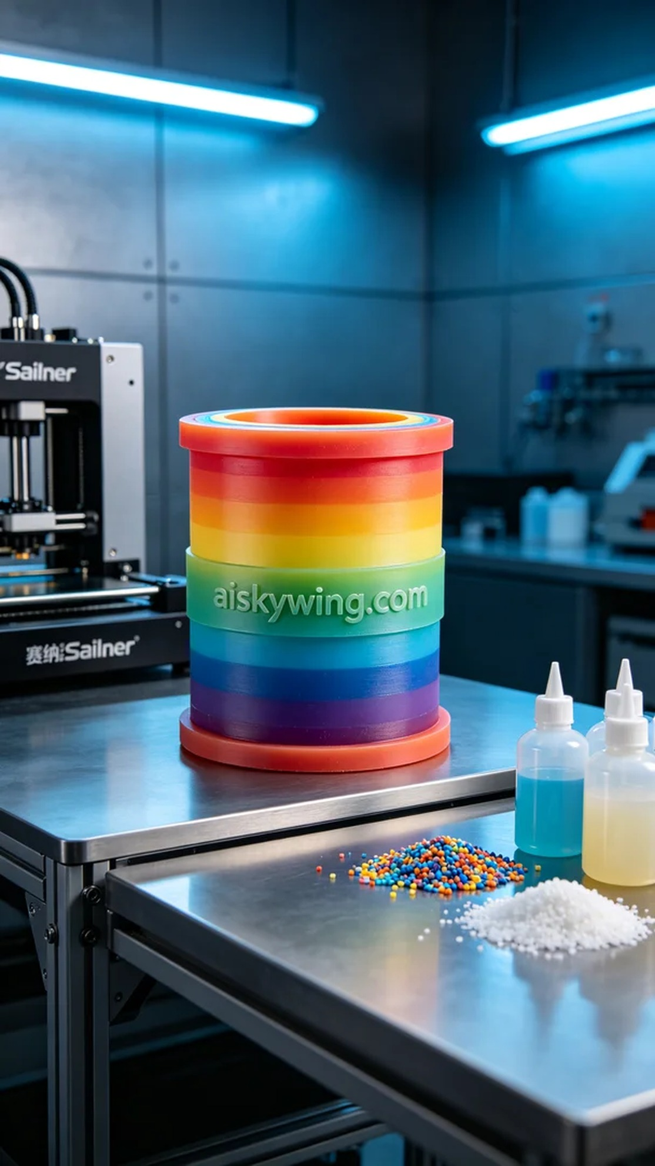
Aiskywing Industrial 3D Printing
Full-color 3D printed drum model


