0506-全彩建筑沙盘模型的打印记录
Full-color architectural sand table model
🖨️ 全彩3DP
🖥️ 打印机: Systems
📦 材料: 全彩3DP
生活就像3D打印，每一步都需要精准和坚持。有人在Instagram上看到我们的全彩建筑沙盘模型，正因对色彩和细节有高要求，找上了我们。
Life is like 3D printing; every step requires precision and persistence. Someone saw our full-color architectural model on Instagram and reached out to us due to their high demands for color and detail.
________________________________________________________________________________
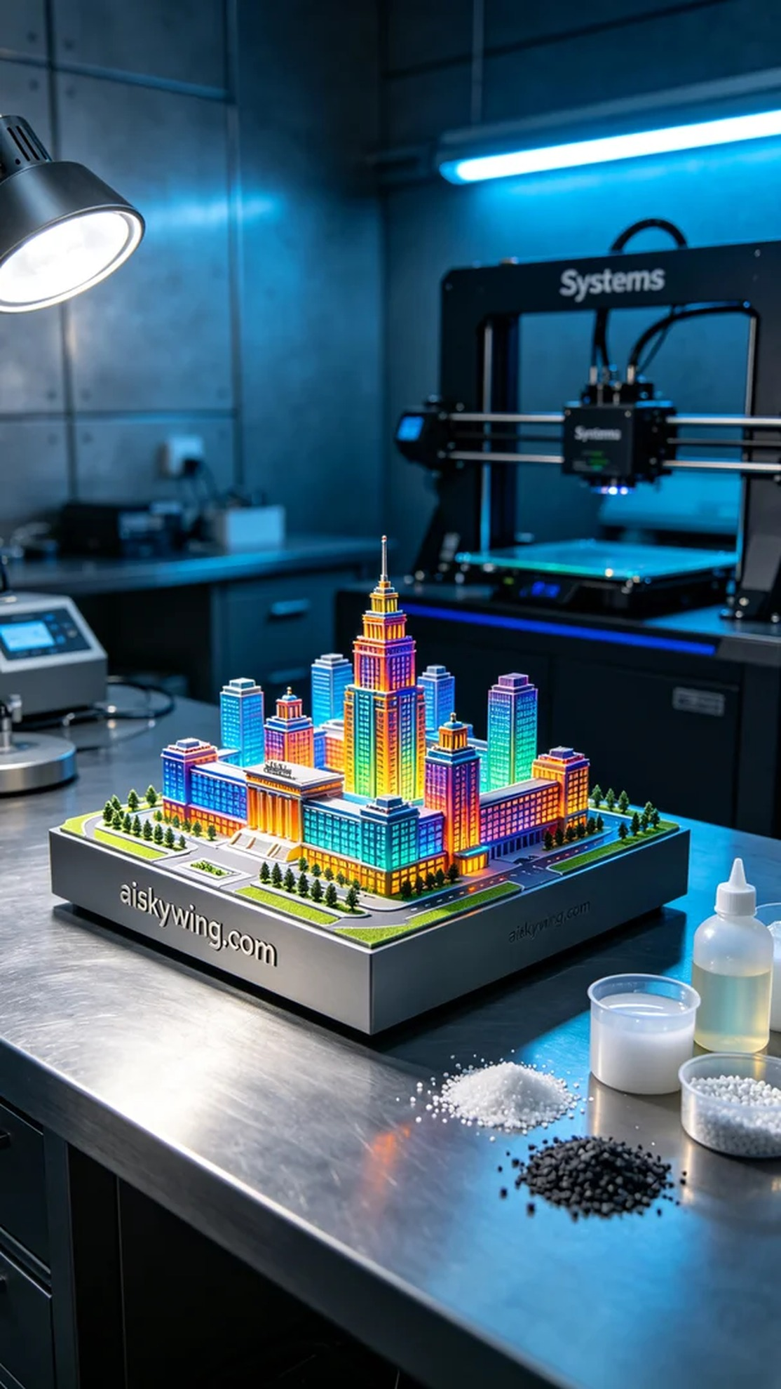
Life is like 3D printing; every step requires precision and persistence. Someone saw our full-color architectural model on Instagram and reached out due to their high demand for color and detail.
The raw material we used this time is full-color 3DP, known for its excellent richness in color and detail presentation. In the preparation phase, we selected a Systems brand 3D printer. To ensure printing quality, we set the layer thickness to 0.1 mm, printing temperature at 60 degrees Celsius, power at 60W, and speed at 30 mm per second. The entire printing process was expected to take 12 hours.
During the printing process, the Systems printer operated smoothly, while the monitoring system observed the print quality in real-time. As each layer gradually deposited, the details of the model became more apparent. The cold industrial light reflected off the surface of the model, showcasing stunning high-definition color textures. Staff members maintained high levels of concentration in the workshop, ready to address any unexpected issues.
After printing, we proceeded to the post-processing phase. First, we immersed the model in a cleaning solution to remove any residual photopolymer resin. Once cleaned, we carried out sanding to ensure a smooth surface free of imperfections. Next, we placed the model in a curing device for UV curing, guaranteeing that every detail was robust and durable. Finally, we conducted a thorough inspection of the model to ensure vibrant colors and flawless details.
After this meticulous series of processes, we proudly presented the full-color architectural model. Each printing job is a new challenge, but every successful completion brings us immense pride.
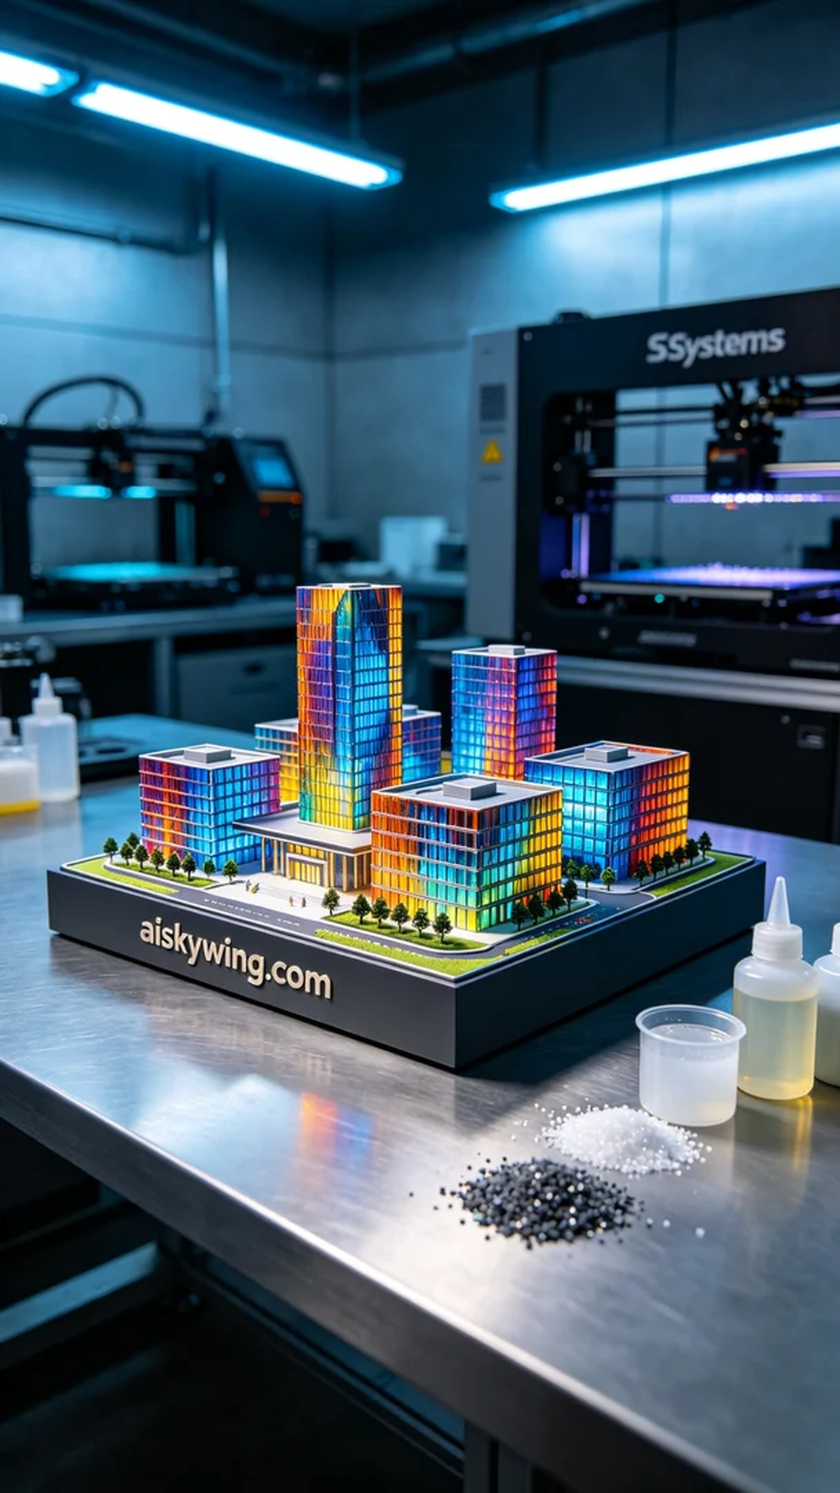
我们这次使用的原材料是全彩3DP，具有出色的色彩丰富性和细节呈现。打印准备阶段，我们选择了Systems品牌的3D打印机。为了确保打印效果，我们设定了层厚0.1毫米，打印温度为60摄氏度，功率60W，速度为30毫米每秒。整个打印过程预计需要12小时。
在打印过程中，Systems打印机运行稳定，监控系统实时观察打印质量。随着每层的逐渐沉积，模型的细节逐渐显露。冷色调的工业光线反射在沙盘模型的表面，展现出令人惊艳的高清彩色纹理。操作间内，工作人员保持着高度集中，随时准备处理可能出现的意外情况。
打印完成后，我们进入了后处理工序。首先，我们将模型浸入清洗液中进行清洗，以去除残余的光敏树脂。清洗完成后，进行打磨处理，确保表面光滑无瑕疵。随后，将模型放入固化设备中，进行UV固化，确保每个细节都坚固耐用。最后，我们对模型进行仔细检验，确保色彩鲜明且细节完美。
经过这一系列精细的工序，最终呈现出这款全彩建筑沙盘模型。每一次的打印都是一次新的挑战，但每一次的成功都让我们感到无比自豪。
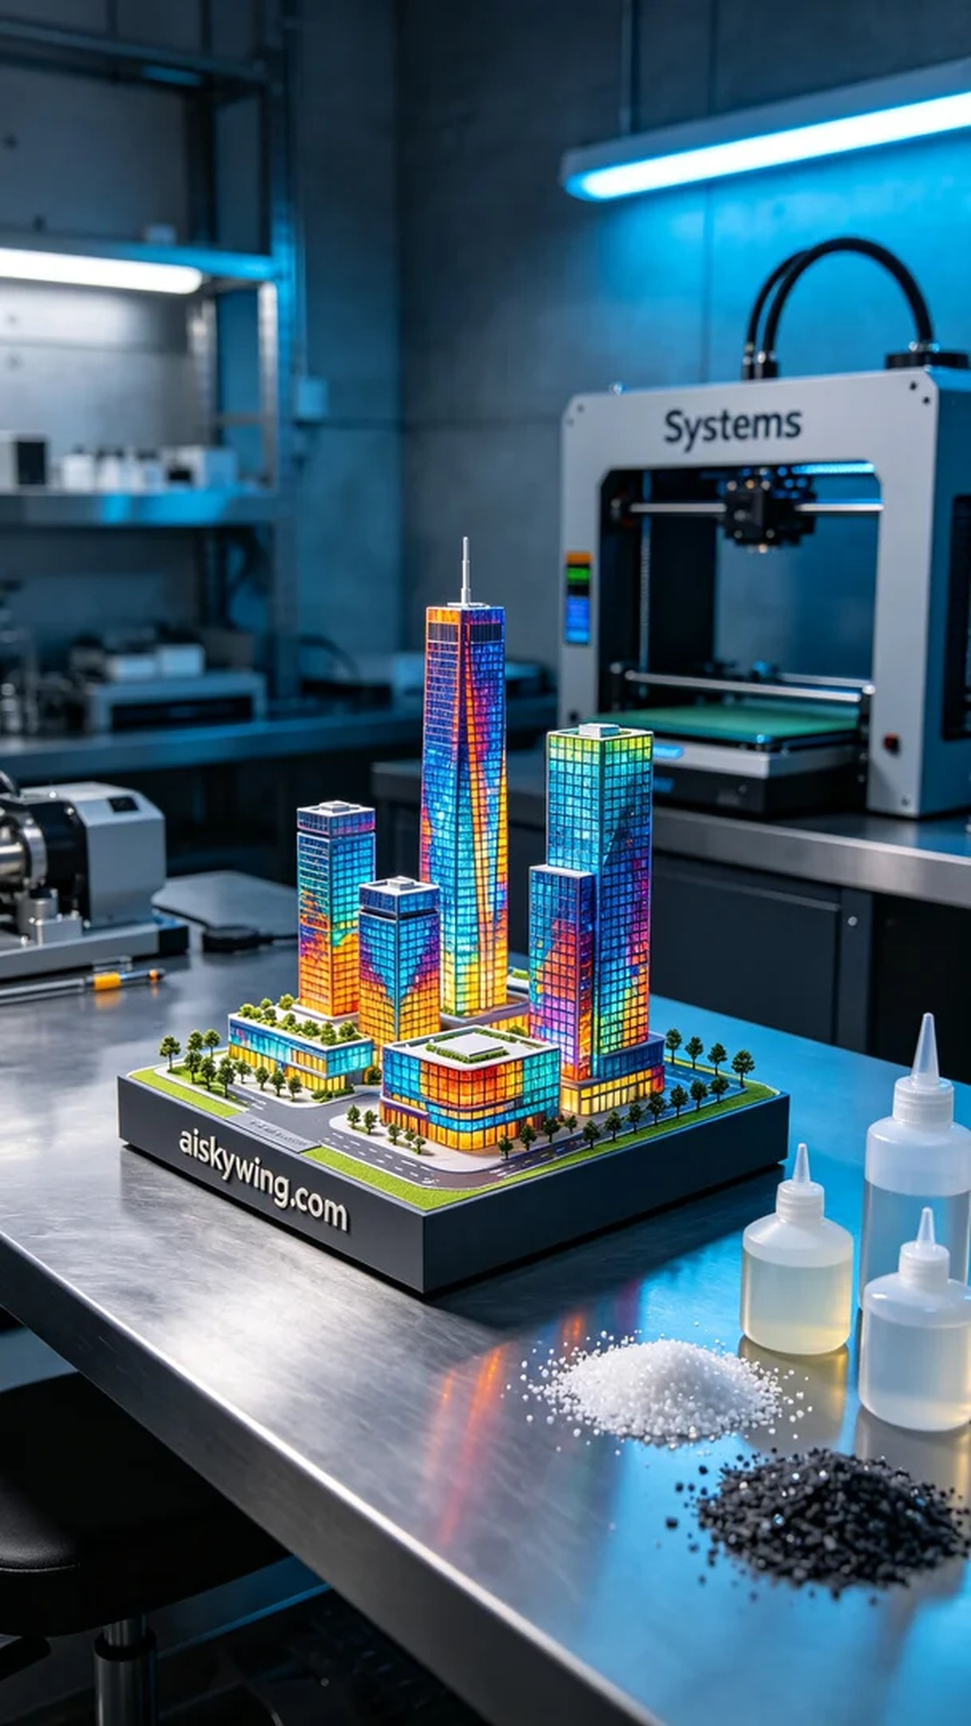
Aiskywing Industrial 3D Printing
Full-color architectural sand table model


