0507-3D打印乐器模型生产记录
Colorful 3D Printed Musical Instrument Model
🖨️ 全彩3DP
🖥️ 打印机: Carbon
📦 材料: 全彩3DP彩色树脂
生活就像3D打印，每个层次都在构建我们的未来。近日，有人通过Facebook找到我们，希望制作一个彩色3D打印乐器模型，以展示其独特的艺术魅力。
Life is like 3D printing, with each layer building our future. Recently, someone reached out to us through Facebook, hoping to create a colorful 3D printed musical instrument model to showcase its unique artistic charm.
________________________________________________________________________________
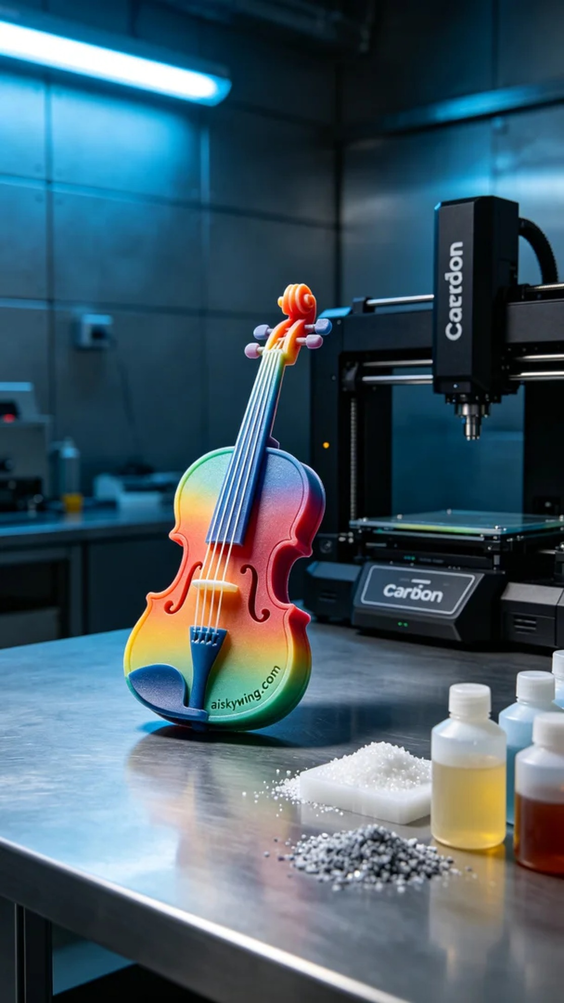
Life is like 3D printing, where each layer builds our future. Recently, someone reached out to us through Facebook, hoping to create a colorful 3D printed instrument model to showcase its unique artistic appeal.
To ensure the best results, we selected full-color 3DP resin as our material. This type of resin not only has vibrant colors but also excellent detail presentation capabilities. We used a Carbon 3D printer, setting parameters to a layer thickness of 0.1 mm, a printing temperature of 25°C, a power setting of 50W, and a speed of 30mm/s. These settings allowed us to efficiently complete the print while maintaining quality.
Each detail of the printing process requires strict monitoring. We initiated the Carbon printer and observed the formation of each layer. Due to the complexity of the instrument model, we paid particular attention to the flow of resin and the adhesion between layers. After several hours of printing, we successfully constructed all the details layer by layer, and the model gradually became visible.
Once printing was completed, we carried out detailed post-processing. First, we immersed the model in cleaning solution to remove any uncured resin residue. After cleaning, we meticulously sanded the surface of the model with specialized tools to ensure smoothness. Finally, we cured the model under UV light to ensure its strength and color durability. After all processes were completed, we carefully inspected each model's quality to ensure that precision and detail met expectations.
After a series of meticulous crafts and treatments, this colorful 3D printed instrument model finally shone before us. Every detail sparkles with artistic brilliance, bringing us great satisfaction.
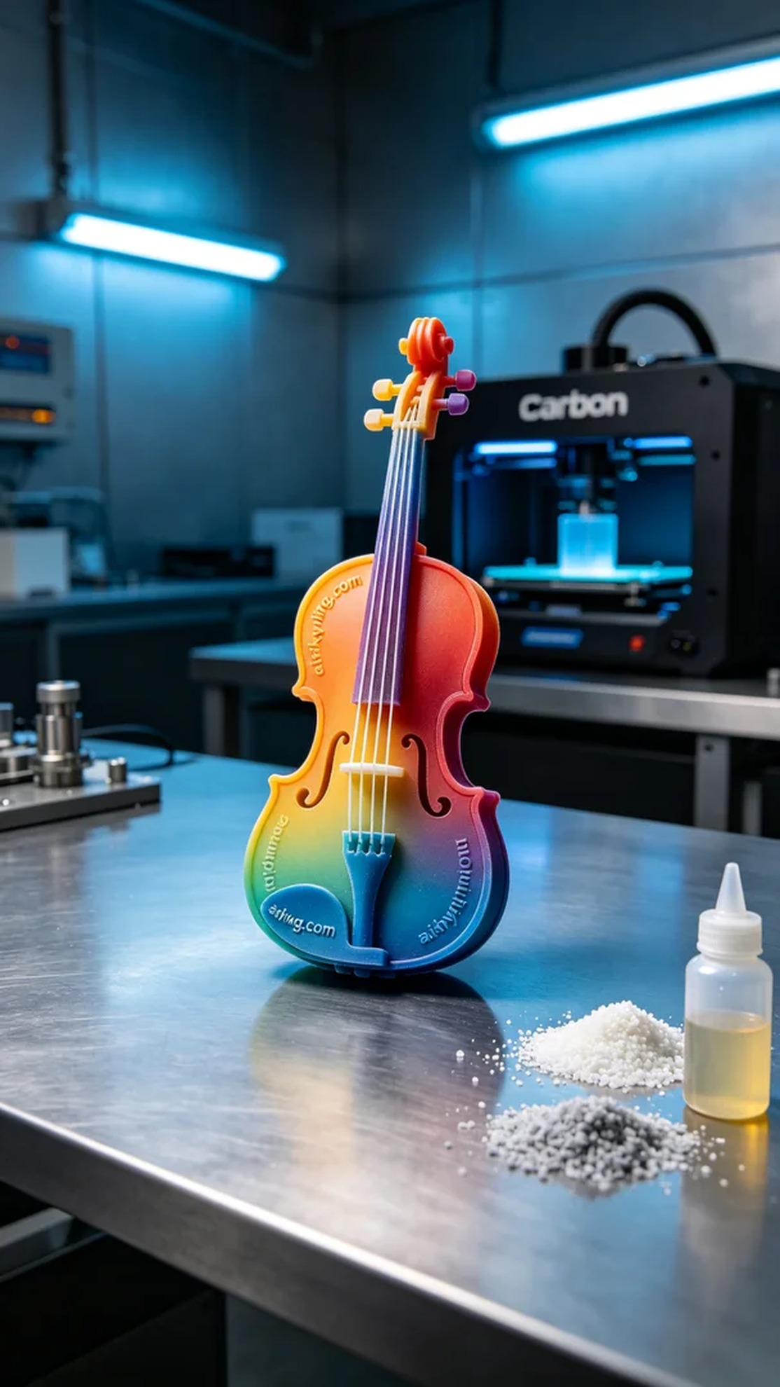
我们接到一个有趣的项目，通过Facebook联系到我们的人希望制作一个彩色3D打印乐器模型。他们遇到的问题是，传统手工制作的乐器无法展现他们设计的复杂色彩與细节效果。因此，我们决定利用全彩3DP技术来完成这个挑战。
为确保打印出理想的效果，我们选择了全彩3DP彩色树脂作为材料。这种树脂不仅色彩饱和，而且具有良好的细节呈现能力。设备方面，我们使用了Carbon品牌的3D打印机，设置参数为层厚0.1毫米，打印温度为25°C，功率为50W，打印速度设定为30mm/s。这些参数让我们在确保质量的同时，能够更高效地完成打印。
打印过程中的每个细节都需要严格监控。我们开启了Carbon打印机，观察每一个层的形成。由于乐器模型复杂，打印过程中我们特别注意树脂的流动和层间的粘合性。在持续几个小时的打印下，我们成功地将所有的细节逐层构建出来，模型逐渐清晰可见。
完成打印后，我们进行了详细的后处理工序。首先将模型浸入清洗液中，去除未固化的树脂杂质。清洗完成后，使用专业的打磨工具对模型表面进行了细致打磨，确保光滑度。最后，我们将模型放置在紫外灯下进行固化处理，确保其强度与色彩的持久性。在所有工序完成后，我们逐一检验每个模型的质量，确保精度和细节均达到预期标准。
经过一系列精细的工艺与处理，这个彩色3D打印乐器模型终于成功呈现在我们眼前。每一处细节都在闪烁着艺术的光辉，令我们倍感欣慰。
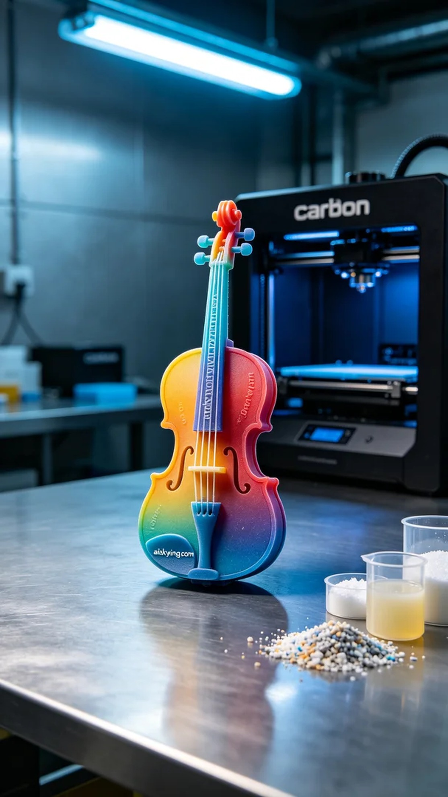
Aiskywing Industrial 3D Printing
Colorful 3D Printed Musical Instrument Model


