0508-3D打印人物半身像生产记录
Colorful 3D Printed Bust of a Character
🖨️ 全彩3DP
🖥️ 打印机: Rize
📦 材料: 全彩3DP彩色打印
生活再难，也别停下脚步。就像这次的彩色3D打印人物半身像，我们始终相信技术能帮助我们实现梦想。
No matter how difficult life gets, don't stop moving forward. Just like this colorful 3D printed bust, we always believe that technology can help us achieve our dreams.
________________________________________________________________________________
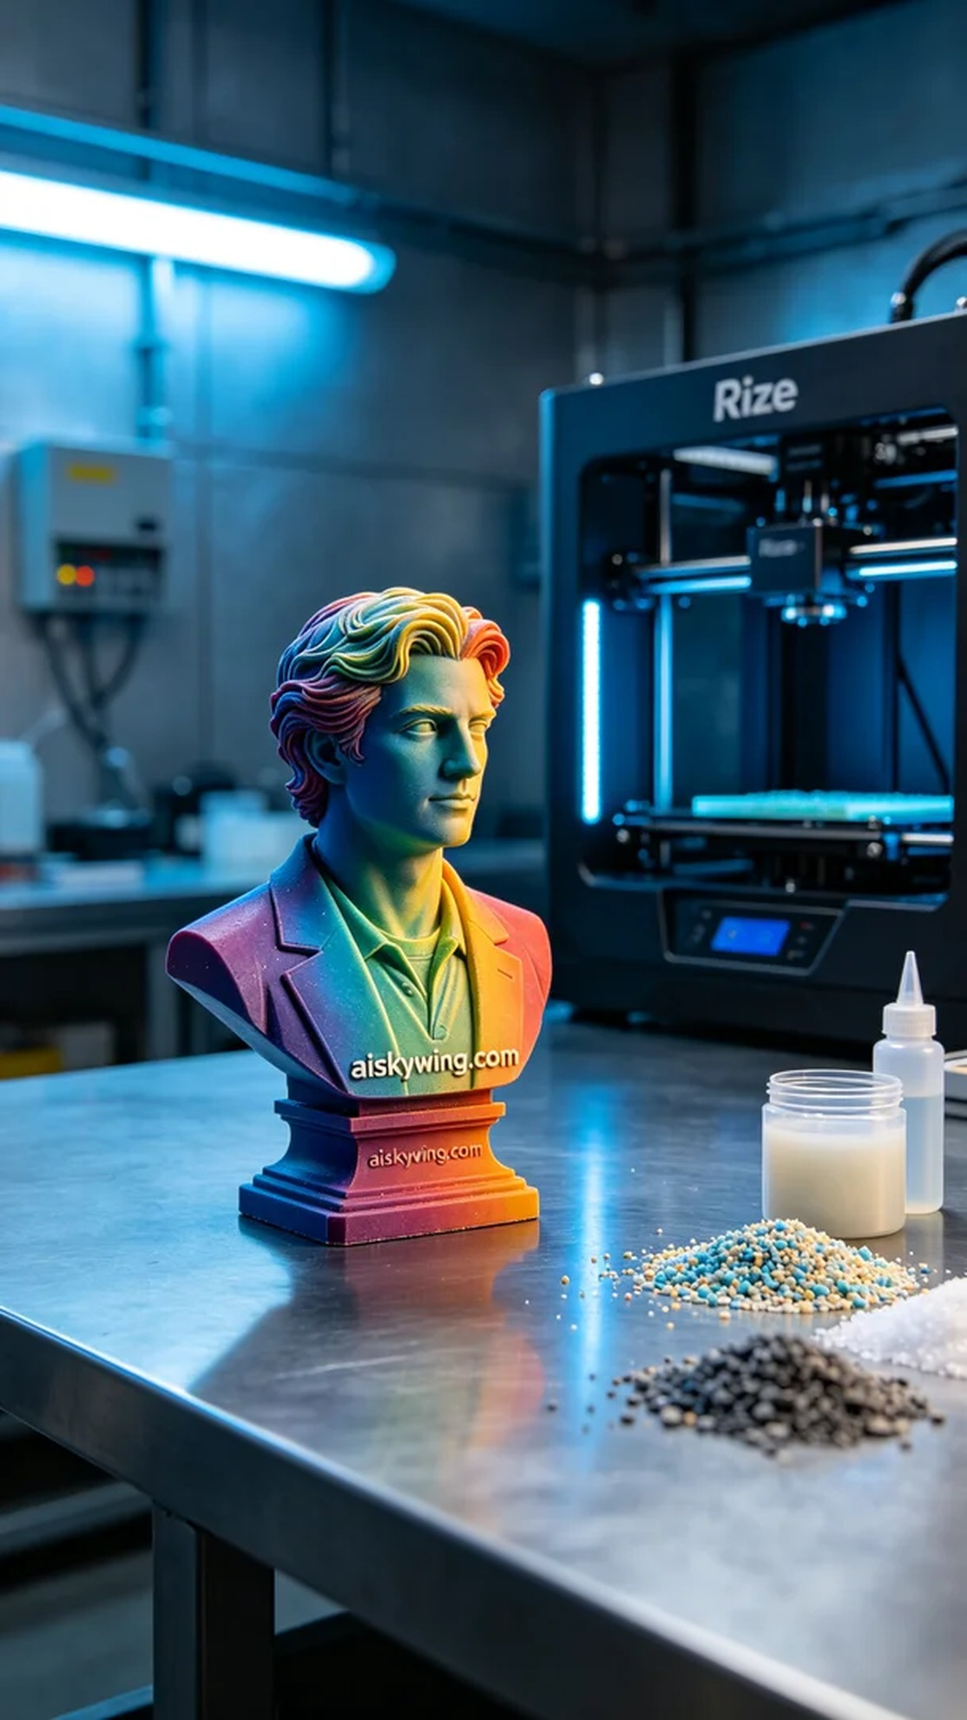
Life can be tough, but we must not stop moving forward. Just like this time with the colorful 3D printed bust, we firmly believe that technology can help us realize dreams.
On Instagram, someone wanted to create a lively colorful 3D printed bust for personal display and promotion. Thus, we took on this challenge to deliver a high-fidelity piece for them.
First, material selection is crucial. This time we used full-color 3DP printing materials, which have excellent color representation and detail reproduction capabilities. To ensure a smooth print, we chose the Rize brand 3D printer, setting the layer thickness to 0.1mm, maintaining the printing temperature at 25°C, the power setting at 80W, speed adjusted to 50mm/s, with an estimated print time of 8 hours.
During printing, the Rize printer operated steadily, and I monitored the entire process. Using monitoring software, I kept an eye on print quality, ensuring that every layer's color gradient and details met expectations. As time passed, the gradually constructed bust began to reveal its contours and colors.
After printing, we moved on to the post-processing stage. First, we cleaned the finished piece to remove any residual liquid photopolymer resin on the surface. Then we carried out careful sanding to enhance the tactile and visual quality, finally placing the bust into the curing device for solidification, ensuring the model's durability and stability. After completion, we inspected the final piece to ensure all parameters met the requirements.
With this production, the colorful 3D printed bust finally presented itself before us, vibrant in color and rich in detail, perfectly showcasing our craftsmanship and technical expertise. Every challenge is a chance to grow, and this piece has added valuable experience to our journey.
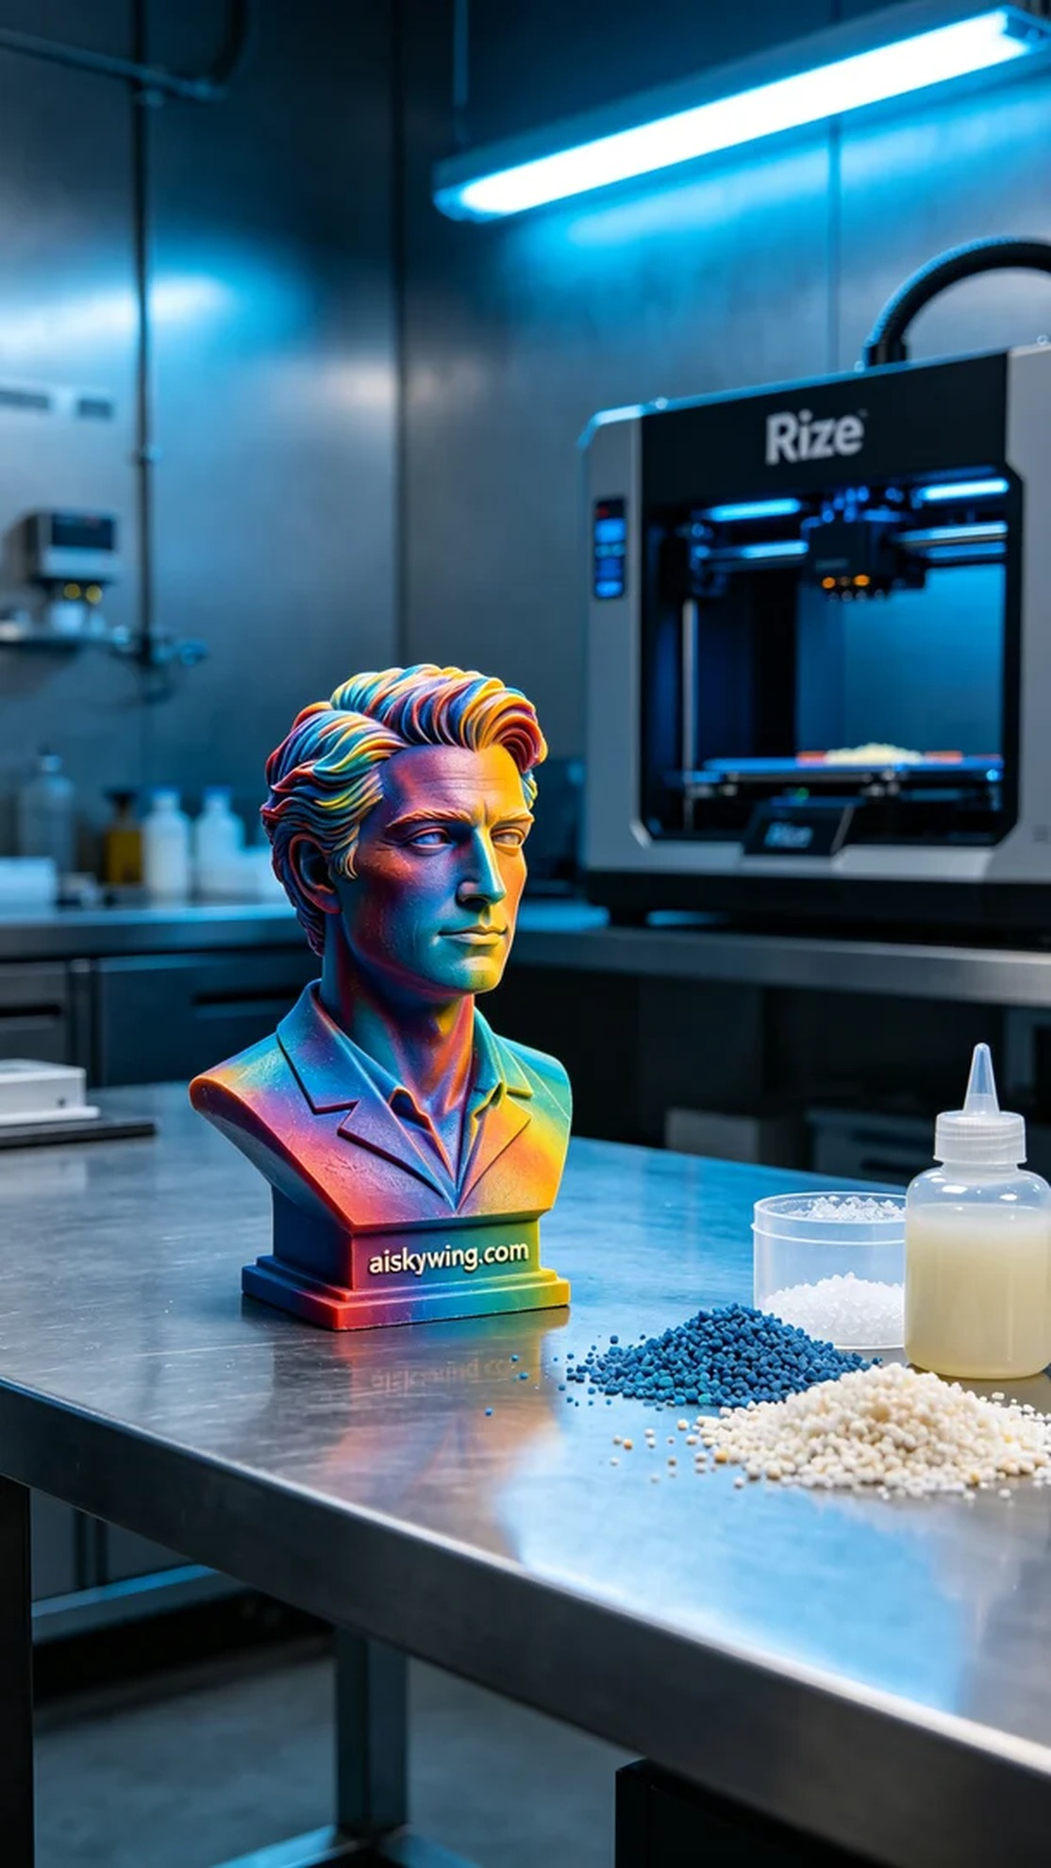
在Instagram上，有人希望制作一款生动的彩色3D打印人物半身像，以用于个人展示和推广。因此，我们接下了这个挑战，准备为他们带来一个高保真的作品。
首先，原材料的选择至关重要。这次我们使用的是全彩3DP彩色打印材料，具有极好的色彩表现力和细节再现能力。为了确保顺利打印，我们选择了Rize品牌的3D打印机，设置了层厚为0.1毫米，打印温度保持在25℃，打印功率设定为80W，速度调节为50mm/s，预计打印时间为8小时。
打印过程中，Rize打印机稳定运行，整个过程都在我的监控之下。通过监控软件，我时刻关注着打印质量，确保每一层的色彩渐变和细节呈现都达到预期效果。随着时间的推移，逐层构建的半身像逐渐显现出它的轮廓和色彩。
打印完成后，我们进入了后处理阶段。首先对成品进行清洗，确保去除表面残留的液态光敏树脂。接着进行细致的打磨，以提升表面的触感和观感，最后将半身像放入固化设备中进行固化，确保模型的耐用性和稳定性。完成后，我们对成品进行检验，确保各项指标符合要求。
经过这次的制作，彩色3D打印人物半身像终于呈现在我们眼前，色彩鲜艳且细节丰富，完美展现了我们的工艺和技术水平。每一次的挑战都是一次成长，而这次的作品又为我们积累了宝贵的经验。
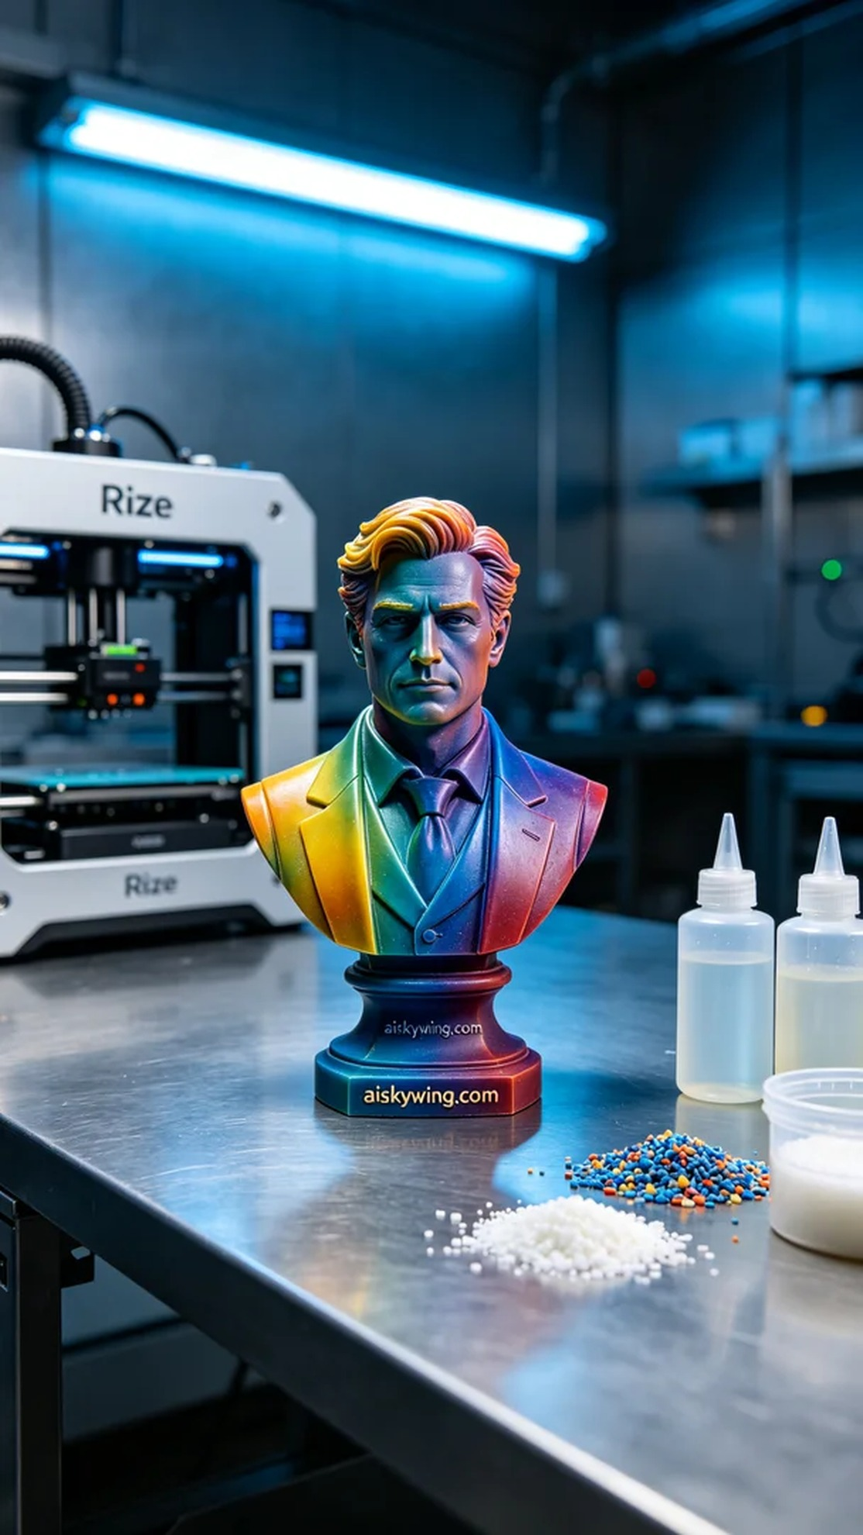
Aiskywing Industrial 3D Printing
Colorful 3D Printed Bust of a Character


