0509-彩色3D打印动漫手办生产记录
Colorful 3D Printed Anime Figurines
🖨️ 全彩3DP
🖥️ 打印机: EOS
📦 材料: 摆放着未成型的液态光敏
生活再难，也别停下脚步。就像接下这个彩色3D打印动漫手办的单子，有人希望我们能将幻想变为现实。
No matter how difficult life gets, don't stop moving forward. Just like taking on this order for a colorful 3D-printed anime figure, someone hopes we can turn their fantasy into reality.
________________________________________________________________________________
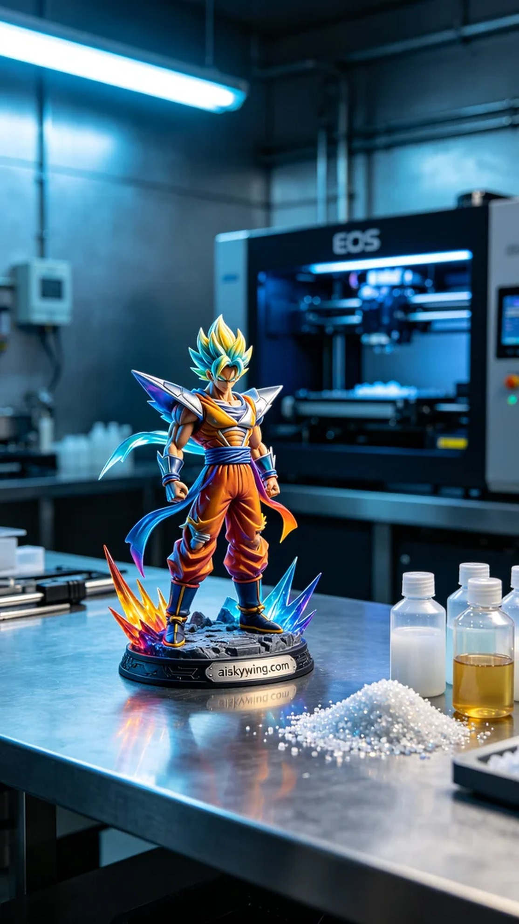
Life can be tough, but don't stop moving forward. It's just like taking on the task of creating a colorful 3D printed anime figure; someone hopes we can turn their fantasy into reality.
We chose to use unformed liquid photopolymer resin as the material, which offers excellent detail reproduction and color clarity. To ensure the best print quality, we equipped ourselves with an EOS 3D printer and set the appropriate parameters, including a layer thickness of 0.1mm, a temperature control at 25°C, a power setting of 80%, and a print speed of 40mm per second. The entire print process was expected to take around 8 hours.
During the printing process, the EOS printer operated steadily, ensuring that every detail was captured perfectly. We continuously monitored the print quality, observing the color gradient and surface smoothness, making adjustments as necessary to guarantee that each layer was flawlessly rendered.
Once printing was complete, we moved on to the post-processing stage. First, we cleaned the figure to remove excess resin residue. Next, we meticulously sanded it down to ensure a smooth surface. After that, we used UV curing to enhance the durability of the figure. Finally, we conducted rigorous inspections to ensure that each figure met our high standards.
After a series of meticulous processes, this colorful 3D printed anime figure was finally completed. Every detail was vividly represented, making it feel almost alive, which brought us immense satisfaction.
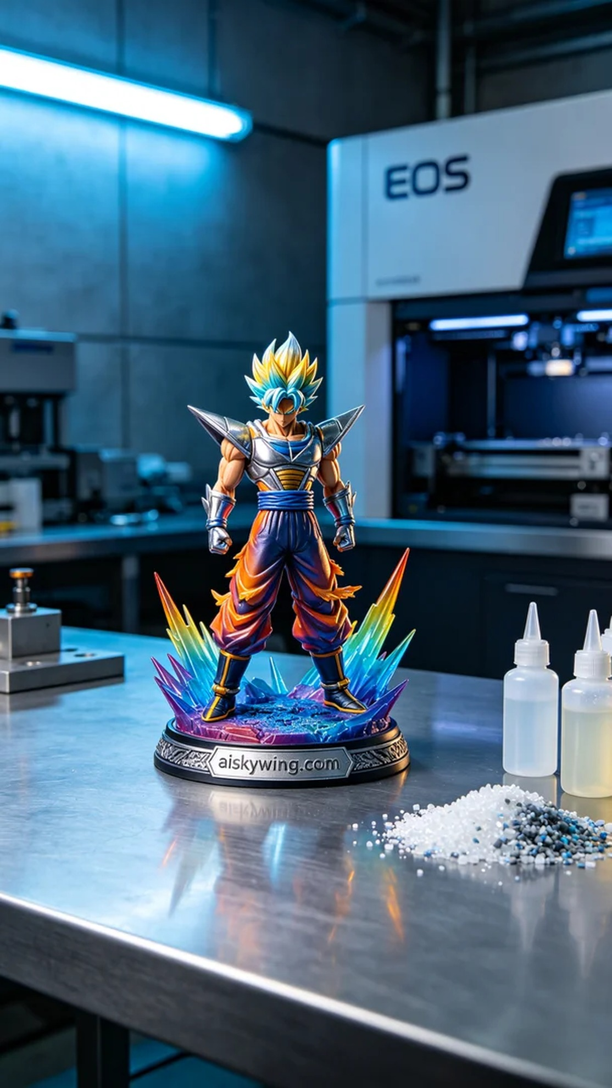
在Twitter上，有人因为想要一款颜色丰富的动漫手办而联系到我们，特别希望我们能打造这款彩色3D打印动漫手办。这个项目不仅要求高精度打印，还希望能够展现出细腻的色彩渐变，满足他们对产品的期待。
我们选用了摆放着未成型的液态光敏树脂作为原材料，这种材料具有极好的细节呈现和色彩清晰度。为了确保打印效果，我们配备了EOS品牌的3D打印机，设置了合理的打印参数，包括层厚为0.1毫米，温度控制在25℃，功率设定为80%，打印速度为40毫米每秒。整个打印过程预计需要8个小时完成。
在打印过程中，EOS打印机稳定地运行，确保每一个细节都能得到充分呈现。我们持续监控打印质量，观察色彩的渐变效果和表面光滑度，随时进行调整，确保每个层次都能如预期般完美展现。
打印完成后，我们进入了后处理工序。首先进行清洗，去除多余的树脂残留，然后进行细致的打磨，确保表面光滑。接下来，我们使用紫外线固化，进一步增强手办的耐久性。最后，我们进行严格的检验，确保每款手办都能达到高标准。
经过一系列精细的工序，这款彩色3D打印动漫手办终于完成。每个细节都展现得淋漓尽致，仿佛它们真的活过来了，令人倍感欣慰。
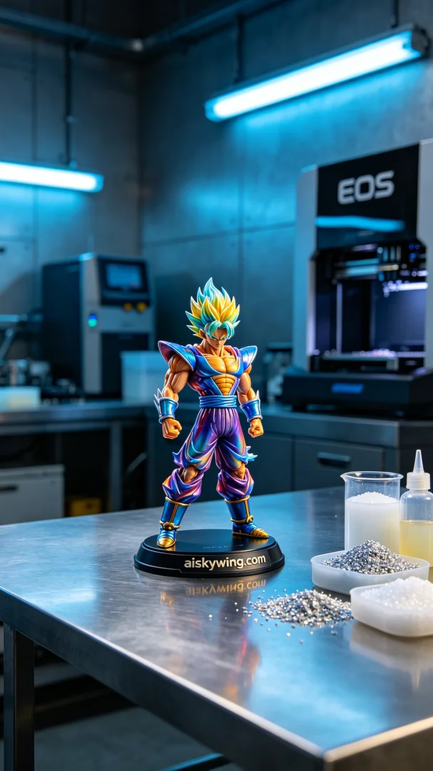
Aiskywing Industrial 3D Printing
Colorful 3D Printed Anime Figurines


