0512-AGV小车车轮护盖3D打印生产记录
AGV cart wheel cover
🖨️ SLA光固化
🖥️ 打印机: Rize
📦 材料: SLA
在Facebook上，有人因为需要修复AGV小车车轮护盖而来找我们。我们深知，细节决定成败，正如生活中每一个选择。
On Facebook, someone came to us because they needed to repair the wheel cover of an AGV cart. We understand that details determine success or failure, just like every choice in life.
________________________________________________________________________________
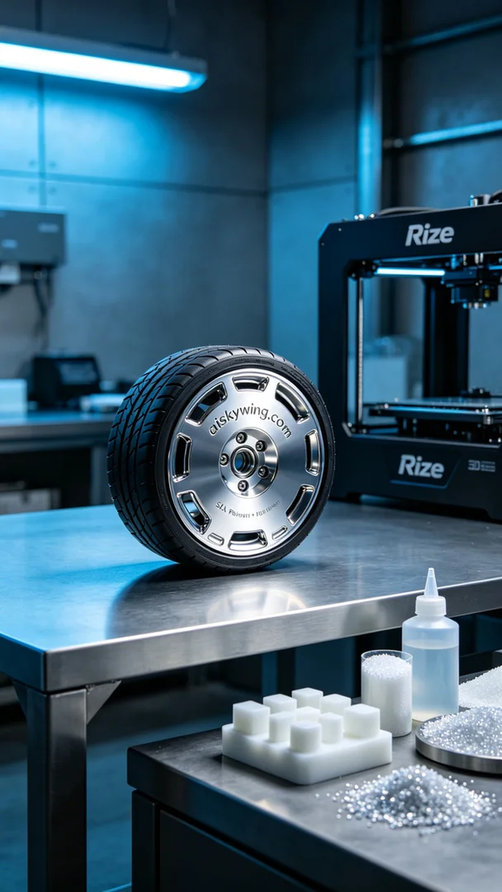
Today’s task is to print an AGV wheel cover for a friend. They found that the wheel covers were easily damaged during use and hoped we could provide a more durable alternative. We decided to use SLA curing technology, which provides high precision details and a smooth surface.
We chose high-quality SLA photopolymer resin as the printing material. This material not only has excellent fluidity but also solidifies quickly under ultraviolet light, ensuring the precision and strength of the finished product. When setting the printing parameters, we adjusted the layer thickness to 0.05mm, set the printing temperature to 25℃, kept the power at 50% for optimal curing effect, and controlled the printing speed at 30mm/s, with the entire process taking about 2 hours.
During the printing process, the Rize printer operated steadily, and I monitored the printing status to ensure the quality of each layer. As time passed, the AGV wheel cover gradually took shape, its surface smooth and details sharp, especially the engraved “aiskywing.com” text, which was crucial. The device ran without any deviations, making the whole process quite smooth.
Once printing was complete, we entered the post-processing phase. First, we immersed the finished product in a cleaning solution to remove any uncured resin. Next, we sanded the edges to ensure a smooth finish. Finally, we placed the cover in a UV curing machine for complete solidification, ensuring its strength. After inspection, all parameters met the standards, and the quality of the finished product was satisfactory.
After a series of meticulous steps, the AGV wheel cover was finally completed. It’s not just a product but a reflection of our hard work and perseverance in the field of 3D printing.
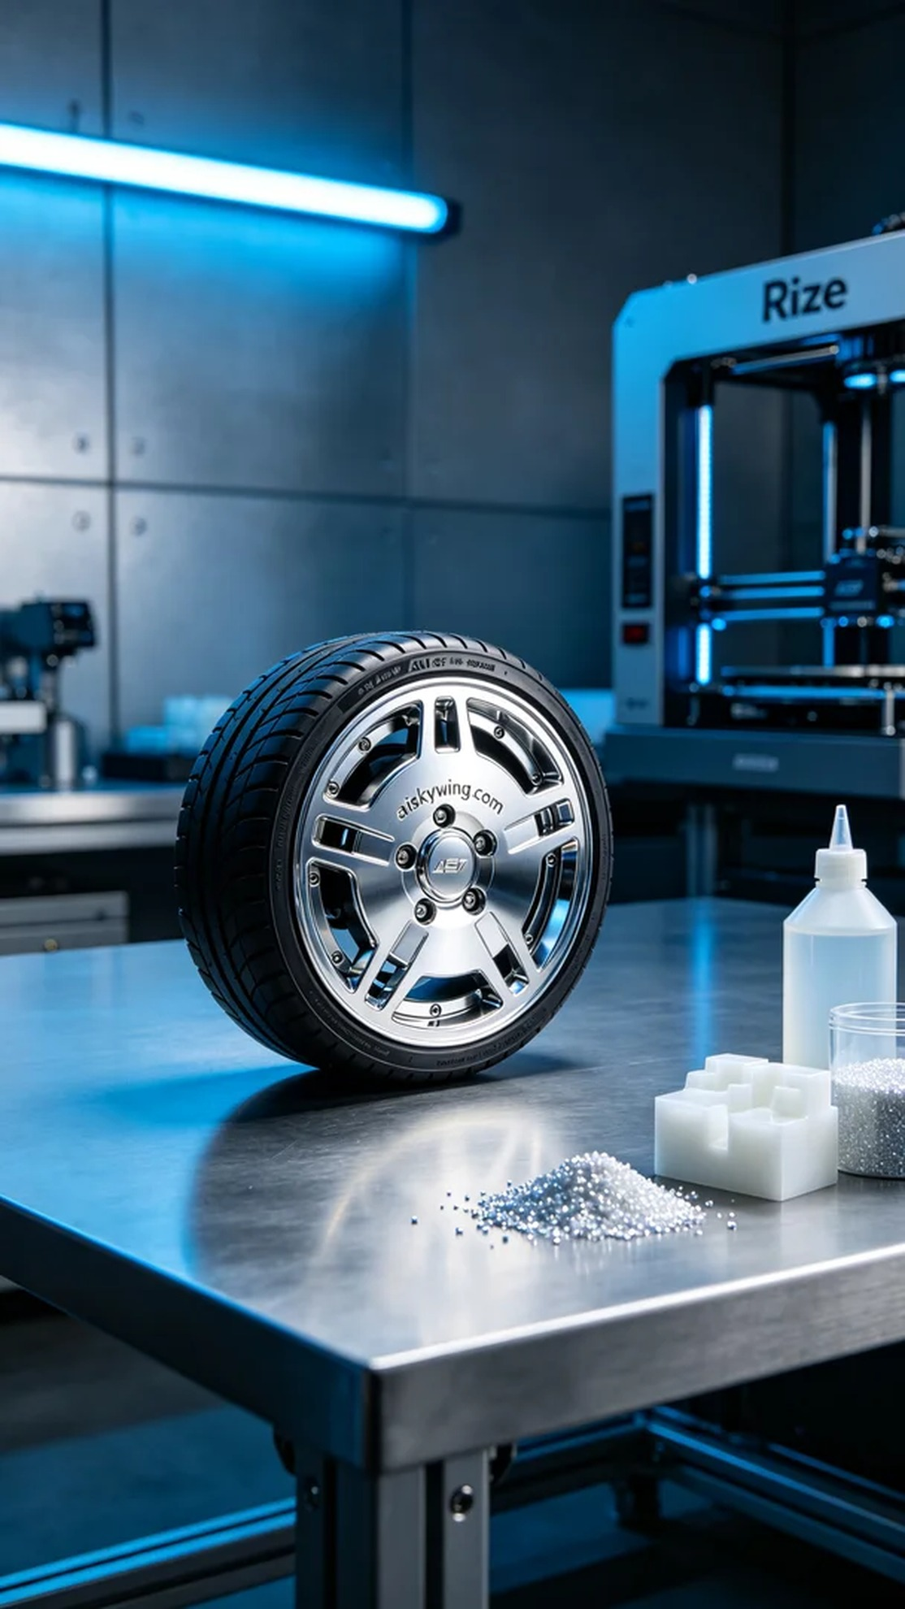
今天的任务是为一位朋友打印AGV小车车轮护盖。他们在使用过程中发现车轮护盖容易损坏，因此希望我们能提供一个更耐用的替代品。我们决定使用SLA光固化技术，这种工艺能够提供高精度的细节和光滑的表面。
我们选择了高质量的SLA光敏树脂作为打印材料。这种材料不仅具备优异的流动性，还能在紫外线照射下迅速固化，确保成品的精密度和强度。在设置打印参数时，我们将层厚调整为0.05毫米，打印温度设定为25℃，功率保持在50%以确保最佳固化效果，打印速度控制在30毫米/秒，整个打印过程大约需要2小时。
打印过程中，Rize打印机稳定地运转，我随时监控打印状态，以确保每一层的质量。随着时间推移，AGV小车车轮护盖逐渐成形，表面光滑且细节清晰，尤其是上面雕刻的“aiskywing.com”字样，愈发显得分外重要。设备的运行状态良好，没有出现任何偏差，整个过程很顺利。
打印完成后，迎来了后处理环节。首先，我们将成品浸入清洗液中，去除未固化的树脂。接着，对其进行打磨，确保每个边缘都光滑无瑕。最后，我们将护盖放置在UV固化机中进行全面固化，确保其强度。经过检验，所有参数均符合标准，完成品的质量让人满意。
经过一系列精细的工序，AGV小车车轮护盖终于完工。这不仅是一件产品，更是我们在3D打印技术中所付出的努力和坚持的体现。
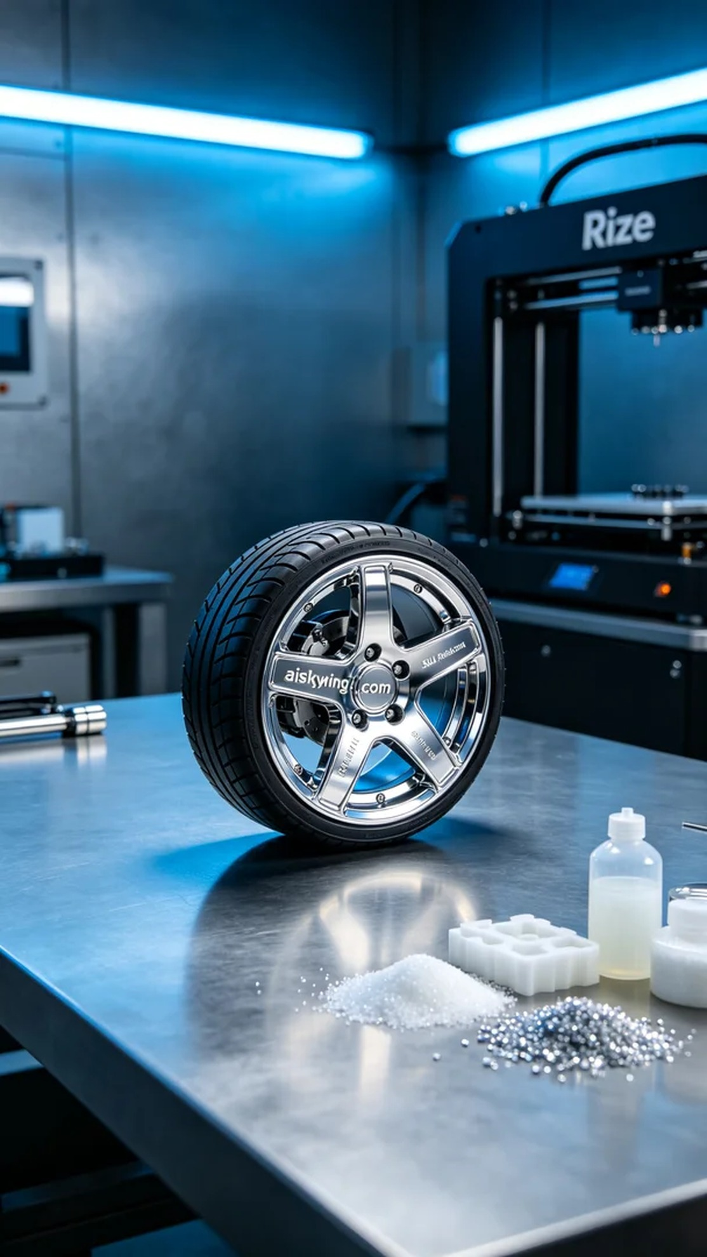
Aiskywing Industrial 3D Printing
AGV cart wheel cover


