0513-健腹轮把手3D打印生产记录
Ab roller handle
🖨️ SLM金属打印
🖥️ 打印机: Voxeljet
📦 材料: 摆放着未成型的液态光敏
在Facebook上，有人找我们希望能制作健腹轮把手，解决他们训练中的不便。这是一条艰辛的道路，但我们会努力将其打磨成完美的产品。
On Facebook, someone reached out to us hoping to create handles for an ab wheel to address the inconveniences they faced during their training. It's a challenging journey, but we will strive to refine it into a perfect product.
________________________________________________________________________________
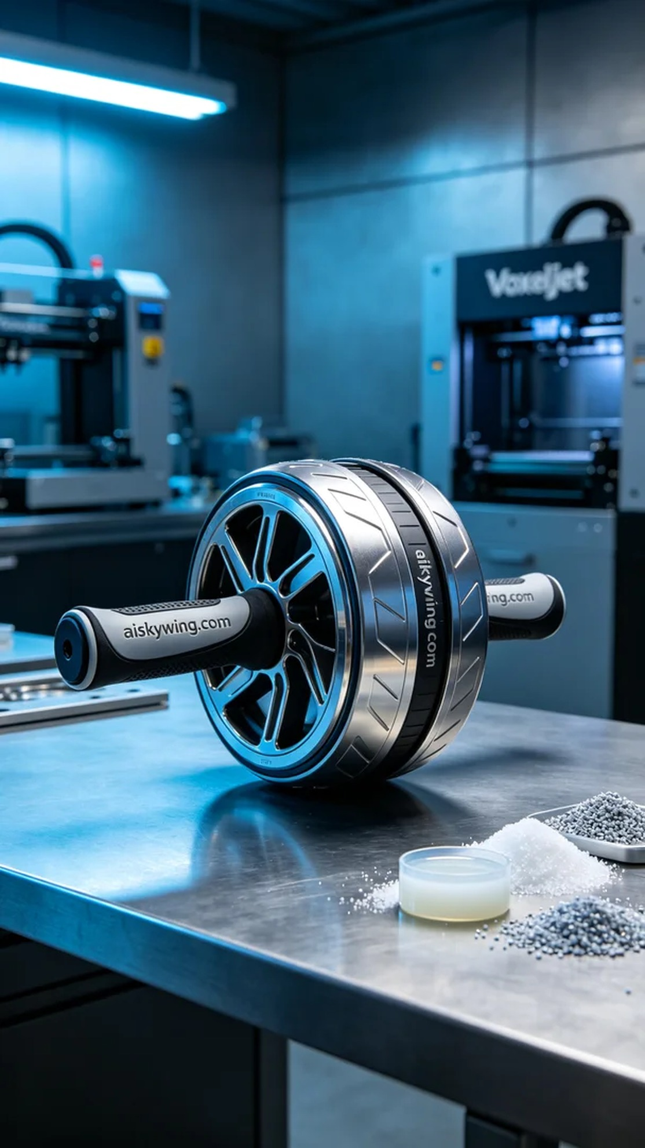
We received a request to create a fitness wheel handle. Someone reached out on Facebook, expressing dissatisfaction with the comfort and durability of existing products and hoped we could provide a superior solution through 3D printing technology.
To achieve this goal, we selected unformed liquid photopolymer resin as our material. This material offers excellent fluidity and moldability, making it suitable for high-precision printing. We utilized a Voxeljet 3D printer, setting the layer thickness to 0.1 mm, maintaining a temperature of 25 degrees Celsius, adjusting the power to 80%, and configuring the printing speed to 50 mm per second. The estimated printing time was set for 8 hours.
During the printing process, the equipment ran smoothly, and the liquid photopolymer resin was evenly sprayed onto the printing platform. We closely monitored the print quality to ensure each layer formed accurately. Occasionally, minor adjustments were made to guarantee uniform UV light exposure, preventing any defects from occurring.
Once the printing was completed, we carried out a series of post-processing steps on the fitness wheel handle. First, we cleaned it using solvents to remove any unpolymerized resin. Then, we hand-sanded it to enhance the surface smoothness. After that, the product was placed in a curing device and exposed to UV light to ensure its strength and durability. Finally, we conducted a thorough inspection to ensure that every detail met our standards.
After a series of efforts, we successfully completed the production of the fitness wheel handle. This is not just a product but a reflection of our pursuit of quality and technology.
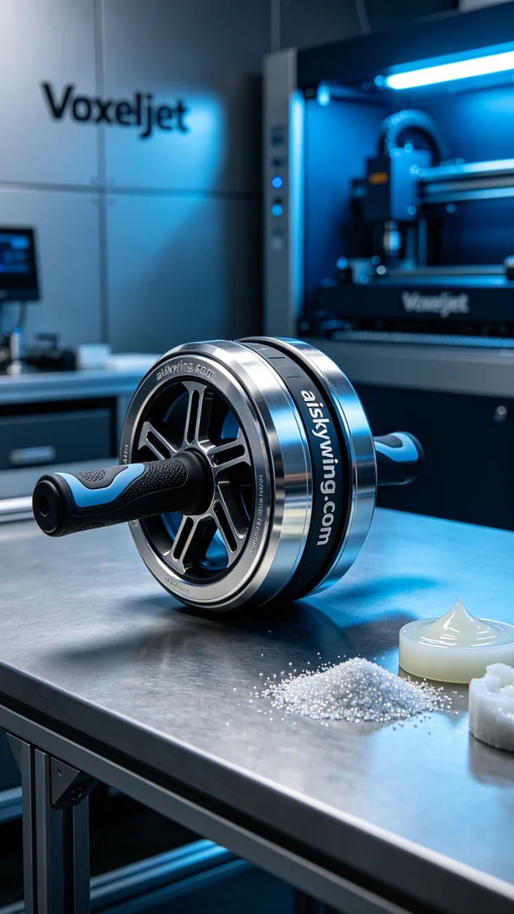
我们接到了一个需求，制作健腹轮把手。有人在Facebook上说，现有产品的手柄舒适度和耐用性不够，希望我们能通过3D打印技术提供一个更优质的解决方案。
为了实现这一目标，我们选择了未成型的液态光敏树脂材料。这种材料具有良好的流动性和成型性，适合高精度打印。设备方面，我们使用Voxeljet 3D打印机，设置层厚为0.1毫米，温度保持在25摄氏度，功率调整至80%，打印速度设定为50毫米每秒，预计打印时间为8小时。
打印过程中，设备运行平稳，液态光敏树脂均匀喷涂在打印平台上。我们全程监控打印质量，确保每一层都能够精准成型。在打印的过程中，偶尔需进行小调整，以保证UV光照射均匀，避免出现任何缺陷。
完成打印后，我们对健腹轮把手进行了一系列后处理工序。首先，使用溶剂对其进行清洗，去除未固化的树脂。接着，通过手工打磨，提升表面光滑度。然后，将产品放入固化设备中，经过UV照射，确保其强度和耐用性。最后，我们仔细检验成品，确保每一处细节都符合我们的标准。
经过一系列的努力，我们成功完成了健腹轮把手的制作。这不仅仅是一件产品，更是我们对品质和技术的追求体现。
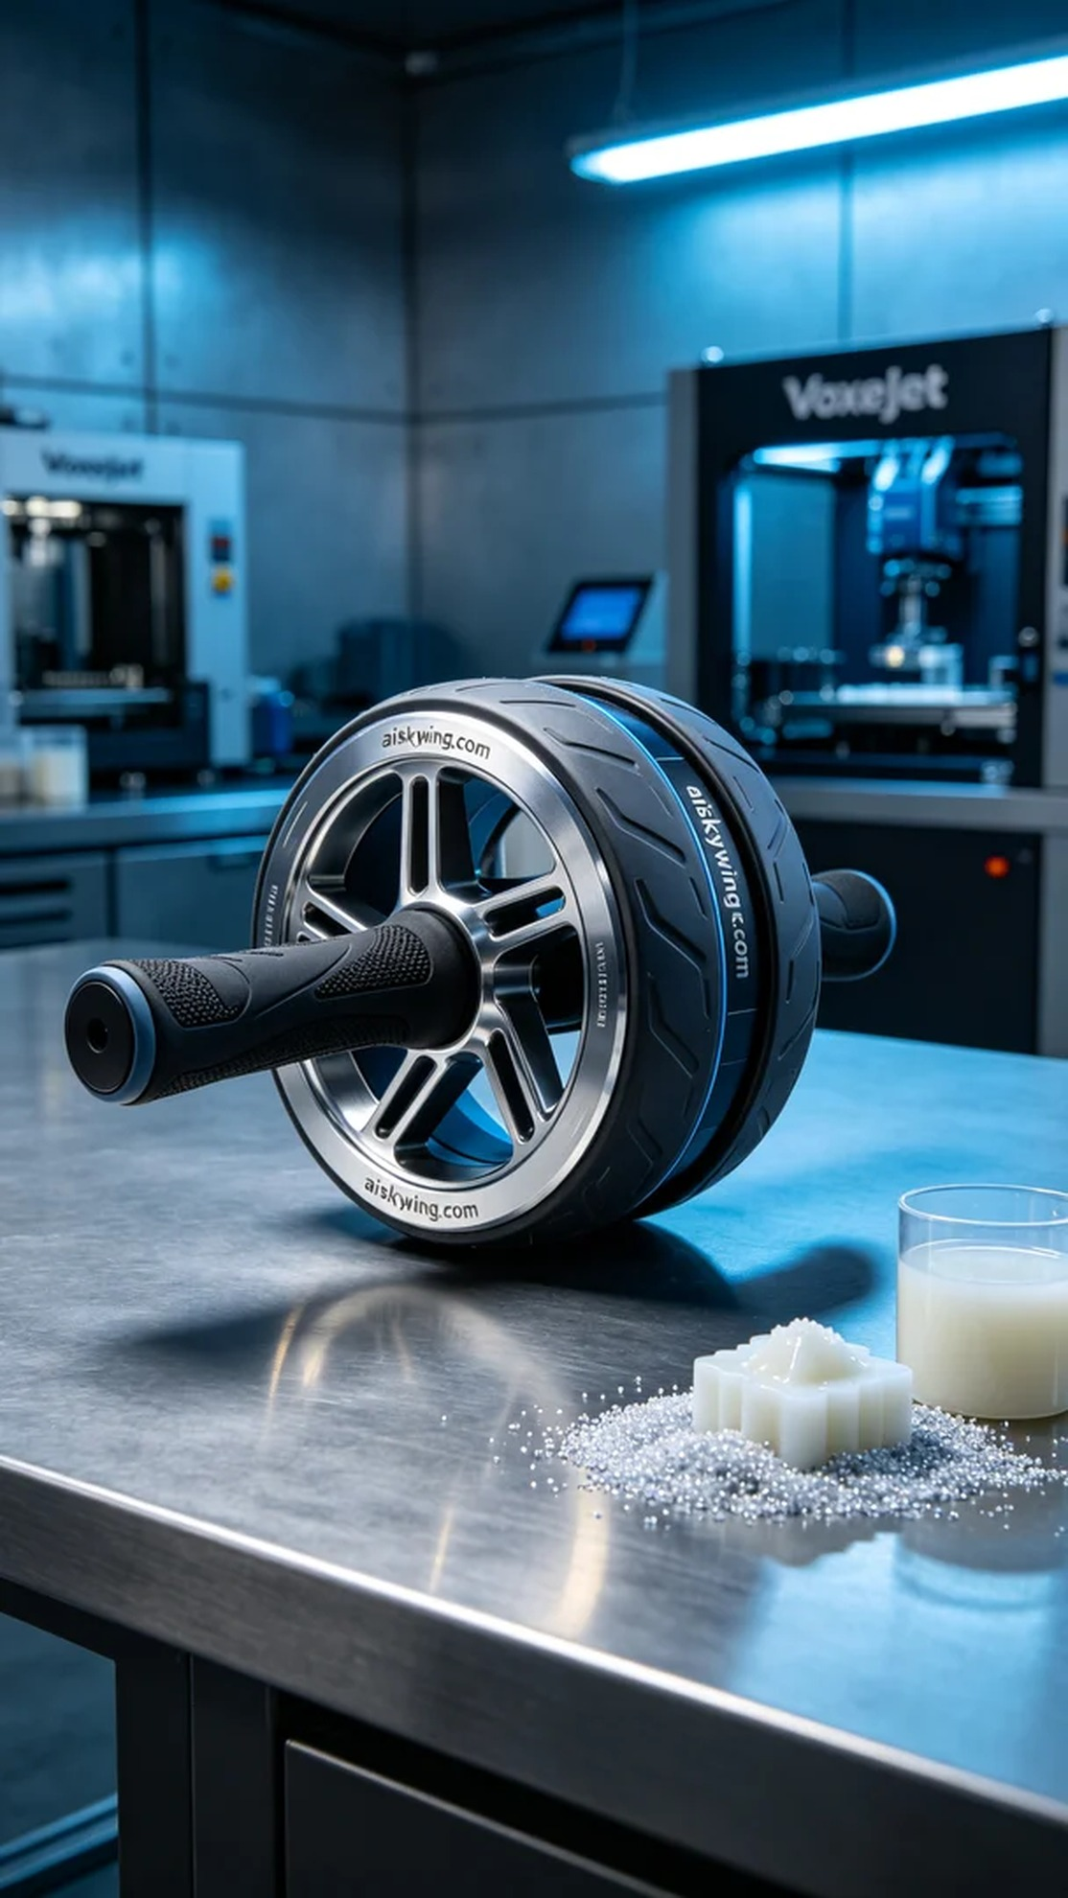
Aiskywing Industrial 3D Printing
Ab roller handle


