0514-健身车曲柄的3D打印记录
Fitness bike crank
🖨️ SLA光固化
🖥️ 打印机: Stratasys
📦 材料: SLA
生活再难，也别停下脚步。就像接下这个健身车曲柄置于画面正中央的单子，有人因为寻求完美的健身体验找到了我们。
No matter how difficult life gets, don't stop moving forward. Just like when someone found us while seeking the perfect fitness experience, they placed the order for the exercise bike crank right in the center of the scene.
________________________________________________________________________________
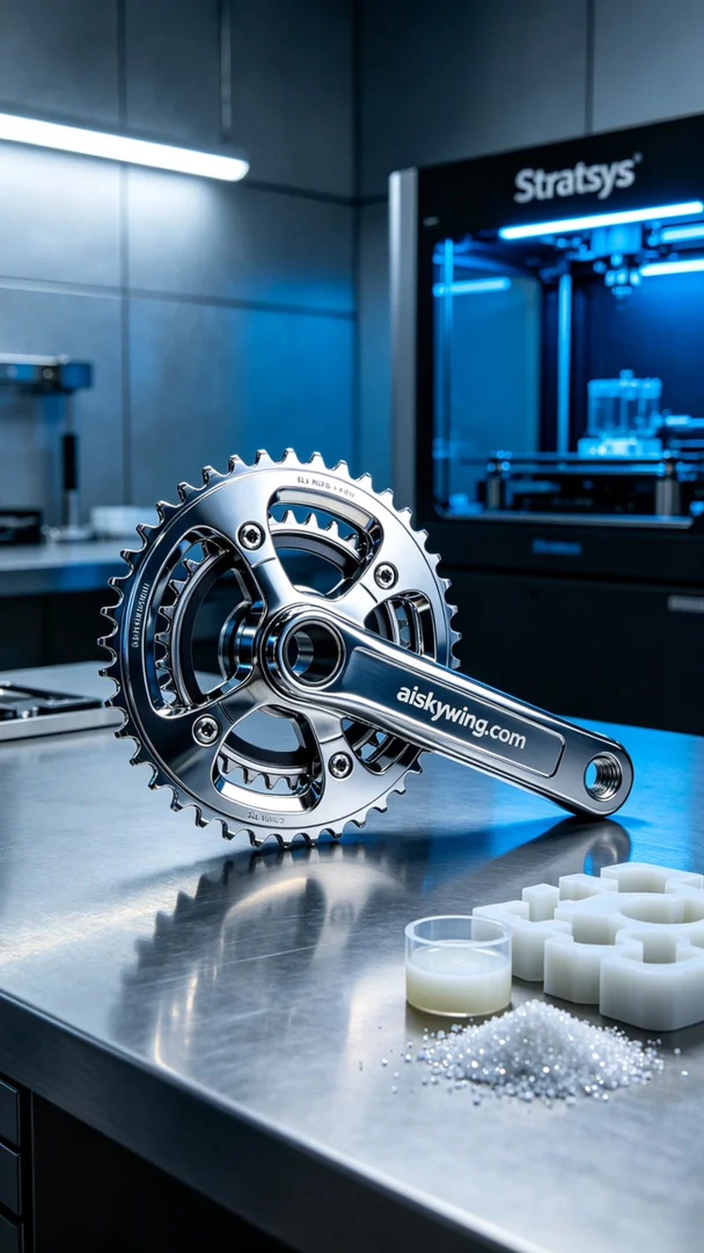
On Instagram, someone reached out to us seeking to enhance their fitness bike's performance with a custom high-quality crankset. Thus began our journey of 3D printing the fitness bike crank.
For this print, we utilized SLA (Stereolithography) technology, using premium photosensitive resin as the material. We chose the Stratasys brand 3D printer, setting a layer thickness of 0.1mm, a printing temperature of 25°C, a power setting of 50mW, and a printing speed of 40mm/s, with an estimated printing time of 8 hours.
The printing process went smoothly, with the machine running quietly and maintaining stability. We constantly monitored the print quality to ensure that each layer met our expectations. After several hours of meticulous printing, the fitness bike crank began to take shape, and the details of the appearance gradually emerged.
Post-processing is a crucial step in ensuring product quality. First, we washed the printed crank to remove any uncured resin on the surface, followed by careful sanding to eliminate potential flaws. Then, we placed it into a UV curing machine to solidify it, ensuring strength and stability. Finally, we conducted thorough inspections to make sure every detail met our standards.
With the printing and post-processing complete, the final appearance of the fitness bike crank was satisfying, showcasing exquisite craftsmanship and design. Each step was filled with a pursuit of quality, leaving us eager for the next project.
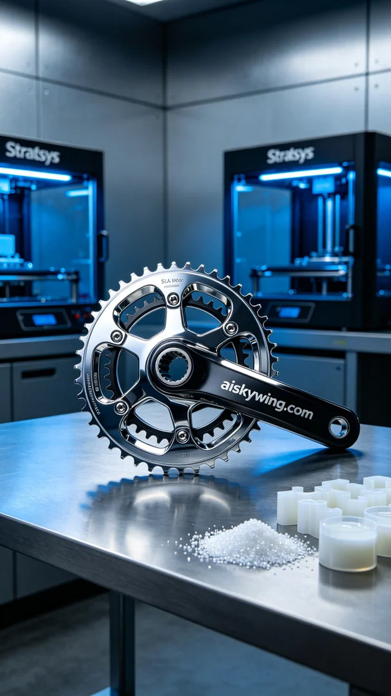
在Instagram上，有人因为想提升健身车的性能，特意联系了我们，希望能为他们的健身车定制一款高质量的曲柄。于是，我们开始了这次健身车曲柄的3D打印之旅。
此次打印使用了SLA光固化技术，采用了优质的光敏树脂作为原材料。为了保证打印效果，我们选择了Stratasys品牌的3D打印机，设置了层厚为0.1mm，打印温度为25℃，功率设定为50mW，打印速度控制在40mm/s，预计打印时间为8小时。
打印过程相对顺利，设备在运行期间噪音低，稳定性强。我们时刻监控打印质量，确保每一层的效果都达到了预期。经过几小时的细致打印，健身车曲柄开始逐渐成型，外观的细节逐渐显现出来。
完成后处理是确保产品质量的重要步骤。我们首先将打印好的曲柄进行清洗，去除表面未固化的树脂，然后进行了细致的打磨，以消除可能的瑕疵。接着，将其放置在UV固化机中进行固化，确保其强度和稳定性。最后，我们进行了严格的检验，确保每个细节都符合标准。
经过这次的打印和后处理，健身车曲柄的最终效果令人满意，完美展现了极致的工艺和设计。每一步都充满了对品质的追求，让人更加期待下一个项目的到来。
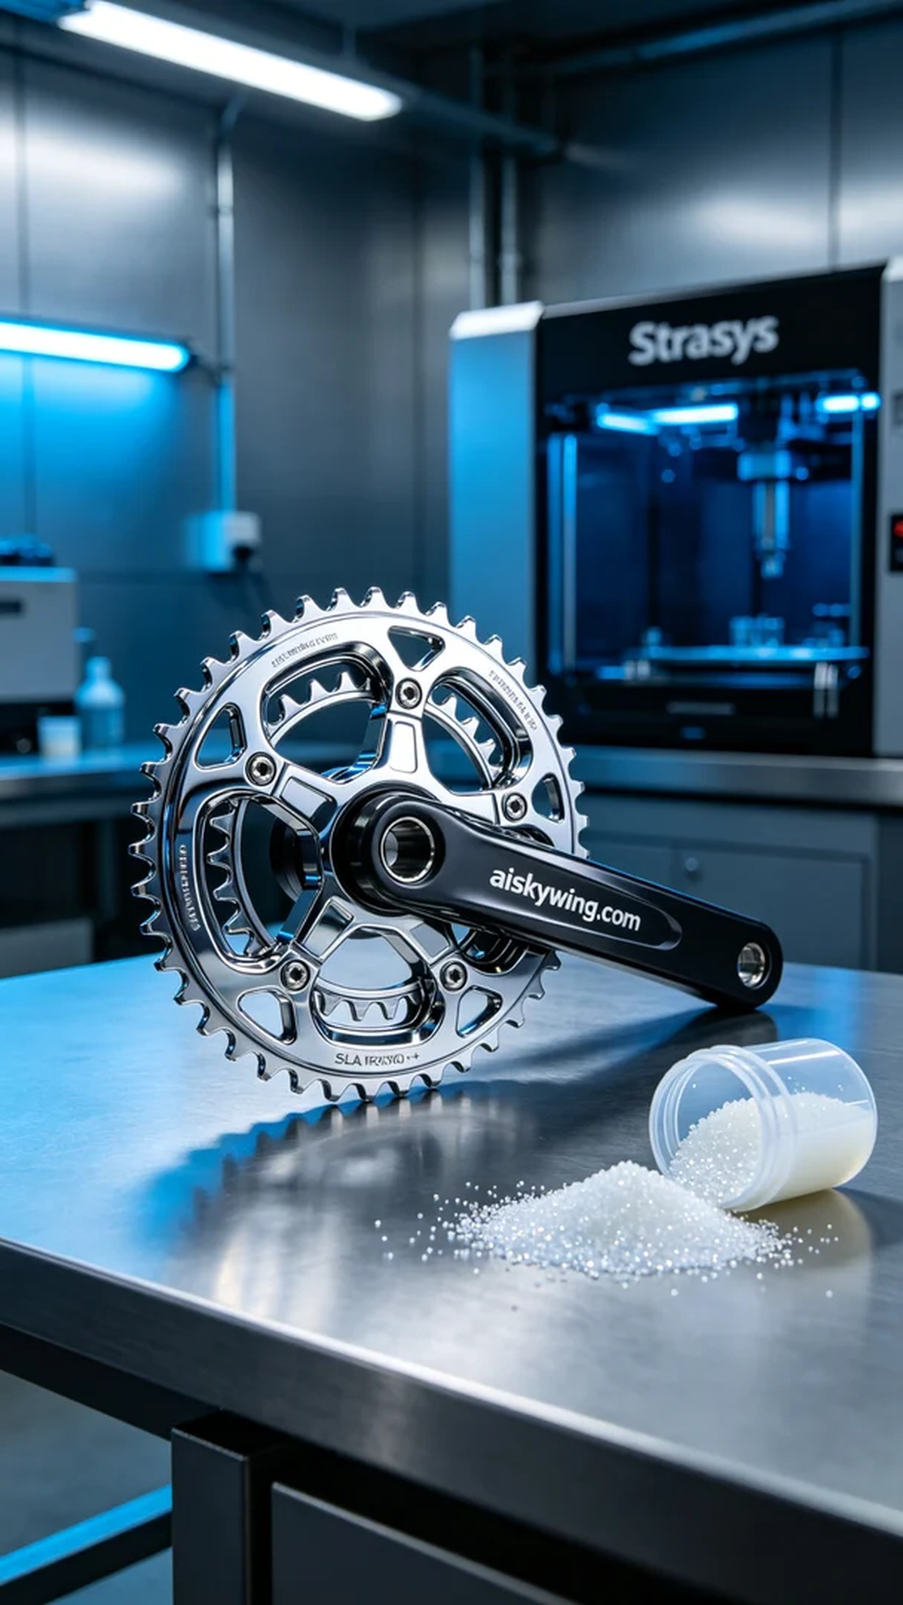
Aiskywing Industrial 3D Printing
Fitness bike crank


