0515-冰箱门把手3D打印生产记录
Refrigerator door handle
🖨️ SLM金属打印
🖥️ 打印机: Voxeljet
📦 材料: 摆放着未成型的液态光敏
有时候咬牙坚持，不是为了证明什么。就像做这个冰箱门把手，我在TikTok上看到有人对它的设计赞不绝口。
Sometimes, gritting your teeth and persevering is not about proving anything. It's like making this refrigerator door handle; I saw someone on TikTok praising its design endlessly.
________________________________________________________________________________
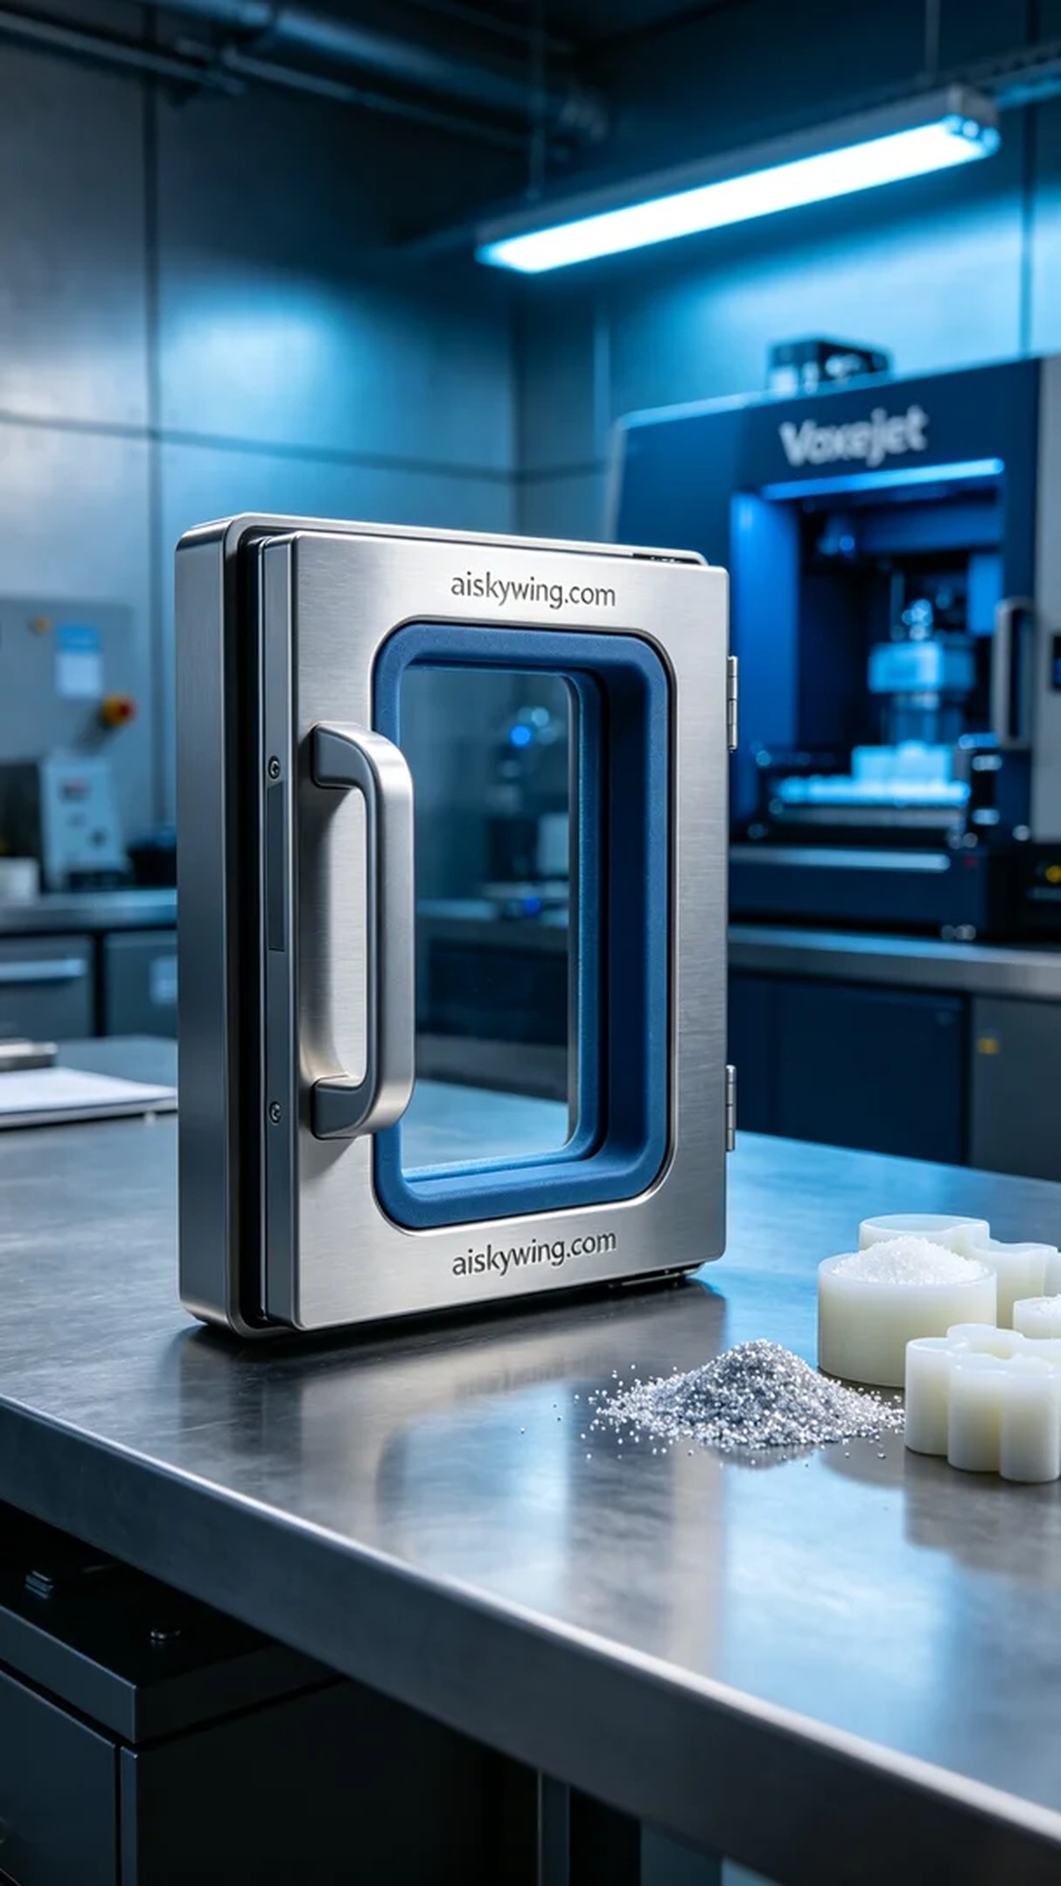
Sometimes, holding on isn't just about proving something. Just like making this refrigerator handle, I came across someone on TikTok praising its design.
In our workshop, someone reached out to us needing a high-quality refrigerator handle. They wanted it to be durable while also looking aesthetically pleasing to meet their personalized needs. After some discussion, we decided to use SLM metal printing technology to achieve this goal.
To print the ideal refrigerator handle, we chose unformed liquid photopolymer resin as our raw material. The advantages of this material lie in its excellent fluidity and good printing stability. We used a Voxeljet 3D printer, setting the layer thickness at 0.1 mm, maintaining the printing temperature at 25 degrees Celsius, with a power setting of 100 watts and a printing speed of 10 mm per hour. The entire printing process was expected to take about 4 hours.
As the printing commenced, the machine operated smoothly, with the liquid resin accumulating layer by layer, gradually forming the handle's outline. Throughout the printing process, we closely monitored the quality to ensure that each layer cured evenly without bubbles or defects. As time passed, the shape of the handle became more apparent, reflecting a metallic sheen under the light, which was exciting to see.
After printing, we conducted meticulous post-processing. First, we placed the printed object in a cleaning machine to remove excess resin with alcohol, ensuring a smooth surface free of impurities. Next, we proceeded with sanding to enhance the handle's tactile feel and aesthetics. Finally, it was placed in a curing chamber to ensure its strength met the standards. After rigorous inspection, the quality of the refrigerator handle received our approval.
This 3D printing process allowed me to better appreciate the importance of detail. In the end, this refrigerator handle not only had an exquisite appearance but also excellent durability, exceeding expectations.
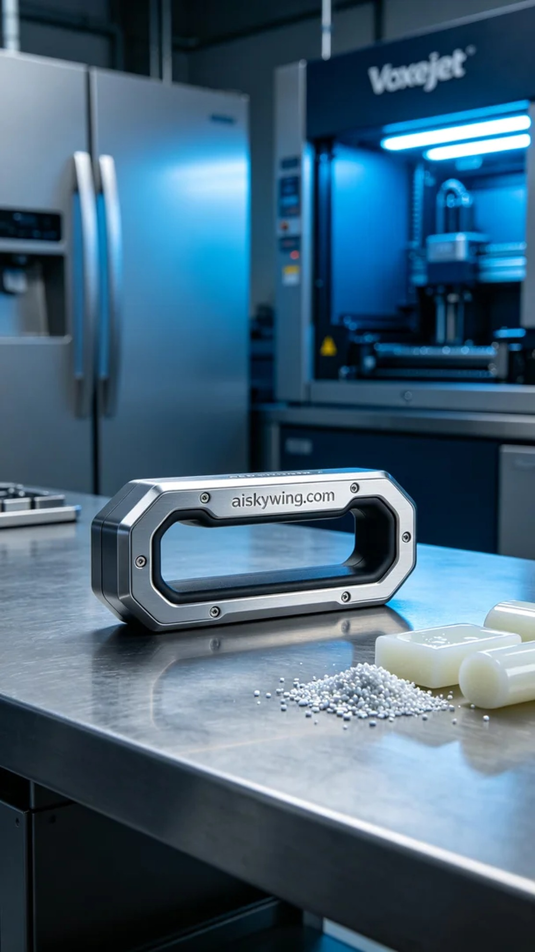
在我们的工作室，有人因为急需一款高品质的冰箱门把手找到了我们。他们希望这款把手不仅能耐用，而且在视觉效果上也要出色，满足其个性化需求。经过沟通，我们决定使用SLM金属打印技术来实现这个目标。
为了打印出理想的冰箱门把手，我们选择了未成型的液态光敏树脂作为原材料。这个材料的优点在于它具有优良的流动性和较好的打印稳定性。我们使用的是Voxeljet品牌的3D打印机，设置层厚为0.1毫米，打印温度维持在25摄氏度，功率设定为100瓦，打印速度为每小时10毫米，预计整个打印过程需要约4小时。
打印开始后，设备启动顺利，液态树脂在打印头的喷射下逐层累积，逐渐形成把手的轮廓。在这个过程中，我们密切监控打印质量，确保每一层都能均匀固化，没有气泡或缺陷。随着时间的推移，把手的形状逐渐显现出来，光线下金属感十足，令人期待。
打印完成后，我们进行了细致的后处理工序。首先将打印件放入清洗机中，用酒精清洗去除多余的树脂，确保表面光滑无杂质。接着，我们进行打磨，以提升把手的手感和美观度。最后将其放入固化箱中进行固化，确保其强度达到标准。经过严格的检验，冰箱门把手的质量获得了我们的认可。
这次3D打印的过程让我更加体会到细节的重要。最终，这款冰箱门把手不仅外观精致，同时也具备了良好的耐用性，超出了预期。
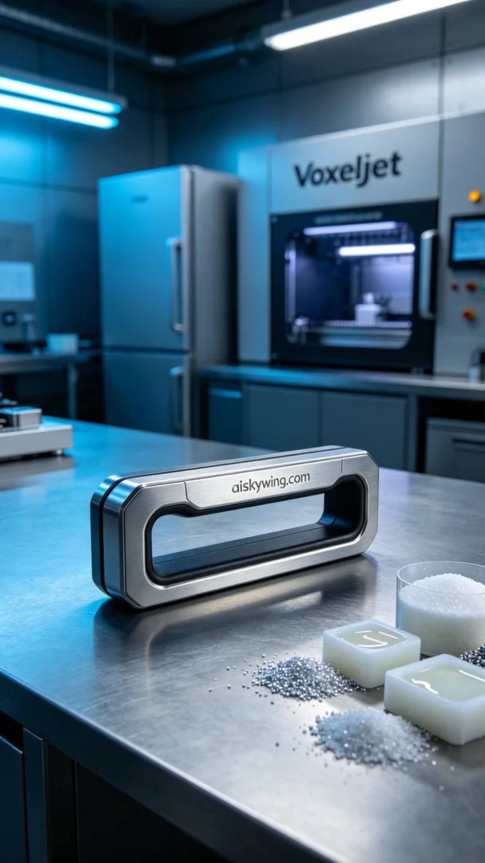
Aiskywing Industrial 3D Printing
Refrigerator door handle


