0516-划船机滑轨的生产记录
Rowing machine slide rail
🖨️ SLA光固化
🖥️ 打印机: EOS
📦 材料: SLA
在Twitter上，有人因为划船机滑轨的精度和稳定性找上我们，真正的工艺和用心才能带来完美的产品。
On Twitter, someone reached out to us regarding the precision and stability of the rowing machine's slide rail. It is true craftsmanship and dedication that can create a perfect product.
________________________________________________________________________________
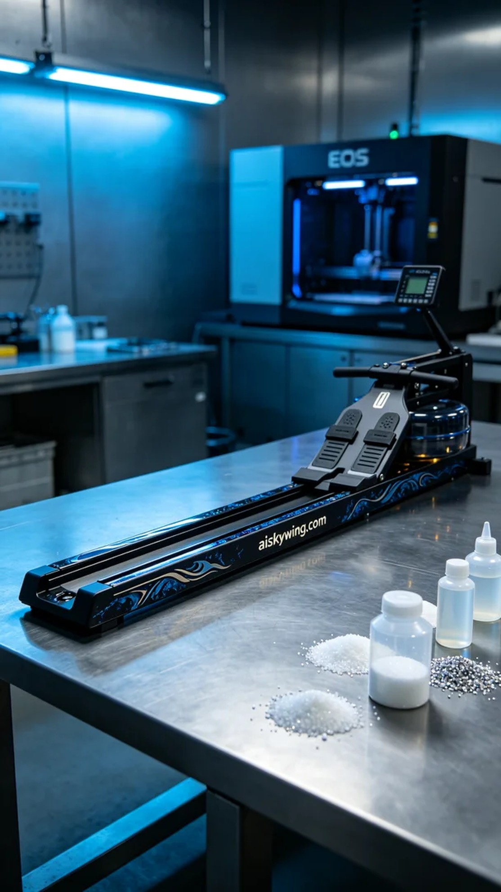
We received an order for a rowing machine rail, requiring a high-precision component to ensure optimal performance during use. Someone reached out to us hoping our equipment could provide a better solution, helping their product stand out in the market.
For this production, we chose SLA resin as the raw material, which offers high precision and excellent surface finish. Using the EOS printer, we set the printing parameters to a layer thickness of 0.1mm, maintaining a temperature of 25°C, a power of 50mW, and a printing speed of 40mm/s. This combination ensures the rail is printed with meticulous detail.
During the printing process, the EOS printer operated steadily with the liquid photopolymer resin evenly distributed on the build platform. We continuously monitored the progress to ensure each layer's exposure time was precise, avoiding any potential defects and maintaining high overall quality.
After printing, we carried out a series of post-processing steps. First, we placed the printed part in a cleaning solution to remove excess resin, followed by sanding to ensure a smooth surface. Then we cured the part under UV light to enhance the material's strength. Finally, we meticulously checked every detail to ensure there were no flaws, meeting our high standards.
After a series of processes, the rowing machine rail was successfully completed, and the final result was satisfying, fully showcasing our craftsmanship and commitment to quality. This product is not just an item; it is a testament to our team's hard work.
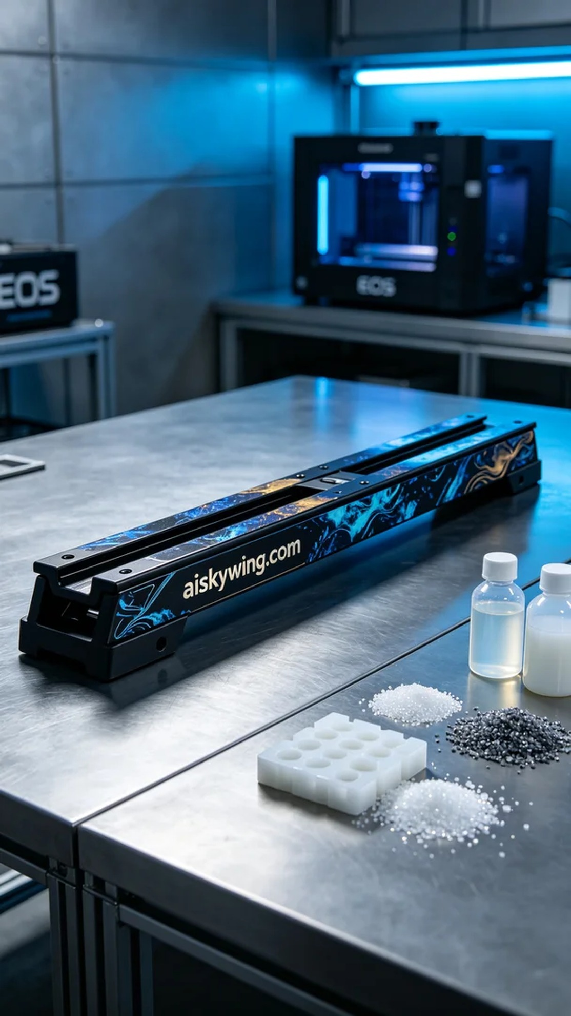
我们接到了一个关于划船机滑轨的订单，需求是要高精度的部件，以确保在使用过程中达到最佳性能。有人希望我们的设备能提供更好的解决方案，让他们的产品在市场上脱颖而出。
这次生产我们选择了SLA树脂作为原材料，具有高精度和良好的表面光洁度。使用EOS品牌的打印机，打印参数设定为层厚0.1mm，温度保持在25℃，功率为50mW，打印速度设置为40mm/s。这样的参数组合确保了打印出细致入微的滑轨。
在打印过程中，EOS打印机稳定运行，液态光敏树脂均匀分布在打印平台上。我们时刻监控打印进度，确保每一层的曝光时间精准，避免任何可能的缺陷，保持整体质量的高标准。
完成打印后，我们进行了一系列的后处理工序。首先将打印件放入清洗液中，去除多余的树脂，接着进行打磨，以确保表面光滑。然后进行固化处理，通过UV灯照射，使得材料更加坚固。最后，仔细检查每一个细节，确保没有瑕疵，达到了我们的高标准。
经过一系列的过程，划船机滑轨顺利完成，最终效果让人满意，充分展示了我们的工艺和对品质的坚持。这不仅是一个产品，更是我们团队努力的见证。
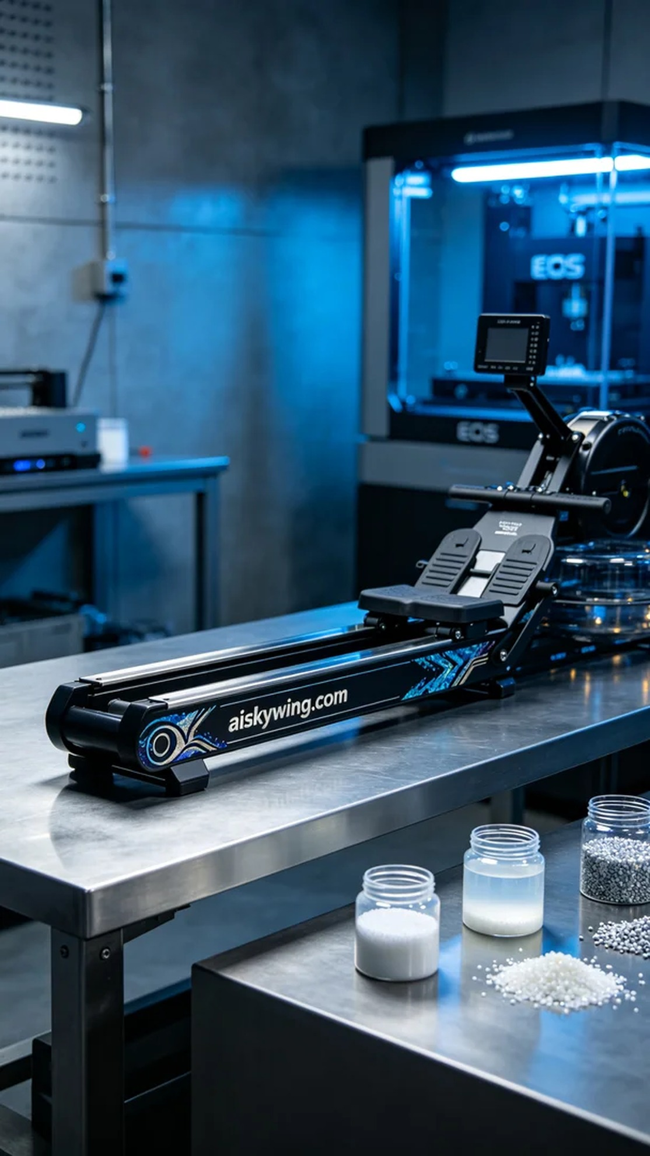
Aiskywing Industrial 3D Printing
Rowing machine slide rail


