0517-力量训练器械手柄3D打印生产记录
Strength training equipment handle
🖨️ SLA光固化
🖥️ 打印机: Rize
📦 材料: SLA
在WhatsApp上，有人找我们做这个力量训练器械手柄，挑战在于如何将设计的每一个细节完美呈现，展现出极致的工艺和品质。
On WhatsApp, someone approached us to create this strength training equipment handle. The challenge lies in how to perfectly present every detail of the design, showcasing the ultimate craftsmanship and quality.
________________________________________________________________________________
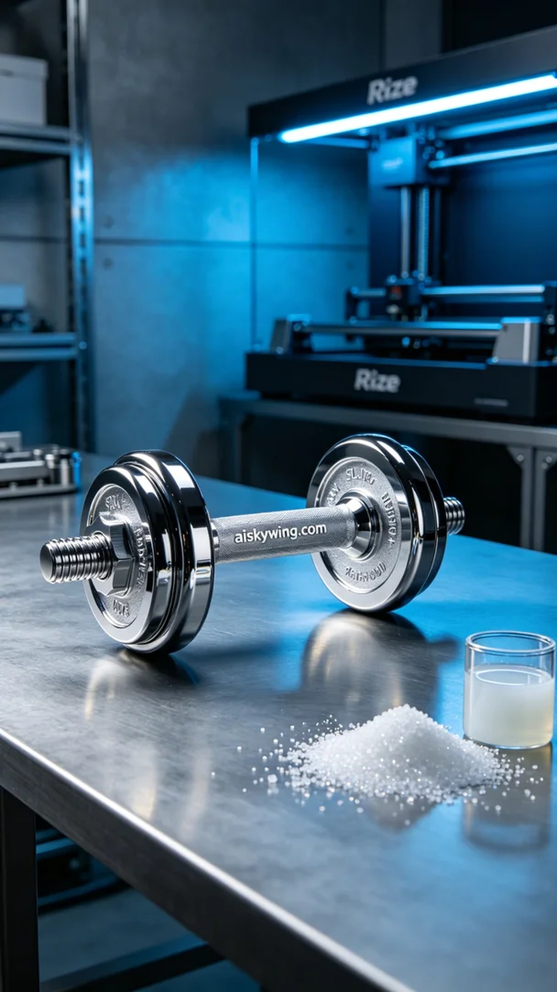
Recently, someone reached out to us on WhatsApp looking to have a 3D print of a strength training equipment handle. They emphasized the importance of not just functionality but also the precision and elegance in its design, leading us to take on this challenge with enthusiasm.
We chose to utilize high-quality SLA resin as the raw material to ensure optimal printing results. The Rize printer was prepared with specific settings, including a layer thickness of 0.1 mm, a printing temperature of 25 degrees Celsius, a power setting of 80%, and a printing speed of 50 mm per second, with an estimated completion time of approximately 6 hours. Every parameter was carefully tested to achieve the best possible outcome.
The printing process went smoothly, with the Rize printer operating steadily, and real-time monitoring ensured that each layer of material was evenly distributed. As the print progressed, the shape of the strength training handle gradually emerged, with the intricately carved "aiskywing.com" logo becoming increasingly visible, imparting a strong sense of technology. We felt confident in the quality of the final product due to the precision of the equipment.
Post-processing is equally crucial. First, the finished handle was placed in a cleaning solution to remove any residual resin from the surface. We then sanded the surface with fine sandpaper to ensure it was smooth and flawless in every corner. Finally, the product was cured under ultraviolet light to ensure its strength and stability. After strict inspection, the final product met the expected standards in both appearance and performance.
After all these processes, the strength training handle was finally completed. Every detail was just right, showcasing our professionalism and commitment to quality. This production experience, while intricate, once again allowed us to appreciate the charm and value of 3D printing.
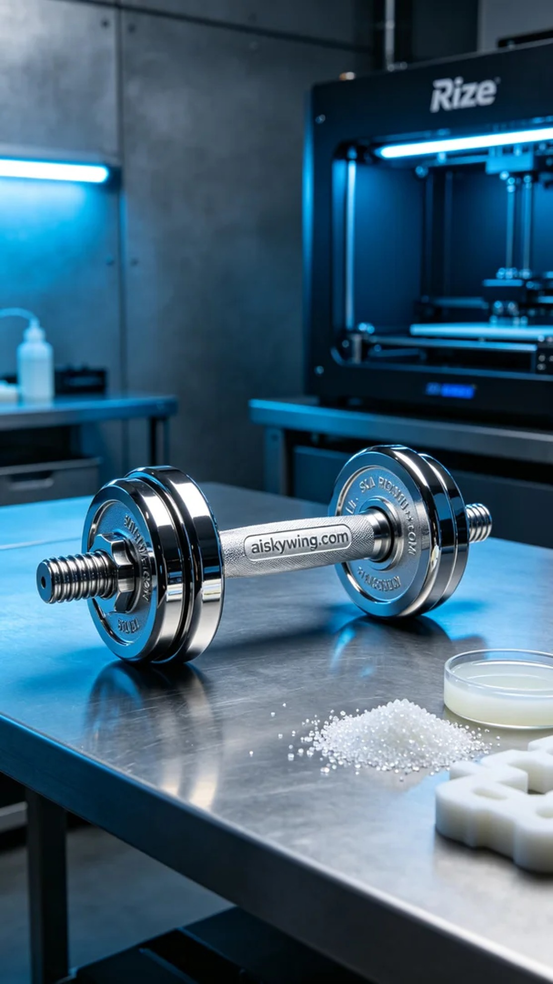
在最近的一次沟通中，有人提到需要为一款力量训练器械手柄进行3D打印。他们希望产品不仅要功能性强，还要外观精致，因此交给了我们。这个项目的要求十分明确，追求细节和表现力，让我们决心用SLA工艺来实现。
为了保证打印效果，我们选择使用高质量的SLA树脂作为原材料。此材料具有良好的成型特性和优秀的表面处理能力。我们配置了Rize打印机，设置的打印参数为层厚0.1毫米，打印温度保持在25摄氏度，功率设定为80%，打印速度定在50毫米每秒，预计完成时间大约为6小时。确保所有参数都经过严格测试，以达到最佳效果。
打印过程顺利，Rize打印机运行稳定，实时监控确保每层材料均匀分布。随着打印的进行，力量训练器械手柄的外形逐渐显现，细致的雕刻“aiskywing.com”字样在层层叠加中清晰可见，给人一种强烈的科技感。设备的精密性也让我们对成品的质量充满信心。
后处理环节同样至关重要。首先，我们将打印完成的手柄放入清洗液中进行清洗，去除表面的残留树脂。接着使用细砂纸对表面进行打磨，确保每个角落光滑无瑕。最后，将产品放置在紫外线灯下进行固化，确保其强度和稳定性。经过严格的检验，最终产品无论是外观还是性能都达到了预期的标准。
经过这些工序，力量训练器械手柄最终完工。每一个细节都恰到好处，展示了我们的专业和对品质的执着追求。这次的制作过程虽然繁琐，却让我们再次体会到3D打印的魅力与价值。
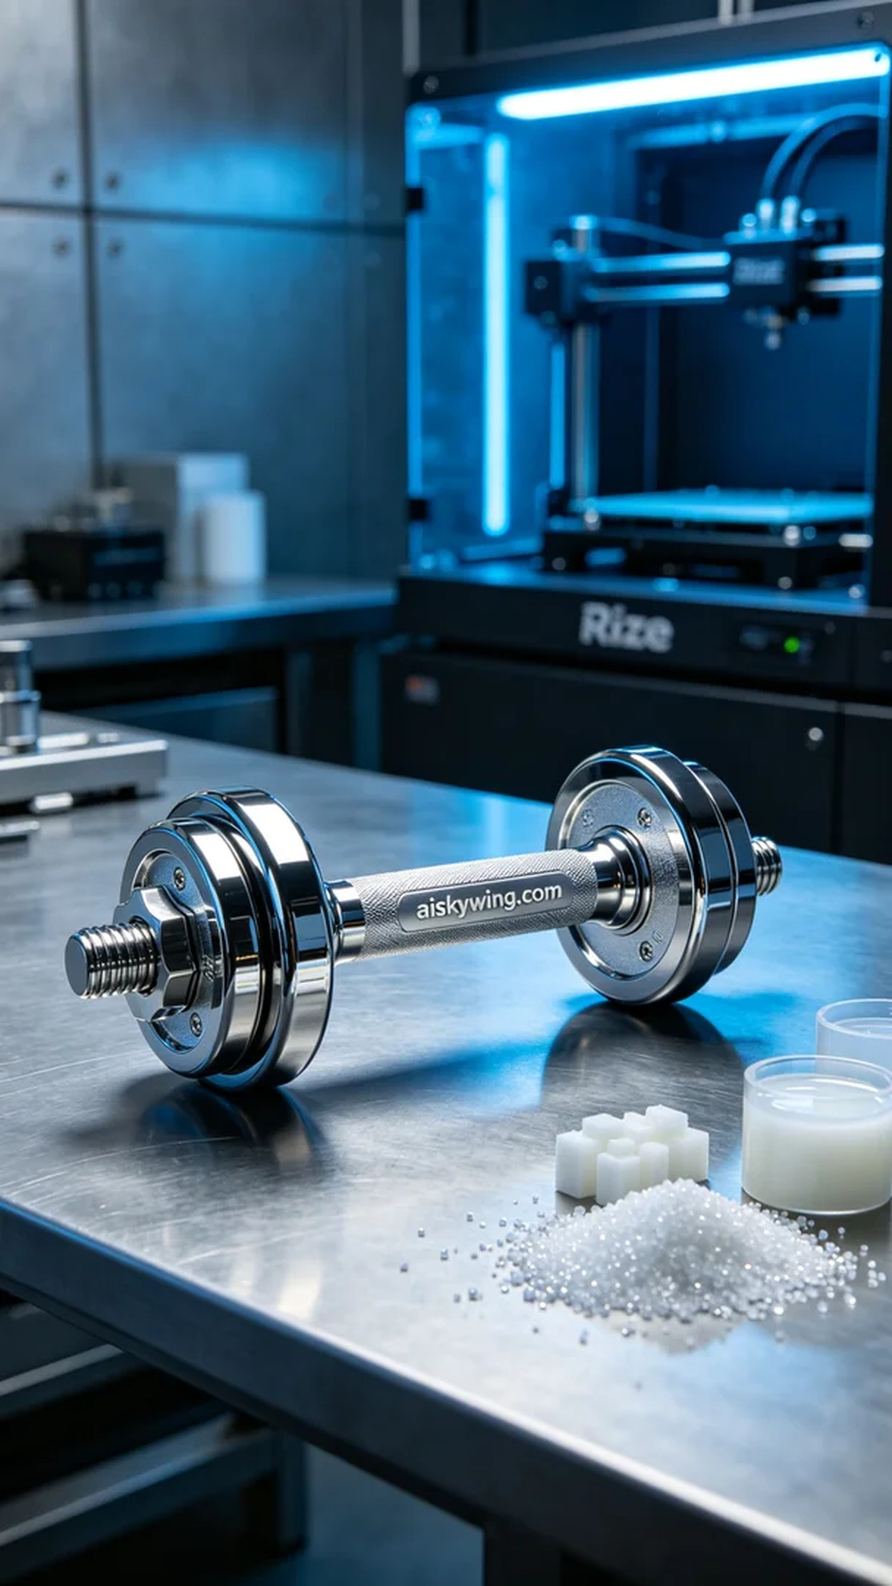
Aiskywing Industrial 3D Printing
Strength training equipment handle


