0518-加湿器水箱盖的3D打印制作记录
Humidifier water tank cover
🖨️ SLA光固化
🖥️ 打印机: Mimaki
📦 材料: SLA
在Instagram上，有人为了提升家居环境而寻找我们，专注于这个加湿器水箱盖的制作，分享生活中的小确幸。
On Instagram, some people seek us out to enhance their home environment, focusing on the creation of this humidifier tank cover and sharing the little joys of life.
________________________________________________________________________________
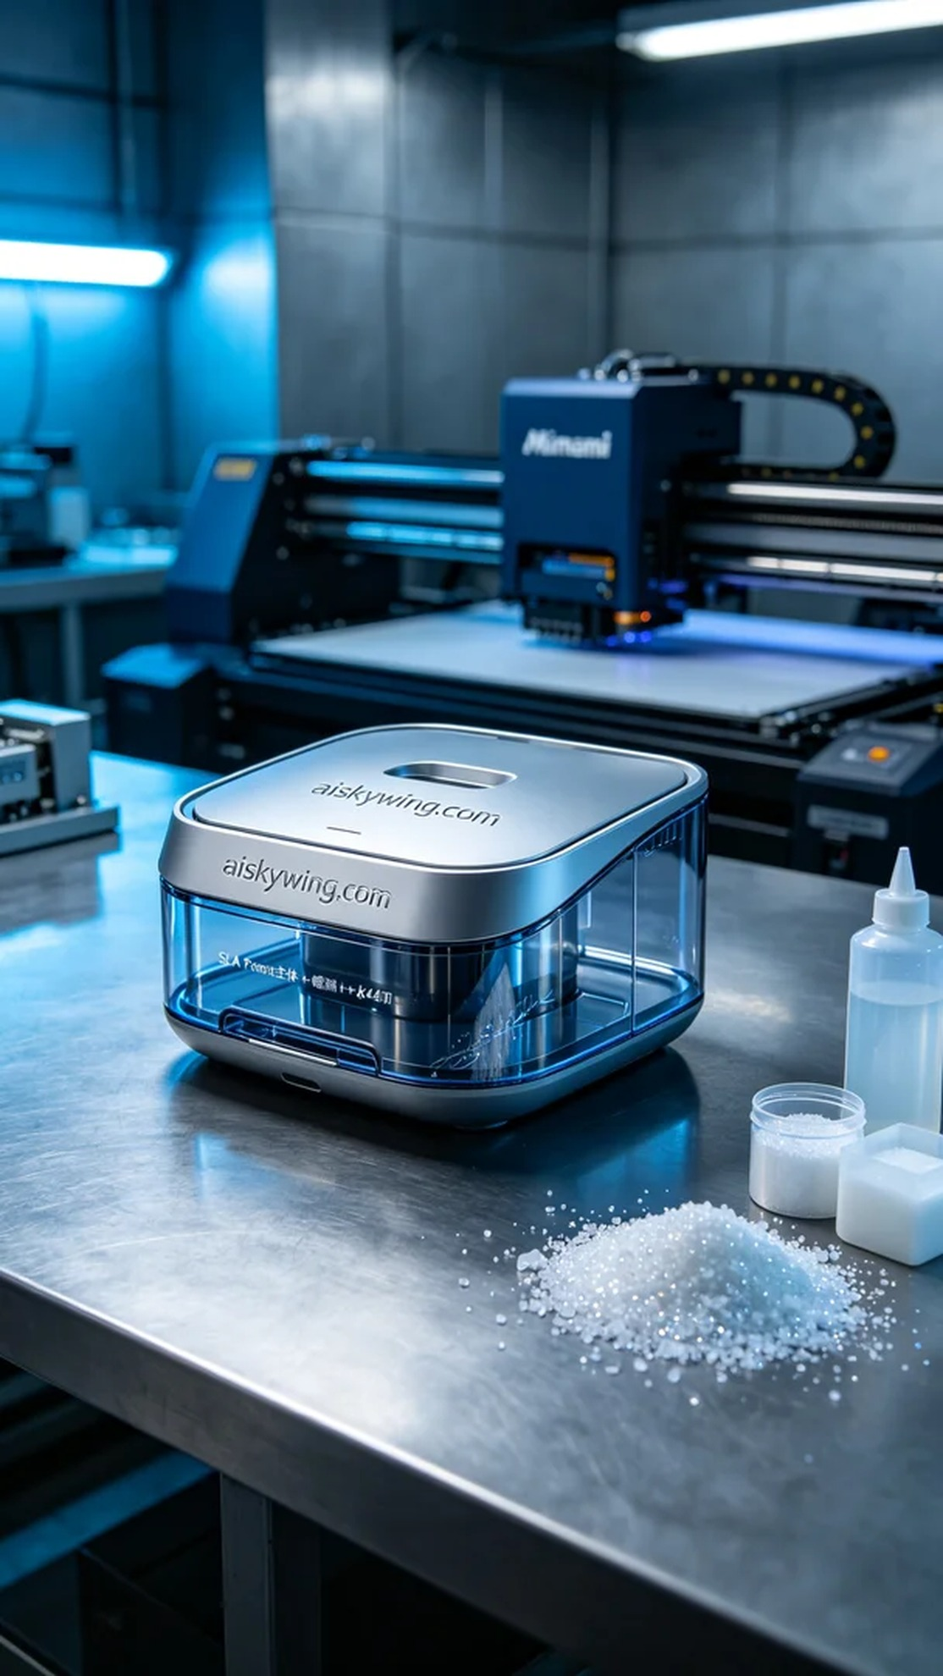
Recently, a person reached out to us through Instagram, looking to enhance their home environment with a new humidifier water tank cover. The old one was damaged, and they wished to create a beautifully designed yet functional replacement.
We prepared high-quality liquid photopolymer resin, known for its excellent tensile strength and durability to ensure the final product would last. Using a Mimaki 3D printer, we set the layer thickness to 0.05mm, maintained a printing temperature of 20°C, operated at a power of 60W, and set a printing speed of 30mm/s, estimating the print time to be 6 hours. This setup allowed us to capture intricate details and a smooth finish.
During the printing process, the Mimaki printer operated smoothly, and the curing process was stable. We continuously monitored the print quality, and each layer cured perfectly, with a smooth surface and the "aiskywing.com" engraving clearly visible. The entire printing process felt like an artistic creation, with every layer quietly coming to life.
Once the printing was completed, we moved on to the post-processing steps. First, we soaked the finished product in a cleaning solution to remove any residual resin. Next, we sanded it with fine sandpaper to ensure the edges were smooth and free of burrs. Finally, we placed the product in a curing machine to enhance its strength and durability, and after inspection, the product met our expectations flawlessly.
After a series of meticulous manufacturing processes, the humidifier water tank cover was finally completed. It not only showcases the charm of personalized customization but also represents a perfect combination of quality and functionality.
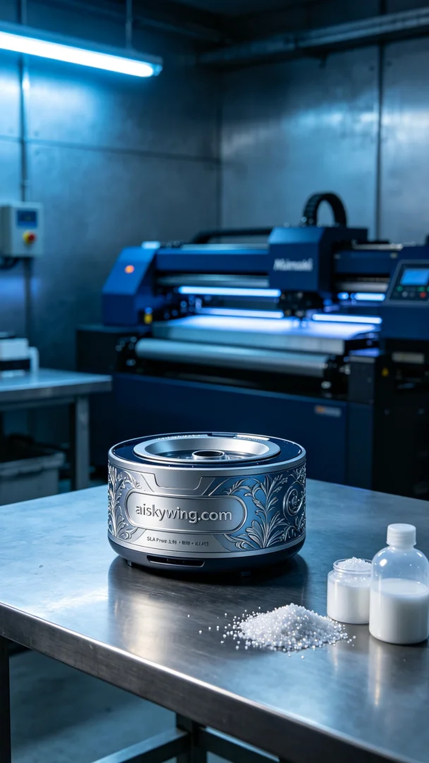
这次的项目是为了一位追求品质生活的人制作加湿器水箱盖。由于旧水箱盖损坏，他希望能定制一个既美观又实用的新盖子。经过沟通，他决定采用SLA光固化工艺来实现他的想法。
我们准备了高质量的液态光敏树脂，具备优异的抗拉伸和耐磨性，确保成品的耐用性。选择了Mimaki品牌的3D打印机，设置层厚为0.05mm，打印温度保持在20°C，功率为60W，打印速度为30mm/s，预计打印时间为6小时。这样的设置能够确保打印出细致的表面和清晰的雕刻细节。
打印过程中，Mimaki打印机运转顺畅，光固化的过程稳定，我们持续监控打印质量。每一层的固化情况都十分理想，表面光滑，雕刻的"aiskywing.com"字样清晰可见。整个打印过程如同艺术创作，每一层都在悄然成型。
完成打印后，我们进入后处理工序。首先，将成品浸泡在清洗剂中，去除残留的树脂。随后用细砂纸进行打磨，确保边缘光滑无毛刺。最后，将成品放入固化机中进行固化，增强其强度与耐久性，经检验，成品符合预期，完美无缺。
经过一系列精细的制作流程，这个加湿器水箱盖终于完成。它不仅体现了个性化定制的魅力，更是品质与功能的完美结合。
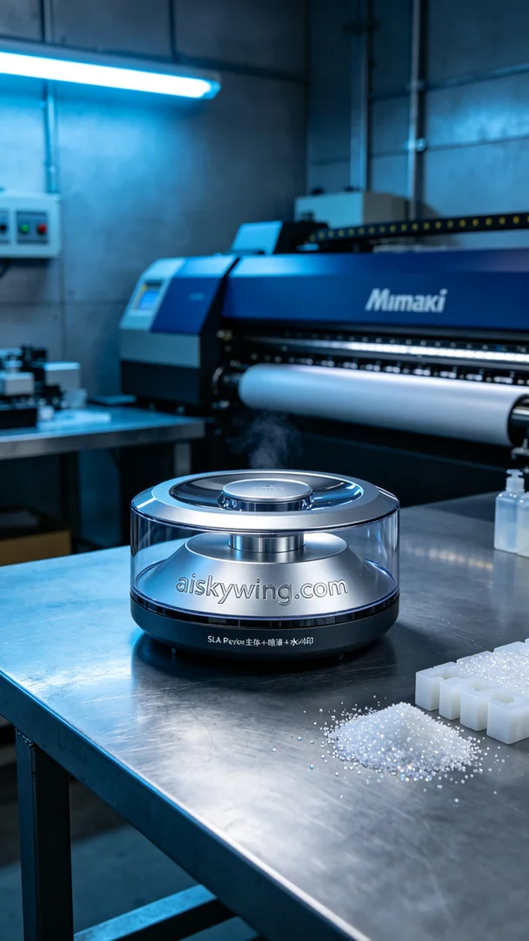
Aiskywing Industrial 3D Printing
Humidifier water tank cover


