0519-动感单车脚踏的3D打印生产记录
Stationary bike pedals
🖨️ SLS尼龙烧结
🖥️ 打印机: EOS
📦 材料: 摆放着未成型的液态光敏
在生活的旅途中，我们总会遇到各种挑战，就像这次的动感单车脚踏置于画面正中央的制作请求，今天我们又迎来了新的机遇。
On the journey of life, we always encounter various challenges, just like the request to place the spinning bike pedals right in the center of the frame. Today, we are greeted with new opportunities once again.
________________________________________________________________________________
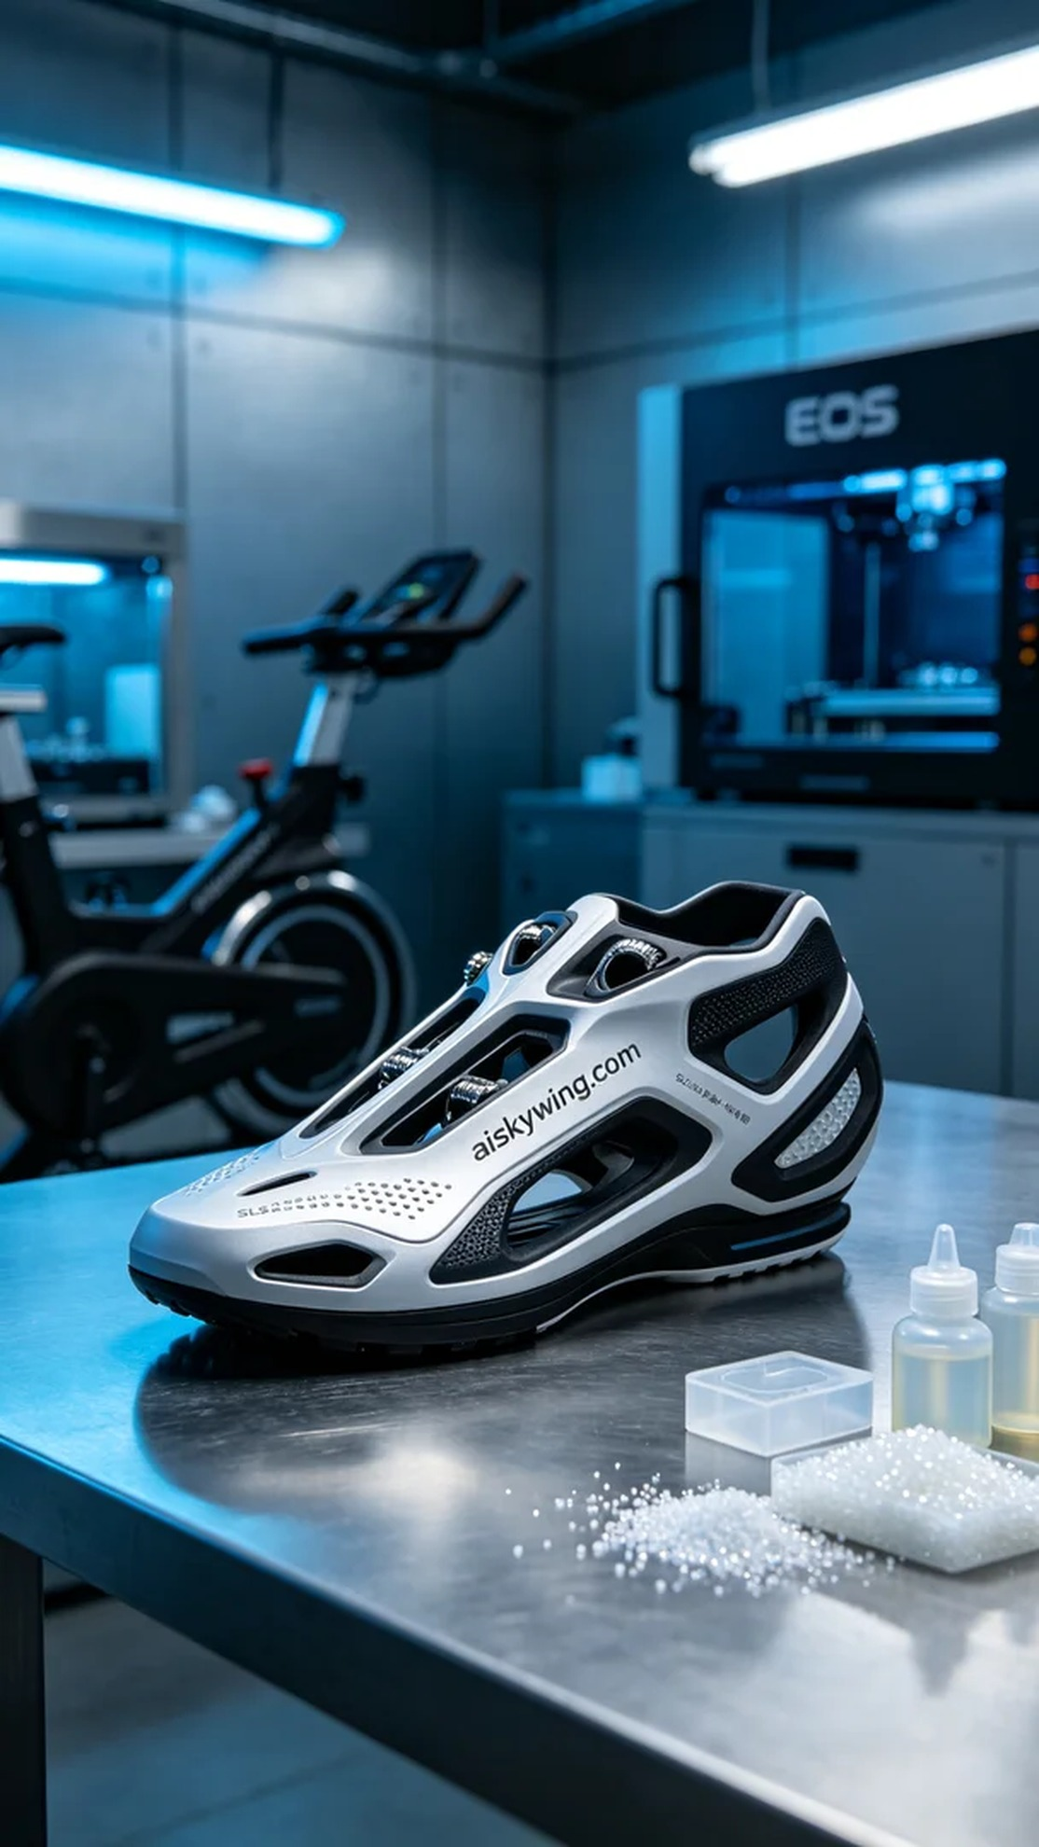
Someone reached out to us via WhatsApp, asking if we could help create a dynamic bike pedal. They required precision and an industrial aesthetic, emphasizing the need for a blend of rigidity and flexibility in the design to suit a strong industrial atmosphere.
We chose to use unformed liquid photopolymer resin as our raw material, which offers excellent fluidity and high precision, perfect for detailing. After preparing the EOS printer, we set the printing parameters: layer thickness of 0.1mm, maintaining a temperature of 25°C, power set at 300mW, and a printing speed of 50mm/s, taking about 30 hours.
During the printing process, the EOS printer operated steadily, allowing us to monitor in real time to ensure that each layer formed correctly. We noted that the combination of SLS nylon skeleton and silicone encapsulation worked well, with the engraved text on the product's surface appearing particularly sharp, reflecting the cold industrial light effectively.
After printing, we conducted strict post-processing, including washing, sanding, and curing. First, we used an ultrasonic cleaner to remove any residual resin from the surface, followed by manual sanding of the edges to ensure smoothness, and finally placed the product in a UV curing machine to solidify, ensuring its strength and durability met the standards.
After a series of procedures, we successfully produced the dynamic bike pedal, achieving a satisfactory overall effect that showcased both industrial style and meticulous detailing. Another challenge completed, and we look forward to the next project.
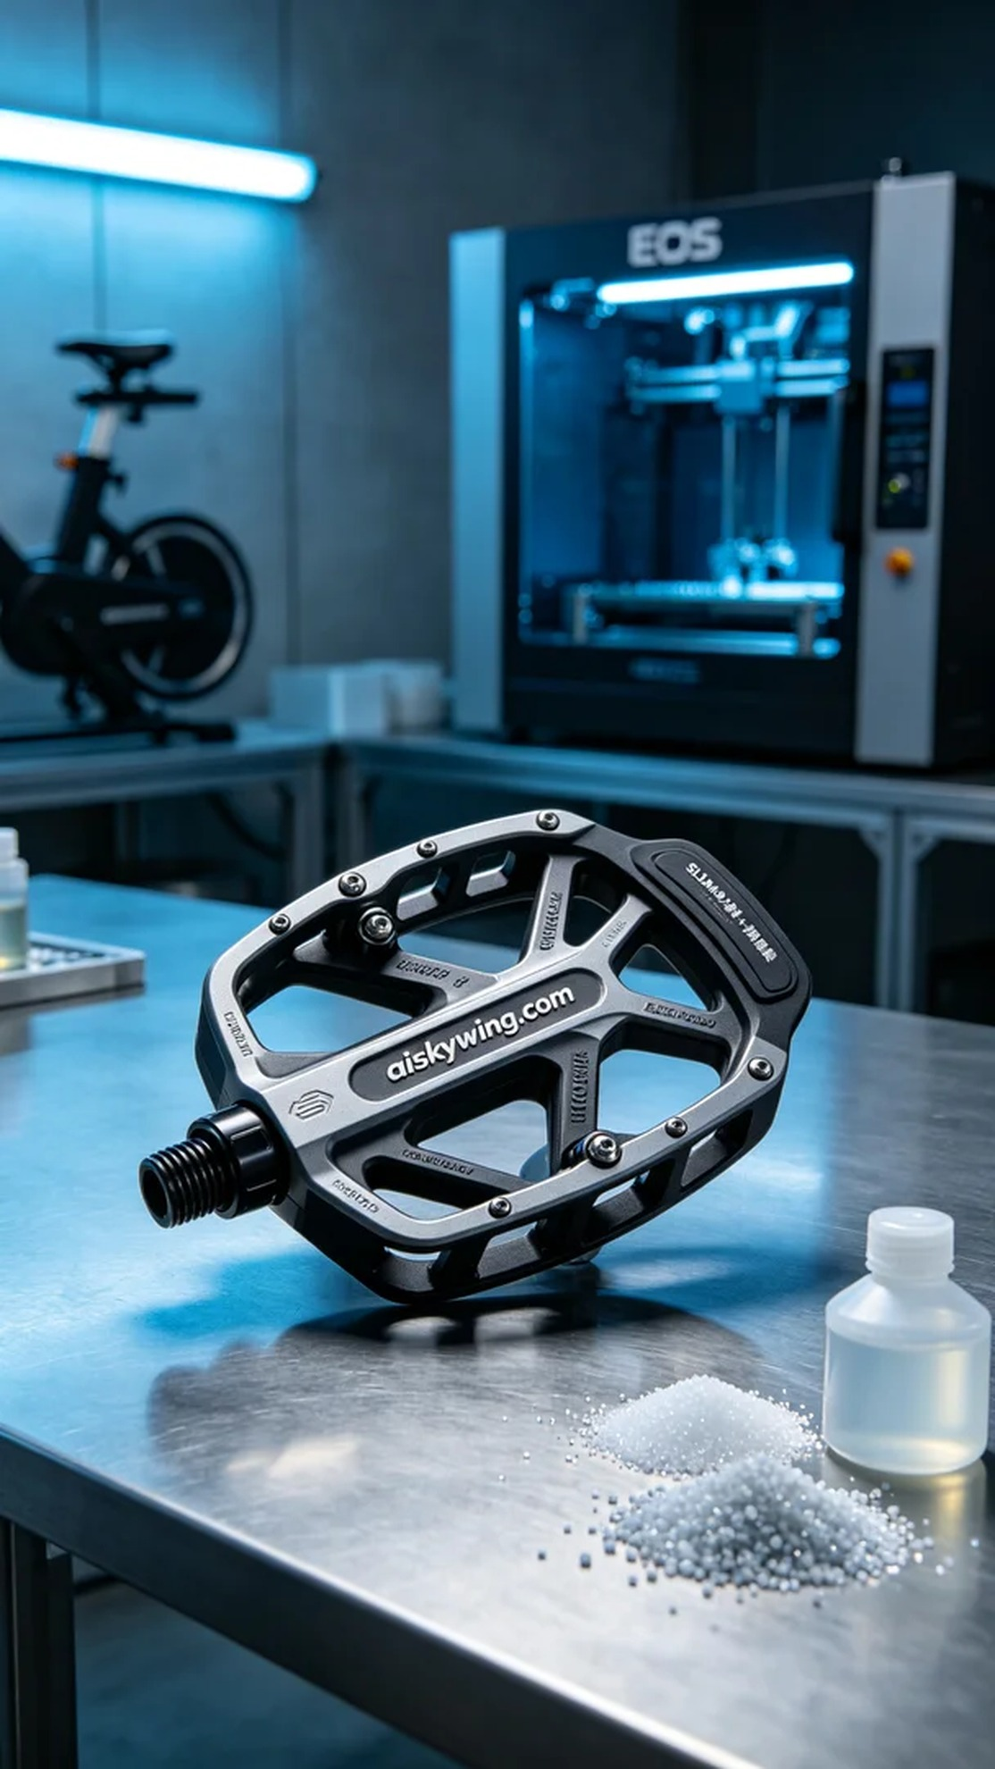
有人通过WhatsApp联系到我们，询问能否帮助制作一款动感单车脚踏，要求精密且具有工业美感。对方特别强调了设计的刚柔结合，需要在强烈的工业氛围中展现出产品的细腻。
我们选择使用未成型的液态光敏树脂作为原材料，这种材料具有优良的流动性和高精度特性，适合细节丰富的产品。准备好EOS打印机后，我们对打印参数进行了设置：层厚0.1mm，温度保持在25°C，功率设定为300mW，打印速度为50mm/s，用时约30小时。
在打印过程中，EOS打印机稳定运行，通过实时监控确保每层都能正确成型。我们观察到，SLS尼龙骨架与硅胶复模外层的结合效果良好，产品表面雕刻的字样也显得格外清晰，反射出冷峻的工业光线。
打印完成后，我们进行了严格的后处理，包括清洗、打磨和固化等工序。首先使用超声波清洗机去除表面的残留树脂，随后手工打磨边缘以保证光滑度，最后将产品放入UV固化机中进行固化，确保其强度和耐用性达到标准。
经过一系列工序，我们得到了这款动感单车脚踏，整体效果令人满意，既展示了工业风格，又不失细节的精致。又一次的挑战成功完成，期待下一个项目的到来。
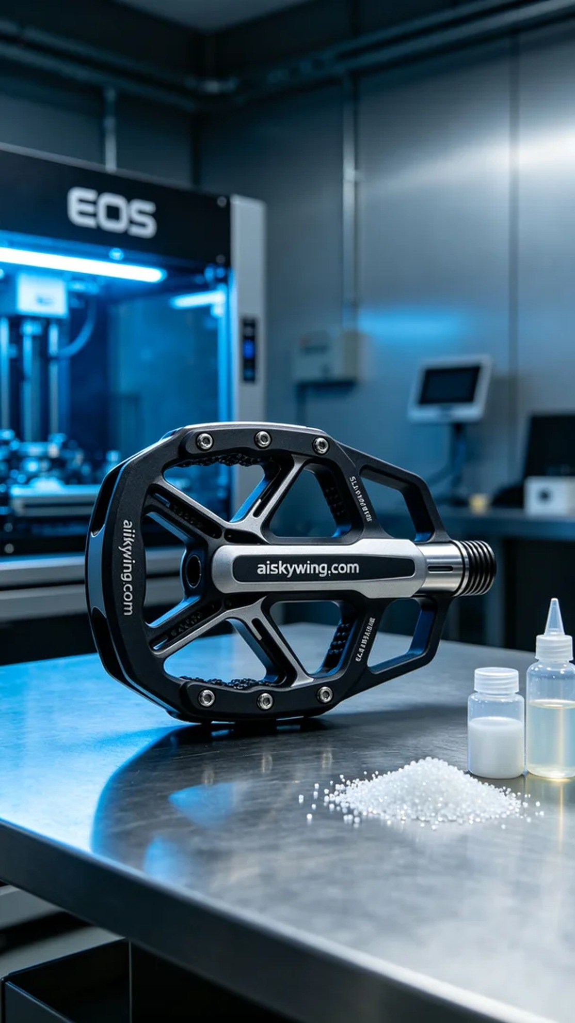
Aiskywing Industrial 3D Printing
Stationary bike pedals


