0520-卧推架挂钩的3D打印生产记录
Bench press rack hook
🖨️ SLS尼龙烧结
🖥️ 打印机: Rize
📦 材料: 摆放着未成型的液态光敏
生活的每一步都与坚持息息相关。最近，有人通过YouTube找到我们，希望解决卧推架挂钩的设计需求。
Every step of life is closely related to perseverance. Recently, someone found us through YouTube and hopes to address the design needs for a bench press rack hook.
________________________________________________________________________________
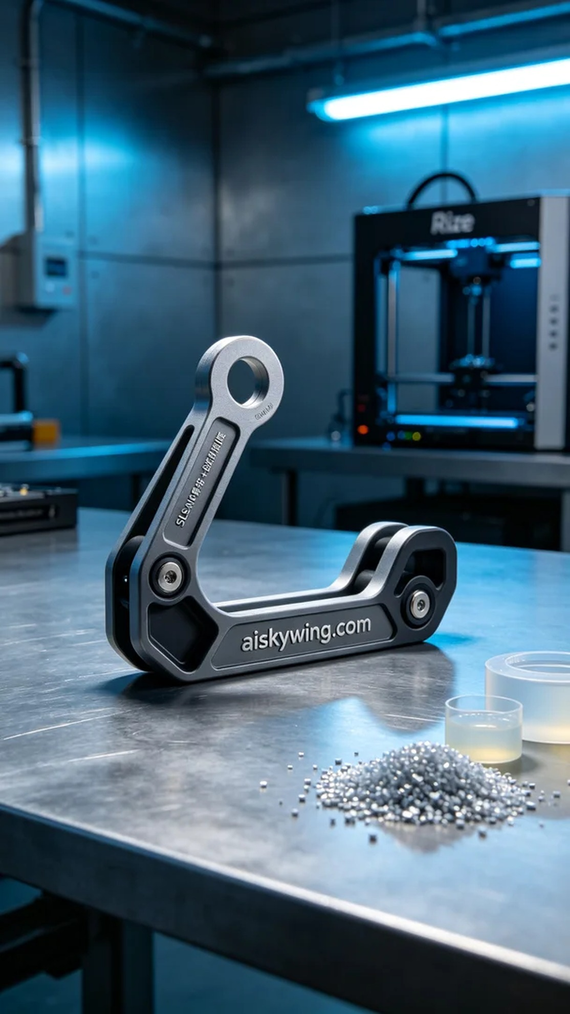
Every step in life is closely tied to perseverance. Recently, someone found us through YouTube, seeking to solve the design needs for a bench press hook.
For this project, we chose the SLS nylon sintering process, using unformed liquid photopolymer resin as our material. This material boasts excellent strength and flexibility, making it ideal for creating robust yet somewhat elastic products. For printing, we set the layer thickness on the Rize printer to 0.1 mm, maintained the temperature at 60 degrees Celsius, set the power at 100 watts, and the printing speed at 50 mm per second. The entire printing process was expected to take about two hours.
During the printing process, we closely monitored the operation of the equipment. The precision control system of the Rize printer ensured the printing quality remained consistent, with details clearly visible. To ensure every detail met the design standards, we regularly checked the printing progress to avoid any flaws or unexpected halts.
After printing, we performed multiple post-processing steps. First, the printed hook was placed in a cleaning solution to remove surface residues. Next, we meticulously sanded it to achieve a smooth, flawless surface. After that, the product was cured to enhance its durability and strength. Finally, we conducted stringent inspections to ensure that all specifications met the expected standards.
With a series of meticulous procedures, this bench press hook not only fulfills its practical purpose but also showcases exceptional industrial design. The dedication to craftsmanship has made each product a source of pride for us.
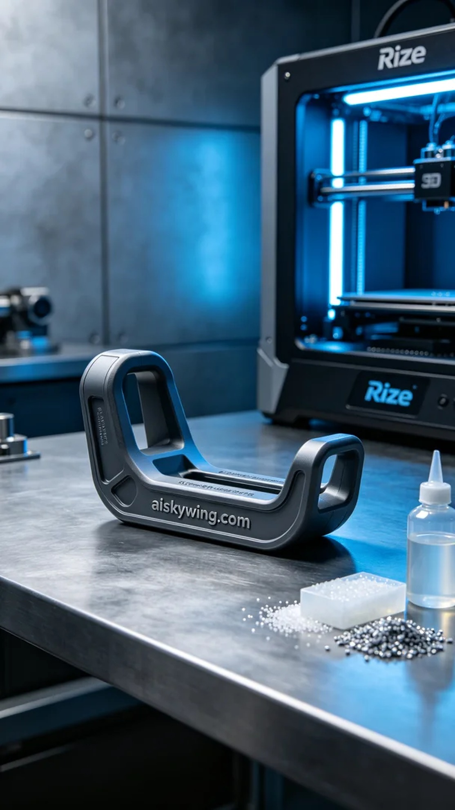
这次的卧推架挂钩项目，源自于一位健身爱好者的需求。他在YouTube上看到了我们的作品，希望我们能为他提供一个既实用又美观的挂钩。经过沟通，他明确了产品的功能和设计要求，我们开始了这项工作。
我们选择了SLS尼龙烧结工艺来进行打印，使用的原材料是未成型的液态光敏树脂。这种材料具有优良的强度和柔韧性，适合制造坚固且有一定弹性的产品。打印时，我们将Rize打印机的层厚设置为0.1毫米，温度保持在60摄氏度，功率设定为100瓦，打印速度为50毫米每秒。整个打印过程预计耗时约两小时。
在打印过程中，我们严格监控设备的运行状态。Rize打印机的精密控制系统使得打印质量始终保持稳定，细节清晰可见。为了确保每一个细节都达到设计标准，我们定期检查打印进程，确保没有出现任何瑕疵或意外停机。
打印完成后，我们进行了多道后处理工序。首先，将打印出来的挂钩放入清洗液中进行清洗，去除表面的残留物。接着，通过细致的打磨将表面处理得光滑无瑕。之后，将产品进行固化，以提高其耐久性和强度。最后，我们对成品进行了严格的检验，确保其各项指标符合预期要求。
经过一系列的精细工序，这个卧推架挂钩不仅具备了实用性，还展现了卓越的工业设计感。用心的制作让每一件产品都成了我们的骄傲。
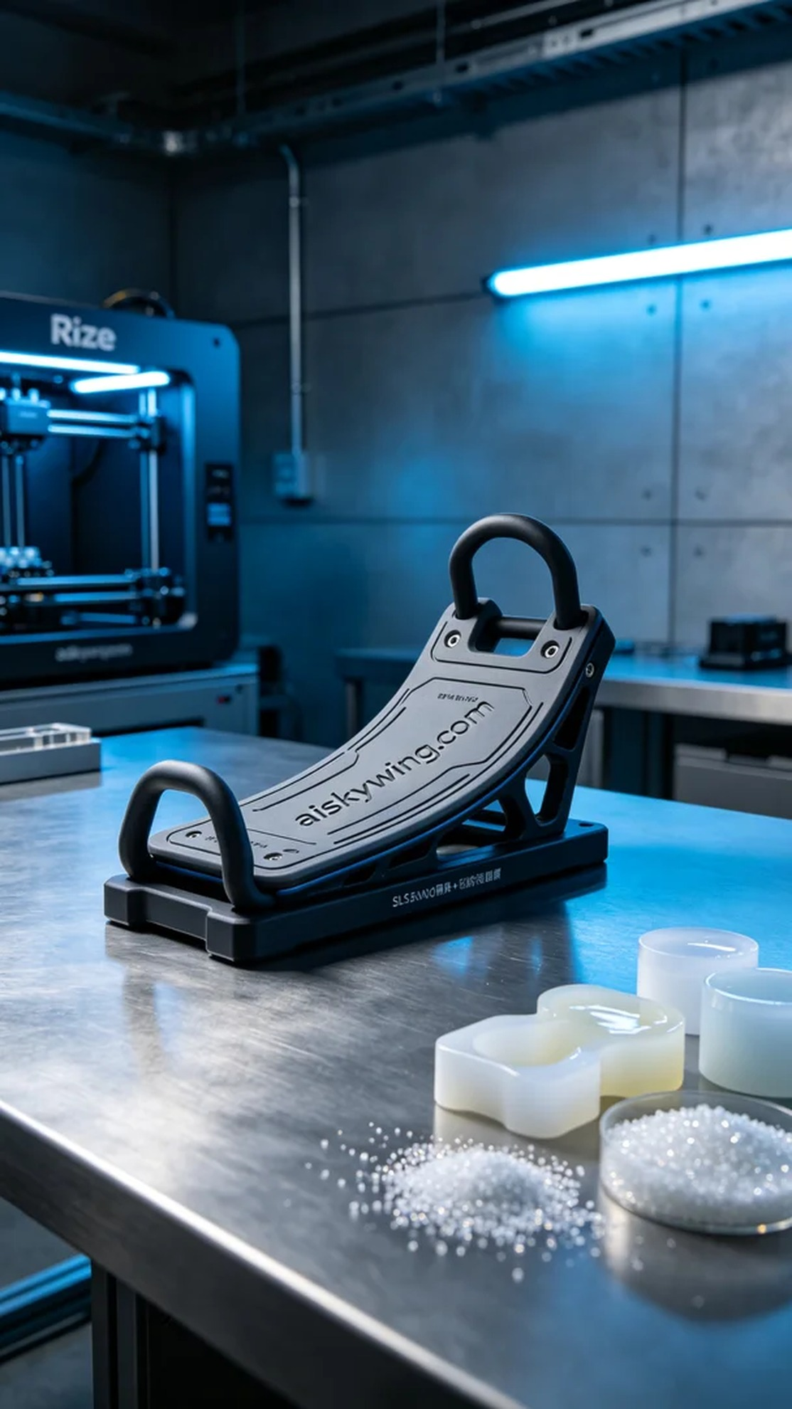
Aiskywing Industrial 3D Printing
Bench press rack hook


