0521-吸尘器风道管3D打印生产记录
Vacuum cleaner duct管
🖨️ SLM金属打印
🖥️ 打印机: Voxeljet
📦 材料: 摆放着未成型的液态光敏
生活再难，也别停下脚步。就像接下这个吸尘器风道管的单子，有人通过WhatsApp联系我，提出了他们在项目中遇到的挑战。
No matter how difficult life gets, don't stop moving forward. Just like when I took on the task of the vacuum cleaner duct, someone contacted me via WhatsApp and shared the challenges they faced in the project.
________________________________________________________________________________
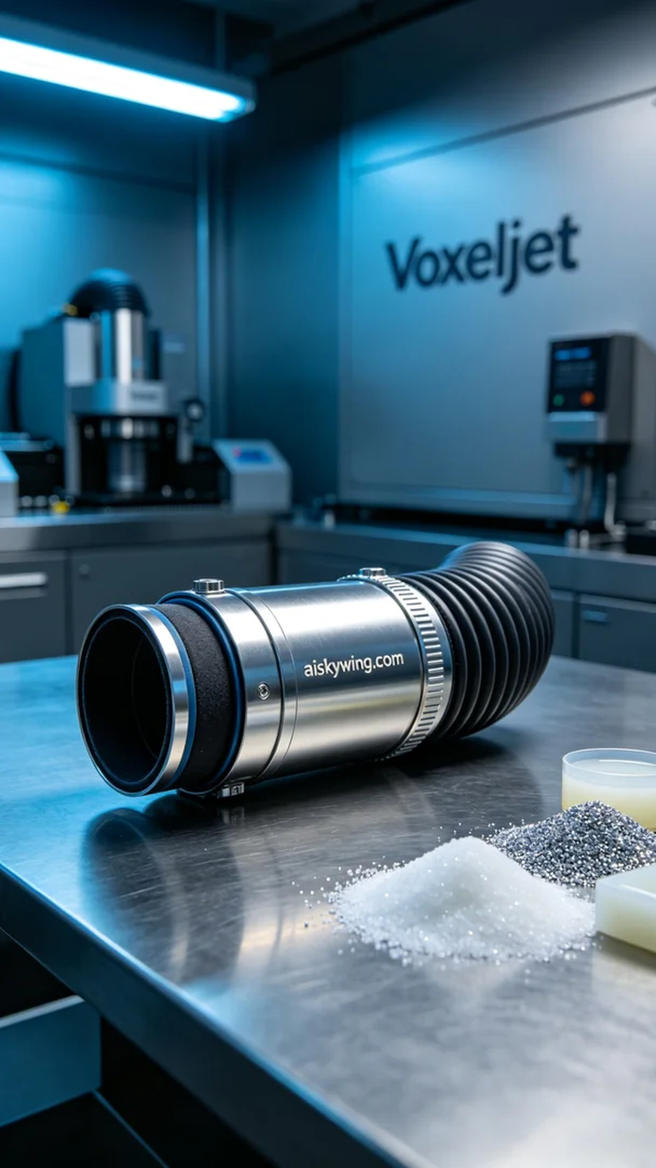
Life can be challenging, but we must keep pushing forward. Recently, someone reached out to me via WhatsApp regarding their need for a vacuum cleaner duct. Faced with tight deadlines and high technical requirements, I decided to take on this challenge using our 3D printing technology.
We chose to use liquid photopolymer resin as the raw material, known for its excellent fluidity and adhesion during printing, ensuring perfect detail representation. To proceed smoothly, I prepared the Voxeljet 3D printer and set appropriate parameters, including a layer thickness of 0.1mm, a temperature maintained at 25 degrees Celsius, a printing power of 80%, a speed of 50mm per hour, and an estimated printing time of six hours.
During the printing process, the machine operated steadily, and the liquid photopolymer resin gradually formed on the printing platform. We continuously monitored the equipment's operating status, observing the quality of each layer to ensure there were no flaws or bubbles. As the printing progressed, the vacuum cleaner duct slowly revealed its exquisite outline, leaving us excited for the final result.
After printing, we first cleaned the finished piece with isopropyl alcohol to remove any uncured resin on the surface. We then polished it to ensure a smooth finish. Finally, we placed the product in a curing chamber and used UV light to cure it, ensuring the material's strength and stability met the requirements. After curing, we conducted rigorous inspections on the product to ensure every detail met our standards.
Ultimately, this vacuum cleaner duct not only completed the printing process but also received unanimous praise. Through this experience, I realized that combining technology and persistence can yield satisfactory results when faced with challenges.
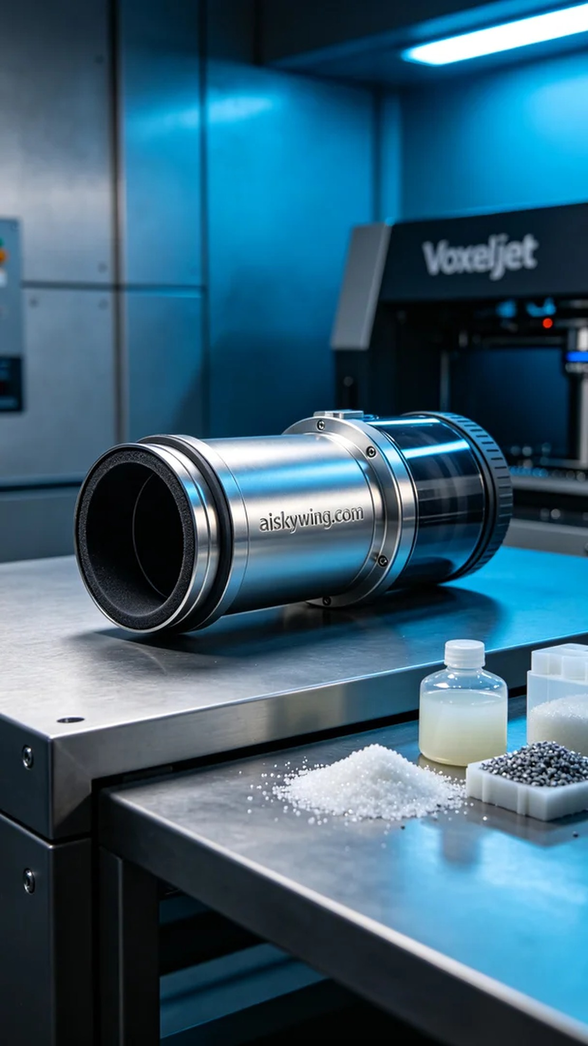
在最近的一次沟通中，有人通过WhatsApp和我聊起他们在生产过程中遇到的问题，主要是关于他们所需的吸尘器风道管。面对时间紧迫和技术要求高的任务，我决定接下这个挑战，利用我们的3D打印技术来解决他们的问题。
我们选择使用液态光敏树脂作为原材料，这种材料在打印时具有优良的流动性和附着力，能够确保细节的完美展现。为了顺利进行打印，我准备了Voxeljet 3D打印机，设置了合适的打印参数，包括层厚0.1mm，温度保持在25摄氏度，打印功率为80%，速度设置为每小时50mm，预计打印时间为6小时。
打印过程中，机器稳定运转，液态光敏树脂缓缓在打印平台上成型。我们始终监控设备运行状态，观察每一层的打印质量，确保没有出现任何瑕疵和气泡。随着打印的进行，吸尘器风道管逐渐显现出精致的轮廓，令人倍感期待。
完成打印后，我们首先用异丙醇对成品进行清洗，以去除表面的未固化树脂。接着对其进行打磨处理，以确保表面光滑。最后，我们将成品放入固化机中，使用UV灯照射进行固化，确保材料强度和稳定性达到要求。固化后，我们对成品进行了严格的检验，确保每一个细节都符合标准。
最终，这个吸尘器风道管不仅完成了打印，还得到了一致的好评。通过这次经历，我深刻体会到，面对挑战时，技术与坚持的结合总能带来满意的结果。
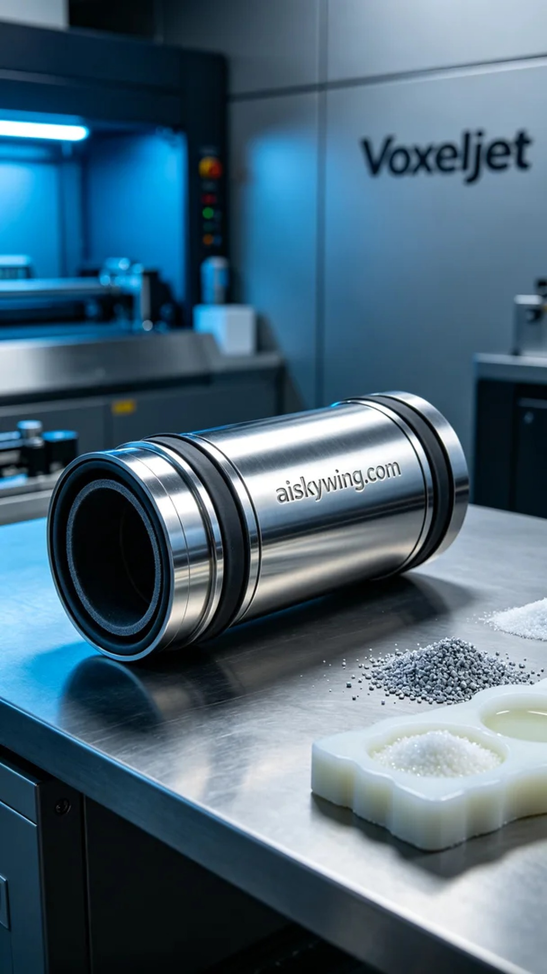
Aiskywing Industrial 3D Printing
Vacuum cleaner duct管


